User Guide  FOR Application Form | Abstract  This user guide describes the step by step procedure on how to apply for and get approval to be an organiser for The FA Mars Just Play Programme.

Contents
1. Landing Page 2
2. Application Form 2
a. Programme Selection 3
a. Applicant Personal Details 4
b. Delivery Organisation Information (Screen 1) 5
c. Delivery Organisation Information (Screen 2) 6
d. Delivery Organisation Information (Screen 3) 7
e. Delivery Organisation Information (Screen 4) 8
f. Venue Information (Screen 1) 9
g. Venue Information (Screen 2) 10
h. Venue Information (Screen 3) 11
i. Documentation Upload 12
j. Staff Information – Coach 13
k. Terms & Conditions 14
l. Summary Screen 16
m. Submission Confirmation Screen 18
3. Support Contact Details 19

Landing Page
The application for The FA Mars Just Play Programme can be completed by the lead coach for the centre, this person must be aged 18+ hold a minimum of FA level 1, an in date FA CRC, FA Safeguarding and FA Emergency aid qualifications at the point of application. Although this is not a mandatory criterion, any person (without login credentials) can create a new account and proceed to fill and submit an application form for the Programme
Screen(s):
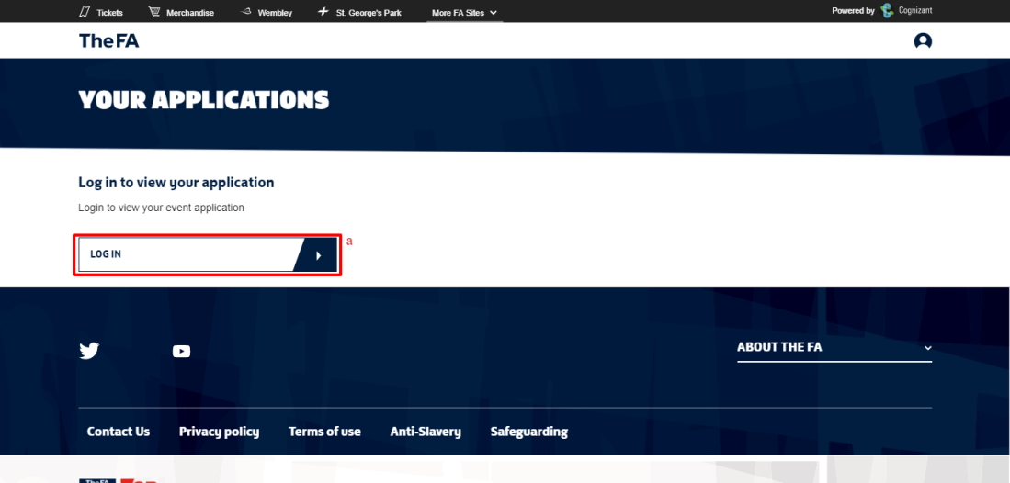
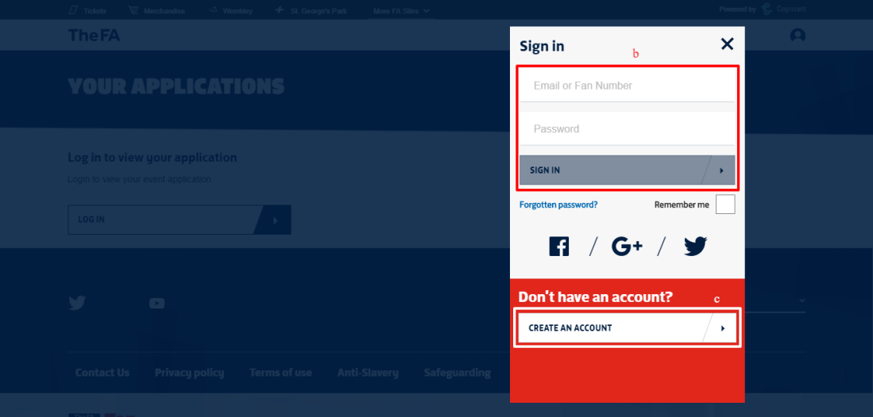

Application Form
Each application is for a centre. If the applicant is running an additional centre on a different day, please create a second application for this centre. This section explains the step by step procedure to filling up an application form in order to Apply for and host The FA Mars Just Play Programme.
The application form consists of 3 major sections.
- Delivery Organisation Information
- Venue Information
- Staff (Coach/Volunteer/DSO) Information
The Applicant will have the “Apply now” option to initiate the Application process in his/her landing page once they have successfully logged in. Existing applications, if any, will also be displayed in the landing page.
- The applications will be made available as per the application statues, which are displayed in the Primary Navigation bar – “In Progress, Submitted, Approved & Rejected”
- User must accept to the “Privacy/Terms & Conditions” in order to proceed with the Application Form
- “APPLY NOW” option will be enabled only after the user has accepted to the “Privacy/Terms & Conditions”
Screen(s):
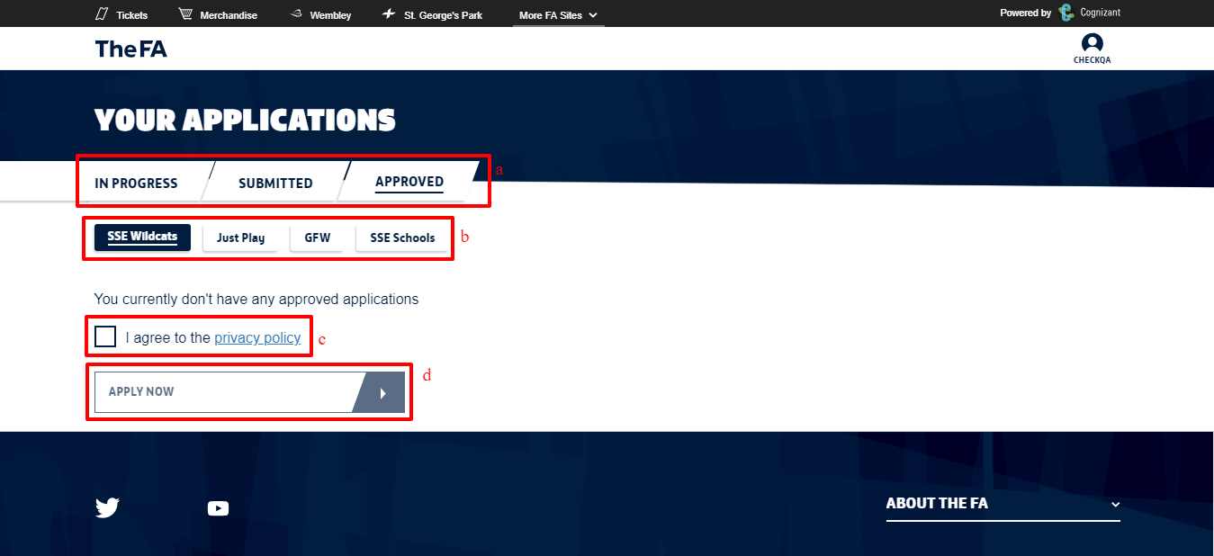
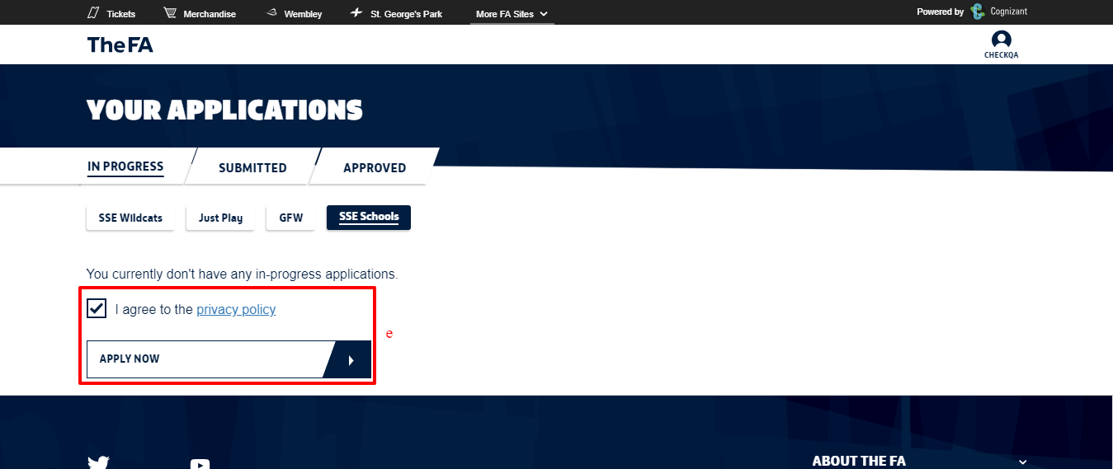

Programme Selection
Select “The FA Mars Just Play” Programme from the dropdown so as to proceed to the next screen
Screen(s):
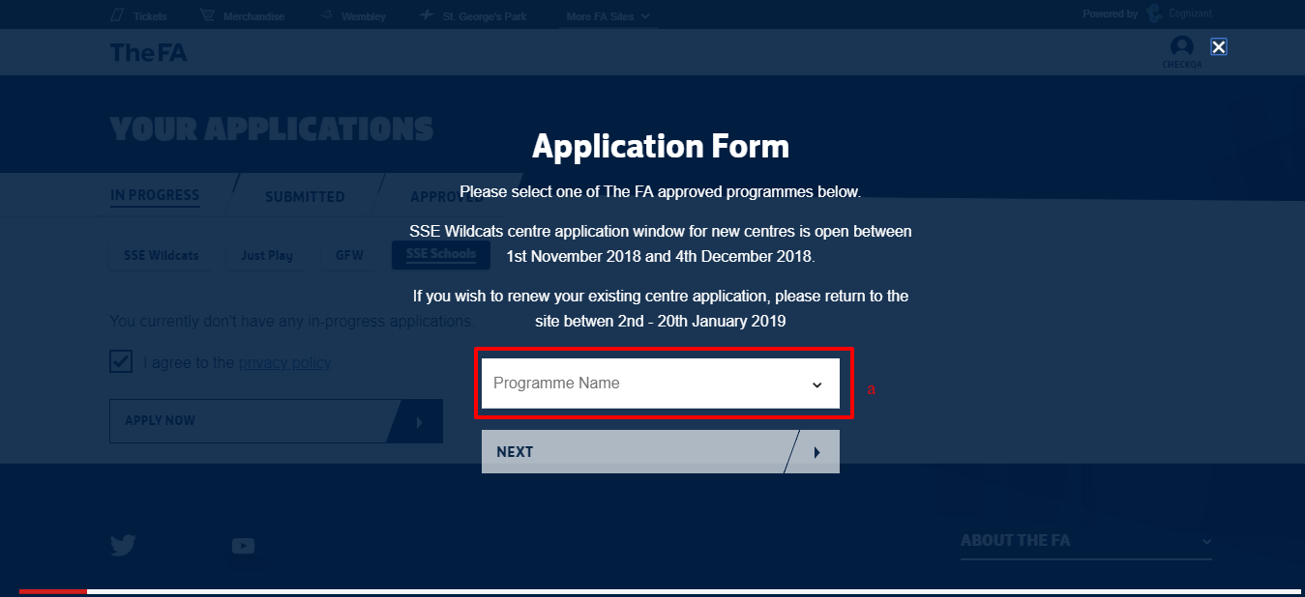
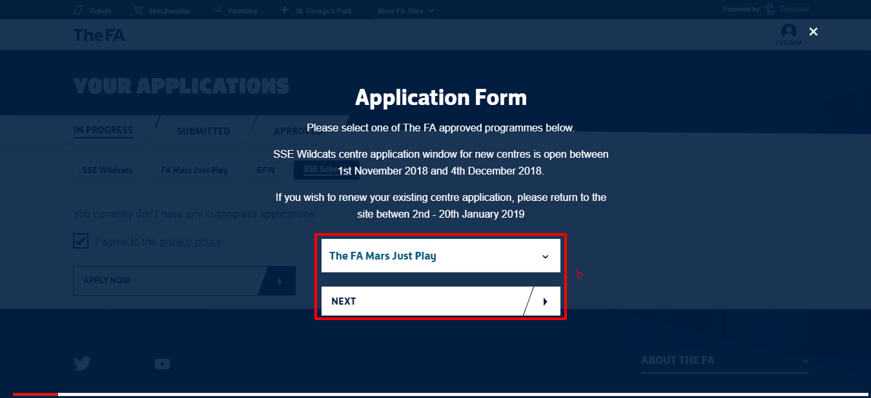

Applicant Personal Details
This screen pre-populates the logged in applicants’ personal details. All details in this screen are view only and cannot be edited. The details displayed include,
- Applicants personal details like
  - First name
  - Last name
  - DOB
  - Email
  - Phone No
  - Post Code
  - Street name
- Option to “SAVE AND CONTINUE”
Screen(s):
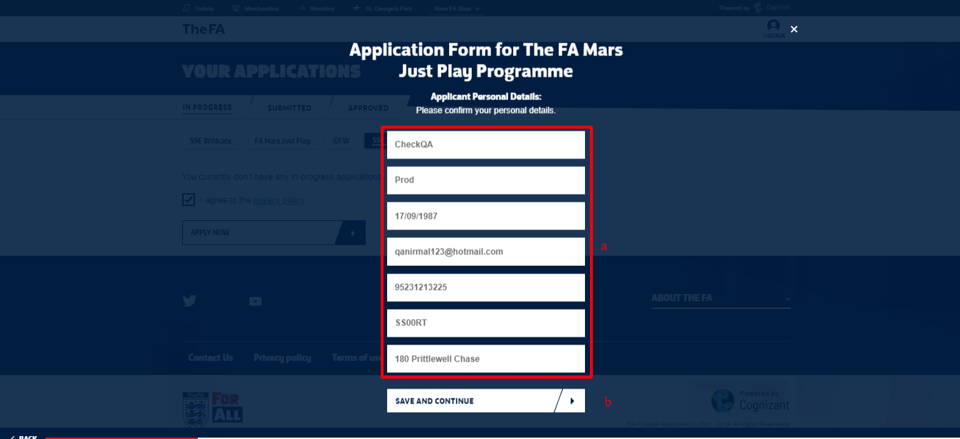

Delivery Organisation Information (Screen 1)
The applicant is required to enter the details of the Delivery Organisation in this screen. All fields are mandatory in order to proceed to the next screen.
Input fields in this screen are,
- Delivery organiser name
- Address Line 1
- Address Line 2
- Town
- Postcode
- Delivery organisation Telephone number
- Delivery organisation Email address
- Option to check if the provided address is same as the one where the activity will be delivered
- Option to “SAVE AND CONTINUE”
Note:
- Where the applicant address is the same as the address where the sessions of the centre would be conducted, select the checkbox “The address provided above is the same venue at which your activity will be delivered”, the Post code entered in this page will be carried forward to the “Venue Information” section. It will be editable and the user can edit or change the entry as required.
Screen(s):
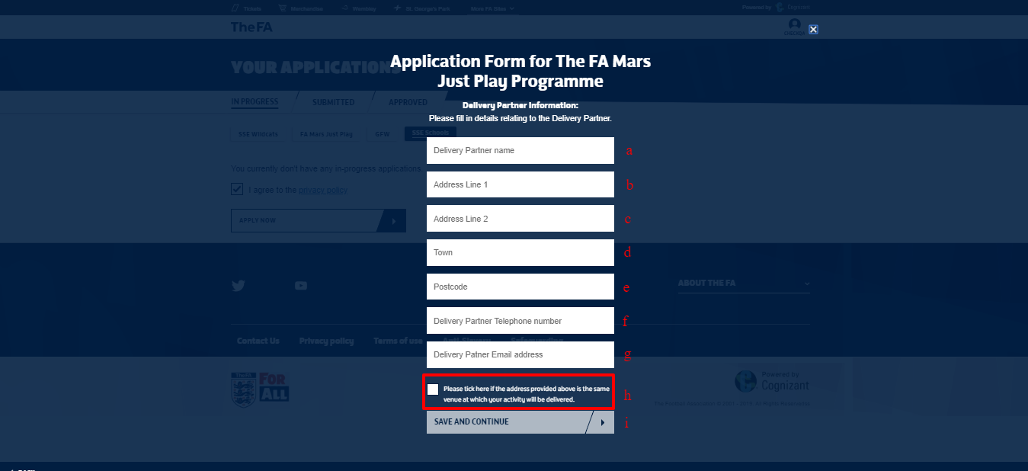

Delivery Organisation Information (Screen 2)
The Applicant is required to enter the details of the Delivery Organisation in this screen. All fields are mandatory in order to proceed to the next screen.
Input fields in this screen are as follows: all the information in this page are mandatory and the applicant can proceed further only after filling all the details of this page.
- Organization Type
- Delivery Type
- Does the organization have a charitable status?
- Please describe who you intend to target through this programme and the outcomes you expect to achieve.
- Please describe who you intend to work with in order to ensure successful delivery of the programme.
- Please describe how the organisation plan to make this programme sustainable.
- Option to “SAVE AND CONTINUE”
Note:
- “Organisation Type” will have the below options for the user to choose from
  - FA Charter Standard Club
  - FA University Hub - Tier 1
  - FA University Hub - Tier 2
  - FA University Hub - Tier 3
  - FA College Hub - Tier 1
  - FA College Hub - Tier 2
  - FA College Hub - Tier 3
  - County Football Association
  - Not Applicable
- “Delivery Type” will have the below options for the user to choose from
  - Community Delivery
  - Disability Delivery
  - Educational Delivery
Screen(s):
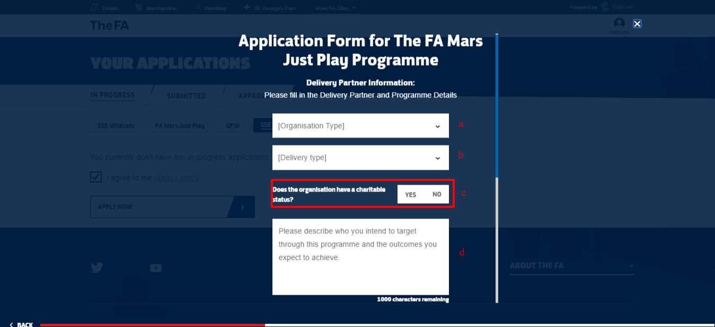
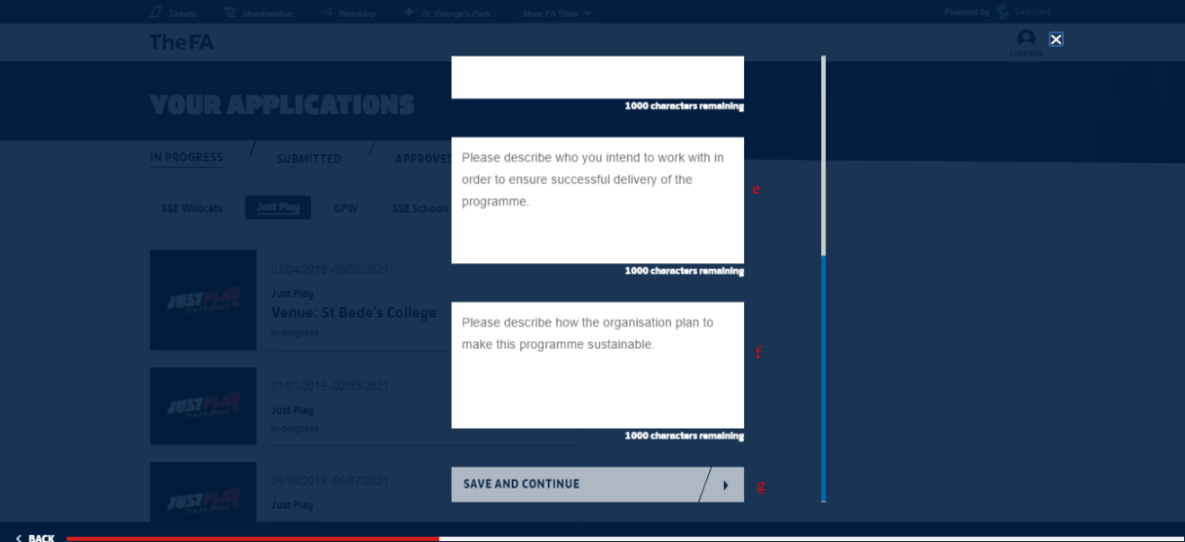

Delivery Organisation Information (Screen 3)
The applicant is required to enter the details of the Delivery Organisation in this screen. All fields are mandatory in order to proceed to the next screen.
Input fields in this screen are,
- Gender selection
- Is this a Disability Specific Event?
- Is this a Walking Football Session?
- Is this a Futsal Session?
- Activity Type
- Minimum Age
- Maximum Age
- Max Session Capacity
- Session Charge
- Option to “SAVE AND CONTINUE”
Note:
- “Activity Type” will have the below options for the user to choose from
- Turn Up & Play Activity
- Soccercise
- For “Is this a Disability Specific Event?” option, if the applicant selects 'Yes', it would confirm that the session is only open to those with a disability.
- In order to be recognised as a “Futsal Session” it must be played on a hard surface, to lines using Futsal goals, a Futsal ball and played to Futsal rules'.
- The minimum age criteria for this Programme is 16.
- The “Max Session Capacity” is set at 16 and the user will not be able to entry a value lesser than this
- The “Session Charge” field should contain a value and cannot be left blank
Screen(s):
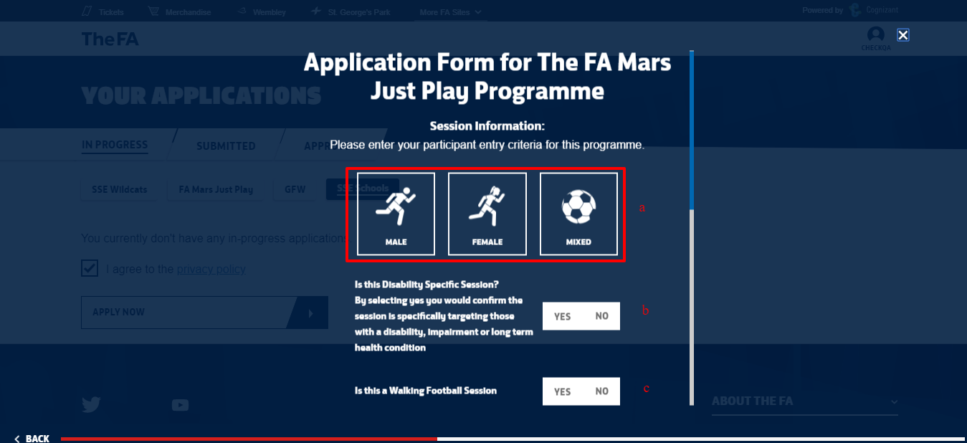
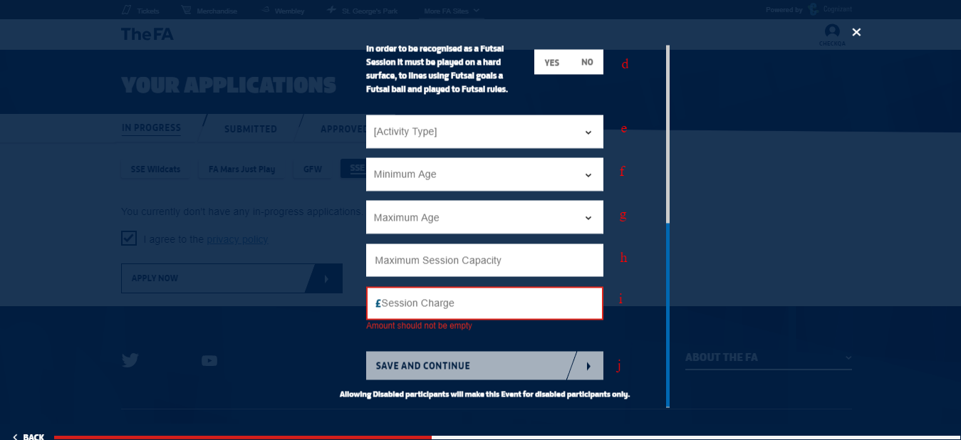

Delivery Organisation Information (Screen 4)
Requirements for the FA Mars Just Play Programme are a minimum of 16/24/32 weekly sessions in the 12 months following commencement of activity depending on the Delivery Type. We encourage applicants to deliver for as many weeks as possible during the year.
Note:
- The minimum number of weeks would change depending on the “Delivery Type” (Community/Disability/Educational) selected previously. The Start & End dates will be validated based on the same.
- Applicant can select a day or combination of Day(s) (Mon to Sun) that they wish to run the programme on.
Screen(s):
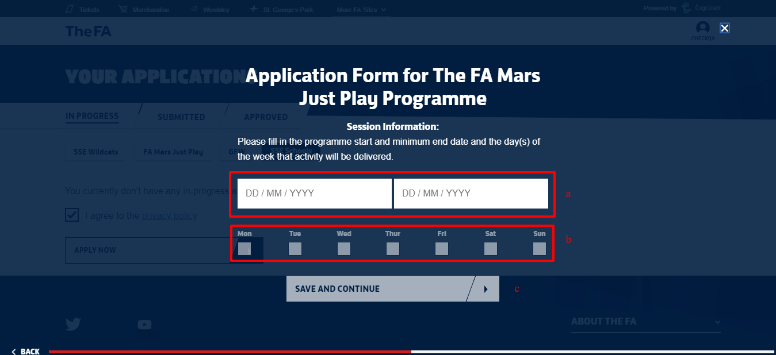

Venue Information (Screen 1)
The applicant is required to enter the Venue detail where the activity will be taking place in this screen. After the user searches for the required Venue, they can select from the list of venues that matches the search criteria. All fields are mandatory in order to proceed to the next screen.
Input fields in this screen are,
- Venue Name/Postcode
- Option to “FIND VENUE”
- Search Results/Venue Selection
Note:
- The user can enter either the Venue Name or the Postcode to initiate the venue search
- If the user had selected the option confirming that “The address provided above is the same venue at which your activity will be delivered”, in the “Delivery Organiser Information” screen, the Post code entered carried forward to the “Venue Name/postcode” field. It will be editable and the user can edit or change the entry as required.
- If the desired venue is not listed in the search results, then the user cannot proceed with the application form and will have to reach out to TheFA via the link provided on screen
Screen(s):
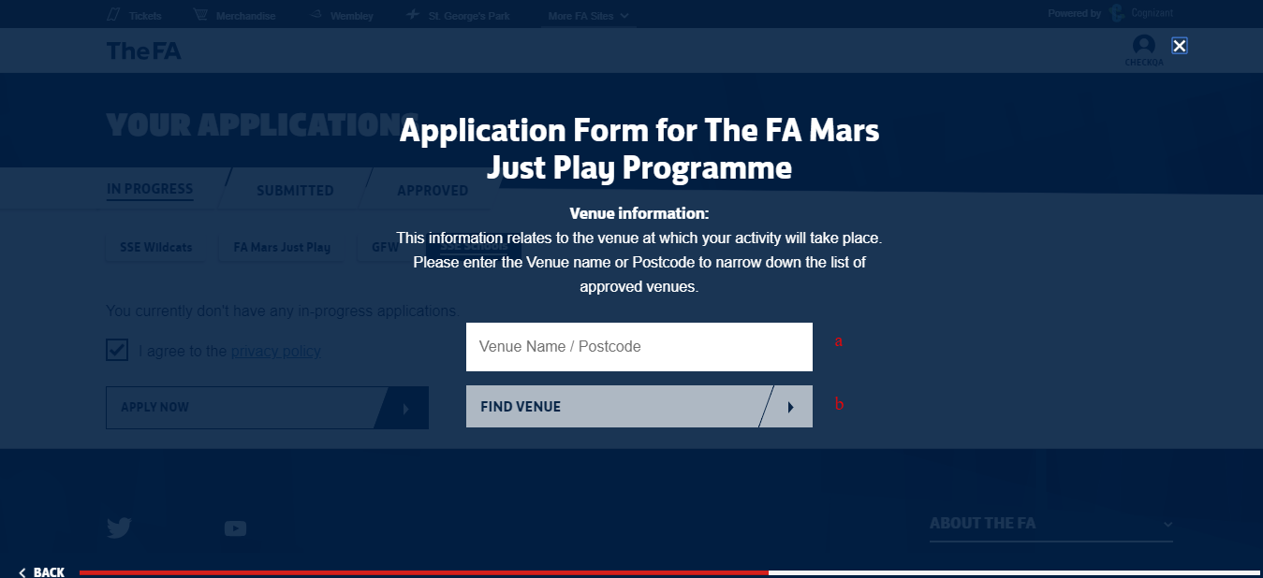
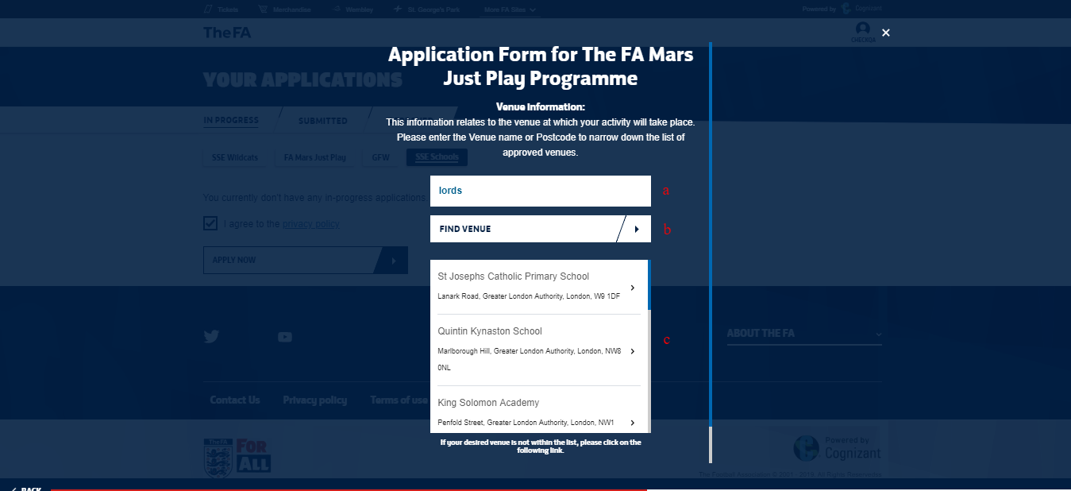

Venue Information (Screen 2)
The applicant is required to select the CountyFA for the venue selected in this screen. All fields are mandatory in order to proceed to the next screen.
Input fields in this screen are,
- Map view of the Venue selected
- Address of the Venue Selected
- County FA Selection
- Option to “SAVE AND CONTINUE”
Note:
- The user can see the Map view and the complete address of the Venue selected in the previous screen
- CountyFAs tagged to a particular County/Venue will be listed and the user can select any one as per their requirement in order to proceed
Screen(s):
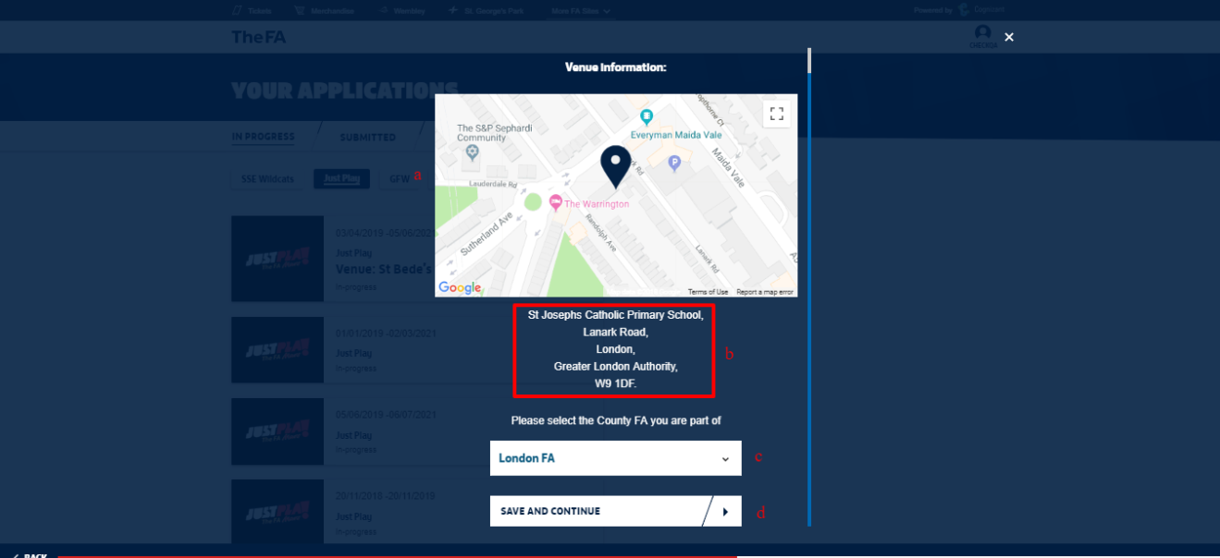

Venue Information (Screen 3)
The applicant is required to provide further information on the venue that has been selected in the previous screen. All fields are mandatory in order to proceed to the next screen.
Input fields in this screen are,
- Facility Type
- Type of Pitch
- No of Pitches
- Option to “SAVE AND CONTINUE”
Note:
- “Facility Type” will have the below options for the user to choose from
  - Owned
  - Rented
  - Leased
- “Type of Pitch” will have the below options for the user to choose from
  - Grass
  - Indoor
  - 3G or Astroturf
  - Other
- The user can enter the required value in numbers for the “No of pitches” as per the requirement
Screen(s):
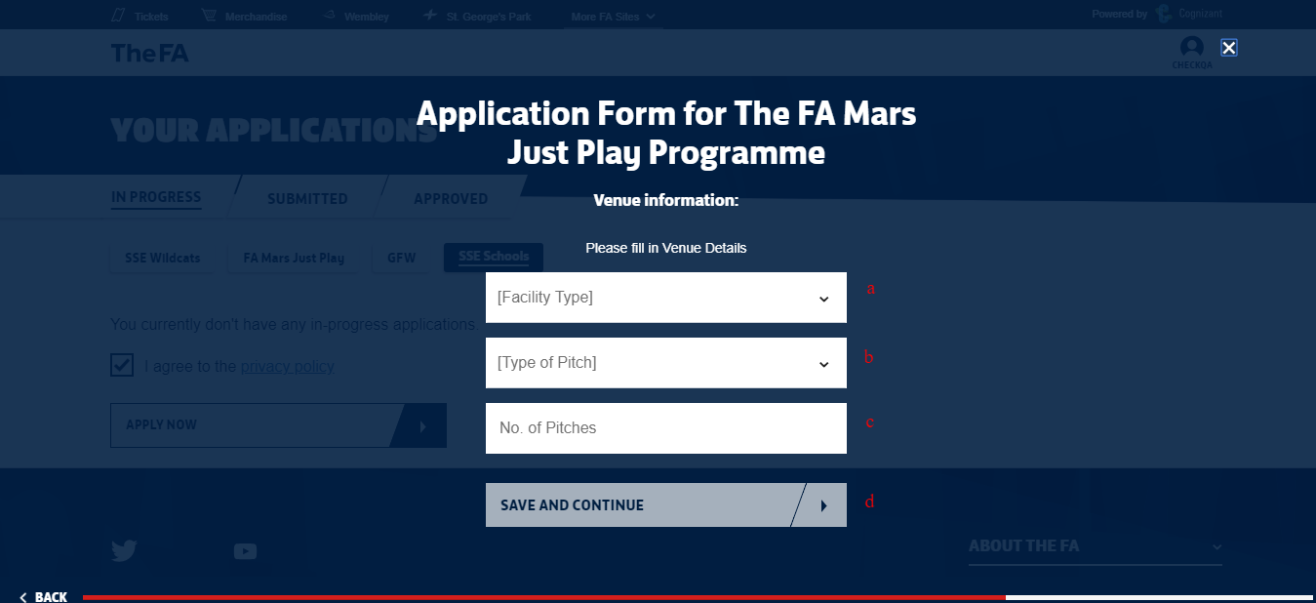

Documentation Upload
The user is required to upload the mandatory documentation(s) in this screen. All fields are mandatory in order to proceed to the next screen. You are required to upload the following documentation:
- Public Liability Insurance
- Health & Safety Policy
- Equal Opportunities Policy
Input fields in this screen are,
- Document Selection - Drop-down
- Option to “SAVE AND CONTINUE”
- Upload Options
  - Select file to upload
  - Add new document
  - Remove
Note:
- The applicant is required to upload at least one documentation for all the Document Types listed in the drop down. The max file size allowed is 1mb
- In order to upload the mandatory document, click on add new document. Select the document type and upload the required document.
- The applicant can remove any wrongly uploaded document and add a new document as required
- The applicant can upload more than one document for a document type if required
- The system will allow the applicant to proceed without uploading the documents. But, it will not allow the user to submit the application without the mandatory documentation(s)
Screen(s):
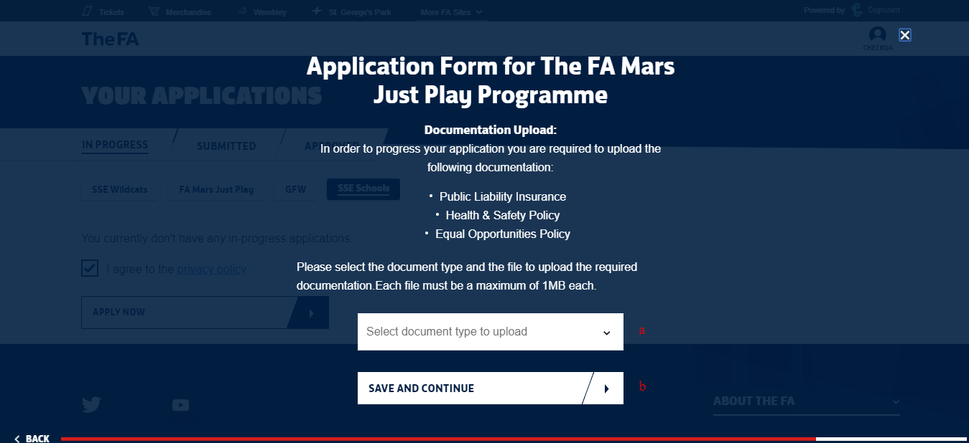
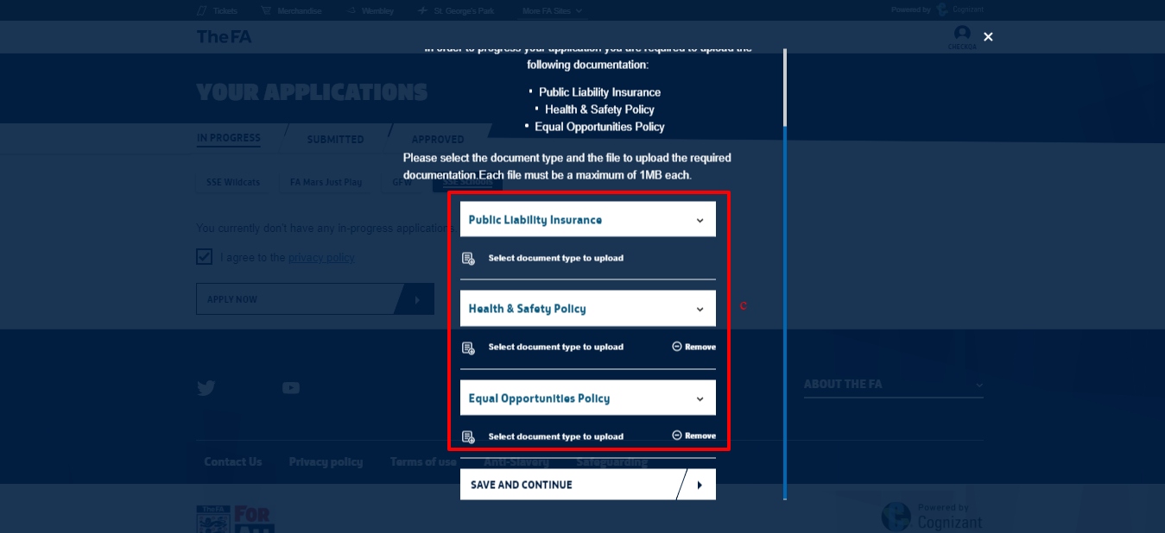

Staff Information – Coach
The programme requires a minimum of one FA Licensed Level 1 Coach. As the lead coach of this programme, please re-enter your FAN number/details to verify you as a coach, you can also add additional coaches to your programme. The applicant can either Key in the coach details or enter the coach FAN Code.
Input fields in this screen are,
- First name
- Last name
- Date of Birth
- Phone Number
- Email
- Fan ID
- Option to “Add another Coach”
- Option to “SAVE AND CONTINUE”
Note:
- Each session should be supervised by a Just Play Organiser of 18 years or over with a current Level One Certificate in Coaching Football & FA Emergency Aid Certificate.
- The user can either enter the details in fields “a” to “f” if they have the details on hand or can enter the Fan ID in “g”. Entering the Fan ID will retrieve all the other details and it will be displayed in the respective fields
- Once a coach details are entered, an invitation email will be triggered. The coach can then “Accept” or “Reject” the invitation. Until then the status will be “Yet to Respond” and the user will not be allowed to submit the application form
- The user can remove a coach in any of the above statuses at any point in time before submission of the application form if they want to replace them with another
- A coach need to be compliant with the certification and other requirements in order to be accepted as a Valid Coach
Screen(s):
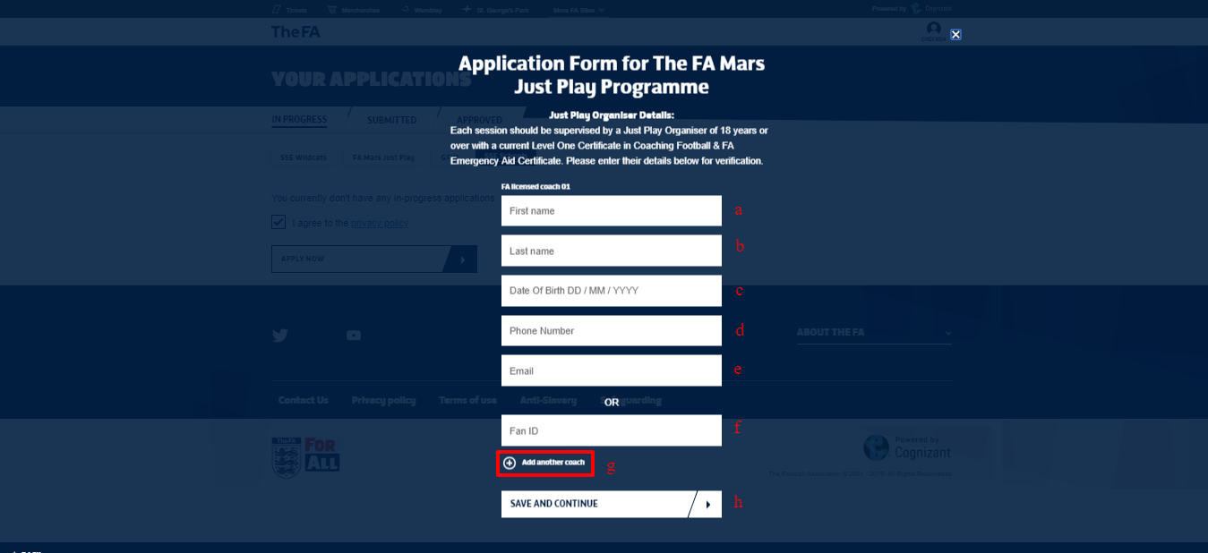

Terms & Conditions
The user is required to review and agree to the terms & conditions in this screen. All fields are mandatory in order to proceed to the next screen.
Input fields in this screen are,
- Agree Terms & Conditions
- Name
- Option to “PRINT THIS PAGE”
- Option to “AGREE AND CONTINUE”
Note:
- The user name will be pre-populated and is non editable
- The user can print this page using the “PRINT THIS PAGE” option
Screen(s):
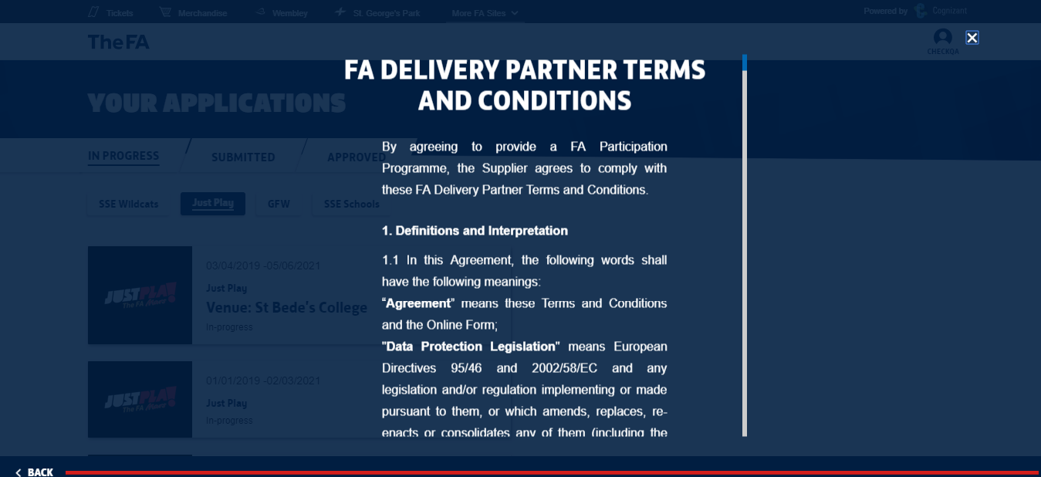
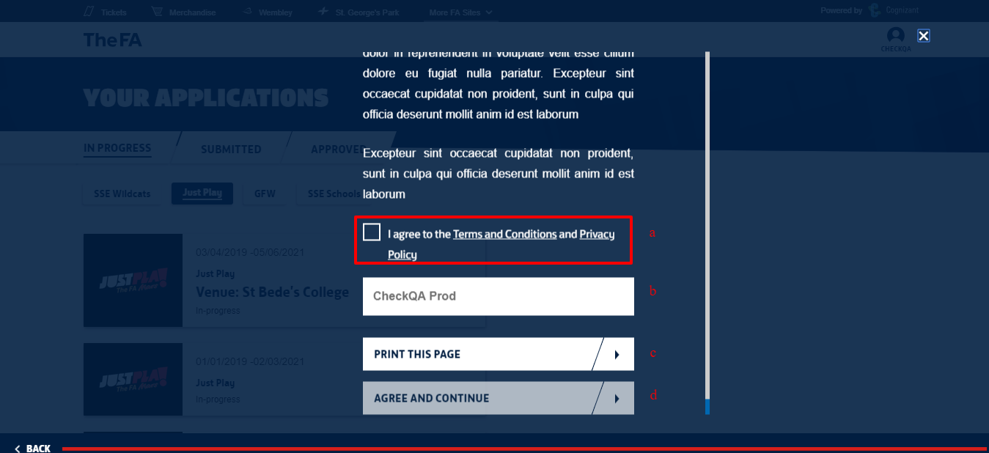
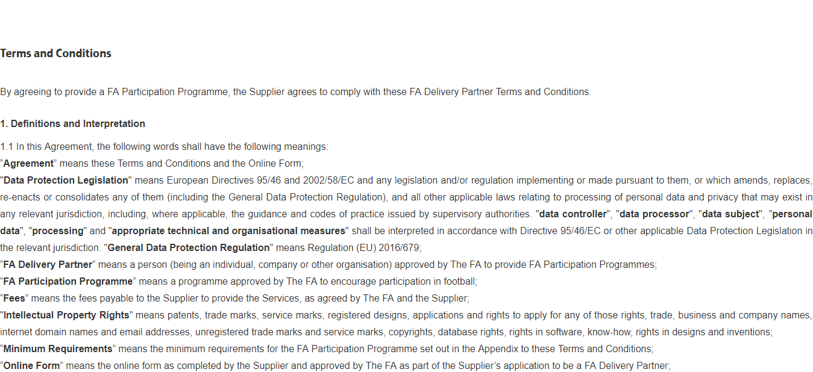
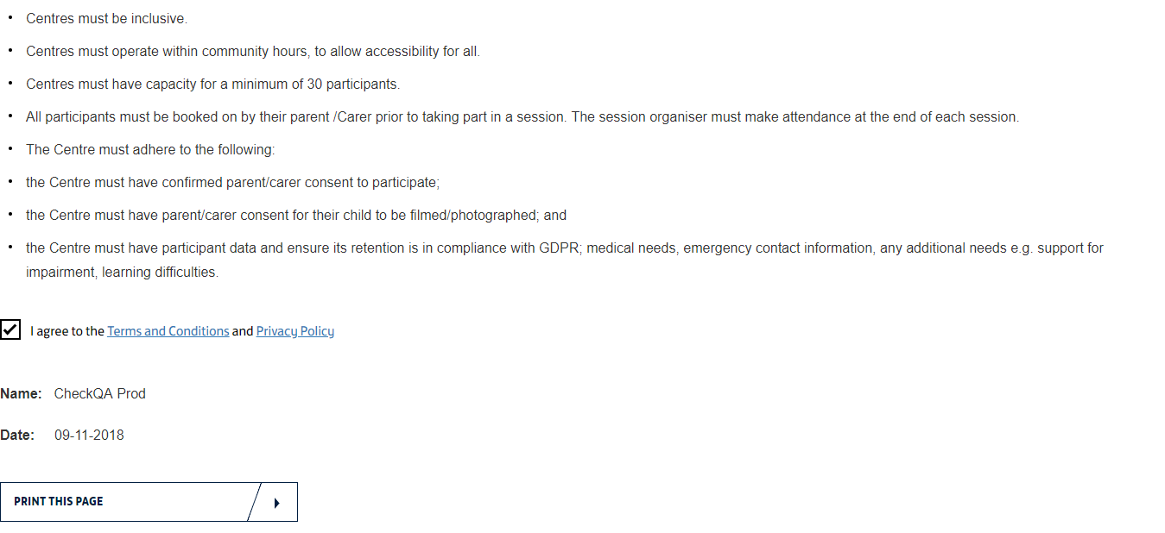

Summary Screen
The summary screen allows the use to look at all the details entered in all the screens/sections so as to identify and update any information as required. The user will be able to edit any information that was entered in any section/screen.
Input fields in this screen are,
- Option to “CONFIRM APPLICATION”
- Option to “CANCEL”
- Options(s) to edit data entered section-wise
Note:
- The user can edit or update information entered previously in the application form flow
- Those screen/sections which have errors will be highlighted in Red and the user needs to action on them in order to proceed to submission
- “CONFIRM APPLICATION” option will be enabled only when all the mandatory details are filled and the entered information is validated/verified to be correct
- “CANCEL” option can be used to discard the form. Though cancelled, all the entered information will be saved and made available. This form can be accessed form “In-Progress” tab in the user’s landing page
Screen(s):
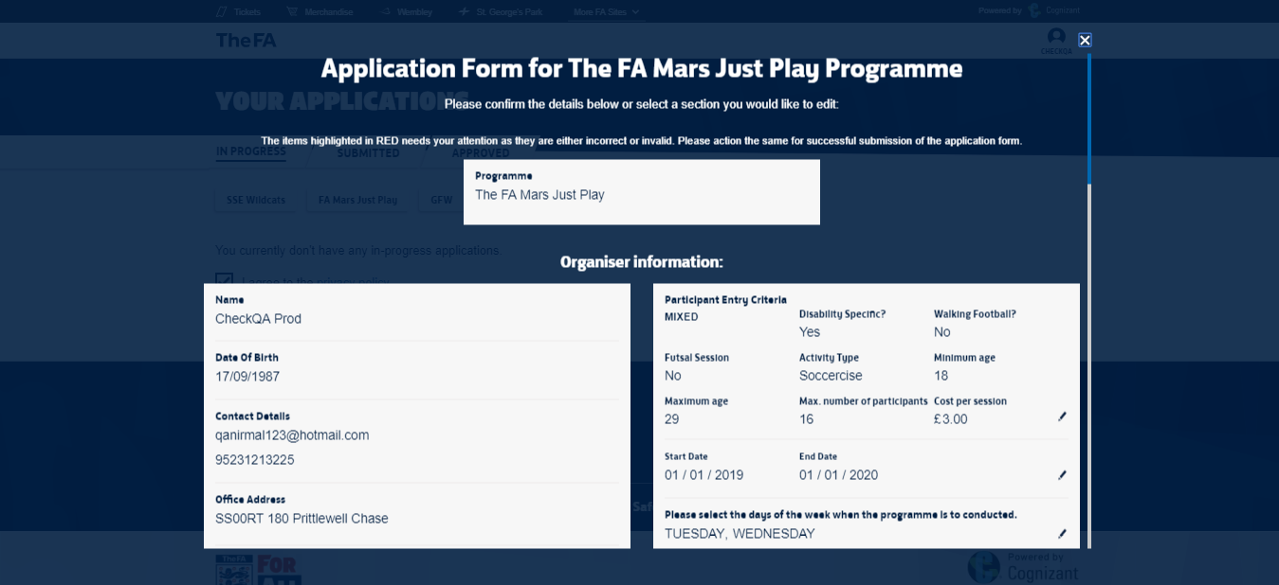
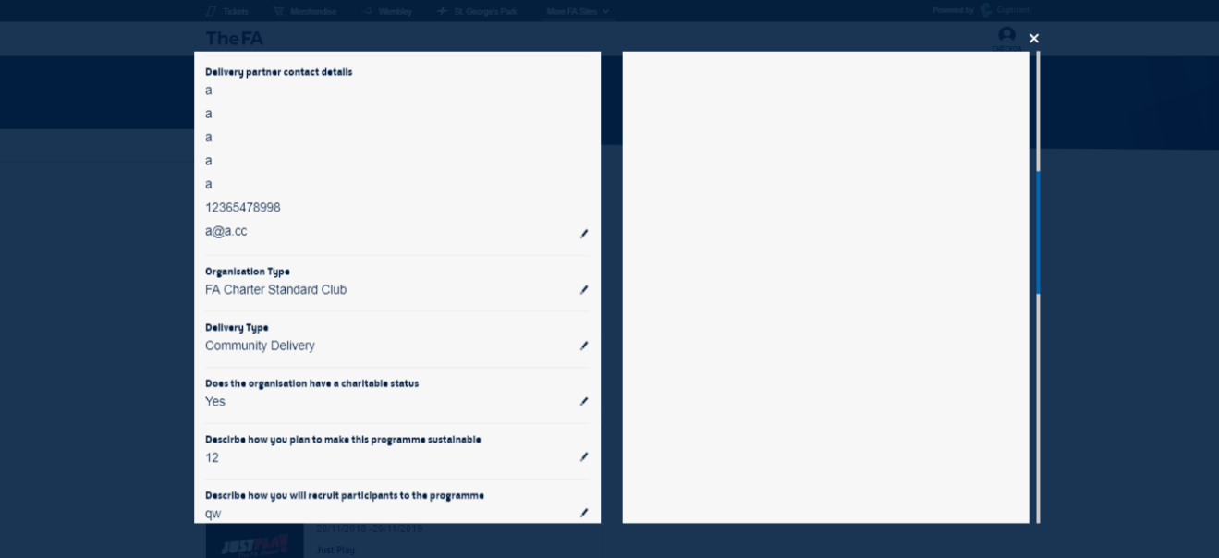
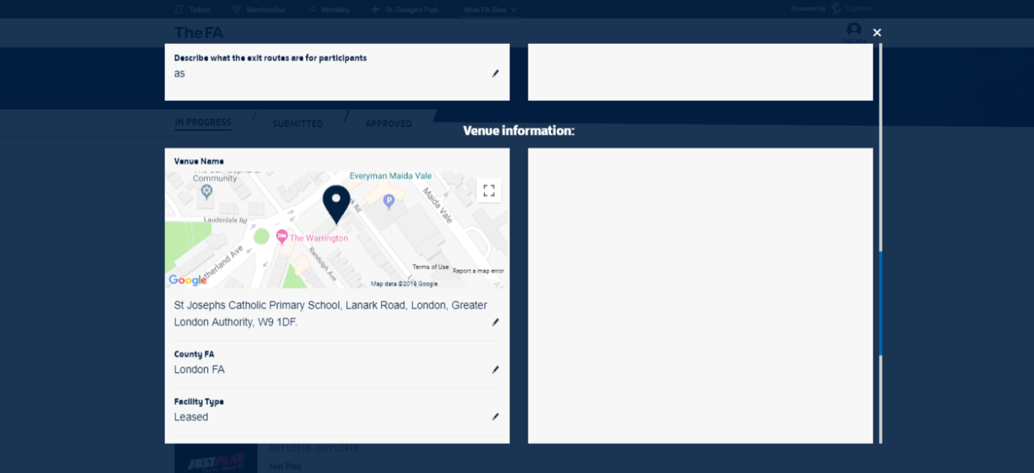
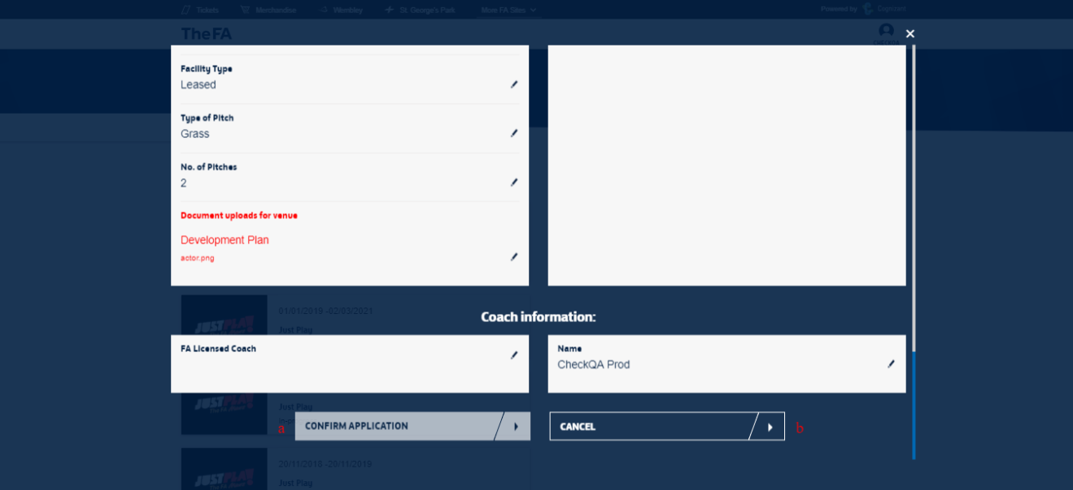
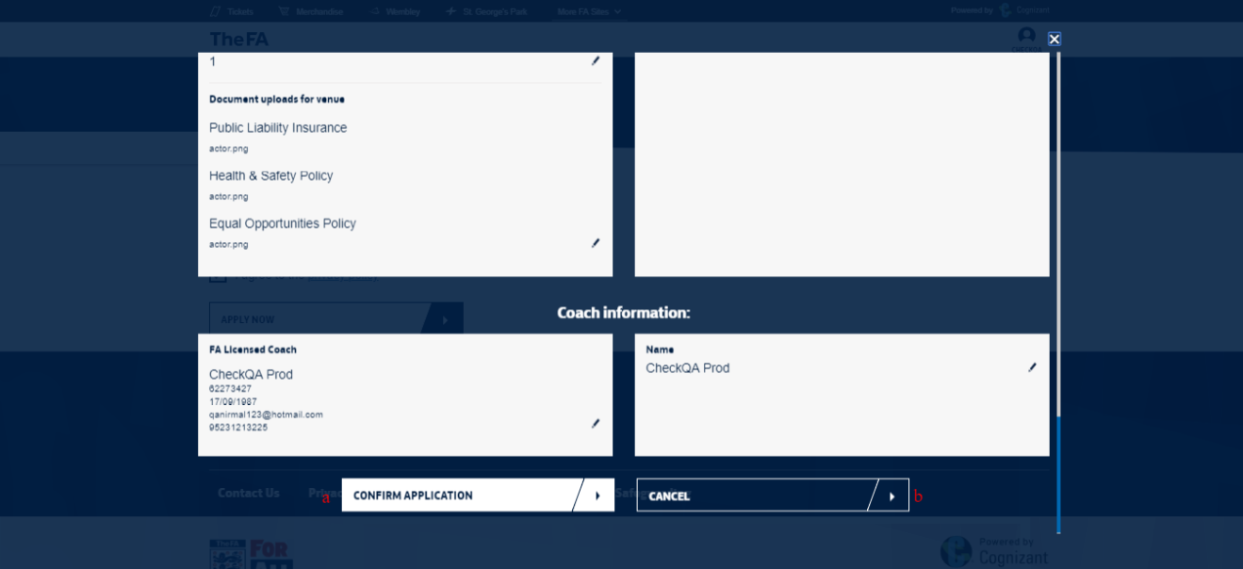

Submission Confirmation Screen
The confirmation screen provides details of the Programme Application that was submitted successfully.
Input fields in this screen are,
- Option to “GO TO MY APPLICATIONS”
- Option to “APPLY FOR ANOTHER PROGRAMME”
Note:
- The Programme Details available in this screen are
  - Programme Logo
  - Start Date & End Date
  - Programme Name
  - Venue
  - Application Status
- The status of the application will be “Submitted” and this form will be available in the respective tab in the user’s landing page
- Once submitted, the form cannot be edited by the user
- “GO TO MY APPLICATIONS” will navigate the user to the landing page
- “APPLY FOR ANOTHER PROGRAMME” will initiate the Application process for another Programme
Screen(s):
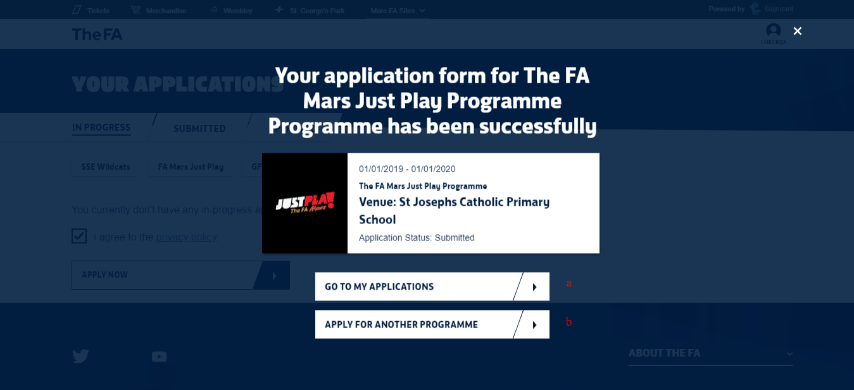

Support Contact Details
The FA Administrator can be reached at,
E-Mail ID: Andy Dyke Andy.Dyke@thefa.com; Rupert Webster <Rupert.Webster@thefa.com>

