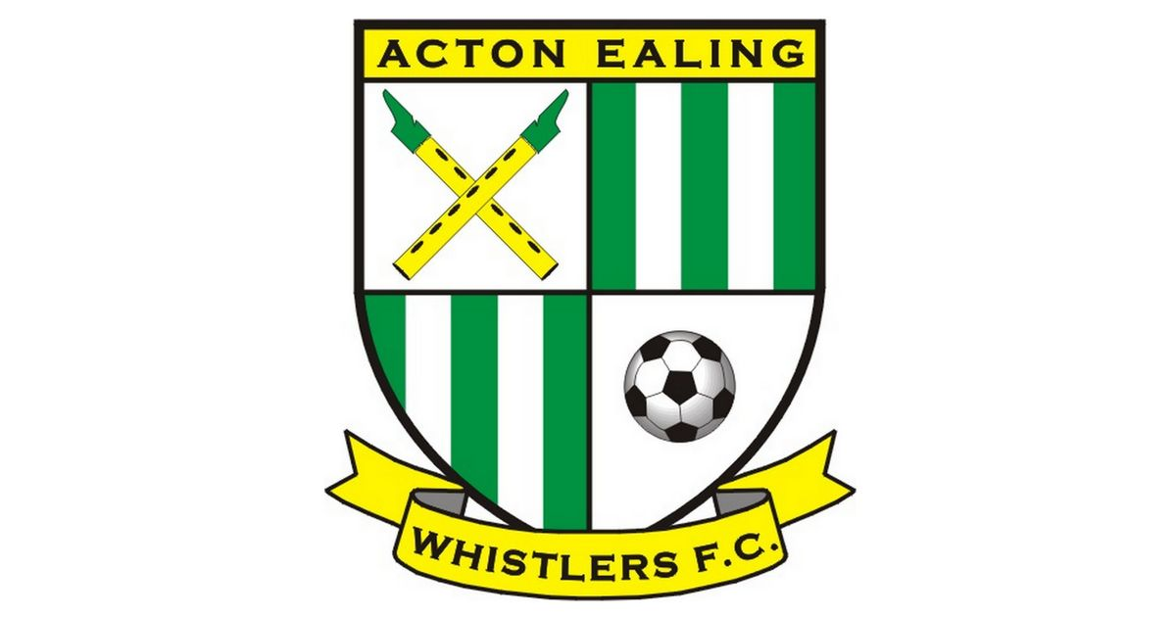

Acton Ealing Whistlers is a youth football club and is now recruiting assistant football coaches on a voluntary basis.

We especially want to welcome female coaches to our friendly community-based club.

About us:
We are an established FA charter standard grassroots football club run entirely by volunteers based in Ealing West London. Our teams compete in the Harrow youth league, Harrow soccer combination and capital girls league. We have recently established a men’s adult football team. We are also partnering with the cross-county football 100 FC scheme which encourages the participation of females and runs coaching programmes exclusively for females who want to get in to coaching.
Promoting some of our core values such as supporting wellbeing, healthy lifestyle, community inclusivity, life skills and teamwork, all conducted in a safe, fun and friendly environment. We provide community football to every child regardless of their ability, they just have to love and want to be involved in the beautiful game.

To find out more about the club please visit our website:
www.aewfc.co.uk

Main Duties:
- Ensuring the safe welfare of the team.
- Support and creating a strong working relationship with team manager, parents/carers and stakeholders.
- Assisting with the planning of training sessions.
- Delivering planned training sessions.
- Team match day duties.
- Attending club & team meetings in person or online.

Requirements:
- No experience required.
- Must be reliable & punctual.
- Be a role model and mentor to the children.
- Like working with young children.
- Being part of a community-based team.
- Desire and commitment to individual/team development & growth.
- Must complete FA Playmaker online training.
- Must be willing to complete FA introduction to coaching football. New FA level one coaching badge. (The club will fully support).

Desirables:
- FA level 1 or 2 coaching badges.
- Experience of coaching & managing a grassroots youth team.
Training & Match:
- Saturday - Training.
- Sunday - Competitive match.
What we provide:
The club will be fully committed to support you on your coaching journey whether you have started or about to start your coaching journey.
The club will provide training equipment for the team and clothing for the coaches. We also provide a coaches information pack giving you more details about the club and your role. You will receive support from the teams lead coach, a designated mentor and the head coach.

Further Notes:
Successful candidates must complete an enhanced DBS check and the following mandatory FA courses which the club will fully support you to obtain.
- FA Safeguarding children online training.
- FA Introduction to first aid in football.
This is an excellent opportunity to get involved with a growing youth community project which is extremely rewarding.
If this opportunity is of interest to you, please email David Osbourne at headcoach@aewfc.co.uk and we can arrange a friendly chat, we are looking forward to hearing from you.

