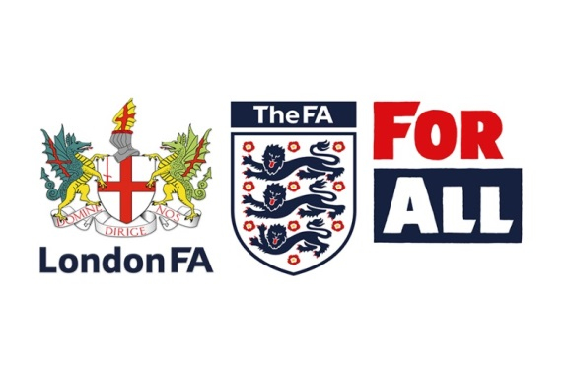
Refereeing Mentors & Observers Application Form
London FA are seeking both roles in the continued development and retention of referees.
As a Mentor, you would be expected to provide guidance and encouragement to a new referee, developing their skills and confidence. We also allocate every promotion candidate with a mentor.
As an Observer you would be expected to offer referees on the promotion scheme positive and constructive help in their desire for development or promotion and a mark them for promotion scheme

If you’d like to apply for either of these roles, please fill-in your details:
Name
Address
Post Code
Email
Contact number

Level | (7) – (6) – (5) – (4 or higher) | FAN Number

I am interested in Mentoring
Observing
Please Note
All Mentors and Observers are required to have an in date and clear FA Enhanced DBS check and as well as FA Safeguarding Children workshop.

Please return to:
Nicholas Wright, London Football Association Ltd, Unit 11 Hurlingham Business Park, Sulivan Road, Fulham, London SW6 3DU
or email to refereeing@Londonfa.com

