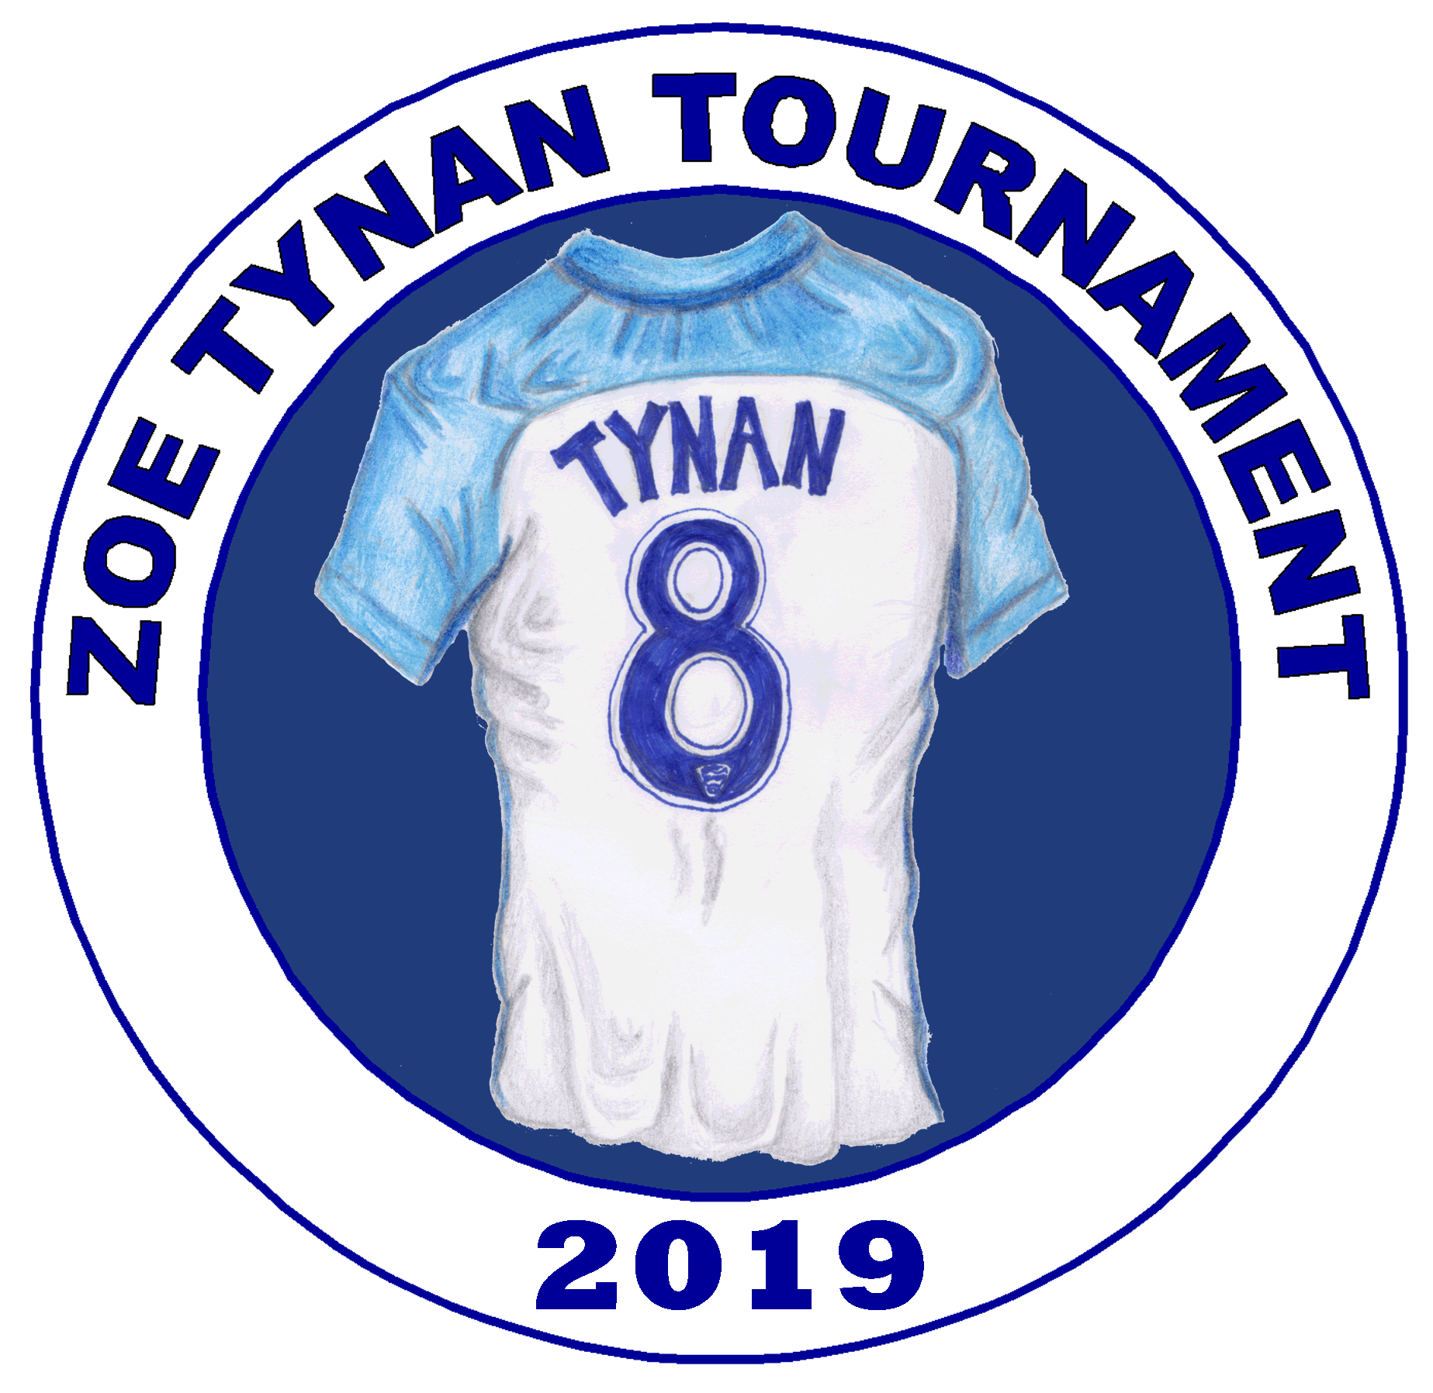
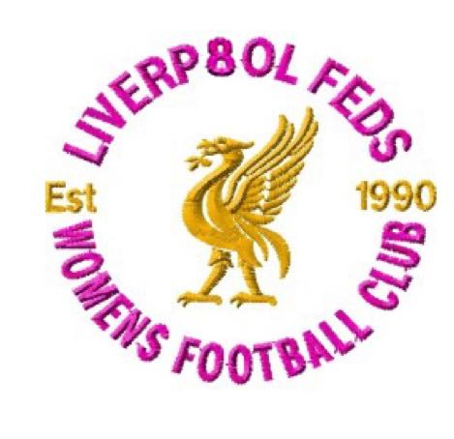

ZOE TYNAN TOURNAMENT

Tournament secretary | Sue Carmichael | 07809150015
Club Treasurer | Janie Moore | 07834164370
Applications to:
10 DEEPFIELD RD
WAVERETREE
LIVERPOOL L155BX

Under 10s and 12s 7 a side tournament
(Register max. 10 in a squad)
SATURDAY MAY 18th 2019
Heron Eccles Football Hub L18 7JS
Register 9:30am - Kick off 10am.
Team name
Contact name

Contact address
Contact email
Contact phone
Team manager name
Team manager contact on day
Team kit colours
County FA and number

League for 2018/19 season

Signed

Please make a payment of £45 per team ( cheque to Liverpool Feds or BACS payment to Liverpool Feds 60 – 01 – 11 43182453 ) and return via to the above address or email to foxtb5@aol.com by March 21st 2019. Each team will have 3 games in a league of 4 and then compete for either the Cup or Plate in a further 3 league games before a semifinal and final for the top teams.
ALL GAMES ON 3G PITCHES
TEAM SHEET
PLEASE SUBMIT TO REGISTRATION BY 9:30 am AT THE TOURNAMENT

Players can only register for one team within the tournament. If a club has more than one team in the tournament a player can only play for ONE team.

Name of club

AGE GROUP

County FA number:

Managers contact

 | Name | Date of birth | Signed
1

2

3

4

5

6

7

8

9

10

Signed ( manager )

Player’s ages groups are for the 2018/ 2019 season
Players who have been registered with a Centre of Excellence / Academy team for the 2018/19 season are not eligible to play.

Zoe Tynan
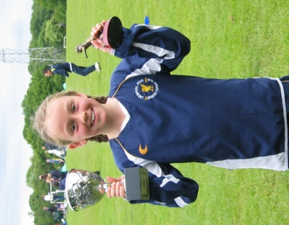
20/5/98 - 30/8/16

The second Zoe Tynan tournament was held on May 19th 2018 and yet again it was a great success. 32 girl’s teams enjoyed matches playing in either a Cup or plate competition. Trophies were presented to the finalists and players of the tournament and medals were awarded to all participants. Money raised on the day through a raffle, tombola and cake sale was donated to two suicide prevention charities ‘If U Care Share’ and PAPYRUS. Both charities attended the event to share awareness of a very important message with players, coaches and parents. The event was a magnificent tribute to a special young lady.

Zoe joined Liverpool Feds at 6yrs old and it was soon obvious how committed Zoe was to her football. Zoe asked technical and tactical questions beyond her years and was dedicated to improve herself and her team. She also juggled her athletics with football….often going off, a bit muddy after a match, to race.
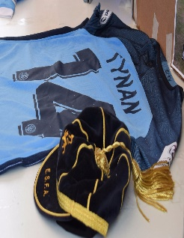
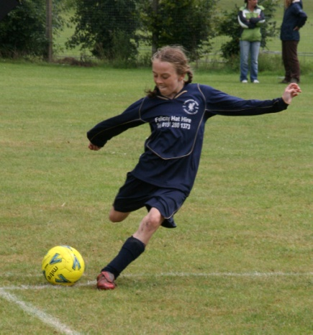
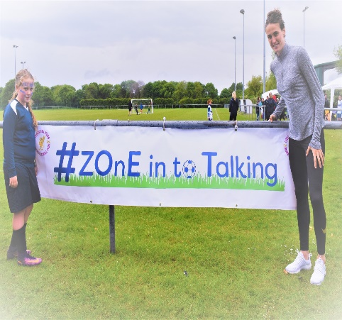

Zoe went to Everton Centre of Excellence with our blessing as we recognised what a talent she was and knew that she need to be at the next level of girls’ football to fulfil her dreams. It was such a thrill for our club that Zoe had recognition at International level with England and went on to play with Women’s Super league teams, Everton Ladies and Manchester City Women.

Zoe and her family never forgot her football roots with the Feds and she came back to help coach our junior teams. Her help, insight and coaching of our younger players is a matter of pride for our club.

We thank Alison, Carl and Beth for their continued support.

We also thank Anna Farrell at the County FA, friends of Zoe and the Tynan family and of course Liverpool Feds players and staff for making this very special tournament happen.

This year, any money raised on the day will be donated to suicide prevention and counselling charities, If U Care share and Paul's Place.

