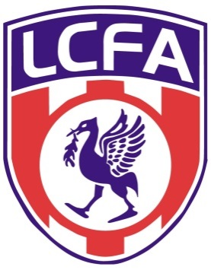LCFA Cup Team Sheet
Home Team v Away Team
Date Played
Kick Off Time
Result
Home Team Away Team
Referee Referee’s Mark
Club Name Secretary PRINT NAME:
PLAYERS NAME | PLAYERS SIGNATURE | SCORERS
1
2
3
4
5
6
7
8
9
10
11
12
13
14
15
16
Please return teams sheet by post:
LIVERPOOL COUNTY FA
WALTON HALL PARK
WALTON HALL AVENUE
LIVERPOOL
L4 9XP

Or

Email to david.pugh@liverpoolfa.com

CLUB INFORMATION – CHECK LIST

HOME CLUBS MUST CONFIRM DETAILS WITH THE REFEREE AND ASSISTANTS (IF APPOINTED) AT LEAST 5 DAYS PRIOR TO THE DATE OF THE GAME

HOME CLUBS MUST CONFIRM WITH THEIR OPPONENTS AT LEAST 5 DAYS PRIOR TO THE DATE OF THE GAME, PROVIDING COLOURS AND VENUE

MATCH FEES –

SATURDAY JUNIOR

REFEREE £32.00 ASSISTANTS £20.00 INCLUSIVE OF TRAVEL ETC

ALL FEES TO BE OFFERED PRIOR TO THE COMMENCEMENT OF THE GAME

TEAM CAPTAINS TO WEAR ARMBANDS

Each Team can nominate 5 substitutes with a player who has been substituted himself becomes a substitute and may replace another player at any time subject to the substitution being carried out in accordance with Law 3 of the Laws of Association Football.

A NAMED SUBSTITUTE BUT NOT HAVING PLAYED IN THE GAME SHALL NOT BE CONSIDERED TO HAVE BEEN A PLAYER IN THAT GAME.

The referee shall be informed of the names of the substitutes before the start of a match.

If scores are still level after 90 minutes then kicks from the penalty mark must take place

THERE IS NO EXTRA TIME IN ALL COUNTY CUP COMPETITIONS

All games must be completed on the day

IMPORTANT INFORMATION

PLEASE NOTE THAT IT IS THE HOME TEAMS RESPONSIBILITY TO NOTIFY THE RESULT OF THE GAME BY TELEPHONING IAN DIBBERT OR REPLYING TO FULL TIME SYSTEM TEXT MESSAGE:

IAN DIBBERT 07734448548

TO AVOID BEING FINED PLEASE OBSERVE AS THE OFFENDING CLUB WILL BE SANCTIONED

