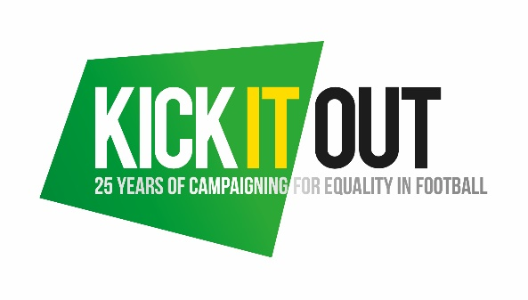

EQUALITY CHARTER
We adhere to the following equality, inclusion and discrimination guidelines set out by Kick It Out. We are committed to ensuring a safe environment for all participants by applying equality, diversity and inclusion in our day to day operations.
We will promote awareness of the benefits of equality, inclusion and diversity with a clear understanding that football belongs to and should be enjoyed by anyone who wants to participate in it.
In activities we will not discriminate or treat anyone less favourably on the grounds of age, gender, gender reassignment, sexual orientation, marital status, race nationality, ethnic origin, colour, religion/belief, ability or disability. We will not tolerate harassment, bullying, abuse or victimisation of any kind and will assure the correct reporting procedures are actioned if any of the mentioned does occur under our supervision. We are committed to taking action where inequalities exist.
We will take a stance assuring good practice is encouraged internally and to our sponsors, partners and the wider community.
As part of our commitment to the eradication of discrimination in football and the promotion of equality, inclusion and diversity, a minimum of one member of our board and/or coaching staff will be fully educated on the procedures around reporting incidents of discrimination – including through the appointed officials, our county FA, the Kick It Out website and app.

Signed:

