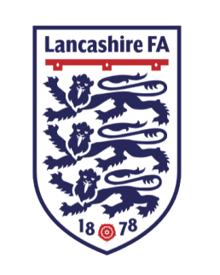
Marketing & Communications Officer

An exciting and rare opportunity has arisen to join the team at Lancashire Football Association as Marketing & Communications Officer.

The successful applicant will lead in the delivery of Lancashire FA's internal and external digital platforms to deliver the business plan, whilst also work tirelessly to increase the relevance of the County FA with local and national media organisations.

We are requesting applications for a highly motivated team player, with a unique drive and passion, to support the development and implementation of the Marketing and Communications Strategy, as well as promote all of the fantastic new facilities we have on offer at the County Ground.

Key Responsibilities:
- Lead on and develop customer insight to drive delivery of our products to support the Business plan.
- Lead the review of the Association’s external and internal publications to ensure consistency of message and maximise efficiency.
- Help in the publication of the Association’s printed & digital material, such as County Cup programmes and sales brochures.
- Work closely with all departments to gather news items to publish on the Association’s website ensuring that it remains a central resource of information to all stakeholders.
- Develop the organisations social media presence to a level fighting that of the largest County FA in the country.
- Develop links within the local media community to ensure that there is regular coverage of the Association’s activities.
- Become the brand champion for Lancashire FA, ensuring all published material is consistent and professional.

Position: Full time (some evening and weekend work will be required)
Employer: Lancashire Football Association Limited
Responsible to: Head of Commercial & Operations
Salary: £16,500
The successful applicant will require:
- The ability to be able to demonstrate a commitment and passion for grassroots football, and the power it is has to influence communities across the country
- Knowledge of Outlook & Excel Systems as well as design programmes such as Adobe Photoshop and InDesign
- Excellent communications and presentation skills
- Excellent interpersonal, communication and team working skills
- Good self-management of time
- Ability to work independently and as a team
- A team player
- Diplomacy and the ability to deal with confidential information.
- Flexibility to work evenings and weekends , particularly during the County Cup Final period of the season (February to May)
- Ability to deal with the public
What can we offer?
- An exciting opportunity to join a forward thinking and changing, progressive business.
- A commitment to empowered and supportive personal development.
- A great team environment and the opportunity for further development
- A Group Life Pension Scheme.
- 22 days holiday per annum including bank holidays plus other benefits
- Ability to work flexibly.

To apply for this exciting position, please email your CV & cover letter to David.Chell@LancashireFA.com
The closing date for applications is 12 noon on Tuesday 10th December 2019.

Interviews will take place on Monday 16th December and Tuesday 17th December 2019.
Due to the volume of applications we receive, if you do not hear from us by Monday 16th December, please assume that your application has not been successful.

Lancashire FA are committed to equality of opportunity and welcome applications from all sections of the community.

