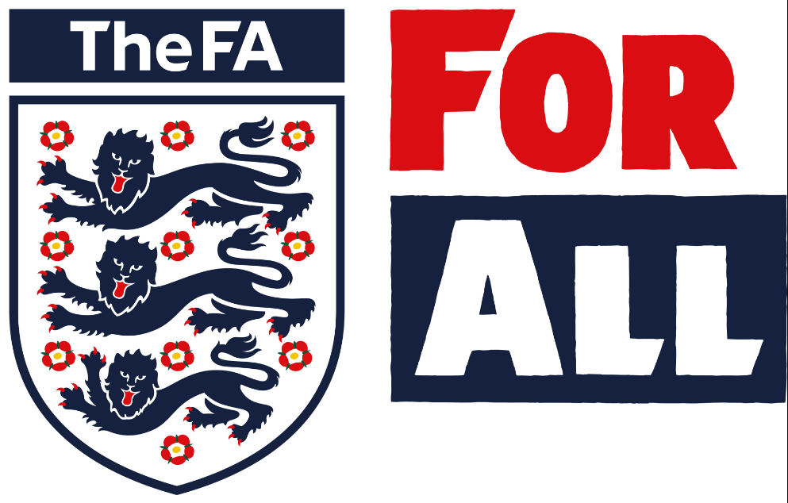
TITLE: THE FA YOUTH COUNCIL 2018-19

EXECUTIVE: Karl Lines

INTENDED AUDIENCE: County Football Associations and potential National Youth Council applicants.

DATE OF ISSUE: 21st June 2018

PURPOSE: To clarify the application process for The FA Youth Council in 2018/19

CONTENT:

This document will;

- Outline the national youth council structure for 2018/19.
- Clarify the application criteria.
- Clarify the application timelines.
- Identify the dates for the year.
- Summarise the process for expectations.

OVERALL SYNOPSIS:

- The overarching structure of the National Youth Council will remain the same for 2018/19
- At least a third of all postions will be made available for new members .
- New positions will be appointed via an open application process with internal interviews only for Vice Chair and senior roles.

YOUTH COUNCIL STRUCTURE:

The FA Youth Council will be a 14 member team with an additional 2 co-opted roles of; Communications Officer and Education Officer.

The positions open for application are as follows:

- 3 x Project Officers (Research & Insight, Leadership Development*, Community**) - with one selected as ‘Lead Project Officer’
- 4 x Engagement Officers North (North East, North West, West Midlands, East Midlands) - with one to be selected as ‘Lead Engagement Officer – North’
- 4 x Engagement Officers South (East, London, South East, South West) with one to be selected as ‘Lead Engagement Officer – South’
- The Lead Project Officer and two Lead Engagement Officers will support the Vice Chairperson and Chairperson in the ‘Leadership Group’
- Positions co-opted to the team are at the discretion of the Chairperson and FA staff

* Leadership Development Project Officer is a name change from ‘Events Officer’ to reflect objectives and activities on the current Youth Council VMOST
**Community Project Officer is a is a name change from ‘Partnerships Officer’ to reflect objectives and activities on the current Youth Council VMOST

APPLICATION CRITERIA

- All applicants must be from a County FA Youth Council or partner organisation (or forum or equivalent) and have the full support of their County FA/ organisation to apply.
- Applicants must be no older than 24 years of age on the term start date (1st September 2018)
- Current members are limited to two terms and must apply for special circumstances if a third term is being applied for. The chair position is extendable to three terms and subject to eligibility criteria.
- Applicants must be able to attend a MINIMUM of 80% of FA YC meetings/events, throughout the course of the season.
- All existing FA Youth Council members who wish to stay on the council, must re-apply
- A minimum of one third of postions will be guaranteed for new members.

APPLICATION & RECRUITMENT TIMELINE

Applications
10th June 2018 | Application window Opens for Vice Chairperson application (internal applicants only)
21st June 2018 | Application window Opens for all Youth Council positions
3rd July 2018 | Application window Closes for Vice Chairperson applications at 5pm. Late applications will not be considered.
6th July 2018 | Notification of interviews (Vice Chairperson)
17th July 2018 | Vice Chairperson Interviews – St. George’s Park
20th July 2018 | Confirmation of Vice Chairperson
20th July 2018 | Application window Closes at 5pm for Youth Council applications. Late applications will not be considered
5th August 2018 | Academy begins (Sunday meeting)
9th August 2018 | Academy closes. End of year celebration (Evening)
10th August 2018 | Review of season and handover process.
w/b 13th August 2018 | Confirmation of Youth Council 2018/19
22nd & 23rd Sept 2018 | FA Youth Council 2018/19 – first meeting. St. George’s Park

Applications will be distributed via current Engagement Officers to County FA members of staff, through FA channels and via the Leadership Academy’s ‘Hive’ for those that attended the July event at St Georges Park.

PROGRAMME DATES

The provisional dates for the 2018-19 term are below. Members must commit to a MINIMUM of 80% of these dates, ideally attending all.

Meeting No. | Dates
1 | September 22nd & 23rd 2018
2 | November 17th & 18th OR 24th & 25th 2018
3 | January 12th & 13th 2019 OR 26th & 27th 2018
4 | TBC
5 | May 4th & 5th OR 11th & 12th 2019
6 | June 1st & 2nd OR 8th & 9th OR 29th & 30th 2019
Academy | July 21st – 26th 2019

Webex Dates to be confirmed between meetings

EXPECTATIONS

Individual expectations will be established through a code of conduct which must be signed and returned and will bound all members to clearly defined standards which are commensurate with a position of responsibility as representing The FA.

All members will undergo appraisals and a PDR process in order to ensure that team members are fully engaged and deliver against priorities.

Team expectations will also be established through consensus through the form of a team activity at the first meeting. This will result in a team charter being agreed and signed by all members.

