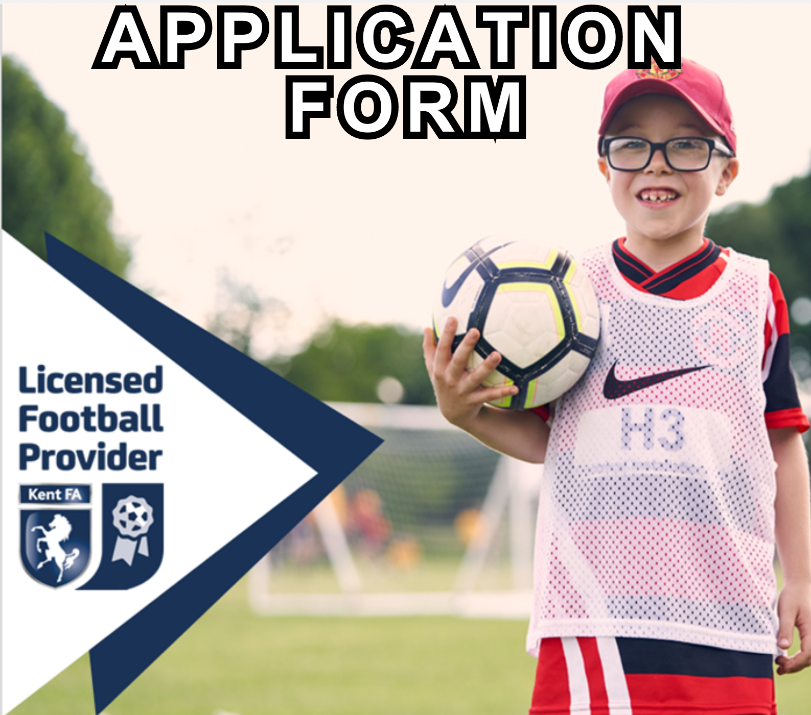

Kent FA Licensed Football Provider Application Form

What is a Kent FA Licensed Football Provider (LFP)?
With no regulation as to who can set up a football coaching company, our licensing programme aims to promote those providers that can evidence provision of high quality, enjoyable and inclusive playing opportunities in a safe environment. This is achieved by certifying that appropriate insurance, policies and qualifications are in place and remain so.

These organisations can provide a variety of activities, including, but not limited to:
- Football in schools
- Extra circular football clubs
- Commercial soccer schools
- Football academies
- Paid-for football coaching sessions
- Community Trust
- School holiday activities
- Education-linked 'academy' programmes for 16–19-year-olds
- Futsal academies

Licensed providers are affiliated to the Kent FA in the same way as a club or league, so are subject to the FA’s and Kent FA’s rules and governance.

The policies and qualifications that are needed to achieve the Licensed Football Provider status are designed to contribute towards a respectful, fun, and safe environment.

What is the process to become a Kent FA Licensed Football Provider?
1 - The football provider must affiliate the organisation and each age group they provide football for to Kent FA via the Club Portal. The process will start by contacting info@KentFA.com advising that you wish to affiliate as a new football provider. We will then ask you certain information which will allow us to create the organisation on the Whole Game System. The affiliation process will ensure the following:
- All coaches/staff working with age groups U18 or below have an FA accepted in-date Criminal Records Check (DBS).
- A Welfare Officer is in place who has both an FA Safeguarding qualification and FA Welfare Officer Workshop qualification.
- The Chairman, Secretary and Welfare Officer have completed the online course ‘Safeguarding for Committee Members’.
- Personal accident cover and public liability insurance are in place.
- All coaches that will be working with the provider are listed.
- All age groups that the provider will be providing football for are affiliated.

2 - Complete the following application form to become a Kent FA Licenced Provider and submit it to development@kentfa.com alongside any supplementary documents and information.

3 - Once the application has been approved, you will be notified, and the organisation can enjoy all of the benefits of being a Kent FA Licenced Football Provider.

What are the benefits of becoming a Kent FA Licensed Football Provider?
By becoming a Kent FA Licensed Football Provider, your organisation will join a prestigious group who have evidenced a safe, inclusive, and high quality set up to the governing body of football in Kent.

The hidden benefits of having our license will have been demonstrated since its inception in 2013. Schools, clubs and parents now recognise the license as a kite mark and are more likely to engage as they know a minimum standard has been met. Therefore, the licence can act as a promotional tool to increase both the quality and quantity of your organisation.

If you are a newly created business then this licence offers an outline of everything a football provider needs to put in place to run efficiently. We hope that by working through the criteria, it will help you establish good practices for years to come.

In addition to these hidden benefits providers also have the opportunity to purchase Public Liability and Personal Accident insurance at a competitive rate through affiliation. After successfully completing the award, we also offer the following:

- Access to ‘Whole Game System’ and ‘Club Portal’ to manage workforce and check qualifications of individuals
- Eligibility to participate in sanctioned leagues, festivals, club tournaments and County FA competitions
- Use of Kent FA Licensed Football Provider Status Logo
- FA Criminal Record Check and Safeguarding Children advice and support network
- Access to information and advice from the County FA personnel
- Access to The FA and County FA publications and resources
- Being part of the structure of the National Game from grassroots upwards
- Discipline, Fair Play and FA RESPECT support
- Kent FA promotion at www.kentfa.com
- Access to bespoke CPD opportunities
- Personal and Public Liability Insurance through the affiliation process

Are there differing levels of Kent FA Licensed Football Providers?
Yes, there are three tiers available on our programme called Gold, Silver and Bronze. The three tiers are differentiated by the quality of provision our providers have in place.

What are the costs of becoming a Kent FA Licensed Football Provider?
The cost to apply for the award is completely free following affiliation.

What is the future of the programme?
Kent FA are fortunate to be chosen as one of a few counties nationally who are trialling a new Licensed Football Provider Programme. Supported by The FA, this trial is part of a long-term initiative of launching the programme nationally.

Until, a national programme is launched, once you have achieved your Licensed Football Provider Status, you will not need to re-apply. However, to continue to remain having the status in place, each season you will be required to re-affiliate with the County FA.

Applying to become a Kent FA Licensed Football Provider:
To ensure the integrity and quality of our licencing programme continues we have a range of criteria which must be achieved.

Your Information
Name of provider: | Click here to enter name of provider.
Name of lead applicant: | Click here to enter name of lead applicant.
Address and postcode of provider: | Click here to enter address and postcode of provider.
Contact number for provider: | Click here to enter contact number of provider.
E-mail address for provider: | Click here to enter email address of provider.
Do you consent to the above email and phone number being published on our online interactive map? | Yes ☐  No ☐
How many employees does your organisation currently have operating in Kent? | Coaches:  Other personnel/employees:
How many sessions will you run, on average, each week in total in Kent? | Click here to enter how many sessions.
Which of the following is your organisation? | Public Limited Company: ☐  Private Limited Company: ☐  Sole Trader: ☐  Professional Club: ☐  Registered Charity: ☐
Which venues does your organisation regularly use? | Name and Postcode: Click here to enter text.  Name and Postcode: Click here to enter text.  Name and Postcode: Click here to enter text.  Name and Postcode: Click here to enter text.  Name and Postcode: Click here to enter text.  Name and Postcode: Click here to enter text.

The following criteria are required to be met to apply as a Licensed Football Provider. Further criteria are to be met to meet the level of bronze, silver or gold.

Staff and Qualifications
Criteria | Our Advice | Checked via:
All coaches to have an in-date, FA accepted DBS check | This is done once you have a Welfare Officer in place | Club Portal
All coaches to have an in-date FA Safeguarding Children Qualification | Visit this link to book an FA Safeguarding Children Workshop | Club Portal
All coaches to have an in-date FA Introduction to First Aid Qualification | Visit this link to book an FA First Aid course | Club Portal
Appointed Welfare Officer with in-date, FA accepted DBS check, FA Safeguarding Children Qualification, FA Welfare Officer Workshop Qualification | Visit this link to book an FA Welfare Officer Workshop | Club Portal
Appointed Chairman, Treasurer and Secretary who has completed the FA Safeguarding for Committee Members Qualification | This can be the same person | Club Portal

Policies and Procedures
Criteria | Our Advice | Checked via:
Personal Accident Cover for all ages that football will be delivered to | This is purchased when you affiliate | Affiliation
Public Liability Insurance of £10m | This is purchased when you affiliate | Affiliation
Facility risk assessment including Safeguarding and Emergency Action Plan (EAP) | An EAP template can be found here | Sharing this document with us when submitting this form
Safeguarding Children and Vulnerable Adults Policy | The 2 safeguarding policies can be found and adopted on the club portal, via the my club section under documentation, FA Policies  https://clubs.thefa.com/#/ | Club Portal
Codes of Conducts for coaches, officials, players and parents and a commitment to The FA RESPECT programme | Code of Conduct templates can be found and adopted on the club portal, via the my club section under documentation, FA Policies  https://clubs.thefa.com/#/ | Club Portal
FA Club Rules/Constitution | A Club Rules template can be found and adopted on the club portal, via the my club section under documentation, FA Policies  https://clubs.thefa.com/#/ | Club Portal
Data protection and Data Privacy Policy | Data Protection can be found here Data Privacy can be found here | Sharing this document with us when submitting this form
Safer Recruitment Policy | Safer Recruitment Policy template can be found here | Sharing this document with us when submitting this form
Equality Policy & FA Leadership Diversity Code | An Equality Policy template and the FLDC can be found and adopted on the club portal, via the my club section under documentation, FA Policies  https://clubs.thefa.com/#/ | Club Portal
Clear and transparent registration process | This must contain photography consent and medical information. | Please share details with us when submitting this form

The above criteria are compulsory. However, the level that you can reach will be defined by the following:

Bronze Level
At least one coach to hold a minimum of a UEFA C or FA Level 2 in Coaching Football.
At least 50% of coaches hold the FA Introduction to Coaching Football/FA Level 1 in Coaching Football qualification and any coaches who don’t must have completed at least the FA EE Playmaker by England Football Course.
A commitment from the organisation to encourage coaches to undertake CPD where possible.
Signposting of opportunities to those that attend your sessions such as local teams.

Silver Level
50% of coaches to hold a minimum of FA Level 2 in Coaching Football or UEFA C.
100% of coaches to hold the FA Introduction to Coaching Football/FA Level 1 in Coaching Football qualification.
A commitment from the organisation to encourage coaches to undertake CPD where possible.
Offer both mixed/girls football opportunities to play and ensure the signposting of opportunities to those that attend your sessions such as local teams.

Gold Level
20% of coaches to hold a minimum of UEFA B in Coaching Football.
At least 50% of coaches to hold a minimum of FA Level 2 in Coaching Football or UEFA C.
100% of coaches to hold the FA Introduction to Coaching Football/FA Level 1 in Coaching Football qualification.
A commitment from the organisation to encourage coaches to undertake CPD where possible.
Offer both mixed/girls football opportunities to play and ensure the signposting of opportunities to those that attend your sessions such as local teams.

Which Level would you like to apply for? (please put an x in the relevant box)
Bronze
Silver
Gold

Declaration:
- Our organisation is committed to the requirements and aims of the Kent FA Licensed Football Provider programme.
- We are aware that if we fail to meet any of the required criteria or embody the aims of the programme then our licence may be removed.
- We commit to abiding by all rules and regulations as outlined in The Football Association Handbook. Breaching these rules could result in our licence being removed.
- We commit to ensuring all staff, coaches or volunteers that are in regulated activity are listed on the Whole Game System/Club Portal and we will follow the process to ensure they have an FA accepted DBS.
- All information given in this application is correct to the best of our knowledge.
- We acknowledge and accept that we may be visited, possibly unannounced, by a Kent FA staff member to conduct checks around safeguarding, quality and qualifications.
Name: | Click here to enter text.
Role: | Click here to enter text.
Signed: | Click here to enter text.
Date: | Click here to enter a date.

For more information or support…
Contact the team on development@KentFA.com
Kent County FA use only
Date application received:
Criteria missing
Additional Feedback
Action Plan

