Application Form

Season 2019/20

What is a Kent FA Licensed Football Provider (LFP)?
With no regulation as to who can set up a football coaching company, our licensing programme aims to promote those providers that can evidence provision of high quality, enjoyable and inclusive playing opportunities in a safe environment. This is achieved by certifying that appropriate insurance, policies and qualifications are in place and remain so. In addition, by becoming a Licensed Football Provider, the organisation will also become an FA Charter Standard Club.

These organisations can provide a variety of activities, including, but not limited to:
- Football in schools
- Extra circular football clubs
- Commercial soccer schools
- Football academies
- Paid-for football coaching sessions
- Community Trust
- School holiday activities
- Education-linked 'academy' programmes for 16-19 year olds
- Futsal academies

Licensed providers are affiliated to the Kent FA in the same way as a club or league, so are subject to the FA’s and Kent FA’s rules and governance. Other Soccer Schools, Academies or commercial coaching providers are not affiliated to or accredited by the governing body and we therefore have no statutory authority to deal with their regulation, enforcing delivery standards or ensuring safeguarding requirements are met.

In addition to policies, procedures and qualifications, the environment that is created by the organisation must be inclusive, respectful and offer a fun and safe space for football to be played in.

The licence encourages the provider to continuously develop, through on-going support from Kent FA staff and to be reviewed annually.

What is the process to becoming a Kent FA Licensed Football Provider?
1 - The football provider must affiliate the organisation and each age group they provide football for to Kent FA via Whole Game System. The process will start by contacting Luke.Baker@KentFA.com advising that you wish to affiliate a new football provider. We will then ask you certain information which will allow us to create the organisation on the Whole Game System. Alternatively, you can call 01622 791850 and somebody will talk you through the affiliation process. The affiliation process will ensure the following:
- All coaches/staff working with age groups U18 or below have an FA accepted in-date Criminal Records Check
- A Welfare Officer is in place who has both an FA Safeguarding qualification and FA Welfare Officer Workshop qualification
- The Chairman, Secretary and Welfare Officer have completed the online course ‘Safeguarding for Committee Members’
- Personal accident cover and public liability insurance are in place
- All coaches that will be working with the provider are listed
- All age groups that the provider will be providing football for are affiliated

2 - Complete the following application form to become a Kent FA Licenced Provider and FA Charter Standard Club. Submit to Luke.Baker@KentFA.com.

3 - Once the application has been approved, you will be notified and all of the benefits of being a Kent FA Licenced Provider and an FA Charter Standard Club will be available to you!

What are the benefits of becoming a Kent FA Licensed Football Provider?
By becoming a Kent FA Licensed Football Provider, your organisation will join a prestigious group who have evidenced a safe, inclusive and high quality set up to the governing body of football in Kent.

The hidden benefits of having our license will have been demonstrated since its inception in 2013. Schools, clubs and parents now recognise the license as a kite mark and are more likely to engage as they know a minimum standard has been met. Therefore, the licence can act as a promotional tool to increase both the quality and quantity of your organisation.

If you are a newly created business then this licence offers an outline of everything a football provider needs to put in place to run efficiently. We hope that by working through the criteria, it will help you establish good practices for years to come.

In addition to these hidden benefits providers also have the opportunity to purchase Public Liability and Personal Accident insurance at a competitive rate through affiliation and our gold level providers get one free banner promoting the achievement. After successfully completing the award, we also offer the following:

- A free pop up banner featuring Kent FA Licensed Football Provider Logo and the logo of the organisation (Gold only)
- 100 Licensed Football Provider A5 leaflets to offer to customers
- Specialised CPD events accessible to Licenced Football Providers only (Gold and Silver only)
- Access to ‘Whole Game System’ to manage workforce and check qualifications of individuals
- Workforce recruitment opportunities through @KentFA Facebook and Twitter
- Eligibility to participate in sanctioned leagues, festivals, club tournaments and County FA competitions
- Use of Kent FA Licensed Football Provider Logo
- Certificate of achievement
- FA Criminal Record Check and Safeguarding Children advice and support network
- Use of The FA Charter Standard Crest
- Access to FA coaching bursaries
- Access to information and advice from the County FA personnel, FA Regional Development Manager and FA Regional Facility Managers
- Access to The FA and County FA publications and resources
- Presentation and press released upon achievement of award (if applicable)
- Being part of the structure of the National Game from grassroots upwards
- Discipline, Fair Play and FA RESPECT support
- Kent FA promotional opportunities including promotion at www.kentfa.com
- Personal and Public Liability Insurance through the affiliation process
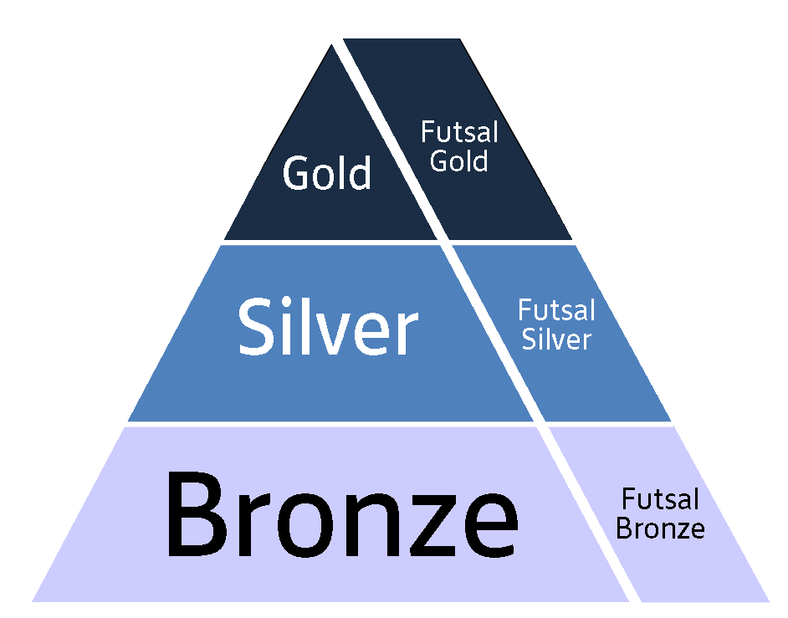
- FA Charter Standard Award status
- Nike Kit and Equipment Discounts

Are there differing levels of Kent FA Licensed Football Providers?
Yes, there are 3 tiers available on our programme called Gold, Silver and Bronze. All will have FA Charter Standard status, but the 3 tiers are differentiated by the quality of provision our providers have in place. More information can be found on page 8. There is also a similar pathway for futsal providers.

What are the costs of becoming a Kent FA Licensed Football Provider?
The cost to apply for the award is completely free following affiliation.

Will we need to renew our Kent FA Licensed Football Provider licence?
The licence we give will last for 2 years from the date of being awarded. This information will be on the certificate that you get for becoming a Kent FA Licenced Football Provider.

What support and guidance can you give us in completing this application?
We can offer the following advice:
- For all of the criteria below which have ‘(FA)’ after them, you can contact Development@KentFA.com to access a template if you would like.
- Once you are confident you meet the Bronze criteria, look carefully at page 8 of the application to see if you are currently suitable to apply for Silver or Gold. If you are exclusively providing futsal then it is important that you look at the optional futsal criteria.

- Make sure all of your coaches are on Whole Game System. This is the system we will use to check your information when you apply.

- If you need any assistance then you can contact Luke on Luke.Baker@KentFA.com. There is no limit to the amount of times that you are able to apply so do not worry if the application is rejected first time as more information is needed, this is completely normal.

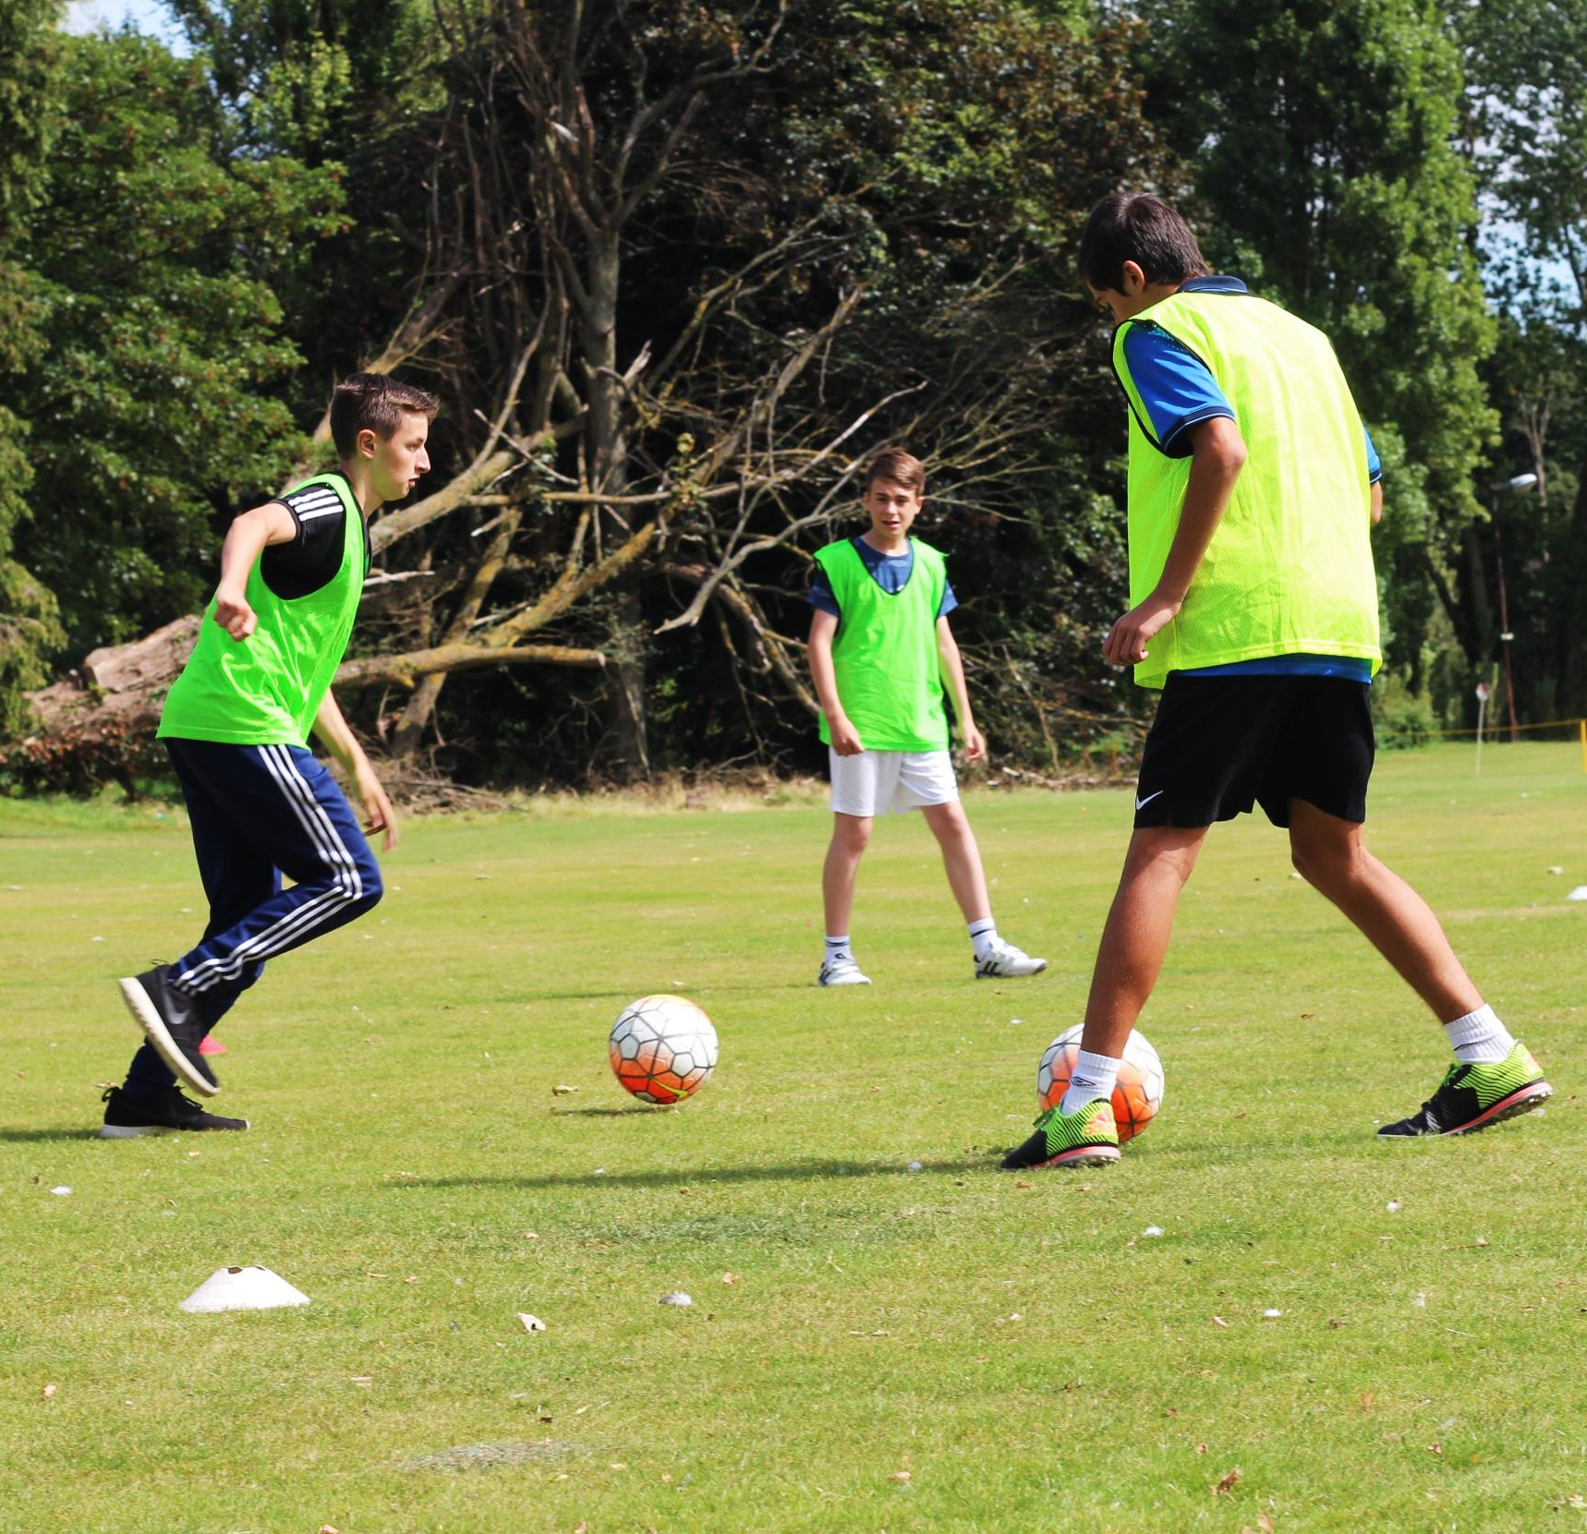
Did you know?
There are only 5 Kent FA Licensed Football Providers in Kent (November 2019)
Applying to become a Kent FA Licensed Football Provider:
To ensure the integrity and quality of our licencing programme continues we have a range of criteria which must be achieved. Some of the criteria are required by The FA for your organisation to become an FA Charter Standard Club.

Your Information
Name of provider: | Click here to enter name of provider.
Name of lead applicant: | Click here to enter name of lead applicant.
Address and postcode of provider: | Click here to enter address and postcode of provider.
Contact number for provider: | Click here to enter contact number of provider.
E-mail address for provider: | Click here to enter email address of provider.
Do you consent to the above email and phone number being published on our online interactive map? | Yes ☐  No ☐
How many employees does your organisation currently have operating in Kent? (this includes coaches delivering sessions) | Click here to enter current number of employees.
How many sessions will you run, on average, each week in total in Kent? | Click here to enter how many sessions.
Which of the following is your organisation? | Public Limited Company: ☐  Private Limited Company: ☐  Sole Trader: ☐  Professional Club: ☐  Registered Charity: ☐
Which venues does your organisation regularly use? | Name and Postcode: Click here to enter text.  Name and Postcode: Click here to enter text.  Name and Postcode: Click here to enter text.  Name and Postcode: Click here to enter text.  Name and Postcode: Click here to enter text.  Name and Postcode: Click here to enter text.

Below is a list of requirements which we would ask you to decide if your organisation does not meet, does meet or will meet in the future. Further into your application, we will advise which of these criteria must be evidenced by submitting supporting documents. By meeting the below criteria, you will become a bronze Kent FA Licensed Football Provider. Further criteria are required to become a silver or gold provider. These can be found on page 8.

The Organisation
No | We will | We do | Criteria |  | Evidenced by: |  | Requires submitting documents?
☐ | ☐ | ☐ | Does your organisation have terms and conditions making reference to:  - Organisation Name  - A commitment to affiliate  - Management committee meetings  - Disciplinary procedures  - Equality  - Data Privacy |  | Submitting constitution (or above) |  | Yes
☐ | ☐ | ☐ | Does your organisation have a formal link with at least one FA Charter Standard Club? |  | Submitting signed partnership agreement |  | Yes
☐ | ☐ | ☐ | Does your organisation commit to completing The FA Charter Standard Annual Health Check each year? |  |  |  | No
☐ | ☐ | ☐ | Is your organisation represented at at least two Kent FA or The FA in-service (CPD) training events per year? |  |  |  | No
☐ | ☐ | ☐ | Does your organisation produce annual accounts and a balance sheet? |  | Submitting previous year accounts |  | Yes
☐ | ☐ | ☐ | Does your organisation have its own separate bank account? |  | Submitting document with name of account holder |  | Yes
☐ | ☐ | ☐ | Does your organisation follow The FA Equality Policy? (FA) |  | Submitting personalised FA Equality Policy |  | Yes
☐ | ☐ | ☐ | Does your organisation affiliate all age groups to Kent County FA annually? |  |  |  | No
☐ | ☐ | ☐ | Does the organisation have a clear and transparent pricing structure? |  | Submitting pricing structure |  | Yes
☐ | ☐ | ☐ | Does the organisation have a comprehensive and reliable registration process? |  | Submitting registration process |  | Yes
☐ | ☐ | ☐ | Does the organisation have Public Liability Insurance, Personal Accident cover, Employers Liability insurance, Business Interruption cover and any buildings or assets cover? |  | Affiliation/submitting insurance documents |  | Yes
The Staff
No | We will | We do | Criteria | Evidenced by:
☐ | ☐ | ☐ | Do all of your officials/staff/managers have clear job descriptions? | Submitting sample job descriptions for at least half of the roles in your organisation |  | Yes
☐ | ☐ | ☐ | Does your organisation have all individuals who will be in regulated activity with children and young people listed on Whole Game System? |  |  | No
☐ | ☐ | ☐ | Does your organisation commit to ensuring that all individuals who will be in regulated activity with children and young people are listed on Whole Game System? |  |  | No
☐ | ☐ | ☐ | Does your organisation follow The FA adult to child ratio of one Coach to 16 players? |  |  | No
☐ | ☐ | ☐ | Does your organisation have a Welfare Officer appointed who has the Welfare Officer Workshop qualification? |  |  | No
☐ | ☐ | ☐ | Does every individual in regulated activity working with teams that are Under 18 and below have an FA accepted, in date Criminal Record Check? |  |  | No
☐ | ☐ | ☐ | Does the organisation have at least one individual FA Level 1 Introduction to First Aid in Football (IFAiF) (previously FA Emergency Aid) with every team? |  |  | No
☐ | ☐ | ☐ | Does the organisation have at least one individual with FA Safeguarding Children with every team? |  |  | No
☐ | ☐ | ☐ | Does the organisation have at least one FA Level 1 individual with every team? |  |  | No
☐ | ☐ | ☐ | Does the organisation have one FA Level 2 (block 1) coach for every 4 teams? |  |  | No
☐ | ☐ | ☐ | Does your organisation consent to receiving a visit(s) from an FA Coach Mentor, FA Coach Educator or Kent FA Staff? |  |  | No

The Environment
No | We will | We do | Criteria | Evidenced by: | Requires submitting documents?
☐ | ☐ | ☐ | Does your organisation have a Safeguarding Children policy? (FA) | Submitting Safeguarding Children Policy | Yes
☐ | ☐ | ☐ | Does your organisation ensure The FA Goal post safety requirements are followed? (FA) |  | No
☐ | ☐ | ☐ | Does your organisation actively promote and use The FA Respect Codes of Conduct? (FA) | Submitting personalised FA Respect Codes of Conducts | Yes
☐ | ☐ | ☐ | Does your organisation have a first aid kit available at all games, training and football events? |  | No
☐ | ☐ | ☐ | Does your organisation organise a briefing for Parents/Carers and Officials at the start of each session to discuss behaviour? |  | No
☐ | ☐ | ☐ | Does your organisation have a player pathway? |  | No
☐ | ☐ | ☐ | Does your organisation carry out written risk assessments each facility that they will regularly use? |  | No

The above criteria are compulsory. However, the below criteria is optional and will allow you to achieve silver or gold status.

Optional Criteria
Tier Criteria | We do | Criteria | Evidenced by:
Silver | ☐ | Has the organisation completed a Football Development Plan? | Submitting Football Development Plan
Silver | ☐ | Does the organisation have a Level 2 block 1 (or Level 2 and Module 1) with every age group? | Whole Game System
Silver | ☐ | Does the organisation have a Level 2 block 2 (or Level 2 and Module 2) with every 4 age groups? | Whole Game System
Silver | ☐ | Does the organisation have a FA Level 2 Emergency First Aid in Football (EFAiF)(previously Basic First Aid in Sport (BFAS) individual for every 4 age groups in the organisation? | Whole Game System
Silver | ☐ | Does the organisation have one UEFA B licenced coach (or working towards it) within the organisation? | Application
Gold | ☐ | Has the organisation completed a Football Development Plan? | Submitting Football Development Plan
Gold | ☐ | Does the organisation have an exit route link with a professional football club? | Submitting Signed Partnership Doc
Gold | ☐ | Does the organisation have a Level 2 block 2 (or Level 2 and Module 2) with every age group? | Whole Game System
Gold | ☐ | Does the organisation have a UEFA B licenced coach (or working towards it) with every 4 teams? | Whole Game System
Gold | ☐ | Does the organisation have a FA Level 2 Emergency First Aid in Football (EFAiF)(previously Basic First Aid in Sport (BFAS) individual for every 2 age groups in the organisation? | Application
Gold | ☐ | Does the organisation have a Coaching Philosophy which has been approved by Kent FA? | Submitting Coaching Philosophy
Gold | ☐ | Has the organisation signed the Equality Charter? | Checking with Inclusion FDO
Gold | ☐ | Does the organisation have a process for listening to the feedback of young people? | Submitting information

Optional Criteria - Futsal
Futsal Tier Criteria | We do | Criteria | Evidenced by:
Futsal Bronze | ☐ | Does the organisation have a Level 1 Futsal qualified coach with every age group? | Whole Game System
Futsal Bronze | ☐ | Are all of the sessions run with appropriately sized futsal balls? | N/A
Futsal Bronze | ☐ | Do all of the sessions have access to the correct sized futsal goals? | N/A
Futsal Bronze | ☐ | Do all of the sessions take place on a hard surface with line markings? | N/A
Futsal Bronze | ☐ | Are any competitive games played by the Futsal Laws of the Game? | N/A
Futsal Silver | ☐ | Has the organisation completed a Football Development Plan? | Submitting Football Development Plan
Futsal Silver | ☐ | Does the organisation have a Level 2 block 1 (or Level 2 and Module 1) with every age group? | Whole Game System
Futsal Silver | ☐ | Does the organisation have a FA Level 2 Emergency First Aid in Football (EFAiF)(previously Basic First Aid in Sport (BFAS) individual for every 4 age groups in the organisation? | Whole Game System
Futsal Silver | ☐ | Does the organisation have a Level 2 futsal coach with every 6 age group? | Application
Futsal Gold | ☐ | Has the organisation completed a Football Development Plan? | Submitting Football Development Plan
Futsal Gold | ☐ | Does the organisation have an exit route link with a futsal club playing in the National League? | Submitting Signed Partnership Doc
Futsal Gold | ☐ | Does the organisation have a Level 2 block 2 (or Level 2 and Module 2) with every age group? | Whole Game System
Futsal Gold | ☐ | Does the organisation have a FA Level 2 Emergency First Aid in Football (EFAiF)(previously Basic First Aid in Sport (BFAS) individual for every 2 age groups in the organisation? | Application
Futsal Gold | ☐ | Does the organisation have a Coaching Philosophy which has been approved by Kent FA? | Submitting Coaching Philosophy
Futsal Gold | ☐ | Has the organisation signed the Equality Charter? | Checking with Inclusion FDO
Futsal Gold | ☐ | Does the organisation have a Level 2 futsal coach for every 3 age groups? | Whole Game System
Futsal Gold | ☐ | Does the organisation have one UEFA B licenced coach (or working towards it) within the organisation? | Application

Contact Luke on Luke.Baker@KentFA.com
For more information or support…

Declaration:
- Our organisation is committed to the requirements and aims of the Kent FA Licensed Football Provider.
- We are aware that if we fail to meet any of the required criteria or embody the aims of the programme then our licence may be removed.
- We commit to abiding by all rules and regulations as outlined in The Football Association Handbook. Breaching these rules could result in our licence being removed.
- We commit to ensuring all staff, coaches or volunteers that are in regulated activity are listed on the Whole Game System and we will follow the process to ensure they have an FA accepted CRC.
- All of the information given in this application is correct to the best of our knowledge.
Name: | Click here to enter text.
Role: | Click here to enter text.
Signed: | Click here to enter text.
Date: | Click here to enter a date.

Kent County FA use only
Date application received:
Football Development Plan Feedback (Gold and Silver only)
Criteria missing
County FA Welfare Officer Feedback
Discipline Feedback
Action Plan

