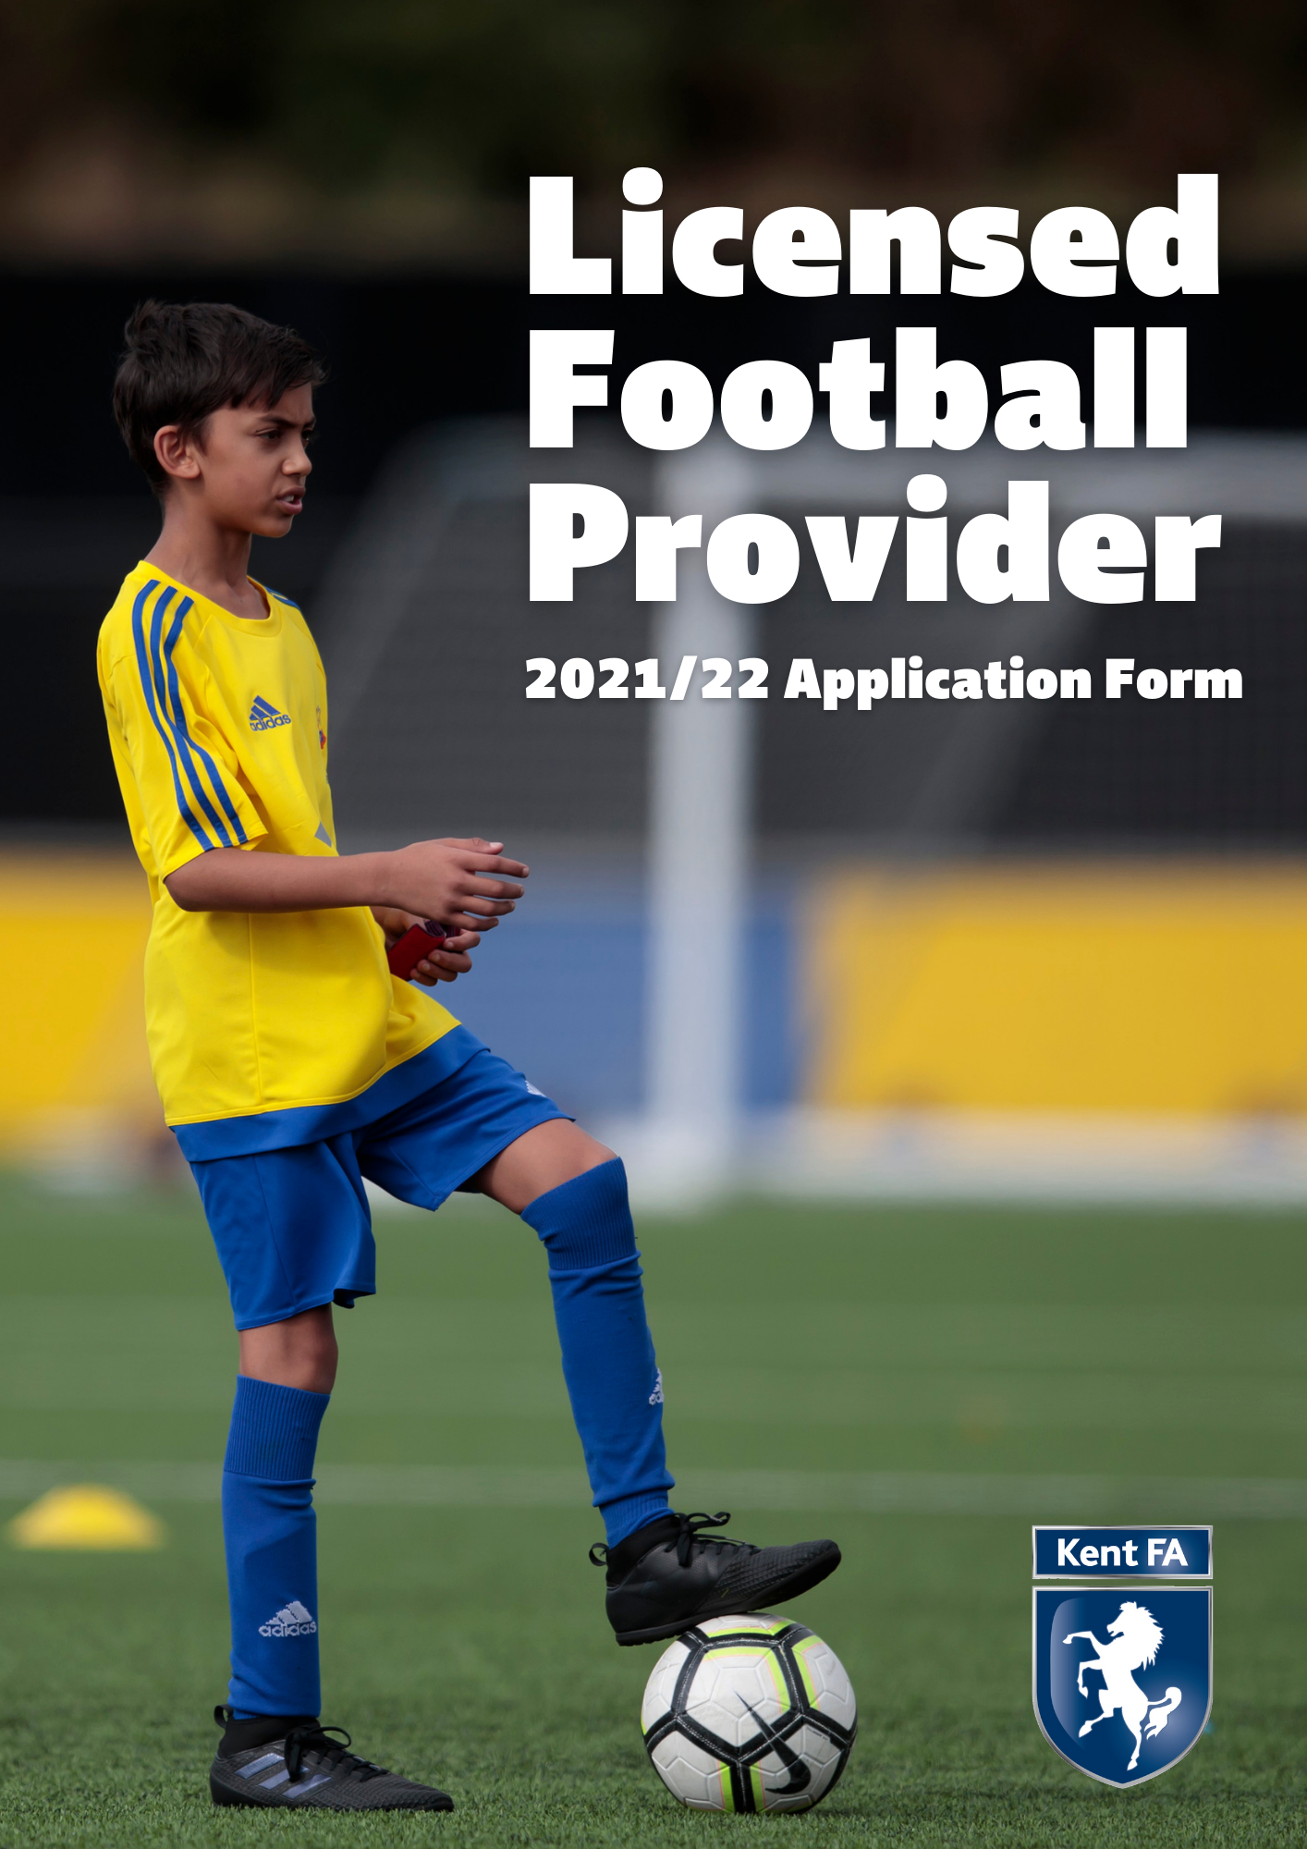

What is a Kent FA Licensed Football Provider (LFP)?
With no regulation as to who can set up a football coaching company, our licensing programme aims to promote those providers that can evidence provision of high quality, enjoyable and inclusive playing opportunities in a safe environment. This is achieved by certifying that appropriate insurance, policies and qualifications are in place and remain so.

These organisations can provide a variety of activities, including, but not limited to:
- Football in schools
- Extra circular football clubs
- Commercial soccer schools
- Football academies
- Paid-for football coaching sessions
- Community Trust
- School holiday activities
- Education-linked 'academy' programmes for 16-19 year olds
- Futsal academies

Licensed providers are affiliated to the Kent FA in the same way as a club or league, so are subject to the FA’s and Kent FA’s rules and governance.

The policies and qualifications that are needed to achieve the Licensed Football Provider status are designed to contribute towards a respectful, fun and safe environment

The licence encourages the provider to continuously develop, through on-going support from Kent FA staff and to be reviewed annually.

What is the process to becoming a Kent FA Licensed Football Provider?
1 - The football provider must affiliate the organisation and each age group they provide football for to Kent FA via Whole Game System. The process will start by contacting info@KentFA.com advising that you wish to affiliate a new football provider. We will then ask you certain information which will allow us to create the organisation on the Whole Game System. The affiliation process will ensure the following:
- All coaches/staff working with age groups U18 or below have an FA accepted in-date Criminal Records Check (DBS)
- A Welfare Officer is in place who has both an FA Safeguarding qualification and FA Welfare Officer Workshop qualification
- The Chairman, Secretary and Welfare Officer have completed the online course ‘Safeguarding for Committee Members’
- Personal accident cover and public liability insurance are in place
- All coaches that will be working with the provider are listed
- All age groups that the provider will be providing football for are affiliated

2 - Complete the following application form to become a Kent FA Licenced Provider and submit to accrediation@KentFA.com.

3 - Once the application has been approved, you will be notified and the organisation can enjoy all of the benefits of being a Kent FA Licenced Football Provider.

What are the benefits of becoming a Kent FA Licensed Football Provider?
By becoming a Kent FA Licensed Football Provider, your organisation will join a prestigious group who have evidenced a safe, inclusive and high quality set up to the governing body of football in Kent.

The hidden benefits of having our license will have been demonstrated since its inception in 2013. Schools, clubs and parents now recognise the license as a kite mark and are more likely to engage as they know a minimum standard has been met. Therefore, the licence can act as a promotional tool to increase both the quality and quantity of your organisation.

If you are a newly created business then this licence offers an outline of everything a football provider needs to put in place to run efficiently. We hope that by working through the criteria, it will help you establish good practices for years to come.

In addition to these hidden benefits providers also have the opportunity to purchase Public Liability and Personal Accident insurance at a competitive rate through affiliation. After successfully completing the award, we also offer the following:

- 100 Licensed Football Provider A5 leaflets to offer to customers
- Access to ‘Whole Game System’ to manage workforce and check qualifications of individuals
- Workforce recruitment opportunities through @KentFA Facebook and Twitter
- Eligibility to participate in sanctioned leagues, festivals, club tournaments and County FA competitions
- Use of Kent FA Licensed Football Provider Logo
- Certificate of achievement
- FA Criminal Record Check and Safeguarding Children advice and support network
- Access to FA coaching bursaries when available
- Access to information and advice from the County FA personnel, FA Regional Development Manager and FA Regional Facility Managers
- Access to The FA and County FA publications and resources
- Presentation and press released upon achievement of award (if applicable)
- Being part of the structure of the National Game from grassroots upwards
- Discipline, Fair Play and FA RESPECT support
- Kent FA promotional opportunities including promotion at www.kentfa.com
- Personal and Public Liability Insurance through the affiliation process
- Nike Kit and Equipment Discounts

Are there differing levels of Kent FA Licensed Football Providers?
Yes, there are three tiers available on our programme called Gold, Silver and Bronze. The three tiers are differentiated by the quality of provision our providers have in place.

What are the costs of becoming a Kent FA Licensed Football Provider?
The cost to apply for the award is completely free following affiliation.

What is the future of the programme?
Kent FA are fortunate to be chosen as one of the five counties nationally who are trailing a new Licensed Football Provider Programme. Supported by The FA, this trial is for the duration of the 2021/22 season with a view to being launched nationally in 2022/23.

Therefore, any successful application received during the 2021/22 season will be granted Licensed Football Provider status until 30th June 2022. Following this date, organisations may need to reapply once the national scheme has been launched. Kent FA will support all existing organisations to do this is the quickest and easiest way possible.
Applying to become a Kent FA Licensed Football Provider:
To ensure the integrity and quality of our licencing programme continues we have a range of criteria which must be achieved.

Your Information
Name of provider: | Click here to enter name of provider.
Name of lead applicant: | Click here to enter name of lead applicant.
Address and postcode of provider: | Click here to enter address and postcode of provider.
Contact number for provider: | Click here to enter contact number of provider.
E-mail address for provider: | Click here to enter email address of provider.
Do you consent to the above email and phone number being published on our online interactive map? | Yes ☐  No ☐
How many employees does your organisation currently have operating in Kent? (this includes coaches delivering sessions) | Click here to enter current number of employees.
How many sessions will you run, on average, each week in total in Kent? | Click here to enter how many sessions.
Which of the following is your organisation? | Public Limited Company: ☐  Private Limited Company: ☐  Sole Trader: ☐  Professional Club: ☐  Registered Charity: ☐
Which venues does your organisation regularly use? | Name and Postcode: Click here to enter text.  Name and Postcode: Click here to enter text.  Name and Postcode: Click here to enter text.  Name and Postcode: Click here to enter text.  Name and Postcode: Click here to enter text.  Name and Postcode: Click here to enter text.

The following criteria are required to be met to apply as a Licensed Football Provider. Further criteria are to be met to meet the level of bronze, silver or gold.

Staff and Qualifications
Criteria | Our Advice | Checked via:
All coaches to have an in-date, FA accepted DBS check | This is done once you have a Welfare Officer in place | Whole Game System
All coaches to have an in-date FA Safeguarding Children Qualification | Visit this link to book an FA Safeguarding Children Workshop | Whole Game System
All coaches to have an in-date FA Introduction to First Aid Qualification | Visit this link to book an FA First Aid course | Whole Game System
Appointed Welfare Officer with in-date, FA accepted DBS check, FA Safeguarding Children Qualification, FA Welfare Officer Workshop Qualification | Visit this link to book an FA Welfare Officer Workshop | Whole Game System
Appointed Chairman, Treasurer and Secretary who has completed the FA Safeguarding for Committee Members Qualification | This can be the same person | Whole Game System

Policies and Procedures
Criteria | Our Advice | Checked via:
Personal Accident Cover for all ages that football will be delivered to | This is purchased when you affiliate | Affiliation
Public Liability Insurance of £10m | This is purchased when you affiliate | Affiliation
Facility risk assessment including Safeguarding and Emergency Action Plan (EAP) | An EAP template can be found here | Sharing document
Safeguarding Children and Vulnerable Adults Policy | Safeguarding Policy Template can be found here | Sharing document
Codes of Conducts for coaches, officials, players and parents and a commitment to The FA RESPECT programme | Code of Conduct templates can be found here | Sharing document
Data protection and Data Privacy Policy | Data Protection can be found here Data Privacy can be found here | Sharing document
Safer Recruitment Policy | Safer Recruitment Policy template can be found here | Sharing document
Equality Policy | Equality Policy template can be found here | Sharing document
Clear and transparent registration process | This must contain photography consent and medical information. | Sharing document

The above criteria are compulsory. However, the level that you can reach will be defined by the following:

Bronze Level
At least one coach to hold a minimum of FA Level 2 in Coaching Football or UEFA C
All coaches to have completed at least the FA BT Playmaker by England Football Course
A commitment from the organisation to continue coaching CPD where possible

Silver Level
The lead coach of all sessions to hold a minimum of FA Level 2 in Coaching Football or UEFA C
All coaches to have hold a minimum of FA Level 1 in Coaching Football or Introduction to Coaching Football
A commitment from the organisation to continue coaching CPD where possible

Gold Level
The lead coach of all sessions to hold a minimum of UEFA B in Coaching Football
At least 50% of coaches to hold a minimum of FA Level 2 in Coaching Football or UEFA C
All coaches to have hold a minimum of FA Level 1 in Coaching Football or Introduction to Coaching Football
A commitment from the organisation to continue coaching CPD where possible

Contact the team on accreditation@KentFA.com
For more information or support…

Declaration:
- Our organisation is committed to the requirements and aims of the Kent FA Licensed Football Provider.
- We are aware that if we fail to meet any of the required criteria or embody the aims of the programme then our licence may be removed.
- We commit to abiding by all rules and regulations as outlined in The Football Association Handbook. Breaching these rules could result in our licence being removed.
- We commit to ensuring all staff, coaches or volunteers that are in regulated activity are listed on the Whole Game System and we will follow the process to ensure they have an FA accepted DBS.
- All information given in this application is correct to the best of our knowledge.
- We acknowledge and accept that we may be visited, possibly unannounced, by a Kent FA staff member to conduct checks around safeguarding, quality and qualifications.
Name: | Click here to enter text.
Role: | Click here to enter text.
Signed: | Click here to enter text.
Date: | Click here to enter a date.

Kent County FA use only
Date application received:
Criteria missing
County FA Welfare Officer Feedback
Discipline Feedback
Action Plan

