CLUB’S NAME GOES HERE

YYYY - YYYY

Use this planner to set goals and tasks you need to complete to form the club identity.

Tip: Visit our England Football League and Club Hub on YouTube for ideas to help you develop a vision and mission for your club.
Visit our England Football Learning Bootroom website for ideas to help you develop your football philosophy.

SEASON PLANNER

Area | Objective/ Aims | How will you achieve this? | Timescale | Who is responsible? | Cost | When will you review this?
New players

Facilities
Sponsorship
Qualifications and First Aid
Vision for club
Committee Growth

PLAN AND CHALLENGES
WHAT ARE YOUR 3 BIGGEST CHALLENGES AROUND RUNNING THE CLUB?
-

-

-

HOW TO ADDRESS THESE CHALLENGES
-

-

-

VALUES LEADING TO THIS VISION

DO YOU REQUIRE ANY SPECIFIC SUPPORT FROM THE KENT FA?

CLUB 2-YEAR VISION

CLUB VALUES
Club Values
How do your values shape the environment and experiences during training, before game and during a game? Do you differentiate between your football offering and the players you interact with? i.e. recreational players/ competitive players, male/ female/ disability, different age groups.
Below are some factors that we believe contribute to the environment. Please consider each factor and fill in each section reflecting the values of your club.

CLUB VALUES
- Please list 4-5 values that you embed into your club’s coaches, players and spectators.

-

-

-

-

-
HOW DOES YOUR CLUB SUPPORT YOUR COACHES DEVELOPMENT?
-
TRAINING VALUES
- How do you ensure training is engaging and supportive of the players growth?

SPECTATORS, ENVIRONMENT AND RESPECT
ACCESSIBILITY AND SIGNAGE

COACHES BEHAVIOUR
TOILETS AND FACILITIES

SIDELINE BEHAVIOUR

EXPERIENCE
How does your club ensure that football is played in a positive environment?

Club contact details
Club Name
Home Ground Address |  |  | Postcode
Telephone
First Aider / Helper Information
Name |  |  | Mobile number
For queries about this EAP
See relevant coach for First Aider on day of match
First Aid Equipment and Facilities
Item |  | Location
Defibrillator
Stretcher
First Aid Room

Access routes
For Ambulance
From Pitch to Ambulance
Where could an Air Ambulance land?

Other Information
Nearest A&E / Trauma Hospital
Fastest Route to A&E / Trauma Hospital
Distance and Journey time
Nearest Walk-in Centre
Alternative Trauma Hospital
Who is responsible for the First Aid kit on match days?

Weekly Club / Team Accounts Sheet (This can be sent to team managers to consider their individual teams finances)
Club
Team
Income |  | Expenditure
Subs |  | Pitch Hire
Raffle |  | Referee Fees
 |  | Washing
Total Income |  | Total Expenditure

Annual Accounts Sheet (Use this sheet to forecast annual finances)
Club
Year
Income |  | Expenditure
Sponsorship |  | Affiliation
Subs |  | Pitch Hire
Donations |  | Training Hire
Grants |  | Referee Fees
Trips |  | Washing
Events |  | Fines
 |  | Equipment
 |  | Events
Total Income |  | Total Expenditure
Opening Balance |  | Who collects match subs?  -  Who pays the referee?  -  Who hires the pitch?
+ Surplus / Deficit
Total / Closing Balance

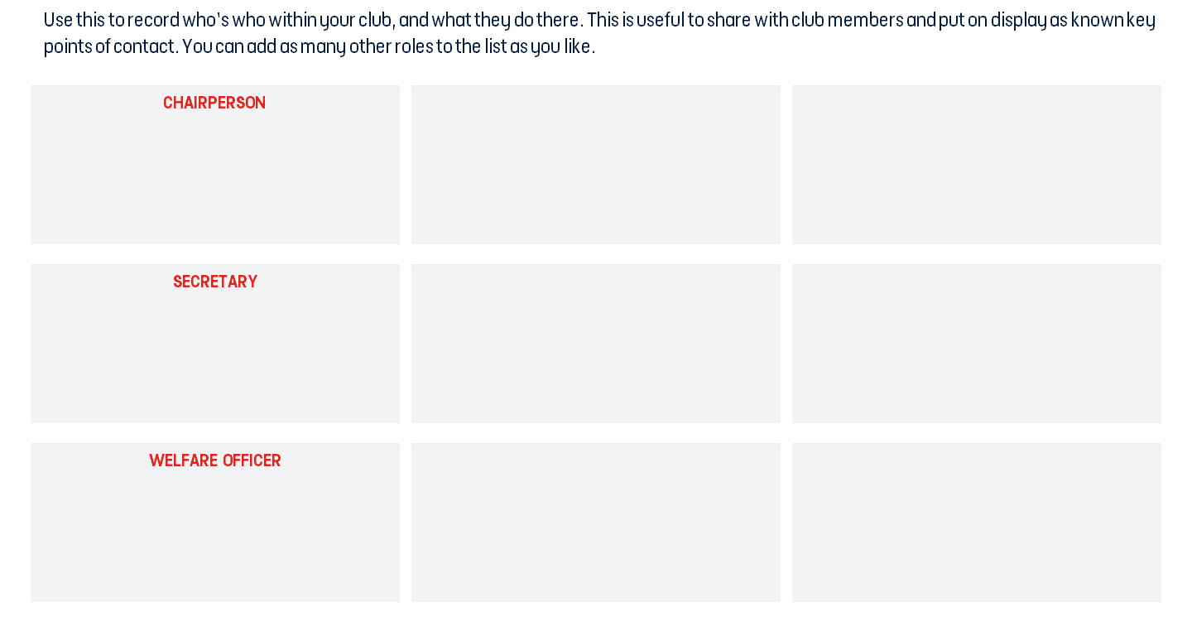

TREASURER

Name:
Role:
Name:
Role:
Name:
Role:

*Enter Role*

Name:
Role:
Name:
Role:
Name:
Role:

Name:
Role:
Name:
Role:
Name:
Role:

TOP TIPS
Clubs that utilise social media effectively are more likely to attract players, volunteers and even sponsors.
- Frequency – consider if you are posting on a match day/ what time you are posting.
- Language – positive, not confrontational
- Content – Engaging, creative, previews/ reviews, videos (e.g. goals/ interviews)
- Videos and pictures – Variety, engaging, creative, previews/ reviews, videos (e.g. goals/ interviews)
- Check if anyone in the club has expertise in this area and can take on this duty.

Which Social Medias do your club use?

What will you post about?
How often will you post?
Do you have any social media commitments to a sponsor?

Resources England Football – Leagues & Clubs England Football Accreditation

Club Learning Opportunities YouTube - The League and Club Hub The Grassroots Football Hub Events England Football Learning Bootroom
Perfect match (Create adverts for players/ volunteers) -https://www.kentfa.com/about/the-perfect-match

Kent FA Development Team email – development@kentfa.com

Kent FA number -
01622 791850

Club Resources
Club Structures Guide
Contact details for County FAs

Other Grassroots Support
Football Foundation
Football Foundation – Local Plans
Sport England
Sport England – Funding

