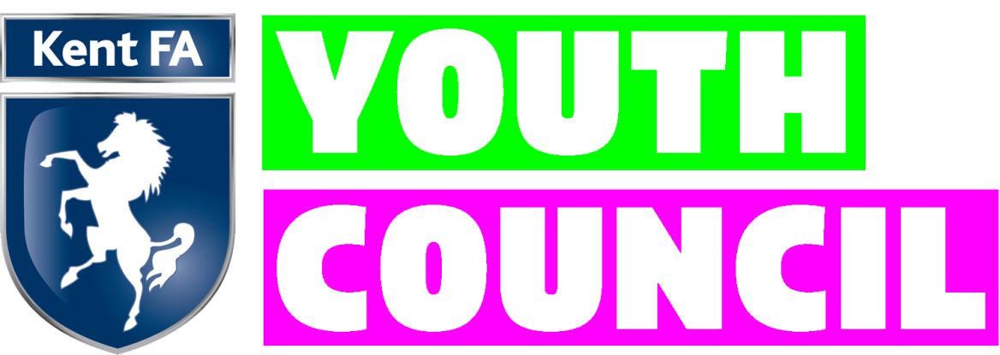
Council Ambassador
Role Description

Overall Purpose:
The Kent FA Youth Council are the voice of young people across our county. We are passionate about building for the future and evolving our game to ensure it is a safe, enjoyable and inclusive place for all.
Qualifications/ Skills/Experience:
Ambassadors need to be passionate about and committed to the development of football at a local level and have some knowledge and experience in grassroots football. You will need to be able to demonstrate team working, good communication skills and ability to manage and administrate your own affairs.

All new ambassadors must be aged between 13 – 22 years old on the date of being appointed and must live in Kent for the duration of the season.
Expectations of a Kent FA Youth Council Ambassador:

- Act as an ambassador for the Kent FA.
- Actively engage in and promote partnership working.
- Adhere and promote Kent FA corporate aims and values.
- Adhere to the FA Safeguarding Children and Equality Policies.
- Attend all Kent FA Youth Council Meetings (At least four per year, weekday evenings – 2 hours or weekday in school holidays – 4 hours, normally at Kent FA HQ in Maidstone)
- Prepare for and participate in the discussions, deliberations and decisions of the Kent FA Youth Council.
- Uphold high standards of personal integrity and conduct.
- Willingness to participate actively in the work of the Kent FA Youth Council.

What Kent FA will offer:
- Experience of operating within the football industry
- Kent FA and Nike branded kit
- Opportunities for references when needed
- Opportunity to influence the development of our game
- Opportunity to work closely with Kent FA staff members
- Personal development opportunities to gain experience and develop knowledge which is transferable throughout life and wide range of careers.
- Transition opportunities for members to be elected on to main Kent FA Council.

