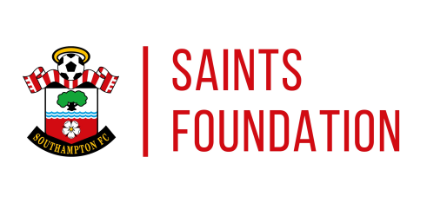

Dear Sir/Madam

My name is Martin Sinclair, I work for Saints foundation as a Saintasbility Development Officer. My role is looking at opportunities for talented players to play elite disability football. We recently had are application accepted from the Football Association to be an FA Regional Talent Hub in Southampton and the surroundings areas to help players progress onto the England pathway.

The talent hub is for people aged 7-16 with Cerebral Palsy, Hearing Impairment and Visual impairment. The hub encompass the FA Four Corner Model and the England DNA to focus on socially, physically, psychologically and technically. We want encourage players to come out of their comfort zone to work on different techniques in helping them to develop on their football development but also their personal development.

The Regional Talent Hub is running an open trial:

Venue: Staplewood Football Development Centre, Marchwood, Southampton SO40 4WR.
Dates: Sunday 30th September.
Time: 15:00 – 17:00.

If you are interested and want to book on please contact msinclair@saintsfc.co.uk

If you have any queries regarding the above please do not hesitate to contact a member of the Saints4all team on 0845 688 9370.

Yours sincerely,

Martin Sinclair
Saintsability Development Officer

