Service Level Agreement between

[Insert media organisation] and Hampshire FA
THIS AGREEMENT is made the day of 2021
BETWEEN:
(1) [Company Name] whose principal address is [Company Address] (the “Media Organisation”)
(2) Hampshire Football Association whose address is: Winklebury Football Complex, Winklebury Way, Basingstoke, Hampshire RG23 8BF (the "Association");

Part A - Introduction & Background
Hampshire FA is the governing body for football in Hampshire and a not-for-profit organisation determined and committed to developing the game at all levels. As one of the largest county FA’s in England, we work with over 5,000* teams in the county, over 50,000* players, 15,000* volunteers, and 1,600* referees in the county along with other impressive stats*.
*stats as at 1st June 2020
To support the plan, we have highlighted the need to build stronger relationships with media in the county in line with our objective of running the game, to market and publicise our opportunities and in turn to increase numbers participating in the game, our key objective.
For marketing purposes, we reach an impressive 11k+* people regularly via Twitter, 3k+ on Facebook, 1k+ on Instagram and LinkedIn whilst our website hits continue to increase on a day by day basis and averages 1,300* hits per day.
*Stats as at 1st June 2020

Part B – Media Specification
To become a Hampshire FA Media Associate the “Media Organisation” must be able to provide one of the following or an alternative mutually agreed with the association:
Type | Please specify (yes/no in the relevant box below):
A weekly or monthly radio slot announcing key messages as provided by the association
A weekly or monthly newspaper column (online feature also accepted) with press releases featured as provided by the association
Freelance media service (photography, video)
Regular TV exposure and/or coverage at key events at the discretion of the association.
Other media – please specify

**Service includes key events notably the Hampshire FA County Cup Finals which take place from March - May and a min x5 finals + additional events held in the year x3. Priority given to the Hampshire FA Grassroots Football Awards.

Please note that all official Media Associates of Hampshire FA will be given equal opportunity to attend events hosted by Hampshire FA.

Part C – Association Obligations
Hampshire FA agrees to provide:
1. A website section dedicated to the “media organisation” with links to website and social media channels
2. Regular social media exposure on our channels of media organisation
3. A Hampshire FA media logo to use on your publications/features recognising your organisation with ‘official media Associate’ status renewed each season
4. Online networking events arranged to find out about upcoming events and the structure of these events before being made public
5. Priority to attend Hampshire FA’s events in the county – news circulated to media Associates before other media organisations
6. ‘Media map’ created with your logo highlighting the location of your organisation along with your website and contact details, featured on our website
7. Articles for events to also include the “media organisation” in attendance
8. Media Certificate sent to media organisation signed by the Hampshire FA CEO in recognition of Associateship

Part D – Agreement
Association Contact Details:
Operational Point of contact name:
Position: Business Development Lead
Contact number: 02393 879998
Email: Isabella.Pearson@HampshireFA.com.

Media Organisation/individual Contact Details:
Operational Point of contact name:
Position:
Contact number:
Email:

Part E – Terms & Conditions
There is no monetary value attached to the media Associate package to recognise media Associates as the ‘official media Associates’ of Hampshire FA. The service provided is mutually beneficial, offering ‘services in kind’ as stated in sections Part B & Part C.
- This Agreement shall come into force on the date as stated on the first page provided it has been signed by the Association and the “Media Organisation” and shall continue in force (subject to proper termination under this Part E) until 30th June 2021 (subject to renewal) unless and until terminated by a party giving the others not less than 7 days’ written notice.
- All freelance media individuals must obtain an FA approved CRC to conduct any work on behalf of the organisation. This must be completed and sent as evidence before any such Associateship is confirmed.

- Newly established radio stations must provide a copy of an Ofsted certificate which confirms as proof they are able to operate
- This Agreement may be terminated by any party on 7 day’s written notice if either party goes into liquidation, either compulsory or voluntary, if either organisation details other evidence-based reasons which have or may result in a negative public perception that may negatively affect or harm the association’s reputation, or if a receiver, administrative receiver or administrator is appointed in respect of the whole or any part of its assets, or any similar event.
- If this Agreement terminates, for whatever reason, the media organisation and/or individual must comply with the following:
- any rights granted under this Agreement shall cease;
- any promotional materials, documents and data are returned to the owning party.
- all marketing/media supplied by Hampshire FA must be removed with immediate effect after written notice

Media Organisation signatory

I ……………………………… of ……………………….. agree and confirm to the terms as stated in the Hampshire FA - Media Service Level Agreement.
Signed: …………………..........…… Print Name: ………….…………………………..
Date: ………………………………….

Hampshire FA signatory

I ……………………………… of Hampshire FA agree and confirm to the terms as stated in the Hampshire FA - Media Service Level Agreement.
Signed: …………………..........…… Print Name: ………….…………………………..
Date: ………………………………….

Thank you for completing all sections in the Media Service Level Agreement. Please return agreement by email to Communications@HampshireFA.com or by post to: Hampshire FA, Winklebury Football Complex, Winklebury Way, Basingstoke, Hampshire, RG23 8BF.

Hampshire FA Logo
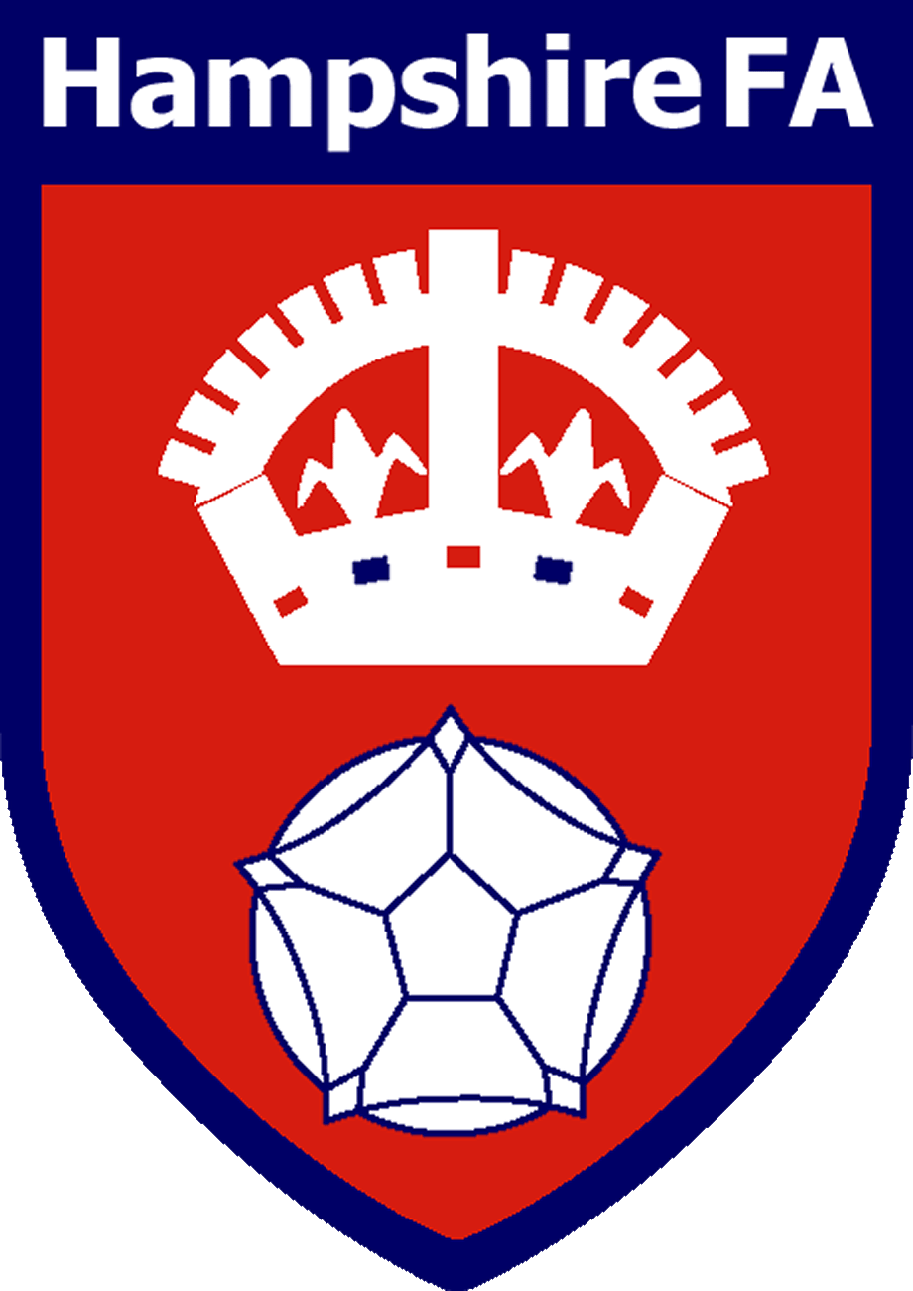

The Media logo will be sent to the “media organisation” once the agreement has been completed and finalised between both parties and includes joint signatory.

Media Organisation Logo
[please enclose]

