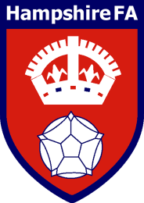

The Hampshire Football Association Discipline Panel Prospective Member Application Pack

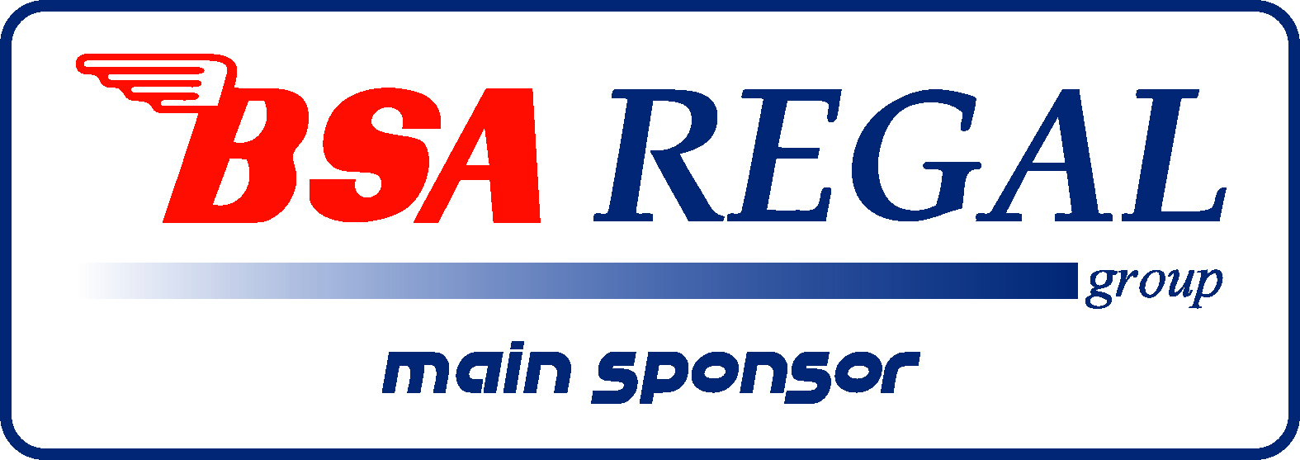

Dear Applicant,
Hampshire FA are an equal opportunities employer and actively encourage people from diverse backgrounds to apply for all roles.

We are seeking to appoint local members for the County Association Discipline Panel; we are looking for a diverse group of committed individuals across the Country with a variety of backgrounds and to be reflective of the local community and local football teams.

If you are interested and would like to apply for a position on the Discipline Panel, please complete the application form and return it by email or post along with your current curriculum vitae (Current members need not include a CV)

Details of where you should send your application back to can be found on the application form.
Training will be given and all panel members will be required to undertake mandatory training prior to being appointed to any panel.

We look forward to receiving your application.”

Kind regards,
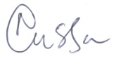
Chief Executive
Hampshire FA

Hampshire FA are an equal opportunities employer and actively encourage people from diverse backgrounds to apply for all roles, including those that are voluntary and within standing committee structures.

Guidance on how to apply

If you are interested in applying to be a member of the Hampshire Football Association Discipline Panel, please complete the application form and return it by email or post along with your current CV to the Hampshire County FA, (Front Lawn Recreation Ground, Somborne Drive, Havant, PO9 5AN) ; Email: debbie.sowton@hampshirefa.com

The appointments are on a voluntary basis although expenses may be paid in line with the County FA expenses policy.

If you feel you require more information about the role or need assistance with your application, please do hesitate to contact debbie.sowton@hampshirefa.com or Tel: 02394 212192
Conversations will be both informal and confidential.

Please note that all applications must be received by Midnight, Saturday 1st May 2021.

A selection panel will meet following this date to shortlist those who will be required to complete in house training prior to being appointed to any panel.

We will be in touch with short listed candidates to provide further information.

Hampshire FA have an understanding and commitment to equality, diversity and inclusion and would be grateful if you could complete an optional, anonymous Equality Monitoring form as part of your application. By completing this questionnaire, you are helping us to plan for the future and ensure we recruit from a diverse pool of applicants that are appropriate and relevant to the community we service. Please complete the Equality Monitoring form by clicking here.

Midnight, Saturday 1st May 2021

Disciplinary
- Terms of reference – To deal with disciplinary and misconduct procedures in accordance with the provisions within the Rules and Regulations of The Football Association and of this
Association.

- Has an understanding and application of inclusion, equality and anti-discrimination, safeguarding and best practice procedures.
- To have an understanding of the Rules of The FA and Hampshire FA relating to Discipline.

- To serve the Association as a Member of Disciplinary Commissions and Boards of Enquiry.

- To represent the Association at meetings and seminars of The FA and other organisations relevant to discipline as and when required.

- To remember at all times that the cases that you will be dealing with require you to remain confidential at all times

- Not currently working within the discipline environment for a County Football Association

Personal Characteristics

The key qualities required are:

- Ability to work collaboratively together and with the football bodies, across all the equality strands
- A sound knowledge of judicial processes and preferably within a sporting context
- Strong interpersonal and influencing skills.
- Understanding of sport and football at all levels.
- Patience and diplomacy
- Proficient with Microsoft Office/Products
- Able to recognise a personal conflict and not be in a position of conflict

Please tell us how you meet the person specification as set out above
(use a separate sheet if required)

Please tell us your reasons/motivations for wanting to be on this Panel
(use a separate sheet if required)

In addition please attach an up to date CV and return this along with your completed form to:
Hampshire County FA, (Front Lawn Recreation Ground, Somborne Drive, Havant, PO9 5AN);
Email: debbie.sowton@hampshirefa.com
All forms (application form & CV) must be returned by (Midnight, Saturday 1st May 2021).
Please complete the Equality Monitoring form by clicking here.

Hampshire FA Discipline Panel
Hampshire FA are committed to safeguarding children and adults at risk.
I wish to be considered to be eligible (subject to training) to sit on the following panel/s for this season, subject to completing and passing the following online courses:
- DBS Check
- FA Safeguarding Course/Safeguarding for all
- FA Committee Members Safeguarding Course
- FA Safeguarding Adults Course
- FA Young People in Football Module
- Attend FA online training as required
- Complete and Pass the FA Online Assessment

- To ensure that the above requirements are updated and retaken as necessary to remain compliant

- Ensure attendance at all modular training sessions
- Ensure all mandatory assessments are undertaken and passed before expiry period.
- Be able to offer Morning and/or Afternoon and/or Evening availability sessions for disciplinary hearings via Judicial Calendar.
- Read, Sign and Abide by the HFA Volunteers Code of conduct which requires re signing periodically.
- Attend Board of Appeal hearings when called upon

- Please Note: should candidate not be up to date with training and DBS requirements then this will prevent you from fulfilling their role until such time as they are compliant.

Please tick all that apply:-
Panel Member – Wing
Chairman
Wish to be considered as a Trainee Chairman
(subject to attending FA training)

HAMPSHIRE FOOTBALL ASSOCIATION
Discipline Panel Members Details 2021-2022

Name
ADDRESS
Telephone | Home:- Work:-  Mobile:-
E-Mail | Home:-  Work:-

Hampshire Football Association
Discipline Panel Members Conflict of Interest Form

Club/s involved with for Season 2021-2022 (Please list age group)
1._______________________________________________________________________
2._______________________________________________________________________
3._______________________________________________________________________
4.______________ _________________________________________________________
5.________________________________________________________________________
League/s Involved with for Season 2021-2022 (Officer/Management Committee/Clubs participate in)
1.________________________________________________________________________
2.________________________________________________________________________
3.________________________________________________________________________
4.________________________________________________________________________
5.________________________________________________________________________

Name__________________________________
Date_________________ _________________
Please attach any additional Clubs/Leagues on a separate piece of paper.
If there are any changes to this list during the 2021/22 season please advise the office on 02394 212192 or discipline@hampshirefa.com

