FA CRC County Applicant Guidance – Getting Started

Go to: https://gbg.onlinedisclosures.co.uk

CLICK ON REGISTER – Do not complete any of the boxes at this stage.

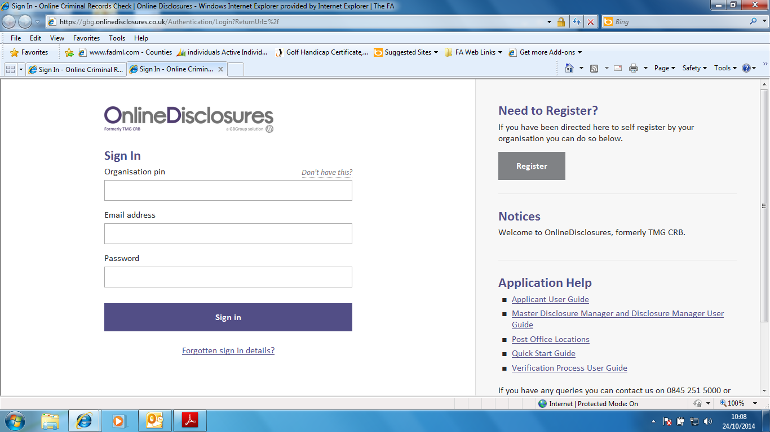

On the page returned, in the boxes provided enter:

102302
Your full name
Your email address
Your email address again

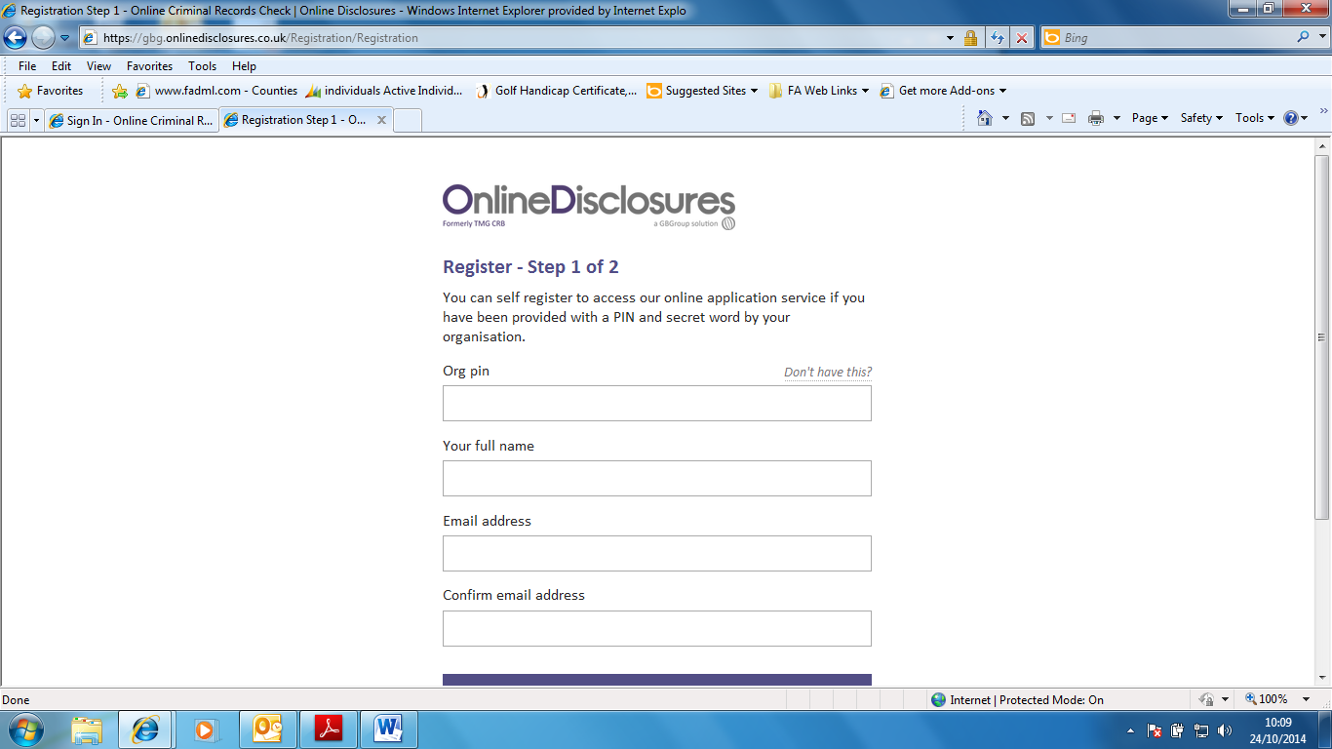

Click ‘Next Step’

On the page returned, in the boxes provided enter:

Roses (our ‘secret word’)
Click in the box to confirm it’s the WRCFA

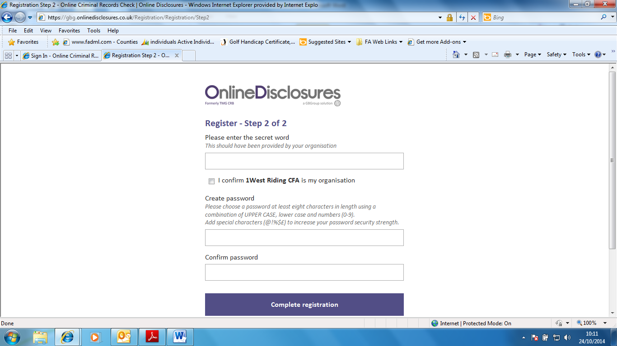

Enter a password of your choice

….and enter the password again

Click ‘Complete Registration’

Returning to the Sign In screen,
Complete the boxes using the details you’ve been given and created yourself and click ‘Sign In’ when completed.

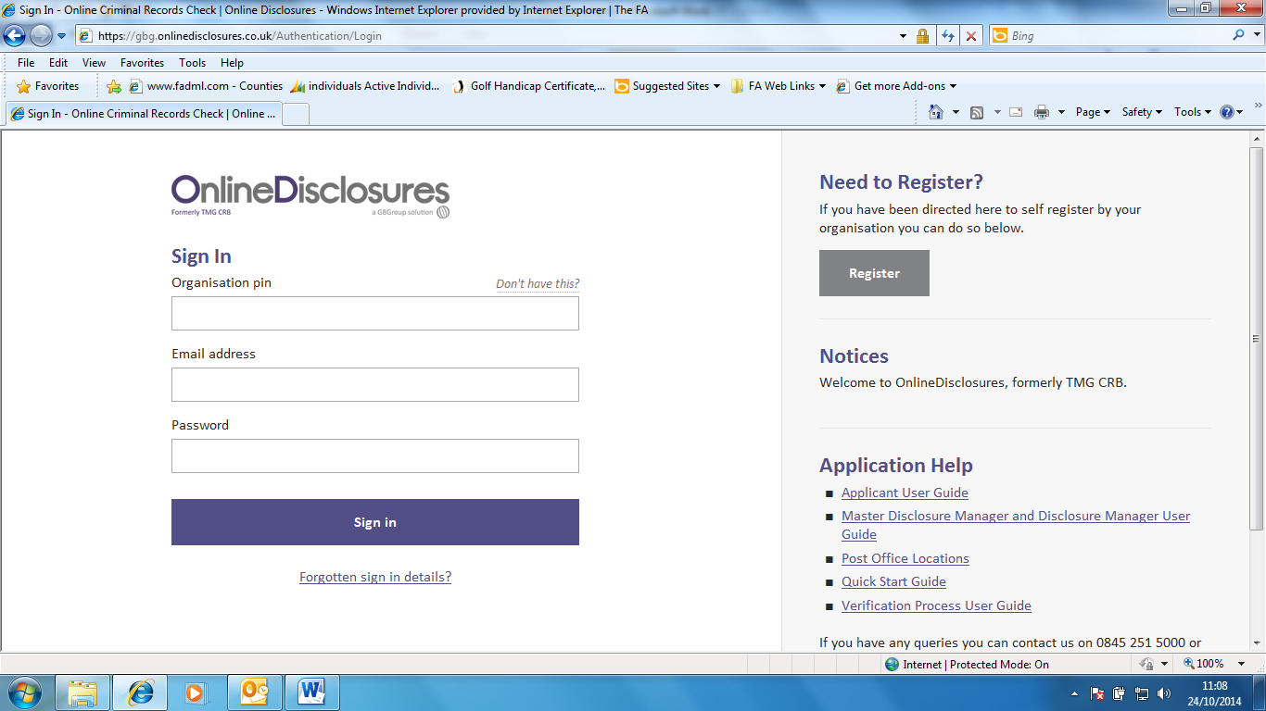

Now you’re registered to make an application, just follow the prompts on each page as they appear!

