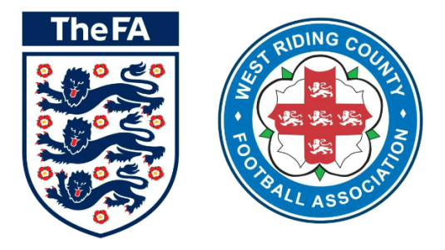
West Riding County FA
Inclusion Advisory Group (IAG)
Chair

Following the release of the FA’s Anti-Discrimination Action Plan (2012), making recommendations to County FA’s on equality, social inclusion and representation, we have revised our procedures and structures to implement two key projects: an Inclusion Advisory Group (IAG) and a Local Football Anti-Discrimination Panel (LFADP) to oversee the wider aspect of Equality in relation to the County FA Business. Volunteer support is required for both projects to ensure their success.

The IAG functions to provide advice, guidance and recommendations to our Board, critiquing the work of WRCFA, embedding good practice with regards to all equality matters into the County Strategic and Operational Plan and ensuring the population we serve receives fair and accessible football opportunities and services. The IAG will also assist the WRCFA to measure the impact of equality and anti-discrimination work in line with English Footballs Inclusion and Anti-Discrimination Action Plan and the Preliminary Level of the Equality Standard.

Members of the IAG will be expected to:

- Widen football’s talent by tackling under-representation and so increase the diversity of football’s talent pool

- Clarify anti-discrimination regulations and sanctions, to create clarity and understanding around the regulations and sanctions related to discriminatory behavior

- Instill confidence in reporting discrimination and to generate confidence in the reporting and subsequent handling of discrimination cases and be transparent with the outcomes

- Increase knowledge, awareness and understanding of equality and inclusion – and what constitutes discriminatory behavior within football, providing information, guidance and training

The group reports directly to the WRCFA Board of Directors on all issues relating to Inclusion, Equality and Diversity.
It is anticipated that the group will meet formally a minimum of four times each calendar year, although members are expected to have the enthusiasm to want to support WRCFA and its equality projects on a regular basis, with the meetings giving the chance to update on overall progress of the Inclusion and Anti-Discrimination Action Plan. The group will lead a pivotal role in delivering this plan as well as challenging and overseeing its outcomes.

How to get involved

We are looking to recruit a Chair for the group who will lead on administration for the group including recruitment of new members and chairing of meetings. We are inviting applications from people of all backgrounds that are reflective of the local community. It is expected that individuals elected to the group will have the appropriate skills, knowledge and experience to have a positive and meaningful impact in relation to the Terms of Reference of the Group. We are happy to accept applications from individuals who have no current involvement with football.

Please note - Posts are available to volunteers only. Expenses will be remunerated.

Application Process

Please complete and return the application form via email to info@westridingfa.com or alternatively post your application to West Riding County FA, Fleet Lane, Woodlesford, Leeds, LS26 8NX.

Closing date for applications: Monday 14th January 2019, 5pm.
Applicants will be invited to interviews w/c 21st January 2019.

