ESSEX COUNTY FOOTBALL ASSOCIATION
INDEPENDENT BOARD MEMBER APPLICATION PACK 2018

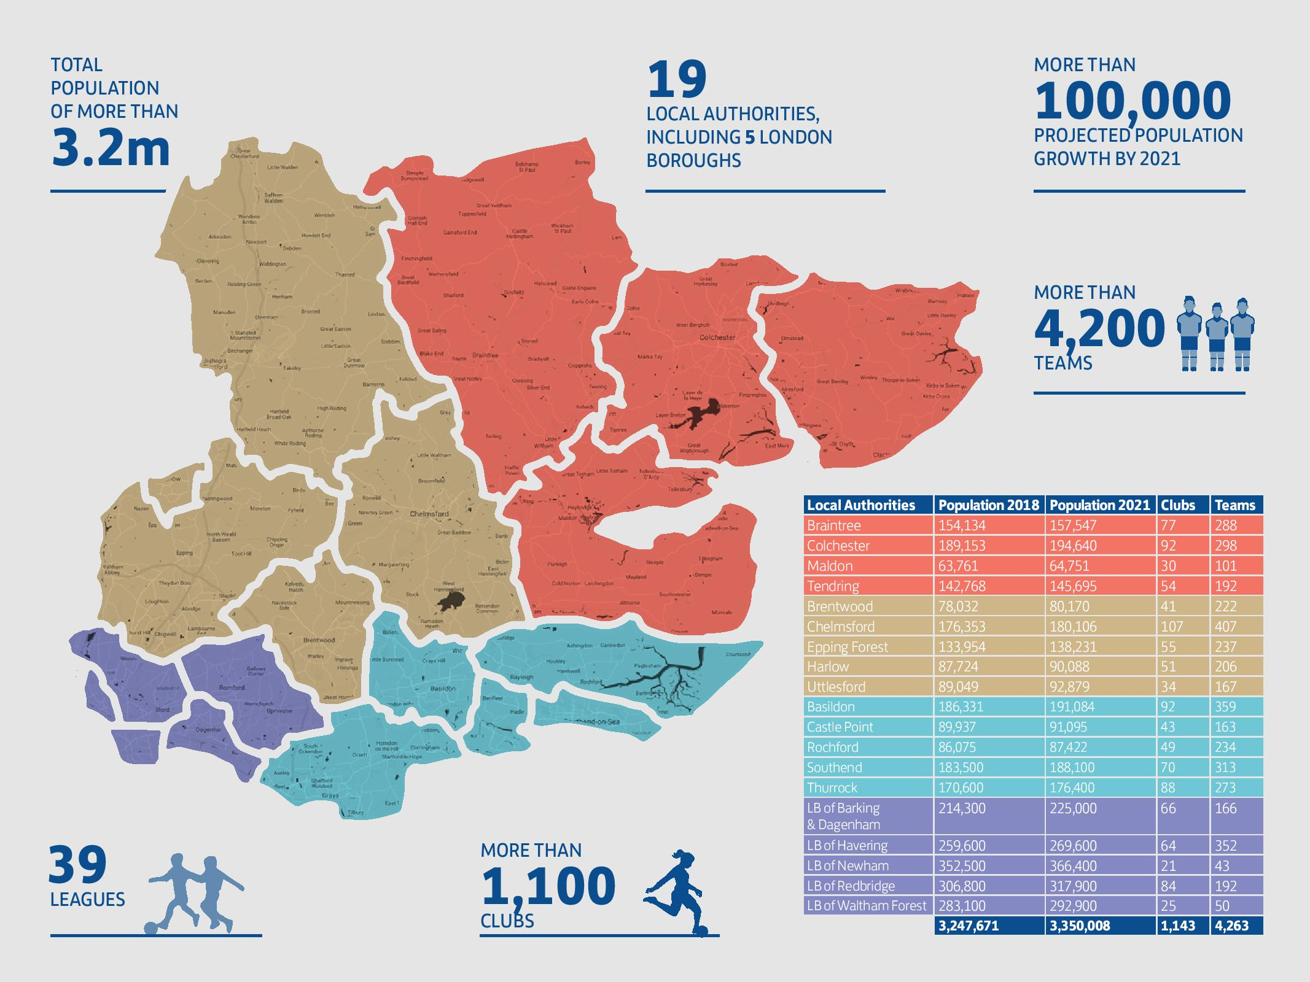



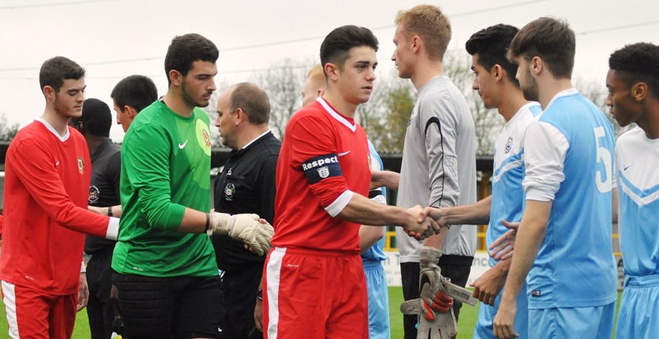
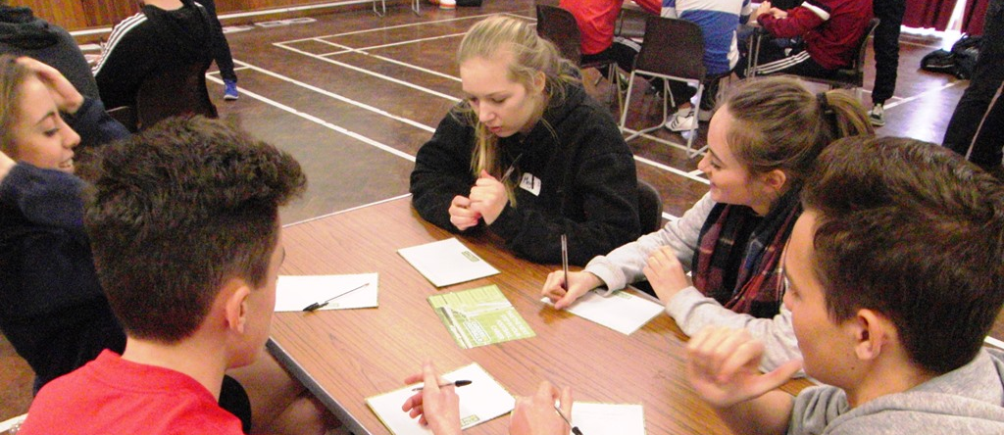
“Creating a united grassroots environment which delivers football opportunity for all”

Thank you for your interest in becoming part of our Board. Football is the most popular sport in the UK and we’re delivering great experiences across Essex.  The Essex County FA are one of the largest County FAs in the country for football participation, with more than 4,200 teams playing football in Essex. The Essex County FA ‘Moving Forward’ and FA National Game Strategies for 2018-2021 outline our strategic direction to create a united grassroots football environment which delivers football opportunity for all.  One of those strategic objectives is to ensure our corporate governance structure is operating effectively and efficiently, and we are seeking to recruit an Independent Director Board Member to support us in achieving that objective.  Whether you’re a life-long football enthusiast, player, volunteer, coach or a corporate professional looking to volunteer your expertise, we are committed to creating a Board of diverse skills, experience and backgrounds which can add value to the game.  We are running an open application process to attract and recruit the best person for the role. In this pack, you will find details of the skills and experience we are looking for, our organisational values and the process for applying. If you have any questions, please contact brendan.walshe@essexfa.com, our Chief Executive Officer. I am looking forward to reading your application.  Wayne Deller  Essex County FA Chairperson | Board Role Overview  The Essex County FA Board is tasked with the following key roles:  Act as leaders to develop, support and govern football across Essex  Monitor and evaluate the Essex County FA’s 2018-2021: Moving Forward Strategy  Ensure that the financial resources and people are in place for the County FA to meet its objectives  Provide effective controls which enable risks to be understood, assessed and managed  Provide monitoring and evaluation of success through effective performance management  Ensure that its obligations to its association members and others are understood and met  Commitment  Board Members are expected to commit, on average, between seven and ten hours per month.  This includes attending the monthly Board Meetings as well as being asked to lead and/or sit on advisory working groups.

Our Board Structure

The Board operates with five members and ensures the Essex County FA is effectively and efficiently run, with appropriate oversight and governance.

Chairperson
(Wayne Deller)

Director  (Andrew Chaplin) | Director  (Barry Fitzgerald) | Director  (David Emerton) | Independent Director  (Vacant)

Board Member Key Accountabilities

All Directors will hold collective responsibility for ensuring the Essex County FA Board is efficient and effective.

The following accountabilities apply to all Board Members.

Strategic | Constructively check/challenge/support the development of the County FA’s strategy  Support the development of plans and programmes which will deliver the strategy  Approve the annual operating and delivery plan
Ambassador | Be a positive ambassador for football in Essex, representing the County FA  Act as a positive voice for the work of the County FA with the media  Seek to expand public awareness of the work of the County FA
Performance | Monitor organisational performance against plans  Review and evaluate organisational performance against agreed objectives  Ensure efficient and effective corporate governance
Finance/Risk | Demand robust measures to ensure integrity of finances  Ensure systems of risk management and controls are in place  Approve annual operating and capital expenditure budgets
People | Determine and approve appropriate levels of resources to deliver the strategy  Use expertise, time and connections to support employees
Football | Act in the best interests of football in Essex  Develop and maintain critical key relationships with the various sporting partners  Continually seek to improve the sporting experience for all



Understand, New Innovations, Integrity, Teamwork, Excellence
Our Shared Values, Behaviours and Skills

Our values are at the heart of the Essex County FA. Applicants who can demonstrate the positive behaviours, approaches and skills will be at an advantage.

Values |  | Behaviours/Approach | Skills
Understand: We are supportive, empathetic and knowledgeable, using insight and data to drive decision-making | Supportive, Empathetic, Knowledgeable | Sensitivity, openness and awareness of others, high levels of self-awareness,  champions use of data and insight to drive decision-making | Able to assess and analyse complex information and identify potential problems, high ethical standards with sound judgement and ability to deal effectively with risk, able to skilfully handle conflict through to resolution
New Innovations: We are proactive and creative to improve existing formats of football and explore new ways of delivering the game | Inspiration, Creative, Commitment | A proactive, solution-focused and positive mind-set, demonstrates confidence, with the ability to gain respect and attention, acts with the future in mind and embraces innovation | Able to think independently and proactively to find solutions, able to analyse the current situation and identify future trends, able to identify new opportunities
Integrity: We are fair, honest, reliable and accountable and commit to “doing what we said we would do”, ensuring equality and diversity to develop football for all and making sure all those who wish to be involved are supported and encouraged | Trust, Honesty, Transparency, Ownership | Interested and inquisitive mind-set, resilient in times of challenge and change, takes ownership, holding self and others accountable | Capable of developing constructive relationships with key partners, able to act as a spokesperson of the County FA, politically astute, well networked and able to engage stakeholders
Teamwork: We work collaboratively and inclusively with each other, across all areas of the business, and with our partners across the game, to optimise all our opportunities | Focus, Challenge, Collaborate, Learn, Share, Feedback | Willingness to learn, challenge and change, determination and drive to succeed | Excellent listening skills, with the ability to appreciate differing perspectives and adapt to different situations, ability to communicate ideas effectively, both verbally and in writing, able to act as a sounding board and critical friend
Excellence: We aim to deliver high-quality football services, seeking feedback and constantly reviewing our work, to develop our services based on the needs of our community and individual customers | Customer Service, Attention to Detail, Hard-Working, Strategic,  High-Performing | Thinks critically with creativity and strategic awareness, performs highly, consistently and efficiently in-line with strategic aims of organisation | Ability to take the wider, strategic view and enable focus, able to check, challenge and champion the work of the County FA, strong commercial acumen with the ability to identify opportunities

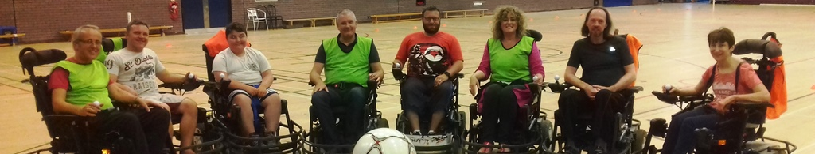
Independent Board Member: Role Description

The Essex County Football Association (ECFA) is on a mission to help more people play football in Essex. We are seeking an experienced individual with strategic thinking and leadership skills who can apply independent expertise to the ECFA Board.

Role Overview: The Independent Director will contribute to the ECFA Board, providing leadership and professional expertise which delivers against the key requirements:  - act as leaders to develop, support and govern the game of football across Essex  - monitor and evaluate the ECFA’s 2018-2021: Moving Forward Strategy  - ensure that the financial resources and people are in place for the ECFA to meet its objectives  - provide effective controls which enable risks to be understood, assessed and managed  - provide monitoring and evaluation of success through effective performance management  - deliver obligations to its association members  The Independent Director will need to allocate sufficient time to meet the expectations of the role, which is estimated at around seven to ten hours per calendar month. In addition to the main Board, the Independent Board Member will be asked to lead and/or sit on advisory working groups. This is a voluntary role and reasonable expenses will be paid.  Personal Specification: The Independent Director will add value to the Board through expert professional knowledge, business leadership, corporate experience and perspective. To support its ambitions, the ECFA is keen to receive applications from candidates with expertise in the following fields:  - Legal & Governance  - Commercial & Sponsorship  - Marketing & Communications  - HR, Safeguarding & People Development  Expertise/Qualifications: Qualified and experienced professionals, with leadership expertise in their specialist field  Experience: A depth and breadth of experience in a specialist area and in organisational leadership  Knowledge: A thought leader within their specific subject matter area  Skills: Able to translate professional expertise to the ECFA context and add value through perspective | 

Independent Director Accountabilities

Working in partnership with other Board Members, the Independent Director will contribute to the effective and efficient governance of the ECFA.

As well as providing overall strategic input and organisational leadership, they will utilise their professional knowledge and expertise, advising the Board and Executive on best practice approaches within their specialist area.

Strategic | Act as a strategic adviser to the Board and Executive on area of specialist expertise
Ambassador | Seek out and utilise business connections to build partnerships to support delivery
Performance Evaluator | Ensure best practice performance management is embedded in area of expertise
Finance & Risk | Advise on finance and risk elements related to area of expertise
People Leader | Add value to the Executive, acting as a subject matter expert and mentor on area of expertise
Football | Whilst an interest in football and/or sport is an advantage, previous experience of working within sport is not a requirement

Application Process

All we need from you at this stage is three things: application form of key information, copy of your curriculum vitae (CV), Section 12 Equality & Monitoring Form

Application | > | Interviews | > | Selection | > | Induction
* complete the application form  * complete the Section 12 Equality & Monitoring Form  * attach your CV  * send to the County FA by the deadline of 10:00am on Monday 23rd July |  | * shortlisted candidates will be asked to interview by Friday 27th July  * interviews will be held during August |  | * candidates will be notified of the outcomes by Friday 14th September  * in-line with good governance practice, we may ask for references, further information and declarations at this stage |  | * induction training will be provided


APPLICATION FORM



Position Applied For | Independent Board Member
In no more than 200 words, please tell us why you are interested in becoming a Board Member
In no more than 200 words, please tell us the key skills you feel you would bring to the Board
Please tell us about any special needs/adjustments we can make to enable you to take part
Have you previously been involved in the ECFA Board or Council? If yes, in what capacity?
Do you have connections to any current ECFA Board/Council Member or employee? If yes, who?
Are you aware of any potential conflicts of interest? If yes, please tell us more

THE INFORMATION YOU SUPPLY ON THIS FORM WILL BE TREATED IN CONFIDENCE

Section 1: Personal Details

Surname |  |  | Forename
Address |  |  | Home No
 |  |  | Mobile No
Postcode |  |  | FAN (if know)
Email Address |  |  | National Insurance No

If you are successful you will be required to provide relevant evidence of the above details.
Section 2: Present Employment
If now unemployed please give details of last employer:

Name of Employer |  |  |  |  | Job Title
Address |  |  |  |  | Date of Appointment
Postcode |  |  |  |  | Department/Location
Salary
Brief Description of Duties (continue on a separate sheet if necessary):
Period of Notice |  |  |  | Last Day of Service (if no longer employed)
Reason for Leaving (if no longer employed):

Section 3: Previous Employment
Most recent employer first.

Name of Employer
Address
Postcode
Position Held
Start Date |  | End Date
Summary of Duties
Reason for Leaving

Name of Employer
Address
Postcode
Position Held
Start Date |  | End Date
Summary of Duties
Reason for Leaving

Name of Employer
Address
Postcode
Position Held
Start Date |  | End Date
Summary of Duties
Reason for Leaving

Section 4: Education
Qualifications obtained from schools, colleges and universities. Please list the highest qualification first.

College or University | Start (MM/YY) | Completed (MM/YY) | Course | Qualifications and Grade Obtained

School | Start (MM/YY) | Completed (MM/YY) | Subjects | Qualifications

Professional Qualifications | Course Details (Level/Pass Date)

Section 5: Training and Development
Please give details of any training and development courses or non-qualifications courses which support your application. Include any on the job training as well as formal course.

Title of Training Programme or Course | Duration of Course
Are you a member of the FA Licenced Coaches’ Club?

Section 6: Personal Statement
Skills, knowledge and experience. Please use this section to explain, in detail, how you meet the requirements of the Job Description. If you are, or have been, involved in voluntary/unpaid activities, please include this information. Attach and label any additional sheets used.

Section 7: Rehabilitation of Offenders Act (1974)

Do you have any convictions which are unspent under the Rehabilitation of Offenders Act (1974)?
If yes, please give details/dates of offence(s) and sentence:

Section 8: Protecting Children and Vulnerable Adults

This following information may be required if the post you are applying for requires a Disclosure and Barring Service (DBS) police check.

Are you aware of any police enquires undertaken following allegations made against you, which may have bearing on your suitability for this post?

Section 9: Disability Discrimination Act
The Act protects people with disabilities from unlawful discrimination. We actively encourage applications from people with disabilities. The Disability Discrimination Act defines a disabled person as someone who has a physical or mental impairment which has a substantial and adverse long-term effect on his or her ability to carry out normal day-to-day activities.

Do you have a disability?
If yes, please give details

We will try to provide access, equipment or other practical support to ensure people with disabilities can complete on equal terms with non-disabled people.

Do we need to make any specific arrangements in order for you to attend the interview?
If yes, please give details

Section 10: References
Please give the names and addresses of your two most recent employers (if applicable). If you are unable to do this, please clearly outline who your referees are.

Reference 1 |  |  | Reference 2
Name |  |  | Name
Position |  |  | Position
Work Relationship |  |  | Work Relationship
Organisation |  |  | Organisation
Address |  |  | Address
Postcode |  |  | Postcode
Telephone Number |  |  | Telephone Number
E-Mail |  |  | E-Mail

Are you willing for this referee to be approached prior to the interview? |  |  | Are you willing for this referee to be approached prior to the interview?

Section 11: Declaration
Signed |  | Date

Please send this form, along with a copy of your CV and the Section 12 Equality & Monitoring Form, to: brendan.walshe@essexfa.com by 10:00am on Monday 23rd July. By submitting your application you confirm that, to the best of your knowledge, the information provided on this form and on your CV is accurate.


SECTION 12: EQUALITY AND DIVERSITY MONITORING FORM

The Essex County FA is committed to making football accessible to all, ensuring that equality and diversity is at the forefront of its thinking when delivering a comprehensive service to Essex football.

We hope you will help us by completing this form, but please be aware that completing the form is entirely voluntary and, if you chose not to complete it, this will not affect your application.

Why Do We Want This Information?

- Asking you for this information makes the Essex County FA workforce more representative. It supports us to ensure our programmes are inclusive and open to everyone, it helps us understand if people from certain backgrounds are not accessing or making the most of opportunities to be involved in football and it helps us to make sure we provide such opportunities in the future
- Only people analysing this data will have access to it and, in-line with diversity, monitoring, good practice and legislation, all the information is collated anonymously

Information provided on this form does not form part of our decision-making process and will not affect your application for registration. Although you are not required to fill in this form, we would like to encourage you to do so because receiving enough information will mean we can undertake robust analysis to ensure our processes are fair, or to make changes to how we work.

You are welcome to select ‘Prefer Not to Say’ if you would rather not share the information about yourself. It is more helpful to us if you select the ‘Prefer Not to Say’ option rather than not to complete, or partly complete, this form. Please complete the form by selecting the appropriate option and return it to us.

Gender
Age
Sexual Orientation
Religion/Belief
Ethnicity

Disability

Under the Equality Act 2010, disability is defined as a physical or mental impairment that has a substantial and long-term adverse effect on the ability to carry out normal day-to-day activities. Substantial means more than minor or trivial. Impairment covers, for example, long-term medical conditions such as Asthma and Diabetes, and fluctuating or progressive conditions such as rheumatoid Arthritis or Motor Neurone Diseases.

A mental impairment includes mental health conditions (such as Bipolar Disorder or depression), learning difficulties (such as Dyslexia) and learning disabilities (such as Autism and Down’s Syndrome). Some people, including those with Cancer, Multiple Sclerosis and HIV/AIDS are automatically protected as disabled people by the Act.

Do you consider that you meet this definition?
If other, please state which

