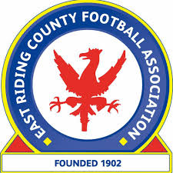
ERCFA Referee Safeguarding Requirements
This document will clearly provide you with the Safeguarding requirements you are expected to have in place when you register as a referee, we politely remind that it is the referees own responsibility to ensure that the below qualifications are valid at all times;

FA DBS (CRC) – Each referee participating in Youth Football must have an in date, FA DBS. You won’t be able to complete your registration prior to the start of the season if you do not have this in place. Once you have completed your CRC, they last for three years before needing to be renewed. This also applies to coaches, observers and mentors of whom are operating below supply leagues. For all information regarding CRC’s, please contact steve.lazenby@eastridingfa.com
FA Safeguarding Workshop - Each referee participating in Youth Football must have an in date, FA Safeguarding Workshop qualification. You won’t be able to complete your registration prior to the start of the season if you do not have this in place. Once you have completed the three hour workshop, they last for three years before needing to be renewed. Once you have complete the workshop you should never need to attend one again as it can be renewed online. This also applies to coaches, observers and mentors of whom are operating below supply leagues. For all information about the FA Safeguarding Workshop, please see our courses page on the website - https://bit.ly/2DXaV8b
Under 18’s Linked FAN – Every referee under the age of 18 is required to have their FAN Number linked with their parent or guardians FAN Number. You will already have received this information from the Referee Development Officer explaining the quick and straight forward process to do this. Feel free to email will.dodds@eastridingfa.com for more info.
ERCFA Designated Safeguarding Officer Details
Name: Steve Lazenby
Working Hours: Monday – Friday, 9:30-4:30
Email: steve.lazenby@eastridingfa.com
Telephone: 01482 221158 | 07795690491

