ERCFA CUP FINALS
MATCH OFFICIALS SEMINAR

Tuesday 25th February 2020
The Pavilion,
Hull University

Introduction & Welcome
As Leader of the ERCFA Referees Development Group, it gives me great pleasure to welcome you to this important seminar as part of the Education and Training Programme provided to you on behalf of the ERCFA.
I always feel very excited at this time of the season. There are really important League and Cup Games coming up and there is nothing like being involved in such important games. Whether it’s a semi-final or final the stakes are high, the expectations are enormous. Teams have fought hard to get to this stage of a competition and as match officials we owe it to every single player, manager and supporter to be mentally and physically ready.
This seminar offers you an opportunity to start your preparations for such important games. Don’t leave it too late as games are coming think and fast.
Looking at the programme you will cover important subjects such as the role of Assistant Referees, teamwork, decision making and pre-match instructions.
At the moment you might not know what role or match{s} you have been appointed to, however you soon will. Whatever role you have been asked to perform please remain professional at all times, assist and help your team mates and above all else ENJOY these very special moments.
Good Luck to you all.

Ian Blanchard
Leader of the ERCFA Referees Development Group

Programme

6.30pm Welcome and Opening Ian Blanchard

6.35pm Overview of Programme Ian Blanchard

6.40pm Guest Speaker
“Managing the BIG Occasion”

7.15pm Workshops 2 x 20 mins
a) Role of Fourth Official Gary
b) Pre – match Instructions Phil Cartlich

8.00pm Outside Technical Sessions
Group split into 2 groups.
AR techniques Wayne Grunill & Matty Wright

8.45pm Announcement of Games

9.00pm Questions & Close

The Assistant Referees

It’s worth reminding ourselves about the important roles AR’s (Assistant Referees) have. Any referee will tell you that quality AR’s, who understand the game, give themselves thinking time and help and support the referee are invaluable.

This brief section is designed to reinforce key aspects of Law 6. Don’t forget there is a lot more advice for AR’s on positioning, movement, communication etc. contained in the Practical Guidelines section of the Laws of the Game.

Assistant Referees indicate when:

- The whole of the ball leaves the field of play and which team is entitled to a corner kick, goal kick or throw in.
- A player in an offside position may be penalized
- A substitute is requested
- At penalty kicks, the goalkeeper moves off the goal line before the ball is kicked and if the ball crosses the line

The AR’s assistance also includes monitoring the substitution procedure

The AR may enter the field of play to help control the 9.15m distance.

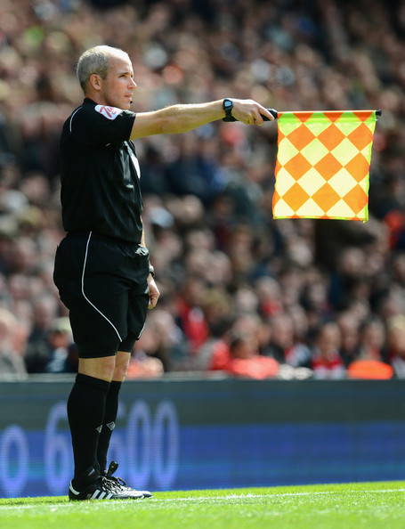

Decision Making

Refereeing is a process driven sport. Yes we need to be physically fit but equally important is the ability to think straight, weigh up what has happened and then make clear, informed and correct decisions. In refereeing we use a number of different PROCESSES in order to come to and make the right decision. This is just one example.

Teamwork

- Expectations - The pre- match instructions provided will be your expectations; this will show how the referee expects you to do your job. If you have any queries or questions just ask the referee. The referee will expect you to support him/her though everything you do during the day.
- Arrive and Leave as a Team - You are a team from beginning to end, don’t forget that, arrive and leave together. You will really look like a team if you all are always together. This is also important if there are any disciplinary issues (it happens even after the game!)
- Know your role:
  - Referee – You are in charge
  - Assistant Referee – You are there to assist no insist
  - Fourth official – You are there to support

You have all been appointed to these games on merit, you deserve to be here. You are also capable of undertaking the position in the team of which you have been appointed.
If you are the referee lead the team, make it clear to everyone you are the leader, shake hands with managers first, tell the assistants and fourth official what you want of them or what you are doing next. E.g. pitch inspection, getting a drink, going for a warm up. Your team members will be following your instructions and you on the day.

- If you are an assistant referee / 4th official listen very carefully to the referee. instructions, let them lead, you may be older, more experienced and have done this before however they are in charge today. Assist don’t insist you are there to support the referee so do so, don’t throw him/her under the bus, help as much as you can and support each other you will get this in return.
- Support - You need to support the referee as best you can, while maintaining credibility, you should not be giving penalties from the half way line, the referee will be in a much better position to do so. However, when justified offer you opinion and help the referee, they will go through this in their pre-match instructions to you. Assist don’t insist. Don’t defend the indefensible, but say something like I have the same angle that you have but the referee is in a better position.
- Eye to Eye Contact - When possible look at the referee / assistant referee plenty of eye to eye contact especially when the ball in in their vicinity and you need their help. This will stop cross flags and will allow you to look like a team. You will get through every game successfully if you work effectively as a team.
- Communication - Communicate clearly with you team members and ask questions if you do not understand. When on the pitch give concise information, for example number 10 red, punched number 3 blue in the face, violent conduct red card. This gives the information that the referee wants not describing everything that has happened the referee wants to know the details of what action he/she needs to take and a reason.
- Use all information you have - If you need to go across and discuss something with your assistant do so. You both may have half of the information to put a full picture together, don’t just assume that one is right and one is wrong. Look at the recent Jon Moss Incident, they both had different parts of the jigsaw you need to put them together to get the right outcome.
- Back your colleagues - Support your colleagues in each decision they make, you are a team their decision is your decision. You can disagree; just don’t throw your colleagues under the bus. Give a diplomatic answer.
- Enjoy it! - It’s a privilege to the officiating in one of these games so enjoy it!

Pre- Match Instructions

It is imperative that all referees offer their team an insight into what they require from each team member. Your pre-match instructions need to be delivered with just your team there, no one else earwigging or listening in.

Where and when is up to the Referee. But allow sufficient time to give your instructions and ask if there are any questions.

As a guide you will need to cover the following:

- Senior AR
- Reinforce the need for cooperation, collaboration and solid teamwork
- Offsides’ – remember referees also have an important part to play, especially when identifying tight offside situations to decide whether a player is interfering with an opponent or if a player has played the ball
- Corner Kicks, Throw Ins etc.
- Fouls – Distance from play, angle of view and appropriate signal
- Penalty Kicks
- Keeping a Record of the Game
- Extra Time roles
- Kicks from the Penalty Mark

Listen to these very carefully, the referee wants you to follow these instructions they are asking you to do something in such a way for a reason. You may have heard 100 pre- matches however you need to listen to this one. You may not have worked with the referee before, he might want more or less help than usual, you need to tune into this.
You must take note of any requirement for extra time and penalties, these are vital and obviously don’t happen often in other games but can be crucial in a cup game. Lots of issues occur around these areas. E.g. making a sub at the end of extra time, not evening up the number of players. Read the laws on this so you can answer any queries!

Role of the 4th official

The 4th Official has an active role to play in assisting and helping the referee and their team. It is not just an observational role, it requires elements of management, control, courage and relationship building.

There are some key responsibilities of the 4th Official, they include:
- To assist the match officials throughout the game, if you require assistance, acquire the match referee’s attention at an appropriate time
- Follow your colleagues pre-match instructions in relation to your role
- Ensure the number in the technical area, corresponds to the team sheet and the guidelines are adhered to throughout the game. (These are on display in both changing rooms and referees room)
- Ensure substitutes warm up in the correct area
- Supervise the substitution procedure
- Checking a players/ substitutes equipment
- Assist the re-entry of the player following a signal/approval from the referee
- Supervise the replacement balls
- Indicate the minimum amount of additional time the referee intends to play at the end of each half (including extra time)
- Inform the referee of irresponsible behaviour by any of the technical area occupants

TECHNICAL AREA GUIDELINES

It is vitally important that Fourth Officials are aware of their responsibilities concerning the Technical Areas. Managers, coaches have been informed of this guidance and there is a clear mandate from everyone at the ERCFA, that all parties should act and behave in a responsible manner.
The Fourth Official is asked to work with key personnel in the Technical Area and remain vigilant and act appropriately should anyone not adhere to the advice/guidance offered.

- All occupants must behave in a responsible manner
- All Occupants must remain seated at all times
- Maximum number 8 occupants including substitutes, Manager, Coach, Physio and 5 subs
- Occupants of the Technical Area identified prior to the start of the match
- Must remain within the technical area except in special circumstances
- Manager /coach allowed to stand and convey tactics from within the technical area

NB. No persons other than those identified on the team sheets are allowed in the technical area.

