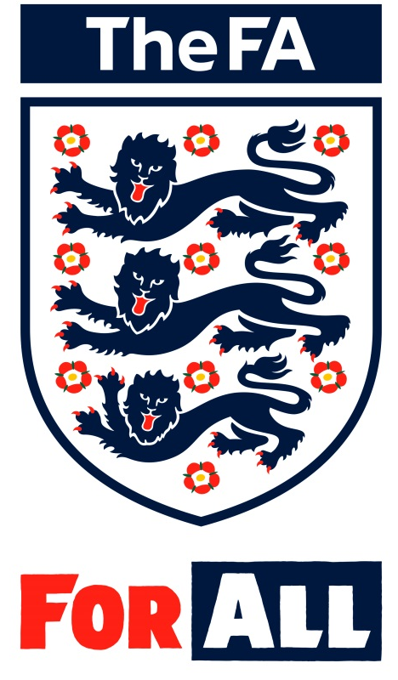

The FA Level 3 (UEFA B) in Coaching Football

Durham FA course application

2020 - 2021

FULL Name:

POSTAL ADDRESS: (Please note you MUST reside in Durham County. Durham FA reserve the right to refuse entry to the course for any coach not residing in the County of Durham or giving a false address).

FAN number: (MUST BE INCLUDED)

Email Address:

Team Name:

Age Group:

Game Format: 11 v 11; 9 v 9; 7 v 7 (Please delete as appropriate).

Do you hold a current and valid FA Level 2 (Feedback from Tutor on sign off or Completed Assessment Form must be included with this application)?

I acknowledge that all course dates MUST be attended as stipulated below:

There will be 2 further Touch Points to be confirmed (expected to attend for additional support prior to the course starting).
UEFA B BLOCK 1
Monday 8th June 2020
Tuesday 9th June 2020
Wednesday 10th June 2020
UEFA B BLOCK 2
Thursday 3rd September 2020
Friday 4th September 2020
UEFA B BLOCK 3
Monday 7th December 2020
Tuesday 8th December 2020
2021
UEFA B BLOCK 4
Monday 19th April 2021
Tuesday 20th April 2021
By applying for the UEFA B course at Durham FA and sending in this application, I acknowledge that all information provided is accurate and true in relation to meeting the course pre-requisites.

Full name: Signed:

Date:

How We Coach
Supporting Statement: UEFA B application 2020 -2021
Please provide a written statement in relation to your strengths, suitability and reasons for applying for the UEFA B course during the season 2020-2021. (No more than 200 words).

