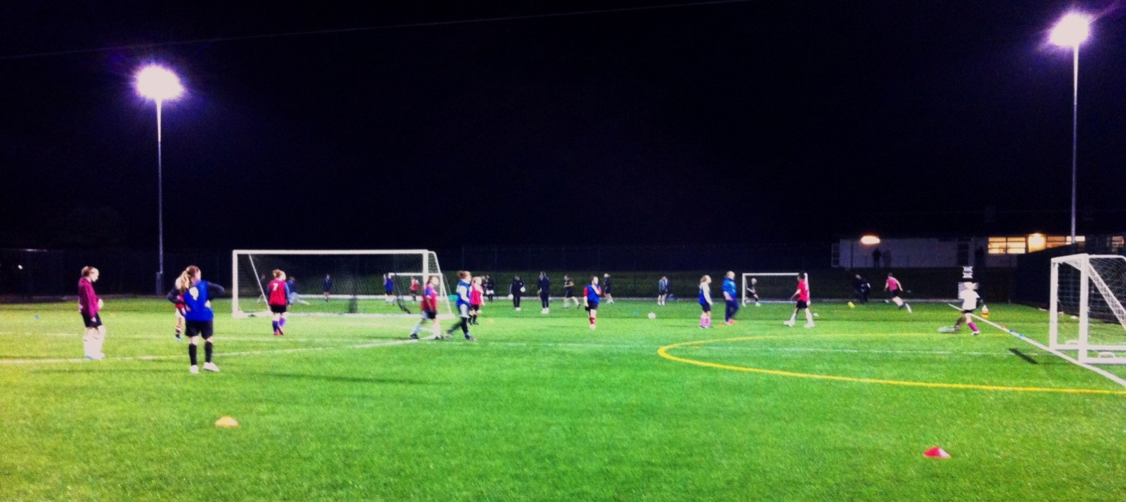**Cornwall FA Girls’**

Advanced Coaching Centre

**Open Trials 2018-19 Season**

Thursday 19th July (PHASE1)-6pm-8pm

Thursday 26th July (PHASE 2)-6pm- 8pm

*All trials held at **Brannel School** (St Stephens, St Austell PL26 7RN) *Registration will be from 5.30pm in the Sports Hub

*Please bring footwear for both grass (boots) and 3G (trainers/Astros)

**Thursday 19th July 2018 (PHASE 1)**

**Open trials**

Phase 1 is for girls wanting to trial for a place at the Advanced Coaching Centre 2018-19 who were not part of the Girls ACC in the 2017-18 Programme. We ask that players are nominated to attend a trial by their club or school, please note that all players are required to be registered with a club to be part of the programme.

**NB:** All players who have been successful in phase 1 of the trials will be notified by 5pm Tuesday 24th July, if you are not contacted by this time you were not successful on this occasion & will not be invited back to Phase 2.

**Thursday 26th July 2018 (PHASE 2)**

**Invite Only**

Players impressing at Phase 1 will be invited to the Phase 2 trials the following week. Here they will join the players who were part of the Advanced Coaching Centre during the 2017-18 Programme.

**NB:** All players who have been successful in the trials and are being accepted onto the 2018/19 Programme will be notified by 5pm on Monday 6th August, players who are not successful will be given feedback via email.

MC900129382[1]

**Trial Nomination Slip** Complete and return by Monday 16th July 2018 to register for trials.

**PHASE 1 PHASE 2**

**Important - We will acknowledge nominations via email. Please enter email address below:**

**Email:**

 EMAIL:

**Parent Email Address:**

**Player Name:**

**School:**

**Club (required):**

**Coach/ Teacher Name:**

**Preferred Playing Position (please tick):**

Goalkeeper Midfielder

  Defender Forward

**Address:**

**Date of Birth:**

**Postcode:**

**Contact Number:**

**Please list any medical details we should be aware of:**

**Please return to Grace Dent at the Cornwall FA in one of the following ways: Post** – Cornwall FA, 15 Callywith Gate, Launceston Road, Bodmin, PL31 2RQ **Email** [–grace.dent@cornwallfa.com](mailto:–grace.dent@cornwallfa.com)