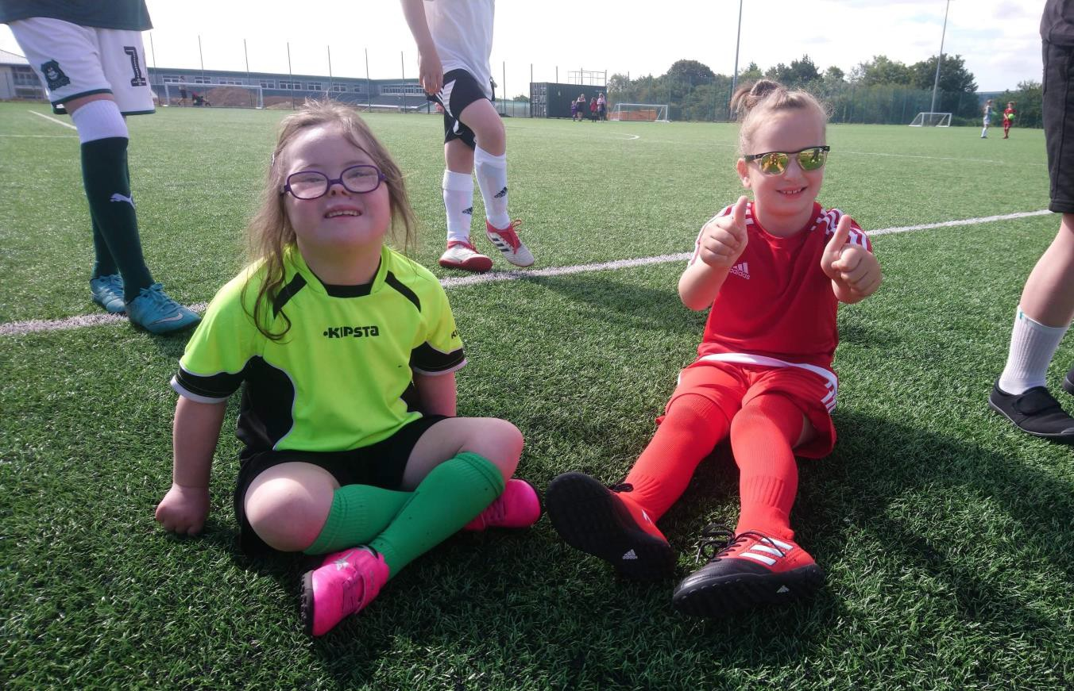
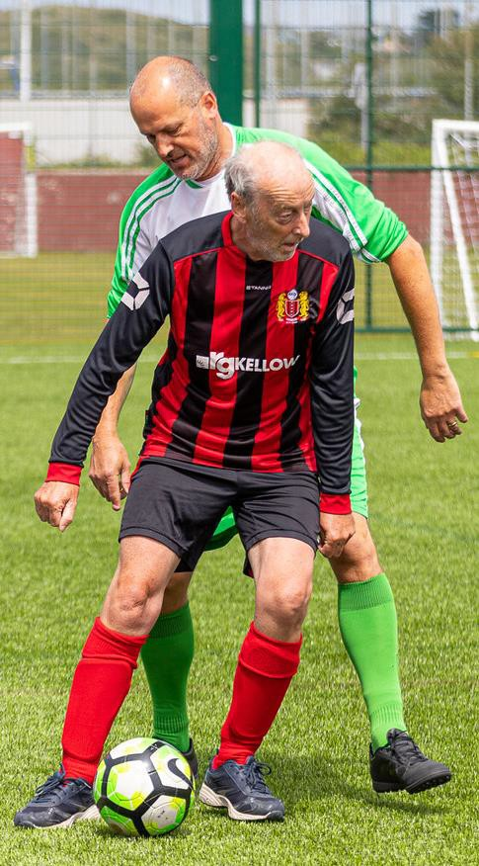

Cornwall County Football Association Diversity and Inclusion Action Plan
Updated: 04/12/2023

Football is for onen hag oll - 'one and all'.

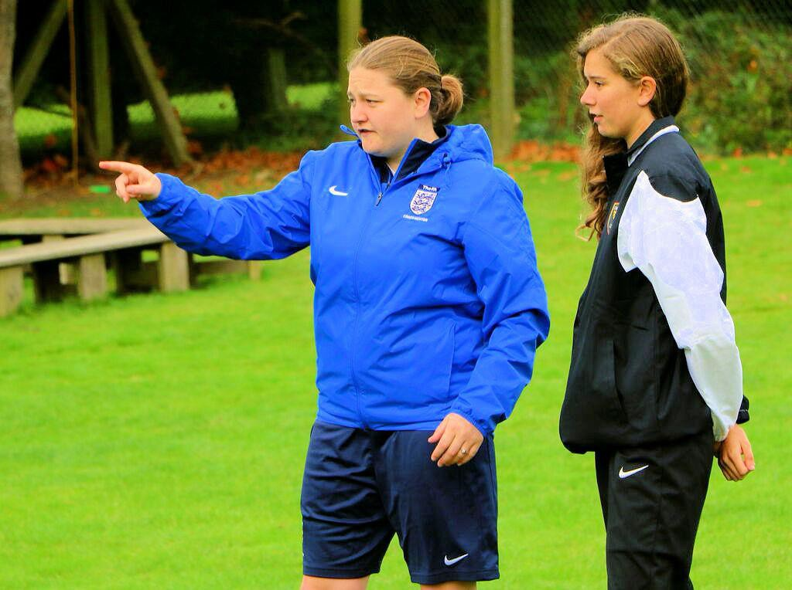
Purpose and Vision
To ensure that football is welcoming, inclusive and accessible for everyone throughout Cornwall. We are determined to challenge any perceptions and any barriers that get in the way of progress. We aim to be representative of the diversity of Cornwall and reflect that diversity within the football community. In Cornwall football is about belonging, Football is for onen hag oll - 'one and all'.

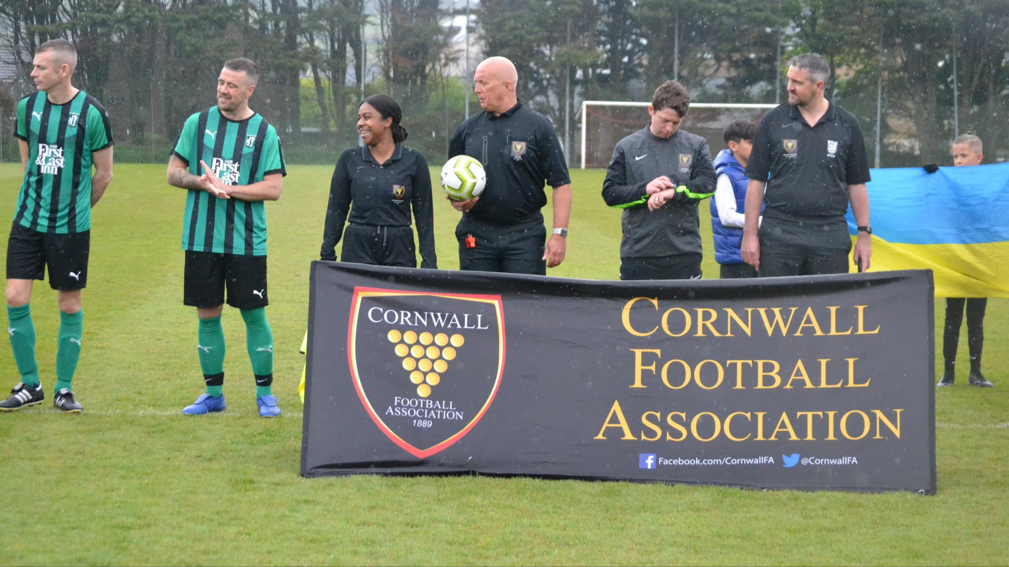

Responsibility
Inclusion is everyone’s responsibility, this means we need to, inform, involve, and engage colleagues, volunteers, referees, coaches, players, and supporters in our efforts. In much the same way as we have embedded safeguarding as a key focus of responsibility, to be successful, we will need to all come together for inclusion.
Our Diversity and Inclusion Action Plan
aims to:
Ensure all aspects relating to the everyday business of the Association is fair, accessible, and equitable
Work towards eliminating all forms of discrimination, harassment and other conduct prohibited by the Equality Act 2010
Reach out to wider audiences and communities to increase participation

Be dynamic and responsive. This plan is subject to annual review

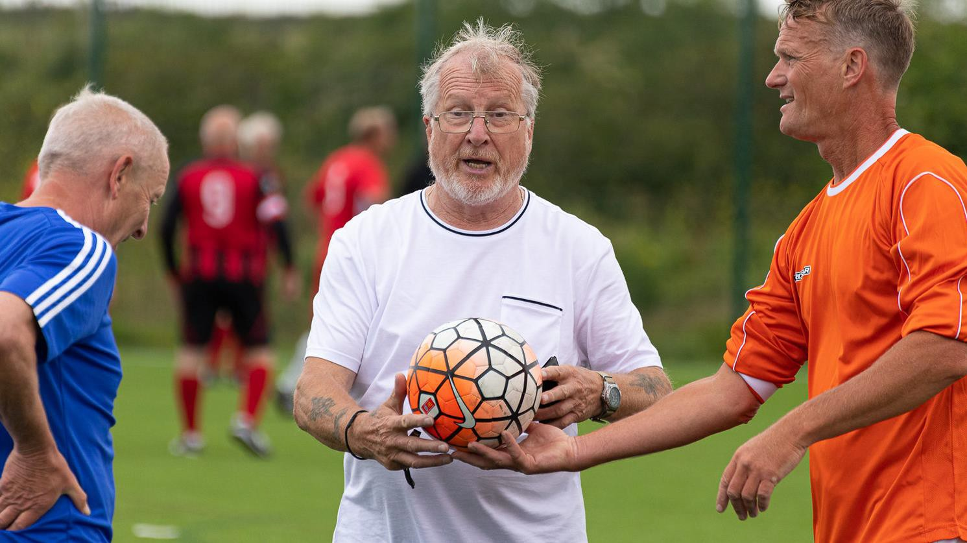

The Equality Action Plan is endorsed by the Chief Executive Officer, The Board, and the Inclusion Advisory Group. The plan will be delivered by the professional staff of the association and will be monitored and reviewed by the Inclusion Advisory Group.

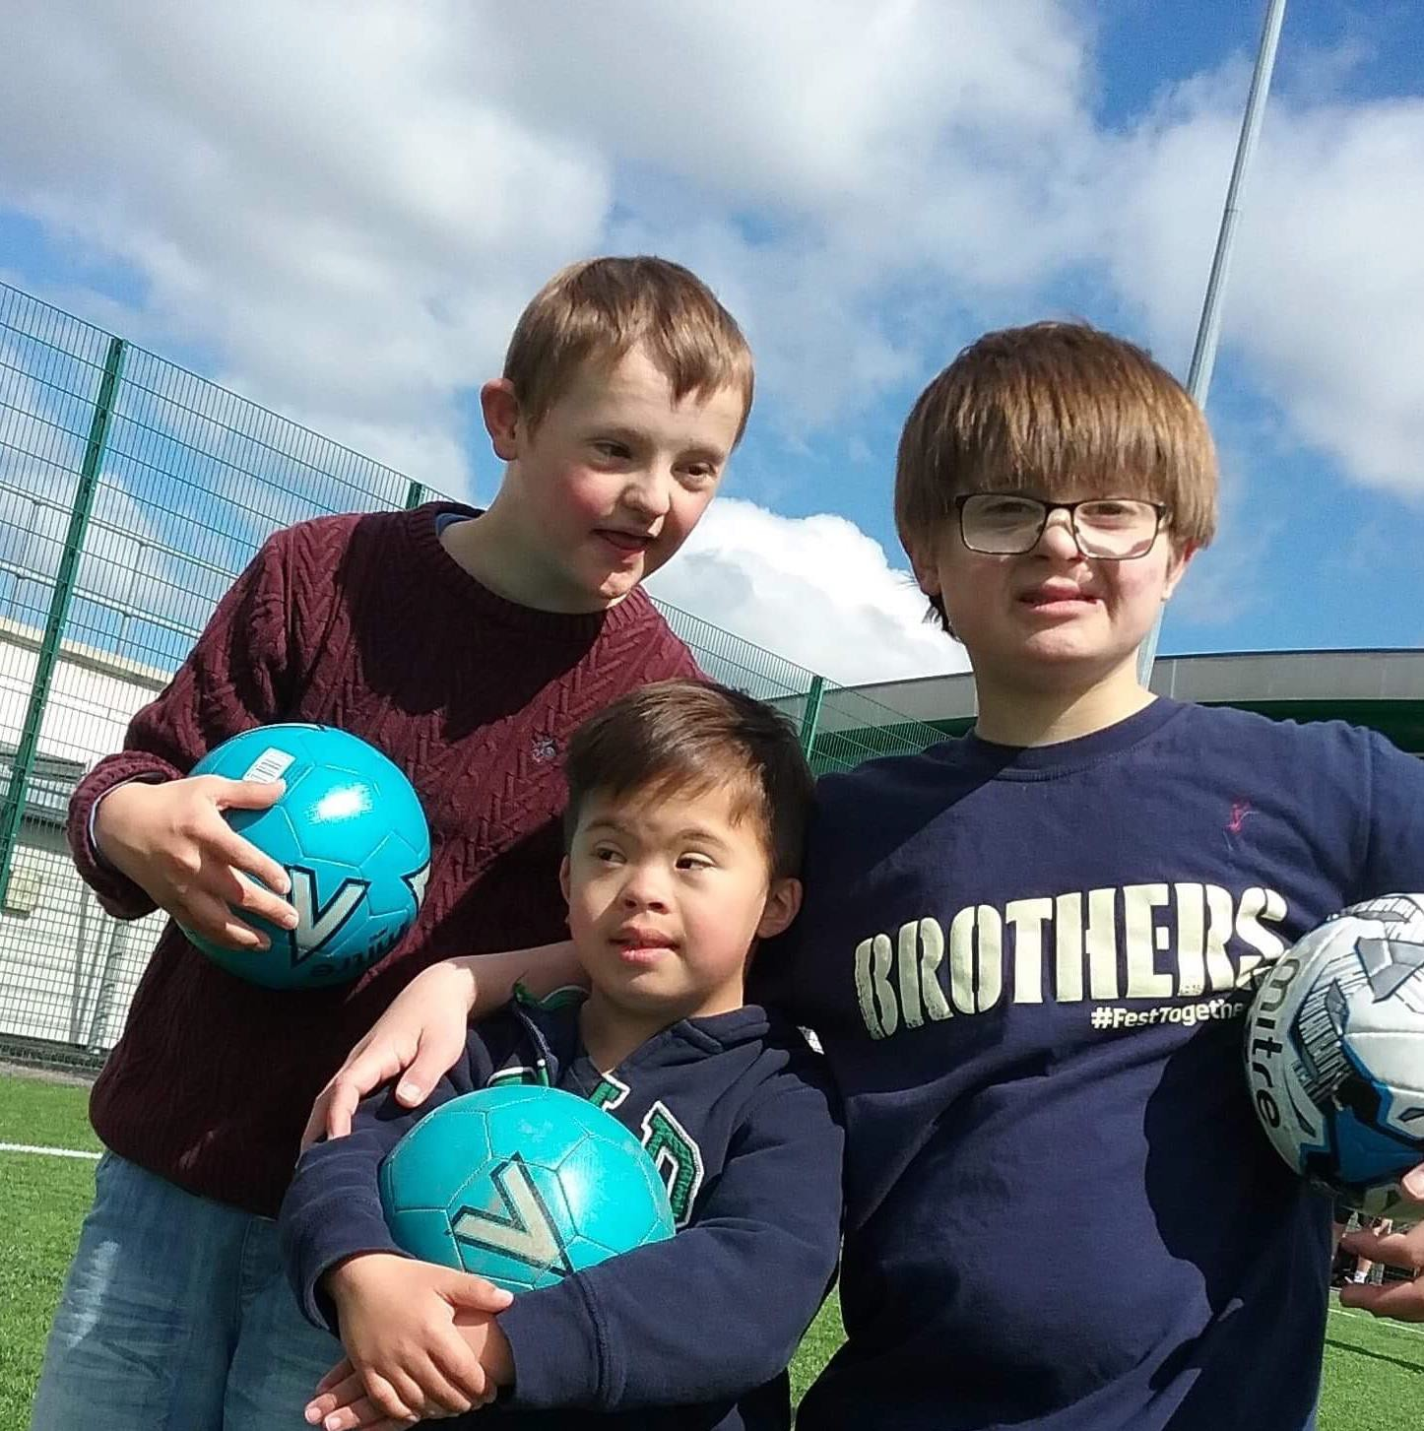
Cornwall FA Inclusion and Diversity Aims
Participation
Increase the participation rates of all forms of football, this includes players, coaches and officials, our aim is to create opportunities for people from all communities and backgrounds to take part in football.

Performance
Provide learning opportunities designed to upskill colleagues,
coaches and participants on inclusion and diversity related topics.

Use Cornwall FA’s channels and platforms to reach a wide audience,
to inform and communicate topics related to inclusion and diversity.
Profile
Seek opportunities to make our pitches more accessible, welcoming,
and inclusive for all who use them.
Pitches

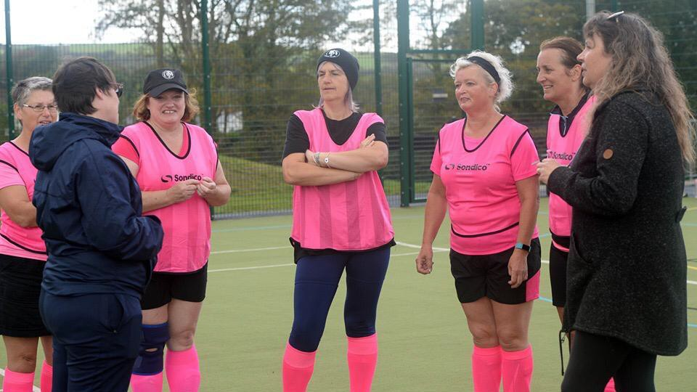
Cornwall FA Inclusion Advisory Group
The purpose of Cornwall FA’s Inclusion Advisory Group is to generate ideas, support activities and steer Cornwall FA’s inclusion action plan. Measuring and holding Cornwall FA to account in terms of its inclusion and diversity objectives.
Key Focus Areas for the Cornwall FA IAG and Cornwall FA:

Mental Health
Disability
LGBT+
Communities

Participation
Actions | Who?
Seek to partner with public health / council run or charity initiatives to encourage greater participation highlighting the mental health benefits of being active and being part of a team | Clubs
Expand disability league growing the numbers of participants by marketing the league and raising awareness | Staff and Board
Support existing clubs with joint centralised recruitment campaigns to ensure sustainability for the disability leagues,  aimed at attracting new players from all areas of the county. | Staff, Board and Clubs
Seek to collect data on disability in relation to current Referees, Coaches, Staff and Board | Referees, Coaches, Staff and Board
Seek to provide opportunities for disability players to be converted into disability league Referees and Coaches | Referees and Coaches
Seek to increase the number of participants particularly in terms of youth players with disabilities | Staff, Board and Clubs
Seek to collect data on LGBT in relation to current Referees, Coaches, Players and Staff/Board | All
Support current and create new Mini-Soccer teams by developing a Central Venue Mini-Soccer programme | Clubs
Support The FA's interventions targeting Early Years age groups | Clubs
Provide club/team support to fill gaps in the provision/pathway | Clubs
Support the creation of a new Walking Football (35+) representative group which will include 1 nominated member  from each affiliated team | Clubs
Support the Walking Football committee to create up to 3 turn up and play Walking Football sessions | Clubs
Offer Women’s Recreation football | Clubs
Offer Women’s Walking Football | Cubs
Aim to increase the diversity amongst Referees | Referees
Run Female only refereeing courses | Referees
Increase the number of female coaches | Coaches
Support and promote transition from school sport to community sport | Clubs
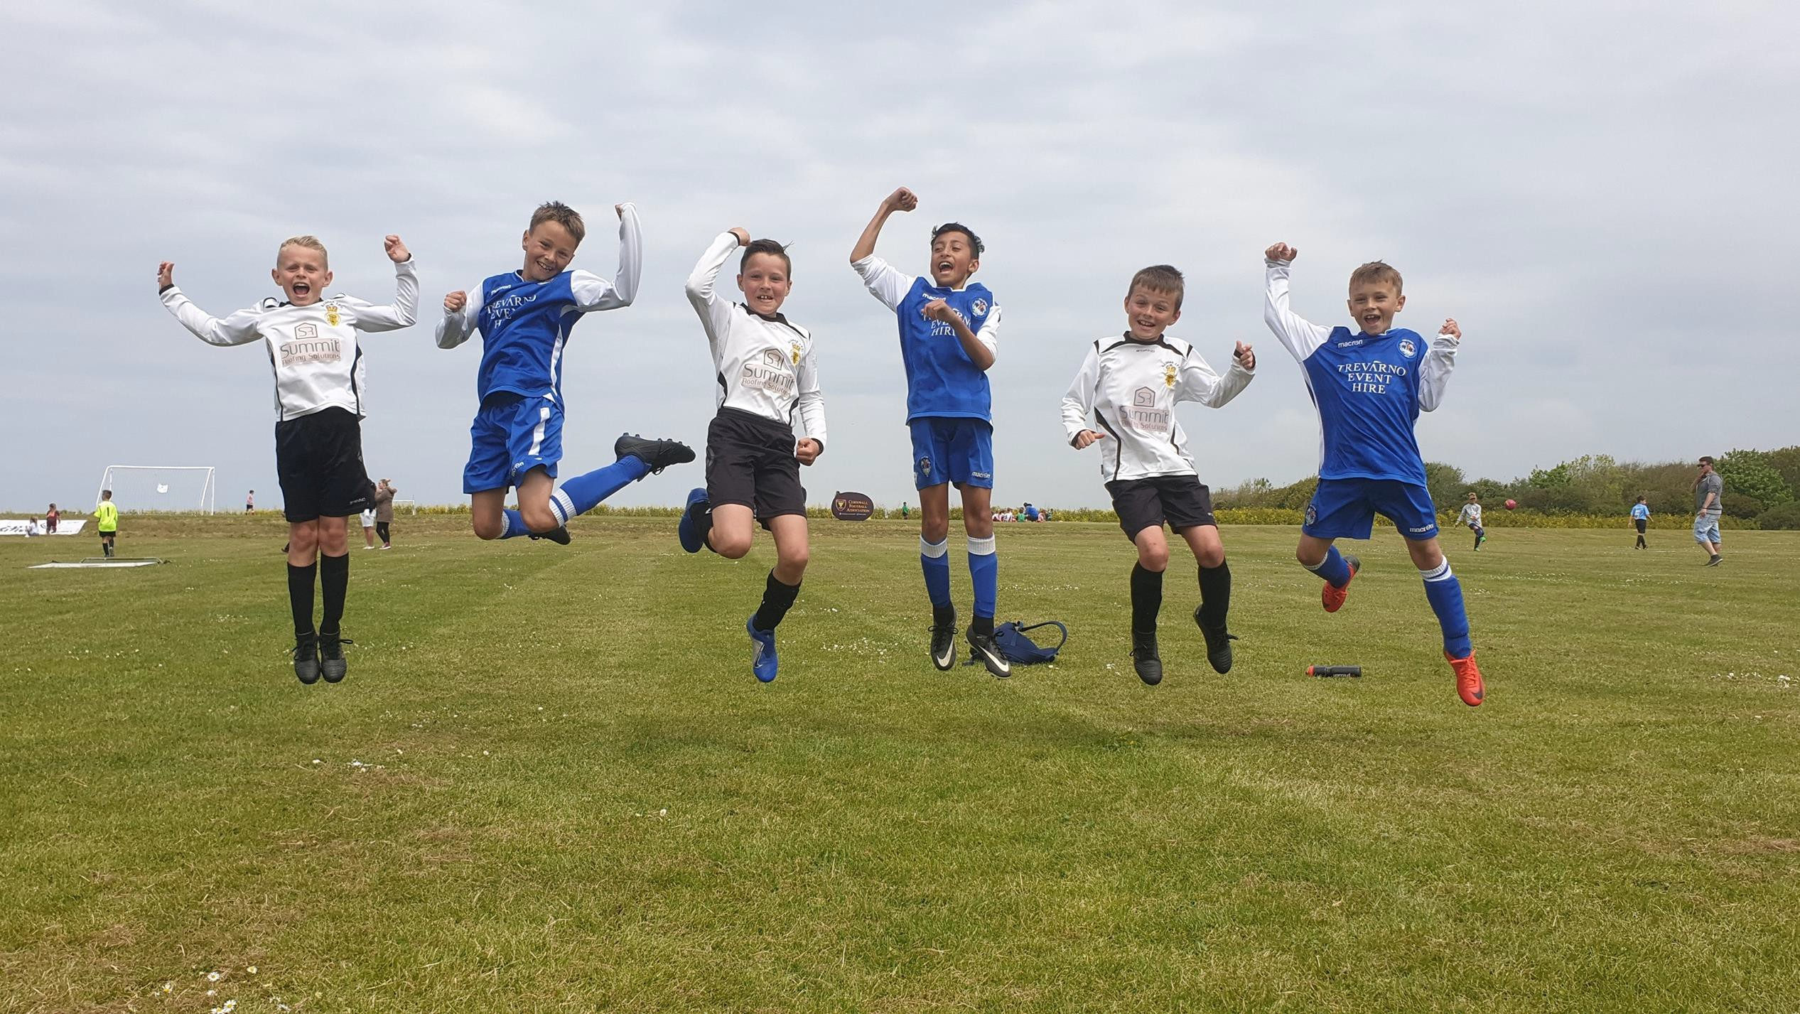

Performance
Action | Who?
Ensure that colleagues involved in communications are trained on accessible communications, utilising resources from British Dyslexia Association, government guidance and colour contrast ratio checkers | Staff and Board
Safeguarding vulnerable adults training to be completed by all Staff and Board | Staff and Board
Look for opportunities to provide work experience for learning disability participants | Staff and Board
Ensure the referees who are involved in the disability league have completed the refereeing disability football module | Referees
Conduct an inclusive language audit on CCFA policies and handbook | Staff and Board
Utilise FA tools to educate referees on inclusive language from a disciplinary perspective | Referees
Aim to engage every Youth Club/League in the County to improve the quality of our Youth Football environment | Clubs
Use PowerBi and the player registration system to study the trends for participation at various age groups to assist with the  transition from youth to adult football | Staff and Board
Barclays Girls Schools Football Partnership, develop and deliver a Cornwall Girls football schools’ strategy | Staff and Board
Ensure that we are doing all required to reach the Preliminary Level of the Equality Standard for Sport | Staff and Board
Ensure a robust process for reporting discrimination, supporting victims and improving confidence in The FA Judicial process, promote Kick It Out and FA reporting methods | Staff and Board

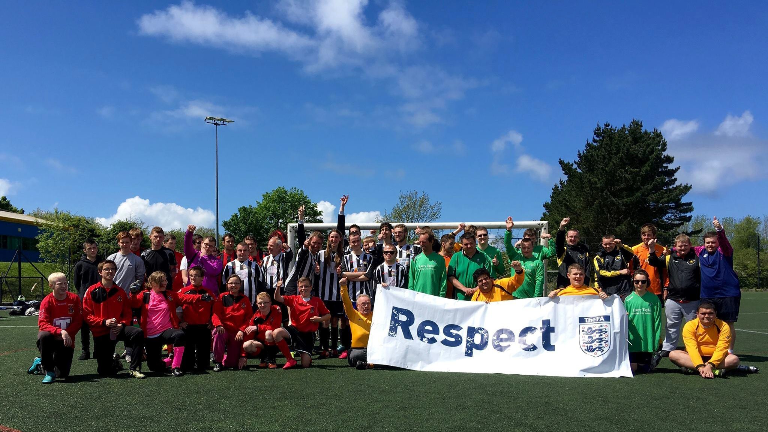
Profile
Action | Who?
Explore the possibility of having a stall or representation at Cornwall Pride events | Staff/ Board
Take part in the Stonewall rainbow laces campaign | All
Raise awareness of inclusive language, using FA guides | Clubs
Seek to partner with local media contacts to promote football as an inclusive sport in Cornwall | Staff and Board
Mental health content to be designed and delivered as part of on-going Referee training and engagement (utilising  the FA’s Mental Health Guidance notes) | Referees
Encourage conversations on mental health and wellbeing between mentors and newly qualified referees | Referees
Encourage conversations on mental health and wellbeing between coaches and players, ensuring coaches are  equipped with the tools to signpost players towards further support when necessary | Coaches
Mental health content to be designed and delivered as part of on-going Referee training and engagement (utilising  the FA’s Mental Health Guidance notes) | Referees
Ensure awareness raising content and communications are shared with Referees, Coaches and Clubs | Referees, Coaches and Clubs
Encourage conversations on mental health and wellbeing between mentors and newly qualified referees | Referees
Encourage conversations on mental health and wellbeing between coaches and players, ensuring coaches are equipped with the tools to signpost players towards further support when necessary | Coaches
Ensure awareness raising content and communications on disability are shared with Referees, Coaches and Clubs | Referees, Coaches and Clubs
Promote the FIFA Women’s World Cup and UEFA Women’s Euro Tournaments | All
Promote the Weetabix Wildcats initiative | All
Design and use promotional material that depict refereeing diversity | Referees
Promote of the benefits of creating a diverse and inclusive workforce that is representative of the wider society | All

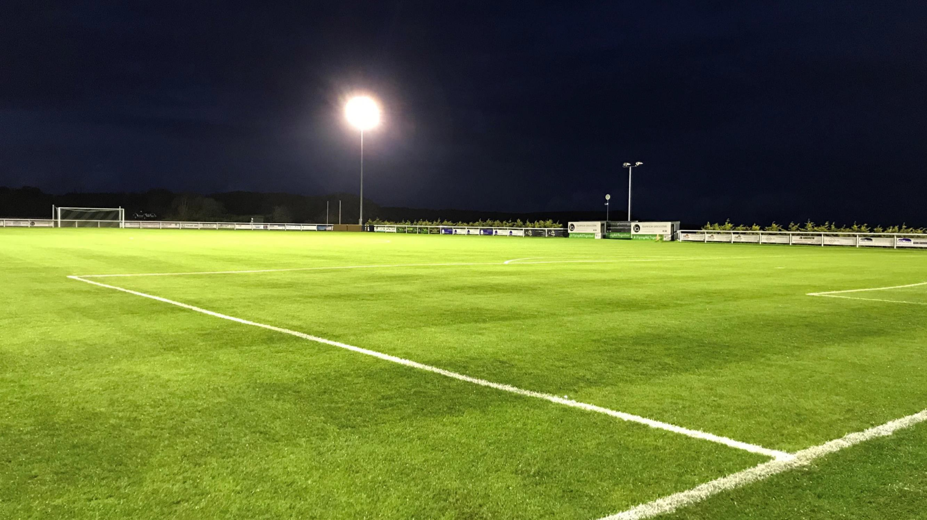
Pitches
Action | Who?
Provide inclusion and diversity awareness raising materials to be used in clubhouses and changing rooms | Clubs
Look for opportunities to widen the geographical reach of the disability league to include more areas of Cornwall | Staff, Board and Clubs
Support the Cornwall Power chair team in terms of facilities | Staff, Board and Clubs
Look for opportunities to play teams from other counties expanding the experience for players and coaches | Clubs, Coaches
Look for opportunities to widen the geographical reach of the disability league to include more areas of Cornwall | Staff, Board and Clubs
Support the Cornwall Power chair team in terms of facilities | Staff, Board and Clubs
Produce materials related to mental health to be used in club houses and changing rooms | Clubs
Identify and prioritise projects which support equal opportunities for women and girls | All
School and community projects. Ensure that every project in application development supports equal access for girls and women in school and community and that robust and ambitious development plans are in place to achieve this | All

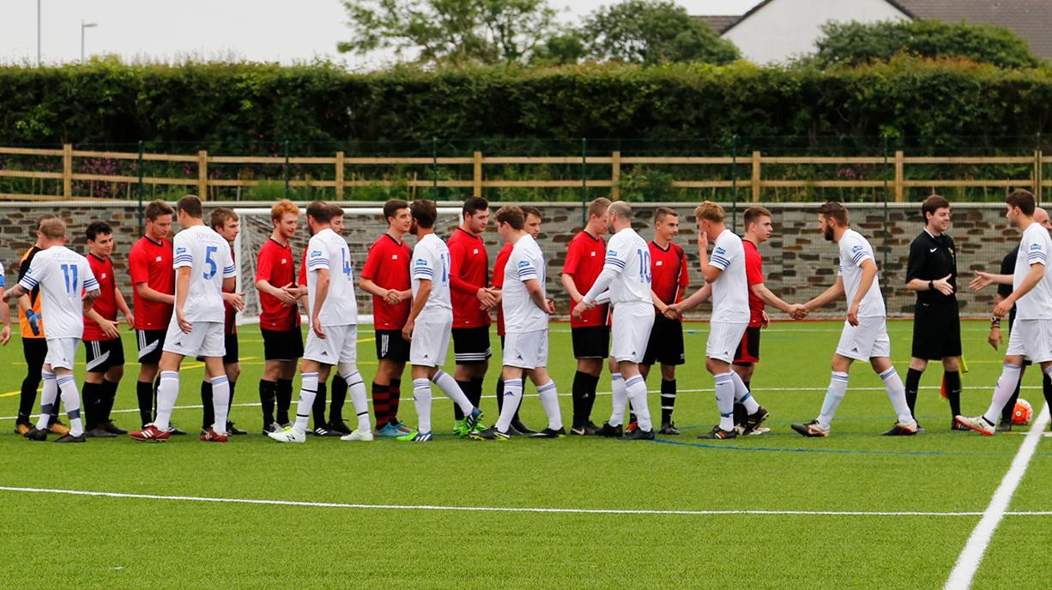
Our Targets and Intended Outcomes
Aim to maintain cultural and disability representative levels amongst the Board and Senior Leadership Team at 10%.

Maintain 100% of staff that feel the County FA is heading in the right direction with equality and diversity (in terms of the state of play survey).

Aim to maintain at least 30% female representation on the Board.
75% of respondents to the Cornwall FA Equality Survey indicating that they feel a sense of belonging within Cornish football.
100% of respondents to the Cornwall FA Equality Survey indicating that they know how to report discrimination.

100% of Board and Staff members to have completed the Cornwall FA Equality Survey.

10% of Cornish Football community to have completed the Cornwall FA Equality Survey.

100% of Board and staff to have completed I&D related training.

100% of all Recruitment board participants to have completed unconscious bias training.

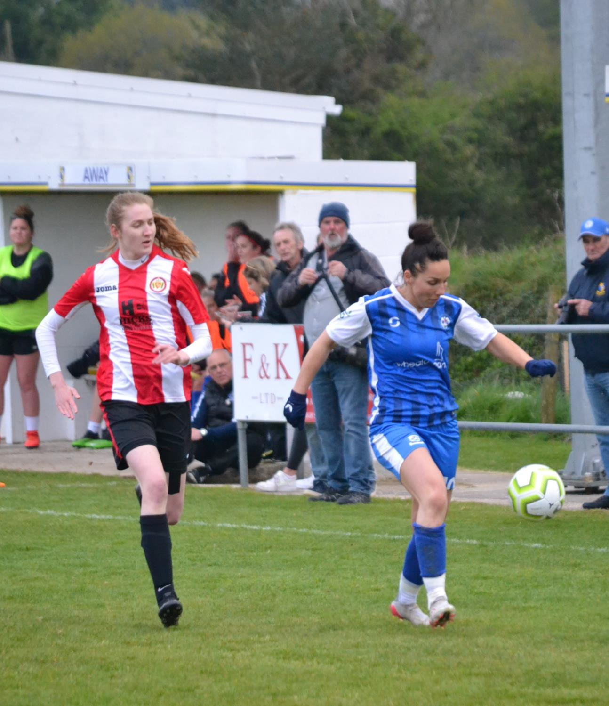

Key Performance Indicators (as of 06/12/23)
KPIs | Base line | Target 2023-24 | Current Position
# registered male players | 13,528 | 13,528 | 14,292
# registered female players | 1,642 | 2,135 | 2209
# registered disabled players | 128 | 176 | 186

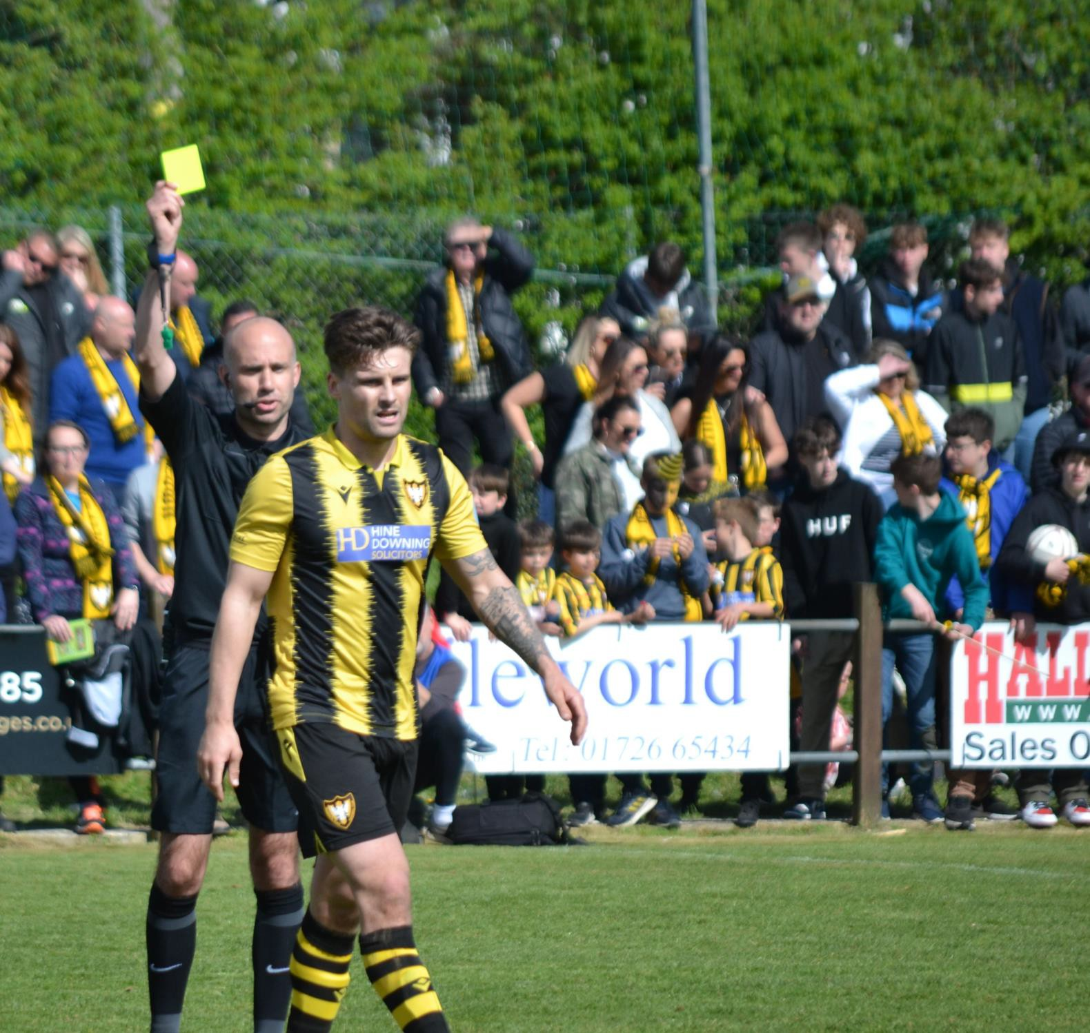

Key Performance Indicators (as of 06/12/23)
Referee Education and Development | Base line | Target 2023-24 | Current Position
1st March Baseline All Referees | 210
30th June 2022 Baseline All L5-L7 Referees | 170
Recruitment Measure Target | N/A | 53 | 43
Conversion Measure Target | N/A | 32 (60%) | 13
Retention measure target | N/A | 168 | 159
Progression measure target | N/A | 16 | 0

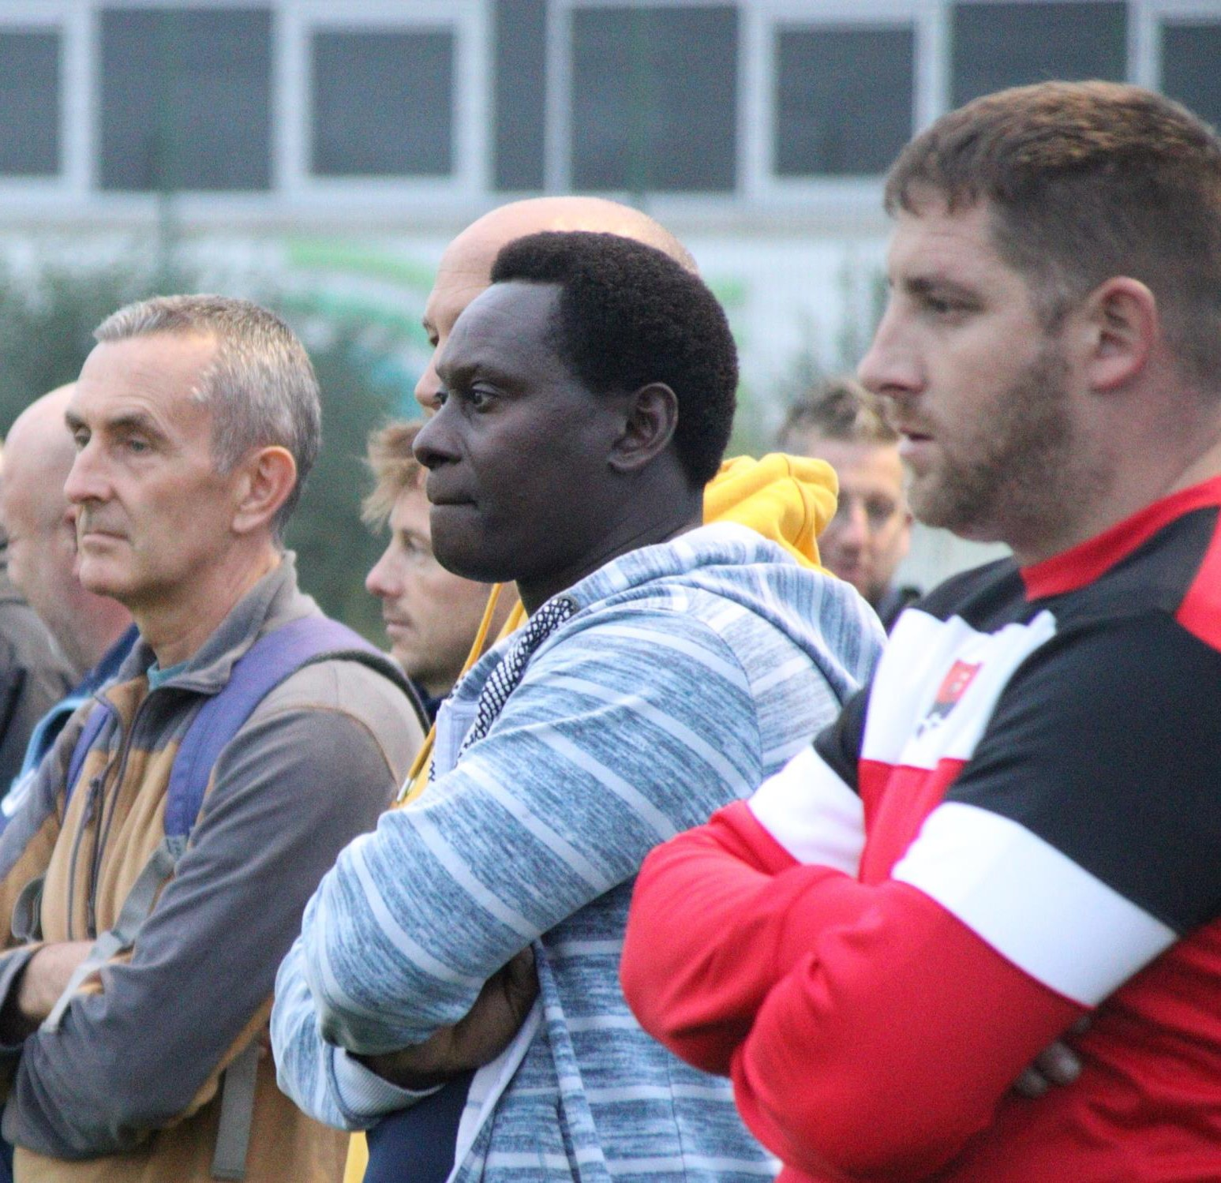

Key Performance Indicators (as of 06/12/23)
Coach Education and Development | Base line | Target 2023-24 | Current Position
1st March Baseline Youth Teams | 641 |  | 602
1st March Baseline YTWAQC | 88% | 90% | 85%
2023/24 CPD Target |  | 326 | 191
Quality Grass Pitches | 68 | 99 | 90

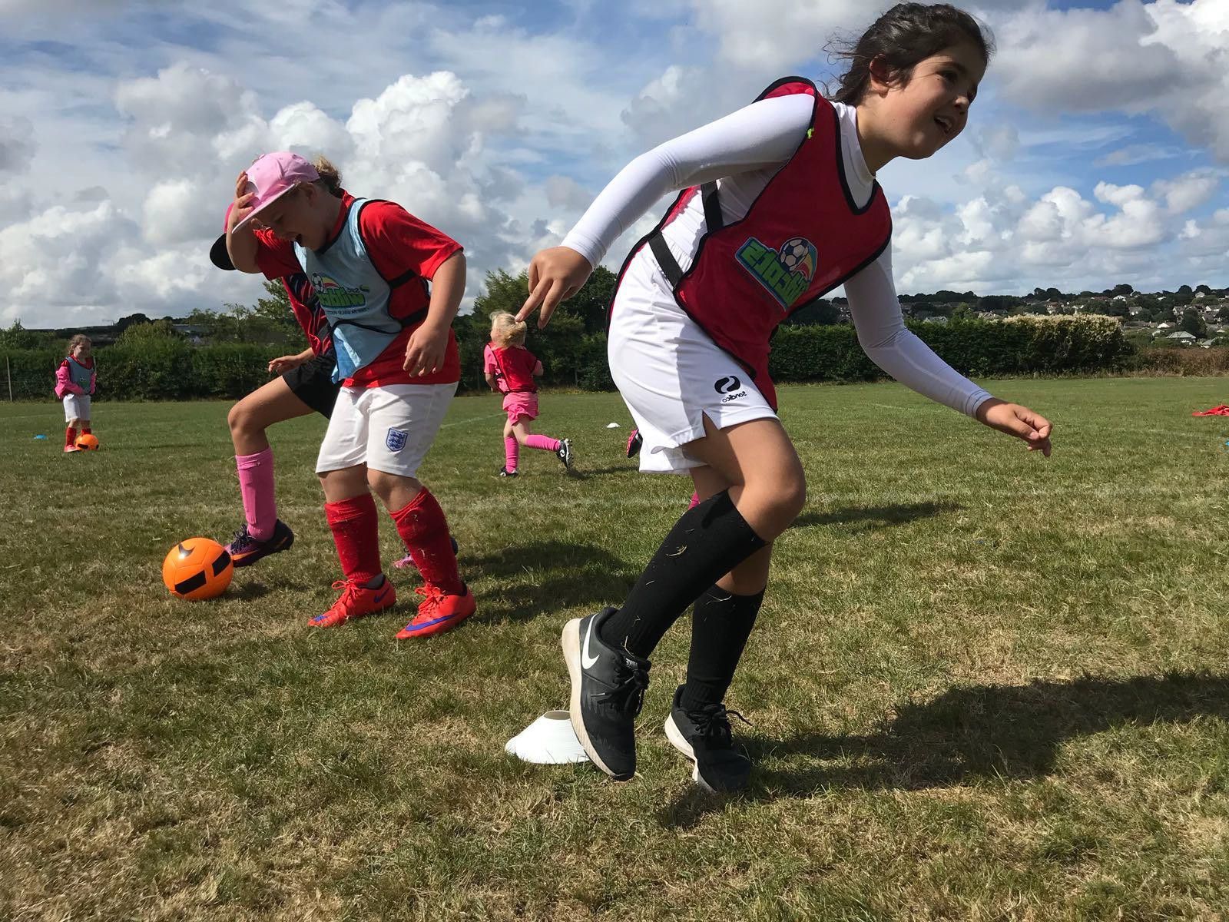

Key Performance Indicators (as of 06/12/23)
Secondary KPIs | Base line | Target 2023-24 | Current Position
Weetabix Wildcats | 30 | 32 | 29 (not all running though)
80% (72%) increase in club + community opportunities girls | 107 | 184 | 138
Female Youth Competition Pathway | No | Yes | Yes
1000 clubs with a female pathway | 2 | 6 | 5
England Football Accreditation – Adult Clubs | 78% | 65% | 90%
England Football Accreditation – Youth Clubs | 96% | 90% | 100%

For more information, please
visit www.cornwallfa.com

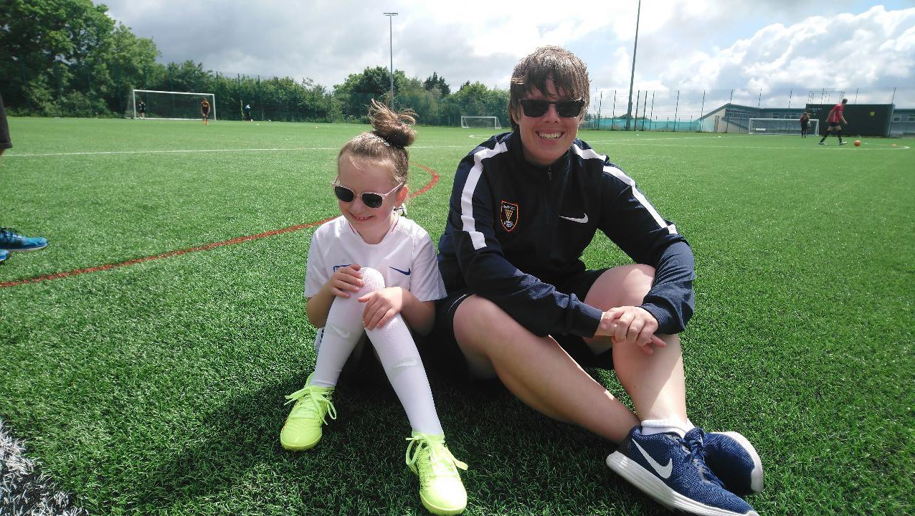
Cornwall County Football Association - Diversity and Inclusion Action Plan

