**Step 1**

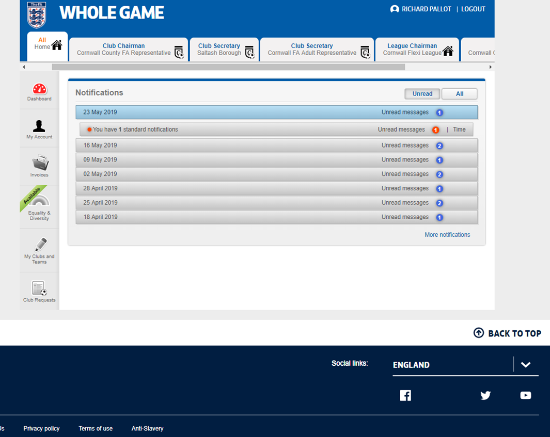

**From the Homepage please select your role to take you to your club dashboard.**

**Step 2**

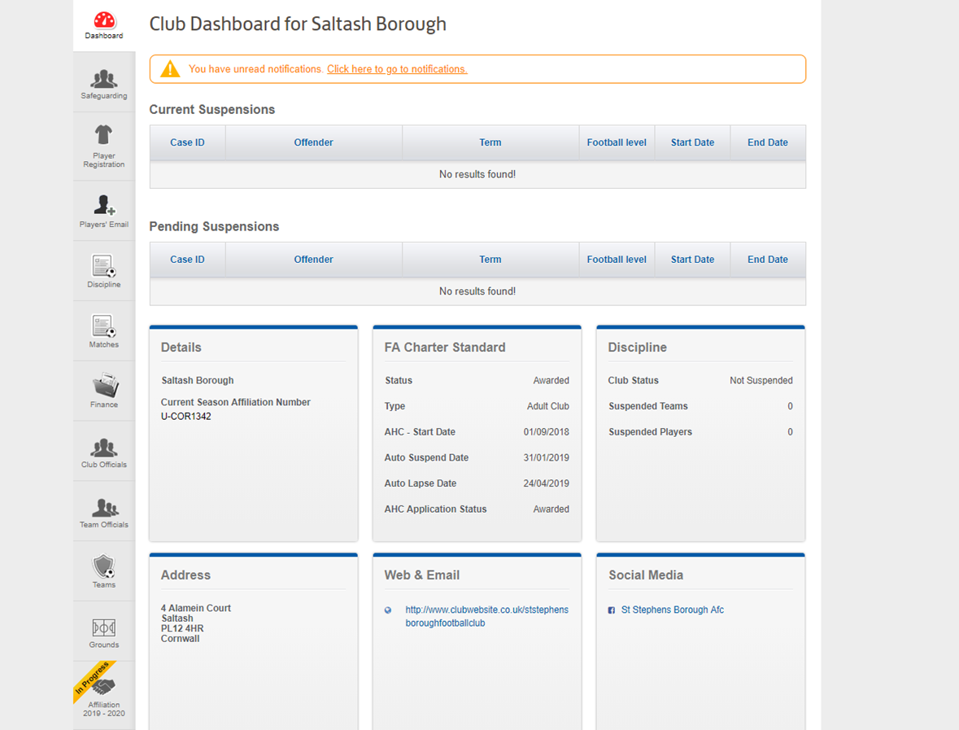

**Click on the affiliation tab to begin the process**

**Step 3**

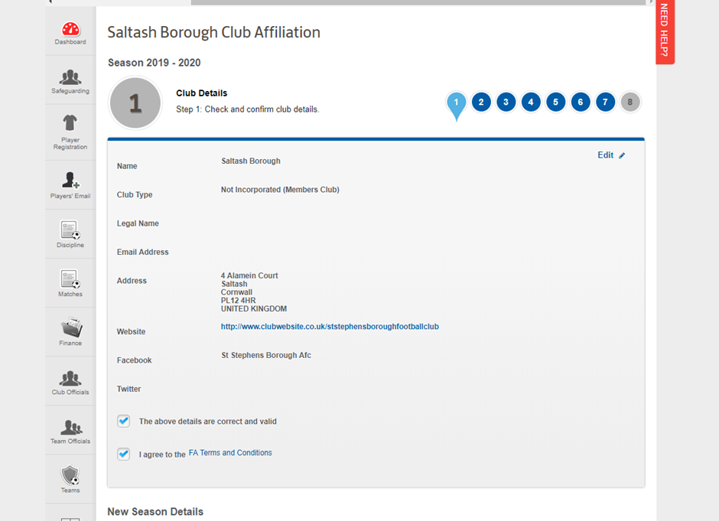

**Follow the 8 Simple Steps to complete your affiliation.**

**Should you need any guidance please click on the Need Help button on the side of the page.**