The Cheshire County Football Association Limited

Witness Statement – 3 pages

Witness Name

Please place your statement below - this should be completed in a chronological order and confirm the time(s), date(s), location(s) and your distance from any incident(s) that you may have witnessed. For each incident please confirm if your view was unobstructed, or impaired. Please provide a detailed physical description of the offender(s) (including, approx. age, height, build, hair / skin colour and any distinguishing features). Please record any offensive language that you heard directly in speech marks (“ “).
Continuation sheet
If applicable, please indicate on the pitch below the location of the relevant individual(s) involved in the incident at the time it happened:

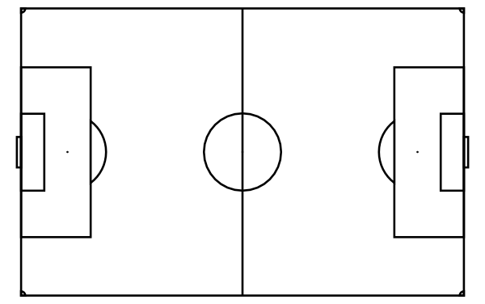

Declaration
This statement is true to the best of my knowledge, information and belief. I understand that it may be given in evidence and used at any subsequent disciplinary proceedings. I am willing to attend a disciplinary hearing if required.

Signature Click here to enter text. Date Click here to enter a date.

Parent/carer (if witness is aged U18):
Signature Enter name here (taken as signature) Date Click to enter date

Your details
Name Click here to enter text.
Age (if U18) Click here to enter text.
Role Choose an item.
Club (if applicable)

