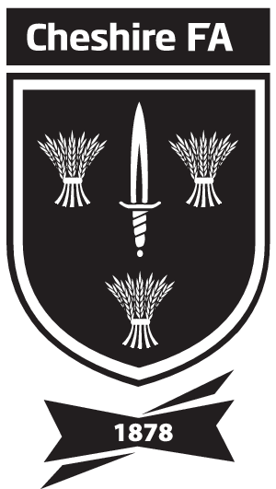TEAM SHEET
Cheshire County FA Girls' Under 13s Minor Cup

Please complete in BLOCK LETTERS in black font or black ink

Your Club:

Date of Match:

Round:

Referee:

Home Club:
Away Club:

TEAM DETAILS

Shirt No. | Surname | First Name | Date of Birth
GK

NOMINATED SUBSTITUTES
Shirt No. | Surname | First Name | Date of Birth

TEAM BENCH OFFICIALS ( Name ) | POSITION / TITLE

Team Colours
Shirts: |  | Shorts: |  | Socks:
Goalkeeper Shirt: |  | Shorts: |  | Socks:

Name: |  | Position at Club:

Copies of this team sheet must be completed & exchanged with your opponent & the referee in accordance with competition rules.

In this competition (Girls’ U13s Cup) this must be at least 10 minutes before the advertised time of kick off or 30 minutes in the Semi-Finals and Final.

SHEETS MUST BE RETAINED BY ALL PARTIES FOR AT LEAST 56 DAYS AFTER THE MATCH.

