
TEAM SHEET
CHESHIRE FA Junior U14s Cup
Please complete in BLOCK LETTERS in black font or black ink
Your Club:

Date: |  | Round: |  | Venue:
Shirts: |  |  | Shorts: |  | Socks:
Goal Keepers Shirt: |  |  | Shorts: |  | Socks:
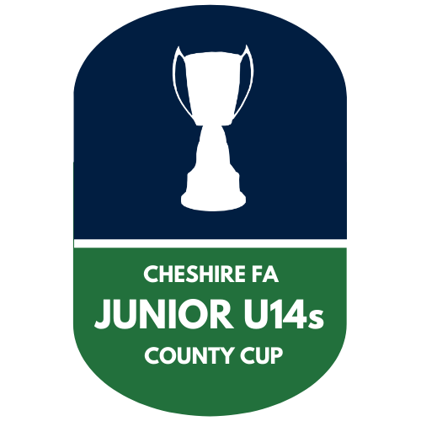

Copies of this Team Sheet must be completed and exchanged with your opponents and Match referee in accordance with the competition rules

In this competition this must be at least 30 Minutes before the advertised time of kick off in all rounds.

Sheets must be retained by all parties for at least 56 days after the match
Team Details
Shirt No. |  | Surname | Forename

Nominated Substitutes
Shirt No | Surname |  |  | Forename

Team Officials | Position


Name: |  | Position:

Please return this form completed to: Ray.Pullen@CheshireFA.com within 72 hours of the game being played.

Please return this form completed to: Ray.Pullen@CheshireFA.com within 72 hours of the game being played.

CheshireFA.com/cups-and-competitions @CCFACountyCups

