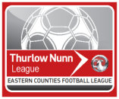
MATCH OFFICIAL’S EXPENSES

Match Official’s Name:

Date:

Home Team:

Away Team:

Played at:

Competition: League/Cup (delete as necessary)

Match fee: = £

Travel expenses:

Car - miles at 34p per mile = £
Rail – From to = £
Other (Specify) = £
Total Claimed = £

Payment will be made by BACS transfer so please provide the following:
Bank Name, e.g. Barclays, NatWest, etc.
Account Name
Account Number
Bank Sort Code

Please note that some clubs will not have this facility so will pay cash on the day but you will be advised of this by the club when they confirm your appointment.

All payments should be received within 48 hours of the game.

