

FINANCE OFFICER
APPLICATION PACK

CONTENTS

VACANCY 3
ABOUT BIRMINGHAM COUNTY FOOTBALL ASSOCIATION 4
CEO INTRODUCTION 5
JOB PURPOSE & PERSON SPECIFICATION 8
APPLICATION PROCESS 13

VACANCY

A fabulous opportunity has arisen to join the team at Birmingham County Football Association. The successful candidate will join a fantastic team and manage and monitor the day-to-day finances of the business and Benevolent Fund and maintain and develop efficient and effective financial accounting practices and processes.

The Finance Officer will analyse financial activities and provide advice and guidance to the Senior Leadership on future financial, risk, compliance, strategies and solutions. The post-holder will play a crucial role in developing and implementing financial plans and policies that support the organisations growth and profitability.

The Finance Officer will also support the successful delivery of the BCFA Business Plan objectives and FA’s National Game Strategy and KPI’s as well as maintaining the financial aspects of the FA’s Code of Governance.

The full time role may appeal to someone who started their journey in a financial career two or more years ago and is looking to take a step up in responsibilities.
A part time option may also appeal to a more experienced candidate who is looking for a better work/life balance at this stage of their career or someone returning to the workplace after an absence.

We have a great team full of supportive people with employees benefitting from a flexible/hybrid approach to work* and over 25 staff benefits which includes Nike kit and access to FA and England tickets.

* after three months’ probation and as per the hybrid working policy

ABOUT BIRMINGHAM COUNTY FOOTBALL ASSOCIATION

An inspiring and professional organisation, Birmingham County Football Association (BCFA) is the not-for-profit governing body of football in the Birmingham, Warwickshire and The Black Country. We are committed to providing opportunities for all our communities to engage in football activities across all the football formats.
There are over 1,000 clubs and 5,000 affiliated teams under our auspices, stretching across one of the largest geographical County FA boundaries in the country. We have delegated powers from the FA to manage rules and regulations to ensure fair play in the grassroots game, both on and off the pitch. We are responsible for promoting and developing the local game and strive to positively influence football participation for all, regardless of age, disability, gender reassignment, marriage and civil partnership, pregnancy and maternity, race, religion or belief, sex, and sexual orientation.

OUR PURPOSE
Improving Lives by Improving Football

OUR VISION
To be a dynamic, progressive, community focused organisation that delivers safe, fun and inclusive football for all whilst caring for our people and our planet

OUR VALUES
Supportive
We work together in an engaging and collaborative way
Innovative
We aspire to work in a creative environment
Inclusive
We are an open and transparent organisation
Positive
We bring energy and enthusiasm to all aspects of our roles

CEO INTRODUCTION

THIS IS A REALLY EXCITING TIME TO BE PART OF BIRMINGHAM COUNTY FA – ONE OF THE LARGEST COUNTY FA’S IN THE COUNTRY.


We have a high-level Board of Directors who meet quarterly with the majority being Independent Non-Executive Directors of the Business. We also have an exceptional Executive team of over 20 employees led by myself and an experienced and high-performing Senior Leadership Team.
As with most organisations, the Board sets and monitors the strategic direction which is closely aligned to the FA’s national game strategy. The Executive are then set several key performance indicators by the FA which have a bearing on our current and future funding levels. In doing so, we have recognised the benefits of hybrid working and empower our fabulous group of employees to achieve their targets whilst allowing them the flexibility to be the best they can be.
However, Birmingham County FA is renowned for going over and above what is expected as we recognise that football is not just a game played for 90 minutes. The game in its wider context is impactful and far reaching and brings communities together both on and off the pitch. Participation will help with mental and physical wellbeing with the positive economic impact of the game within the region being in excess of £520m each season which is why we growth in all areas is so important.
We also recognise that the game has a huge environmental impact on our local and national climate which is why we have set ourselves a BIG ambition to reduce our own and the wider game’s carbon footprint via our renowned and award-winning Save Today, Play Tomorrow programme and educate the football family in doing so.
Safeguarding is another fundamental and mandatory element of what we do and the support we provide Clubs and Leagues is key in making the game safe, fun and enjoyable for all participants and especially the younger generations and vulnerable adults who participate each week.

There have been challenges since Covid but we proudly have the cheapest affiliation fees in the Country which has driven positive growth in all areas and in all formats of the game and in line with our core purpose of Improving Lives by Improving Football. It is this main purpose along with our vision, our culture and our shared values which are the foundations of our successes of which there are many, namely:
- Record numbers of teams affiliating across all formats of the game.
- Continued growth in male participation including the traditional 11v11 game and walking football.
- Substantial growth in all aspects of the women’s and girls’ game along with an enhanced profile.
- Significant growth in the number of disabled players accessing the game.
- An increased commitment and delivery on our wider equality, diversity and inclusion agenda.
- Continued growth in the number of volunteers servicing and supporting the grassroots game.
- A big increase in the number of match officials trained and qualified.
- Development of non-traditional formats of the game.
- A huge investment into improving facilities across the region.
- The development of new partnerships and investment into the game locally;
- Improved relationships with stakeholders and increased levels of customer service.
- The delivery of 15 prestigious County Cup Competitions with record breaking attendances.
- Passing our independent Safeguarding assessment each year since its inception in 2019-20 season.
- Winning several local and national awards for our unique sustainability programme.

However, we are a County FA that does not sit still and rest on our laurels – far from it!
Our successes of the past become the bedrock and benchmarks for our future growth and ensures we deliver a high-quality, safe, fun and inclusive football experience For All members of the various communities which we serve.
Therefore, the position of Finance Officer is a key appointment for the business in order to drive new and existing income, monitor financial performance, reduce risk and ensure the Association continues to be a high performing and well respected within all levels of the game locally, at The FA and across the County FA network.
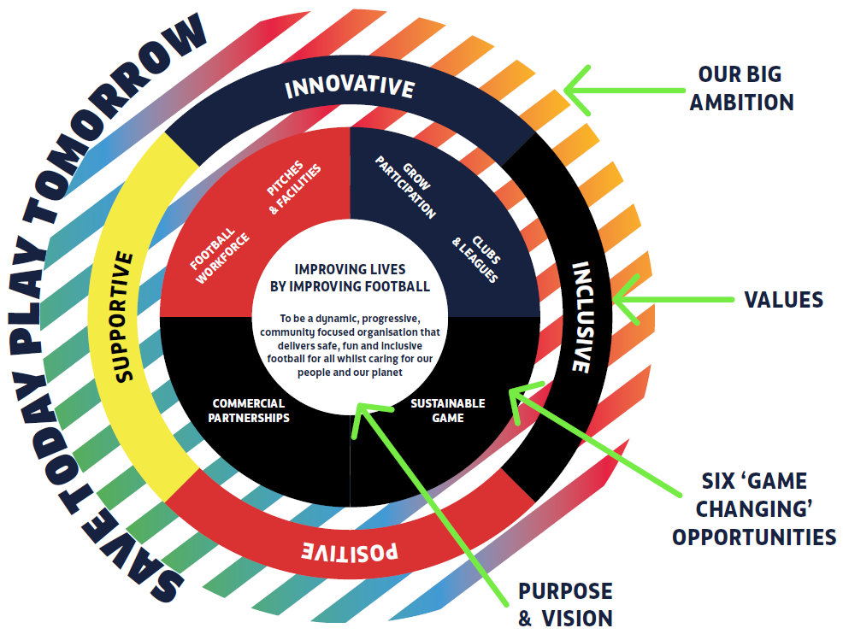
For further information please see the links to our new strategy and governing documents:

BCFA web site: https://www.birminghamfa.com
BCFA Strategy: https://www.birminghamfa.com/about/our-strategy-purpose-and-values
BCFA Governing Documents: https://www.birminghamfa.com/about/board-and-council
Save Today, Play Tomorrow: https://www.birminghamfa.com/about/save-today-play-tomorrow
The Football Association: https://www.thefa.com/
Kevin Shoemake
CEO

JOB PURPOSE & PERSON SPECIFICATION
Job title | Finance Officer
Reports to | Chief Executive Officer
Salary | Up to £28,000pa (based on experience) + benefits
Strategic Group membership | The post holder will be a Trustee and Secretary for the BCFA’s Benevolent Fund

Job purpose(s)
- Maintain the financial health of the organisation and BCFA Benevolent Fund
- Develop financial strategy in line with the BCFA’s business plan and external grants
- Develop cost-effective management mechanisms and financial policies that minimise financial risk
- Develop and manage the financial accounting, monitoring and reporting systems including cash flow/forecasts and projections
- Maintain financial compliance as per the FA’s Code of Governance
- Produce accurate financial reports to deadlines for the CEO, Senior Leadership Team (SLT) and BCFA Board
- Assist with the production of budgets and then manage and monitor budgets whilst providing insight and analysis and recommending further courses of action, financial solutions and cost reductions
- Manage BCFA’s investment portfolio in conjunction with BCFA Director (Finance)
- Keep abreast of changes in financial regulations, legislation and compliance
- Carry out month end and year end processes and produce accurate reports
- Liaise with external auditors/Independent Examiner to ensure annual monitoring is carried out in time for AGM

Direct reports | Chief Executive Officer
Executive lead | Board Audit panel, BCFA Benevolent Fund
External Liaison | FA Support Services Manager (Finance), FA Regional Manager, Auditors, Banks and Financial Institutions, HMRC, Pension provider, Operating system provider, Suppliers
Location | A mixture of office and home working in conjunction with the BCFA Hybrid Working Policy
Working hours | Up to 35 hours per week – part time (28hrs a week) will be considered based on experience and situation
Contract type | Permanent

Responsibilities
- Support the CEO and Senior Leadership Team in all aspects of the day-to-day financial operations of the business
- Accurately manage the monthly payroll using the XERO operating system and pension payments
- Provide accurate monthly management information and financial analysis for each Department lead and SLT and BCFA Board meeting so they can make informed decisions to meet the organisations business objectives
- Raising and processing of invoices and receipts and liaising with suppliers whilst resolving customer queries and any refunds/credits aligned to the FA administration systems
- Managing, reconcile and post the accounts payable and receivable making sure correct coding and authorisations are in place.
- Manage the County FA’s income & banking and credit card reconciliations
- Co-ordinate, monitor and pro-actively chase debtors and manage the monthly aged debtor reports along with departmental leads
- Monitor departmental budgets and produce monthly budget reports including analysis and commentary and suggested interventions
- Monitor bank accounts and investments in line with business practices and reconcile statements
- Provide data and insight in order to support the production of the annual budget with the assistance of department leads
- Ensure compliance with external regulatory agencies such as, HMRC, Accountants, Auditors and Charity Commission
- Take specific responsibility for work linked to the objectives of the business plan including monitoring and reporting of FA funding, FA course commission and other external grants
- Take a leading role in sourcing and submitting funding applications and the monitoring of external grants
- Develop new financial innovations and payment systems such as County Cup Final ticketing, course payments and external site bookings
- Review and develop financial policies and monitor compliance, such as expenses and budget sign-off
- Regularly review main business, mobile phone and utility suppliers and contracts for value for money and in line with business values and sustainable objectives
- Act as a Trustee and secretarial support for the BCFA’s Benevolent Fund and ensure the charity remains compliant with statutory financial regulations aligned to the charity’s governing documents and objectives
- Lead the application process, allocation and payment process of FA, EFL and England tickets as per FA/Wembley regulations
- Source and monitor staff benefits, health insurance levels and incentive programmes
- Support the wider business in customer support which includes email, phone and Freshdesk ‘ticket’ portal
- Uphold and promote the purpose, big ambition, vision and values of the BCFA
- Undertake any such appropriate duties as directed by the CEO from time to time

Person specification
Qualifications
Essential  - A degree level qualification including financial modules  - AAT qualified – level 3 or equivalent  - Minimum of two years’ experience in a Finance Officer/Manager position | Desirable  - Financial management experience  - Business course including financial modules
Skills
Essential  - Proven ability to lead a finance function  - Highly organised and methodical with an eye for detail  - Excellent working knowledge of financial and accounting processes, procedures and reporting  - An excellent working knowledge and understanding of XERO operating software  - Proficient user of MS Excel and other MS platforms and IT systems including outlook and TEAMS  - Strong interpersonal, communication and presentation skills  - The ability to inform, guide, advise and lead colleagues into making sound business decisions and encourage change  - Proven ability to analyse and present financial data and information | Desirable  - A keen interest in sport  - Good understanding of and interest in grassroots football  - Understanding of football/sport administration  - Demonstration of working with partner organisations  - Ability to deal with and manage conflict  - Ability to use data to monitor and evaluate financial activity  - A good understanding of managing investment portfolios  - The ability to coach, guide and support non-financial staff in developing their financial skills and knowledge
Knowledge and experience
Essential  - Excellent knowledge of all statutory legislation and financial regulations and accounting principles  - Good understanding of P11D and P60 payments  - Experience of financial administration in the charity sector and/or charity regulation  - Good understanding of vat returns and partial exemption payments | Desirable  - Knowledge of the FA’s operating and administration systems (PFF/WGS)  - An understanding of the rules and regulations of the Football Association  - Knowledge of the County FA network and how it operates in partnership with the FA  - Experience in costing and financing capital build projects e.g. 3G developments  - Understanding of football affiliation and discipline procedures and processes and related payments  - Knowledge of and commitment to equality, diversity and inclusion.  - Knowledge of The FA’s Safeguarding Operating Standard.  - Knowledge and understanding of working with volunteers
Enhanced DBS Check required? | NO
Full driving licence and/or ability to travel locally and nationally? | YES

The job holder will be expected to understand and work in accordance with the values described below
BCFA Value | Description
SUPPORTIVE | We work together in an engaging and collaborative way to allow everyone to reach their full potential.
INNOVATIVE | We aspire to work in an environment where creative thinking adds value and generates positive output.
INCLUSIVE | We are open and transparent organisation that reflects and respects the skills, knowledge and backgrounds of its people and communities.
POSITIVE | We bring energy and enthusiasm to all aspects of our roles and to inspire others every day with our attitude and commitment.

Job description reviewed and modified by: | KS, LD (FA), SH, TP, LB
Date job description reviewed and modified: | 11th September 2023
Job description authorised by: | Chair, CEO

Signed by job holder (on appointment):
Date signed:

Equality Statement:
Birmingham County FA is committed to equality and diversity and welcome applications from all sections of the community. Pease contact us or refer to our website for a copy of our equality and diversity policy. www.BirminghamFA.com/Equality.

This job description is only a summary of the role as it currently exists and is not meant to be exhaustive.
The responsibilities/accountabilities and skills/knowledge/experience/behaviours might differ from those outlined and other duties, as assigned, might be part of the role.

APPLICATION PROCESS

Please email a copy of your CV along with a ONE PAGE covering letter detailing why you are a good fit for this role, to: The Chief Executive: kevin.shoemake@birminghamfa.com – please add: ‘Finance Officer application’ in the subject line.

The closing date for applications is Sunday 24th September with interviews scheduled for the Friday 29th September at Birmingham County FA’s Headquarters: Ray Hall Lane, Great Barr, Birmingham, B43 6JF

If any applicants do not hear from BCFA by Wednesday 27th September then your application has been unsuccessful.

