

FINANCE OFFICER
APPLICATION PACK

CONTENTS

VACANCY 3
ABOUT BIRMINGHAM COUNTY FOOTBALL ASSOCIATION 4
CEO INTRODUCTION 5
JOB PURPOSE & PERSON SPECIFICATION 8

STAFF BENEFITS 13
APPLICATION PROCESS 14

VACANCY

A fabulous opportunity has arisen to join the team at Birmingham County Football Association. The successful candidate will join a fantastic team and manage and monitor the day-to-day finances of the business and registered charity and maintain and develop efficient and effective financial accounting practices and processes.

The Finance Officer will be a competent user of XERO accounting software (or similar) and analyse financial activities and provide advice and guidance to the Senior Leadership on future financial, risk, compliance, strategies and cost-effective solutions. The post-holder will play a crucial role in developing and implementing financial plans and policies that support the organisations growth and profitability.

The Finance Officer will also support the successful delivery of the BCFA Business Plan objectives and FA’s National Game Strategy and KPI’s as well as maintaining the financial aspects of the FA’s Code of Governance.

There is lots of scope to develop the role as well as personally and professionally and we support our employees with over 27 benefits of employment after a three month probationary period has been successfully completed.

ABOUT BIRMINGHAM COUNTY FOOTBALL ASSOCIATION
An inspiring and professional organisation, Birmingham County Football Association (BCFA) is the not-for-profit governing body for grassroots football in Birmingham, Warwickshire and The Black Country. We are committed to providing opportunities for all our communities to engage in football activities across all the football formats.
There are over 1000 clubs and 5,000 affiliated teams with 78,000 players playing nearly 50,000 matches a season across 55 sanctioned leagues with 1300 Referees under our auspices.
We promote and develop all formats and aspects of the game for the benefit of everyone, both on and off the pitch and in order to increase participation and support our 20,000 volunteers.
We are also responsible for governing the game within the region as per FA rules and regulations and strive to positively influence football participation whilst making sure it is within a structured, fun and safe environment.

OUR PURPOSE
Improving Lives by Improving Football

OUR VISION
To be a dynamic, progressive, community focused organisation that delivers safe, fun and inclusive football for all whilst caring for our people and our planet

OUR VALUES
Supportive
We work together in an engaging and collaborative way
Innovative
We aspire to work in a creative environment
Inclusive
We are an open and transparent organisation
Positive
We bring energy and enthusiasm to all aspects of our roles

CEO INTRODUCTION

THIS IS A REALLY EXCITING TIME TO BE PART OF BIRMINGHAM COUNTY FA – ONE OF THE LARGEST COUNTY FA’S IN THE COUNTRY.


You’ll be joining an exceptional executive team of over 20 supportive employees led by myself and an experienced and high-performing Senior Leadership Team.
As with most organisations, the Board sets and monitors the strategic direction and business objectives which is closely aligned to the FA’s national game strategy. The Executive are then set several key performance indicators by the FA which all have a bearing on our current and future funding levels. In doing so, we have recognised the benefits of hybrid working and empower our fabulous group of employees to achieve their targets whilst allowing them the flexibility to be the best they can be and recognising and promoting a good work/life balance.
However, Birmingham County FA is renowned for going over and above what is expected as we recognise that football is not just a game played for 90 minutes. The game in its wider context is impactful and far reaching and brings communities together both on and off the pitch. Participation will help with mental and physical wellbeing with the positive economic impact of the game within the region being in excess of £520m each season which is why growth in all areas of the game is so important, especially after the pandemic.
We also recognise that the game has a huge environmental impact on our local and national climate which is why we have set ourselves a BIG ambition to reduce our own and the wider game’s carbon footprint via our renowned and award-winning Save Today, Play Tomorrow programme and educate the football family in doing so.
Safeguarding is another fundamental and mandatory element of what we do and the support we provide Clubs and Leagues is key in making the game safe, fun and enjoyable for all participants and especially the younger generations and vulnerable adults who participate each week.

There have been challenges since Covid but we proudly have the cheapest affiliation fees in the Country which has driven positive growth in all areas and in all formats of the game and in line with our core purpose of ‘Improving Lives by Improving Football’. It is this main purpose along with our vision, our culture and our shared values which are the foundations of our successes of which there are many, namely:
- Record numbers of teams affiliating across all formats of the game.
- Continued growth in male participation including the traditional 11v11 game and walking football.
- Substantial growth in all aspects of the women’s and girls’ game along with an enhanced profile.
- Significant growth in the number of disabled players accessing the game.
- An increased commitment and delivery on our wider equality, diversity and inclusion agenda.
- Continued growth in the number of volunteers servicing and supporting the grassroots game.
- A big increase in the number of trained and qualified match officials.
- The development of non-traditional formats of the game.
- A huge investment into improving facilities across the region.
- The development of new partnerships and investment into the game locally;
- Improved relationships with stakeholders and increased levels of customer service.
- The delivery of 15 prestigious County Cup Competitions with record breaking attendances.
- Passing our independent Safeguarding assessment each year since its inception in 2019-20 season.
- Winning several local and national awards for our unique sustainability programme.

However, we are a County FA that does not sit still and rest on our laurels – far from it!
Our successes of the past become the bedrock and benchmarks for our future growth.
Therefore, the position of FINANCE OFFICER is key and pivotal to achieving our strategic and financial objectives, driving the Association’s profitability forward into the future, reduce financial risk and ensuring that the Association continues to be a high performing, well respected and highly regarded County FA that delivers safe, fun and inclusive football experience For All members of the various communities which we, our clubs and our leagues serve.
For further information please see the links to our strategy and governing documents below:

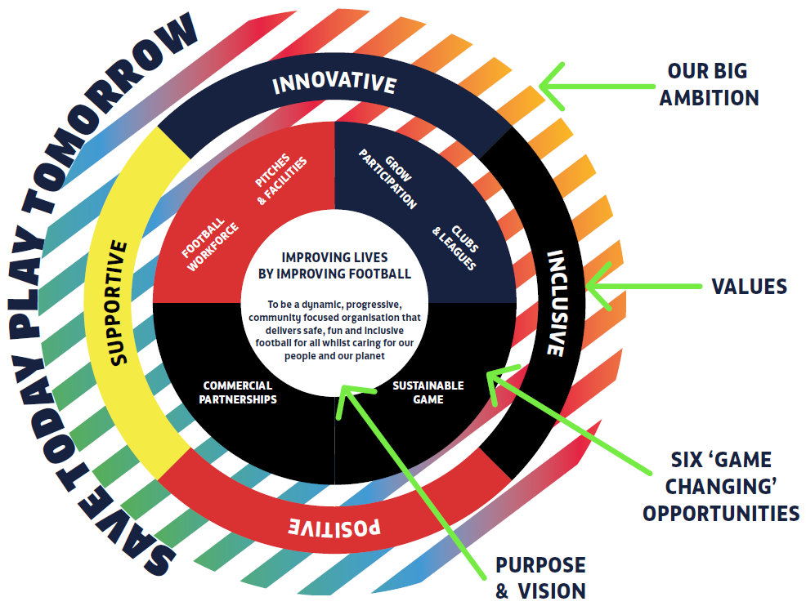

BCFA web site: https://www.birminghamfa.com
BCFA Strategy: https://www.birminghamfa.com/about/our-strategy-purpose-and-values
BCFA Governing Documents: https://www.birminghamfa.com/about/governance
Save Today, Play Tomorrow: https://www.birminghamfa.com/about/save-today-play-tomorrow
The Football Association: https://www.thefa.com/

Kevin Shoemake
CEO

JOB PURPOSE & PERSON SPECIFICATION
Job title | Finance Officer
Reports to | Chief Executive Officer
Salary | Up to £30,000pa (based on experience) + benefits
Strategic Group membership | The post holder will be act as Secretary for the BCFA’s Charitable Fund

JOB PURPOSE(S)
- Taking financial transactions and reconciliation of bank accounts and incoming card payments
- Maintain the financial health of the organisation and BCFA Charitable Fund
- Develop and deliver a financial strategy in line with the BCFA’s business plan and external grants
- Develop cost-effective management mechanisms and financial policies that minimise financial risk
- Develop and manage the financial accounting, monitoring and reporting systems including cash flow/forecasts and investment portfolio and projections
- Maintain financial compliance as per the FA’s Code of Governance
- Produce accurate financial reports to deadlines for the CEO, Senior Leadership Team (SLT) and BCFA Board
- Assist with the production of budgets and then manage and monitor budgets whilst providing insight and analysis and recommending further courses of action, financial solutions and cost reductions
- Manage BCFA’s investment portfolio in conjunction with BCFA Director (Finance) and Audit Committee
- Keep abreast of changes in financial regulations, legislation and compliance
- Carry out month end and year end processes and produce accurate management reports
Liaise with external auditors/Independent Examiner to ensure annual monitoring is carried out in time for the AGM

Direct reports | Chief Executive Officer
Executive lead | Board Audit Committee, BCFA Charitable Fund
External Liaison | FA Support Services Manager (Finance), FA Regional Manager, Auditors, Banks and Financial Institutions, HMRC, Pension provider, Operating system provider, Suppliers, Finance Director
Location | A mixture of office and home working in conjunction with the BCFA Hybrid Working Policy – after a three month probation period
Working hours | Up to 35 hours per week – part time (28hrs a week – pro-rata) will be considered based on experience and personal circumstances
Contract type | Permanent
RESPONSIBILITIES

- Support the CEO and Senior Leadership Team in all aspects of the day-to-day financial operations of the business
- Daily financial transactions and bank reconciliations
- Accurately manage the monthly payroll using the XERO operating system and pension payments
- Provide accurate monthly management information and financial analysis for each Department lead and SLT and BCFA Board meeting so they can make informed decisions to meet the organisations business objectives
- Raising and processing of invoices and receipts and liaising with suppliers whilst resolving customer queries and any refunds/credits aligned to the FA administration systems
- Managing, taking financial transactions, reconcile and post the accounts payable and receivable making sure correct coding and authorisations are in place.
- Manage the County FA’s income & banking and credit card reconciliations
- Co-ordinate, monitor and pro-actively chase debtors and manage the monthly aged debtor reports along with departmental leads
- Monitor departmental budgets and produce monthly budget reports including analysis and commentary and suggested interventions
- Monitor bank accounts and investment portfolio in line with business practices and reconcile statements
- Provide data and insight in order to support the production of the annual budget with the assistance of department leads
- Ensure compliance with external regulatory agencies such as, HMRC, Accountants, Auditors and Charity Commission
- Take specific responsibility for work linked to the objectives of the business plan including monitoring and reporting of FA funding, FA course commission and other external grants
- Take a leading role in sourcing and submitting funding applications and the monitoring of external grants
- Develop new financial innovations and payment and invoicing systems such as County Cup Final ticketing, course payments and external site bookings
- Review and develop financial policies and monitor compliance, such as expenses and budget sign-off
- Regularly review main business, mobile phone and utility suppliers and contracts for value for money and in line with business values and sustainable objectives
- Act as a Trustee and secretarial support for the BCFA’s registered charity and ensure the charity remains compliant with statutory financial regulations aligned to the charity’s governing documents and objectives
- Lead the application process, allocation and payment process of FA, EFL and England tickets as per FA/Wembley ticket regulations
- Source and monitor staff benefits, health insurance levels and incentive programmes
- Support the wider business in customer support which includes email, phone and Freshdesk ‘ticket’ portal
- Uphold and promote the purpose, big ambition, vision and values of the BCFA
- Undertake any such appropriate duties as directed by the CEO from time to time

PERSON SPECIFICATION

Qualifications
Essential  - A degree level qualification including financial modules  - AAT qualified – level 3 or equivalent  - XERO certified/accredited | Desirable  - Financial management experience  - Business course including financial modules  - Other online finance software package
Skills
Essential  - Proven ability to lead a finance function  - An excellent working knowledge and understanding of XERO operating software  - Proficient user of MS Excel and other MS platforms and IT systems including outlook and TEAMS  - Highly organised and methodical with an eye for detail  - Excellent working knowledge of financial and accounting processes, procedures and reporting  - Strong interpersonal, communication and presentation skills  - The ability to inform, guide, advise and lead colleagues into making sound business decisions and encourage change  - Proven ability to analyse and present financial data and information | Desirable  - A keen interest in sport  - Good understanding of and interest in grassroots football  - Understanding of football/sport administration  - Demonstration of working with partner organisations  - Ability to deal with and manage conflict  - Ability to use data to monitor and evaluate financial activity  - A good understanding of managing investment portfolios  - The ability to coach, guide and support non-financial staff in developing their financial skills and knowledge
KNOWLEDGE & EXPERIENCE

Essential  - Minimum of two years’ experience in a Finance Officer/Manager position  - Excellent knowledge of all statutory legislation and financial regulations and accounting principles  - Good understanding of P11D and P60 payments  - Experience of financial administration in the charity sector and/or charity regulation  - Good understanding of vat returns and partial exemption payments  - Fun, pro-active and solution driven attitude  - Good knowledge of charitable finance | Desirable  - Knowledge of the FA’s operating and administration systems  - An understanding of the rules and regulations of the Football Association  - Knowledge of the County FA network and how it operates in partnership with the FA  - Experience in costing and financing capital build projects e.g. 3G developments  - Understanding of football affiliation and discipline procedures and processes and related payments  - Knowledge of and commitment to equality, diversity and inclusion.  - Knowledge of The FA’s Safeguarding Operating Standard.  - Knowledge and understanding of working with volunteers
Enhanced DBS Check required? | NO
Full driving licence and/or ability to travel locally and nationally? | YES

The job holder will be expected to understand and work in accordance with the values described below:

BCFA Value | Description
SUPPORTIVE | We work together in an engaging and collaborative way to allow everyone to reach their full potential.
INNOVATIVE | We aspire to work in an environment where creative thinking adds value and generates positive output.
INCLUSIVE | We are open and transparent organisation that reflects and respects the skills, knowledge and backgrounds of its people and communities.
POSITIVE | We bring energy and enthusiasm to all aspects of our roles and to inspire others every day with our attitude and commitment.

Job description reviewed and modified by: | KS, LD (FA), SH, TP, LB
Date job description reviewed and modified: | 2nd November 2023
Job description authorised by: | Chair, CEO

Signed by job holder (on appointment):
Date signed:

Equality Statement:
Birmingham County FA is committed to equality and diversity and welcome applications from all sections of the community. Pease contact us or refer to our website for a copy of our equality and diversity policy. www.BirminghamFA.com/Equality.

This job description is only a summary of the role as it currently exists and is not meant to be exhaustive.

STAFF BENEFITS

There is a real ‘family’ feel to the business and we look after our exceptional employees with a fantastic array of staff benefits, with some being optional, linked to length of service and some performance related and some, unfortunately, taxed deductible…

BENEFIT | NOTES
Bonus scheme | Discretionary linked to annual PDR process – not guaranteed
Contributory Workplace Pension | Optional - 5% employer contribution / 4% employee
Life Insurance (Death in Service) | 3 x Annual Salary
Simplyhealth | Optional - Hospital Cash Plan – based on length of service
Hybrid/Flexible working | 35 hours per week – spread over 5-7 days - after probation
Home working allowance | £25 per month
Personal Accident cover | Up to 4x salary for certain benefits – for accidents ‘at work’
Laptop | Purchased via the FA IT partner
Mobile phone | Apple iPhone
Annual Leave | 25 days holiday + bank holidays + 1 joy day & 1 community day
Religious Holidays | Opportunity to swap bank holidays for religious holidays
Nike Kit | Free/branded kit and trainers + the occasional football
Free Parking | Secure, on-site office parking
Free electric car charging | Two on-site car charging points
Free refreshments | Tea, Coffee, Milk, Squash
Training & Development | As per PDR development and training budget
FA courses | Contribution to Coaching courses & Referee courses
Employee Assistance Programme (EAP) | Offered to all staff via The FA
Tickets | Opportunity to apply/purchase England & FA Cup tickets
Sick Pay | Full pay – for a defined period based on length of service
Maternity & Paternity pay | Top up to state benefit
Benefit Discount Scheme | Online shopping
Discount cards | Ad-hoc – non taxed
Cost of Living payments | Ad-hoc - taxed
Financial / Mortgage Advice | Free initial consultation
Disclosure & Barring Service (DBS) | Free – paid for by BCFA
Professional Memberships | Linked to role or career - Paid in full or in part by BCFA
Emergency Loans | Discussed and agreed by CEO and Chair

APPLICATION PROCESS

How to Apply:

Please email a copy of your CV along with the completed ED&I monitoring form to:
The Chief Executive: kevin.shoemake@birminghamfa.com with: ‘Finance Officer application’ in the subject line.

If applying via INDEED or similar online platforms then please visit the BCFA web site for the complete application pack, ED&I form and information about the County FA - www.birminghamfa.com

- Application deadline: Sunday 19th November at 6pm
- Interviews scheduled for: Monday 27th November
Interviews at Birmingham County FA’s Headquarters: Ray Hall Lane, Great Barr, Birmingham, B43 6JF

If any applicants do not hear from BCFA by Wednesday 22nd November then your application has been unsuccessful
Thank you for considering joining Birmingham County FA.
We look forward to receiving, reading and assessing your application.

