

FOOTBALL DEVELOPMENT OFFICER
APPLICATION PACK
CONTENTS

VACANCY 3
ABOUT BIRMINGHAM COUNTY FOOTBALL ASSOCIATION 4
CEO INTRODUCTION 5
JOB PURPOSE & PERSON SPECIFICATION 8

STAFF BENEFITS 13
APPLICATION PROCESS 144

VACANCY

A fabulous opportunity has arisen to join the team at Birmingham County Football Association. The successful candidate will join a fantastic team and support the delivery of the FA’s National Game Strategy and BCFA Operational Plan.

The Football Development Officer will have a key focus on Adult Male and Disability Football across the Birmingham County FA Network.

The Football Development Officer will also support the successful delivery of the BCFA Business Plan objectives, Safeguarding 365 standards and elements of the County FA’s Code of Governance compliance.

There is lots of scope to develop the role as well as personally and professionally and we support our employees with over 27 benefits of employment after a three-month probationary period has been successfully completed.

ABOUT BIRMINGHAM COUNTY FOOTBALL ASSOCIATION
An inspiring and professional organisation, Birmingham County Football Association (BCFA) is the not-for-profit governing body for grassroots football in Birmingham, Warwickshire and The Black Country. We are committed to providing opportunities for all our communities to engage in football activities across all the football formats.
There are over 1000 clubs and 5,000 affiliated teams with 78,000 players playing nearly 50,000 matches a season across 55 sanctioned leagues with 1300 Referees under our auspices.
We promote and develop all formats and aspects of the game for the benefit of everyone, both on and off the pitch and in order to increase participation and support our 20,000 volunteers.
We are also responsible for governing the game within the region as per FA rules and regulations and strive to positively influence football participation whilst making sure it is within a structured, fun and safe environment.

OUR PURPOSE
Improving Lives by Improving Football

OUR VISION
To be a dynamic, progressive, community focused organisation that delivers safe, fun and inclusive football for all whilst caring for our people and our planet

OUR VALUES
Supportive
We work together in an engaging and collaborative way
Innovative
We aspire to work in a creative environment
Inclusive
We are an open and transparent organisation
Positive
We bring energy and enthusiasm to all aspects of our roles

CEO INTRODUCTION

THIS IS A REALLY EXCITING TIME TO BE PART OF BIRMINGHAM COUNTY FA – ONE OF THE LARGEST COUNTY FA’S IN THE COUNTRY.


You’ll be joining an exceptional executive team of over 20 supportive employees led by myself and an experienced and high-performing Senior Leadership Team.
As with most organisations, the Board sets and monitors the strategic direction and business objectives which is closely aligned to the FA’s national game strategy. The Executive are then set several key performance indicators by the FA which all have a bearing on our current and future funding levels. In doing so, we have recognised the benefits of hybrid working and empower our fabulous group of employees to achieve their targets whilst allowing them the flexibility to be the best they can be and recognising and promoting a good work/life balance.
However, Birmingham County FA is renowned for going over and above what is expected as we recognise that football is not just a game played for 90 minutes. The game in its wider context is impactful and far reaching and brings communities together both on and off the pitch. Participation will help with mental and physical wellbeing with the positive economic impact of the game within the region being in excess of £520m each season which is why growth in all areas of the game is so important, especially after the pandemic.
We also recognise that the game has a huge environmental impact on our local and national climate which is why we have set ourselves a BIG ambition to reduce our own and the wider game’s carbon footprint via our renowned and award-winning Save Today, Play Tomorrow programme and educate the football family in doing so.
Safeguarding is another fundamental and mandatory element of what we do and the support we provide Clubs and Leagues is key in making the game safe, fun and enjoyable for all participants and especially the younger generations and vulnerable adults who participate each week.

There have been challenges since Covid but we proudly have the cheapest affiliation fees in the Country which has driven positive growth in all areas and in all formats of the game and in line with our core purpose of ‘Improving Lives by Improving Football’. It is this main purpose along with our vision, our culture and our shared values which are the foundations of our successes of which there are many, namely:
- Record numbers of teams affiliating across all formats of the game.
- Continued growth in male participation including the traditional 11v11 game and walking football.
- Substantial growth in all aspects of the women’s and girls’ game along with an enhanced profile.
- Significant growth in the number of disabled players accessing the game.
- An increased commitment and delivery on our wider equality, diversity and inclusion agenda.
- Continued growth in the number of volunteers servicing and supporting the grassroots game.
- A big increase in the number of trained and qualified match officials.
- The development of non-traditional formats of the game.
- A huge investment into improving facilities across the region.
- The development of new partnerships and investment into the game locally;
- Improved relationships with stakeholders and increased levels of customer service.
- The delivery of 15 prestigious County Cup Competitions with record breaking attendances.
- Passing our independent Safeguarding assessment each year since its inception in 2019-20 season.
- Winning several local and national awards for our unique sustainability programme.

However, we are a County FA that does not sit still and rest on our laurels – far from it!
Our successes of the past become the bedrock and benchmarks for our future growth.
Therefore, the position of FOOTBALL DEVELOPMENT OFFICER is key and pivotal to achieving our strategic and financial objectives, driving the Association’s profitability forward into the future, reduce financial risk and ensuring that the Association continues to be a high performing, well respected and highly regarded County FA that delivers safe, fun and inclusive football experience For All members of the various communities which we, our clubs and our leagues serve.
For further information please see the links to our strategy and governing documents below:

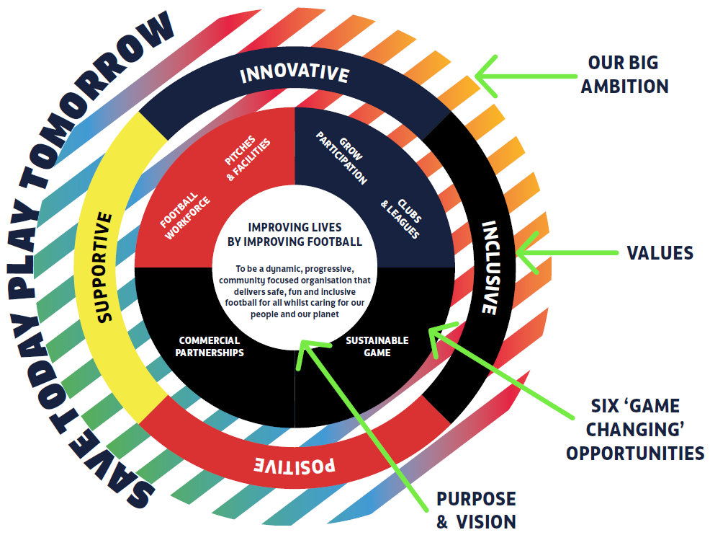

BCFA web site: https://www.birminghamfa.com
BCFA Strategy: https://www.birminghamfa.com/about/our-strategy-purpose-and-values
BCFA Governing Documents: https://www.birminghamfa.com/about/governance
Save Today, Play Tomorrow: https://www.birminghamfa.com/about/save-today-play-tomorrow
The Football Association: https://www.thefa.com/

Kevin Shoemake
CEO

JOB PURPOSE & PERSON SPECIFICATION
Job title | Football Development Officer (Adult Male & Disability Football)
Reports to | Deputy Football Development Manager
Salary | £24,504 + benefits

JOB PURPOSE(S)
- To support delivery of The FA National Game Strategy and the Birmingham County FA Business Strategy.
- To strategically coordinate Disability football provision across the Birmingham County FA network.
- To strategically coordinate Adult Male football provision across the Birmingham County FA network.
- To influence and support the growth and retention of Adult Male & Disability football, including FE & HE establishments.
- To increase the percentage of Teams across the Adult Male and Disability Game playing within England Football Accredited Clubs.
- To contribute to the effective implementation of The FA’s Safeguarding Operating Standard for County FAs.
- To comply with FA rules, regulations, policies, procedures, and guidance that is in place from time to time.
Direct reports | Deputy Football Development Manager
External Liaison | Grassroots Clubs and Leagues, FE & HE establishments, BeActive Sports Partnerships & Third Sector Organisations.
Location | A mixture of office and home working in conjunction with the BCFA Hybrid Working Policy – after a three-month probation period
Working hours | Up to 35 hours per week
Contract type | Fixed Term until 2028
RESPONSIBILITIES

- To strategically lead Disability football provision across Birmingham County FA ensuring an integrated approach with the local grassroots and professional club networks and key partners from across the Disability and community sectors.
- Grow and retain the number of affiliated Disability football teams with an emphasis on creating player pathway opportunities within FA England Accredited Club structures.
- Retain the number of affiliated Adult Male football teams with an emphasis on increasing the number of Adult Teams playing within FA England Accredited Club structures.
- Support and build links between educational establishments and FA accredited clubs to support the growth in Adult Male & Disability football.
- Coordinate the delivery of recreational Disability football sessions for disabled players across key age groups as well as recreational football sessions for Adult Male players.
- Develop and service a modern and sustainable competition structure across pan disability football.
- Co-ordinate the County based work programme for the Regional Disability Mentors and Disability Football Ambassadors,
- Work with the Football Development team to deliver a comprehensive workforce plan that supports Disability football across Coaches, Referees, Volunteers and Young leaders and is inclusive of Disabled people.
- Work with the Football Development team to raise the profile of disability football within Birmingham County FA and communicate the range of disability football opportunities across the pathway.
- Work with FE & HE establishments to ensure the growth and retention of both intra and inter-mural competitions.
- Support the delivery of the County FA’s Aspiring Club Co-ordinators Programme alongside the CFA’s Volunteer Co-ordinator.
- Establish constructive working relationships with the key with internal and external stakeholders, campaigners and networking groups to promote collaboration and sharing of good practice.
- Work with staff across departments to support in the delivery of inclusion targets and ensure that an Inclusive culture is embedded throughout the Birmingham County FA and grassroots football.
- Work with the Birmingham County FA Inclusion Advisory Board to consult on plans and engage to provide advocates for diversity and inclusion activities.
- Collaborate with the Designated Safeguarding Officer in all matters involving under 18s and adults at risk within disability Football Development programmes.
- Provide the highest level of customer excellence to support volunteers access across FA Technology systems (FA Learning, FA Events, Whole Game System, Matchday App and Full-Time).
- Execute tasks as required in order to meet the Birmingham County FA changing priorities.
- Risk assess all events and activities where the County FA directly employ or deploy under-18 referees, coaches and volunteers.
- Support messaging so that under-18s in youth and open-age adult County FA-led football know how to report any concerns about their wellbeing.
- Liaise with Safeguarding Team and follow through on opportunities to listen to and consult with under-18s on their experience of playing, learning and volunteering.

PERSON SPECIFICATION

Qualifications
Essential  - Degree level qualification or equivalent experience | Desirable  - Degree in a Sport Development field
Skills
Essential  - Ability to work strategically with partner organisations across different sectors to plan and deliver football programmes  - Project management skills and experience – to plan, set and achieve objectives to deadlines  - Excellent IT skills including the use of  - Proficient use of Microsoft Office applications  - Ability to work independently and as part of a team  - Excellent time management and prioritisation skills  - Excellent problem solving and decision making skills  - Outstanding communication and presentation skills  - Exceptional customer service  - Budget management skills  - Report writing skills  - Ability to use data to monitor and evaluate programmes  - Influencing skills to champion change | Desirable  - A keen interest in sport  - Good understanding of and interest in grassroots football  - Understanding of football/sport administration  - Practised at developing networks and relationships with a variety of stakeholders in order to support the delivery of strategic priorities  - Skilled in creating, delivering and maintaining pathways which support the growth, transition and retention of players  - Capability to create multiple reports, budgets and plans
KNOWLEDGE & EXPERIENCE

Essential  - Passionate about working in Adult Male & Disability football  - Knowledge and understanding of the barriers to participation faced by players with a disability  - Knowledge and understanding of the infrastructure and networks that exist within education, recreation, competition and talent that can support the development of Disability football  - Knowledge and understanding of the existing Adult Male football structures and the factors that impact Adult Male participation  - Practical experience of Sports / Footbal Development  - Demonstrate a working knowledge of inclusion, equality, anti–discrimination and safeguarding  - Knowledge of The FA Coaching Qualification Framework  - Understanding of the England Football Accredited Programme | Desirable  - Knowledge of the structure and partner organisations within football both nationally and within the County FA locality  - Knowledge of The FA’s National Game Strategy  - Experience of Project Management  - Experience of utilising mapping programmes to support strategic and logistical planning  - Knowledge and understanding of working with volunteers  - Knowledge of and commitment to equality, diversity and inclusion.  - Knowledge of The FA’s Safeguarding Operating Standard.  - Knowledge and understanding of working with volunteers
Enhanced DBS Check required? | YES
Full driving licence and/or ability to travel locally and nationally? | YES (Business Insurance cover required)

The job holder will be expected to understand and work in accordance with the values described below:

BCFA Value | Description
SUPPORTIVE | We work together in an engaging and collaborative way to allow everyone to reach their full potential.
INNOVATIVE | We aspire to work in an environment where creative thinking adds value and generates positive output.
INCLUSIVE | We are open and transparent organisation that reflects and respects the skills, knowledge and backgrounds of its people and communities.
POSITIVE | We bring energy and enthusiasm to all aspects of our roles and to inspire others every day with our attitude and commitment.

Job description reviewed and modified by: | LB
Date job description reviewed and modified: | 3rd November 2023
Job description authorised by: | Chair, CEO

Signed by job holder (on appointment):
Date signed:

Equality Statement:
Birmingham County FA is committed to equality and diversity and welcome applications from all sections of the community. Pease contact us or refer to our website for a copy of our equality and diversity policy. www.BirminghamFA.com/Equality.

This job description is only a summary of the role as it currently exists and is not meant to be exhaustive.

STAFF BENEFITS

There is a real ‘family’ feel to the business and we look after our exceptional employees with a fantastic array of staff benefits, with some being optional, linked to length of service and some performance related and some, unfortunately, taxed deductible…

BENEFIT | NOTES
Bonus scheme | Discretionary linked to annual PDR process – not guaranteed
Contributory Workplace Pension | Optional - 5% employer contribution / 4% employee
Life Insurance (Death in Service) | 3 x Annual Salary
Simplyhealth | Optional - Hospital Cash Plan – based on length of service
Hybrid/Flexible working | 35 hours per week – spread over 5-7 days - after probation
Home working allowance | £25 per month
Personal Accident cover | Up to 4x salary for certain benefits – for accidents ‘at work’
Laptop | Purchased via the FA IT partner
Mobile phone | Apple iPhone
Annual Leave | 25 days holiday + bank holidays + 1 joy day & 1 community day
Religious Holidays | Opportunity to swap bank holidays for religious holidays
Nike Kit | Free/branded kit and trainers + the occasional football
Free Parking | Secure, on-site office parking
Free electric car charging | Two on-site car charging points
Free refreshments | Tea, Coffee, Milk, Squash
Training & Development | As per PDR development and training budget
FA courses | Contribution to Coaching courses & Referee courses
Employee Assistance Programme (EAP) | Offered to all staff via The FA
Tickets | Opportunity to apply/purchase England & FA Cup tickets
Sick Pay | Full pay – for a defined period based on length of service
Maternity & Paternity pay | Top up to state benefit
Benefit Discount Scheme | Online shopping
Discount cards | Ad-hoc – non taxed
Cost of Living payments | Ad-hoc - taxed
Financial / Mortgage Advice | Free initial consultation
Disclosure & Barring Service (DBS) | Free – paid for by BCFA
Professional Memberships | Linked to role or career - Paid in full or in part by BCFA
Emergency Loans | Discussed and agreed by CEO and Chair

APPLICATION PROCESS

How to Apply:

Please email a copy of your CV along with the completed ED&I monitoring form to:
Mohammed.Juned@BirminghamFA.com with: ‘Football Development Officer application’ in the subject line.

If applying via INDEED or similar online platforms then please visit the BCFA web site for the complete application pack, ED&I form and information about the County FA - www.birminghamfa.com

- Application deadline: Monday 20th November at 6pm
- Interviews scheduled for: Wednesday 29th November
Interviews at Birmingham County FA’s Headquarters: Ray Hall Lane, Great Barr, Birmingham, B43 6JF

If any applicants do not hear from BCFA by Wednesday 22nd November then your application has been unsuccessful
Thank you for considering joining Birmingham County FA.
We look forward to receiving, reading and assessing your application.

