

INDEPENDENT NON-EXECUTIVE
COMMERCIAL PARTNERSHIP DIRECTOR
APPLICATION PACK

CONTENTS

VACANCY 3
ABOUT BIRMINGHAM COUNTY FOOTBALL ASSOCIATION 4
CEO INTRODUCTION 5
JOB PURPOSE & PERSON SPECIFICATION 8
APPLICATION PROCESS 11

VACANCY

An exciting opportunity has arisen to join the Board of Directors at Birmingham County Football Association (BCFA) as an Independent Non-Executive Director. The position is voluntary, for which agreed out of pocket expenses will be provided. The appointments start on 1st January 2024 (or before) with Directors appointed on a staggered basis for a maximum of three, three-year terms.

The 12 strong Board of Directors of the Birmingham County Football Association, directs and monitors the business affairs of the Association. In doing so, the Directors determine the purpose, vision, strategy, policies and financial investment required to achieve the overall business objectives. The post requires a commitment to attend up to six Board meetings per year which are during office hours and either online or preferable at the County Headquarters and to support and promote the aims, objectives and activities of the Association whilst supporting the CEO and executive staff in these important areas of activity.

The Non-Executive Commercial Partnership Director will become as an ambassador for Birmingham County Football Association (BCFA) and act as a custodian of the highest standards of integrity and governance. In particular, the Director will bring recent and relevant commercial knowledge and experience to provide support to the development of commercial strategies. The new Director will also offer informed advice and support to the specific BCFA executive and report to the Board on business development, income generation, sponsorships and grant applications, all of which can then be invested back into the business and the grassroots game within the region.

It would also be advantageous if applicants have a good knowledge of PR and marketing in order to support the Executive team to develop and monitor these specific areas of business activity and support Corporate Partnership activity.

ABOUT BIRMINGHAM COUNTY FOOTBALL ASSOCIATION

An inspiring and professional organisation, Birmingham County Football Association (BCFA) is the not-for-profit governing body of football in the Birmingham, Warwickshire and The Black Country. We are committed to providing opportunities for all our communities to engage in football activities across all the football formats.
There are 1000 clubs and 5,200 affiliated teams under our auspices, stretching across one of the largest geographical County FA boundaries in the country. We have delegated powers from the FA to manage rules and regulations to ensure fair play in the grassroots game, both on and off the pitch. We are responsible for promoting and developing the local game and strive to positively influence football participation for all, regardless of age, disability, gender reassignment, marriage and civil partnership, pregnancy and maternity, race, religion or belief, sex, and sexual orientation.

OUR PURPOSE
Improving Lives by Improving Football

OUR CULTURE
Happy, healthy employees thriving in a dynamic workplace

OUR VISION
To be a dynamic, progressive, community focused organisation that delivers safe, fun and inclusive football for all whilst caring for our people and our planet

OUR VALUES
Supportive
We work together in an engaging and collaborative way
Innovative
We aspire to work in a creative environment
Inclusive
We are an open and transparent organisation
Positive
We bring energy and enthusiasm to all aspects of our roles

CEO INTRODUCTION

THIS IS A REALLY EXCITING TIME TO BE PART OF BIRMINGHAM COUNTY FA – ONE OF THE LARGEST COUNTY FA’S IN THE COUNTRY.


We have a high-level Board of Directors who meet quarterly with the majority being Independent Non-Executive Directors of the Business. We also have an exceptional Executive team of over 20 employees led by myself and an experienced and high-performing Senior Leadership Team.
As with most organisations, the Board sets and monitors the strategic direction which is closely aligned to the FA’s national game strategy. The Executive are then set several key performance indicators by the FA which have a bearing on our current and future funding levels. In doing so, we have recognised the benefits of hybrid working and empower our fabulous group of employees to achieve their targets whilst allowing them the flexibility to be the best they can be.
However, Birmingham County FA is renowned for going over and above what is expected as we recognise that football is not just a game played for 90 minutes. The game in its wider context is impactful and far reaching and brings communities together both on and off the pitch. Participation will help with mental and physical wellbeing with the positive economic impact of the game within the region being in excess of £520m each season which is why we growth in all areas is so important.
We also recognise that the game has a huge environmental impact on our local and national climate which is why we have set ourselves a BIG ambition to reduce our own and the wider game’s carbon footprint via our renowned and award-winning Save Today, Play Tomorrow programme and educate the football family in doing so.
Safeguarding is another fundamental and mandatory element of what we do and the support we provide Clubs and Leagues is key in making the game safe, fun and enjoyable for all participants and especially the younger generations and vulnerable adults who participate each week.

There have been challenges since Covid but we proudly have the cheapest affiliation fees in the Country which has driven positive growth in all areas and in all formats of the game and in line with our core purpose of Improving Lives by Improving Football. It is this main purpose along with our vision, our culture and our shared values which are the foundations of our successes of which there are many, namely:
- Record numbers of teams affiliating across all formats of the game.
- Continued growth in male participation including the traditional 11v11 game and walking football.
- Substantial growth in all aspects of the women’s and girls’ game along with an enhanced profile.
- Significant growth in the number of disabled players accessing the game.
- An increased commitment and delivery on our wider equality, diversity and inclusion agenda.
- Continued growth in the number of volunteers servicing and supporting the grassroots game.
- A big increase in the number of match officials trained and qualified.
- Development of non-traditional formats of the game.
- A huge investment into improving facilities across the region.
- The development of new partnerships and investment into the game locally;
- Improved relationships with stakeholders and increased levels of customer service.
- The delivery of 15 prestigious County Cup Competitions with record breaking attendances.
- Passing our independent Safeguarding assessment each year since its inception in 2019-20 season.
- Winning several local and national awards for our unique sustainability programme.
- Plans in place to develop the site including a floodlit 3G

However, we are a County FA that does not sit still and rest on our laurels – far from it!
Our successes of the past form the bedrock and benchmarks for our future growth.
Therefore, the position of INDEPENDENT NON-EXECUTIVE DIRECTOR with overall responsibility of THE WIDER BOARD is pivotal to achieving our strategic objectives, driving the Association forward into the future and ensuring that the Association continues to be a high performing, well respected and highly regarded County FA that delivers a high-quality, safe, fun and inclusive football experience For All members of the various communities which we, our clubs and our leagues serve.
For further information please see the links to our new strategy and governing documents:
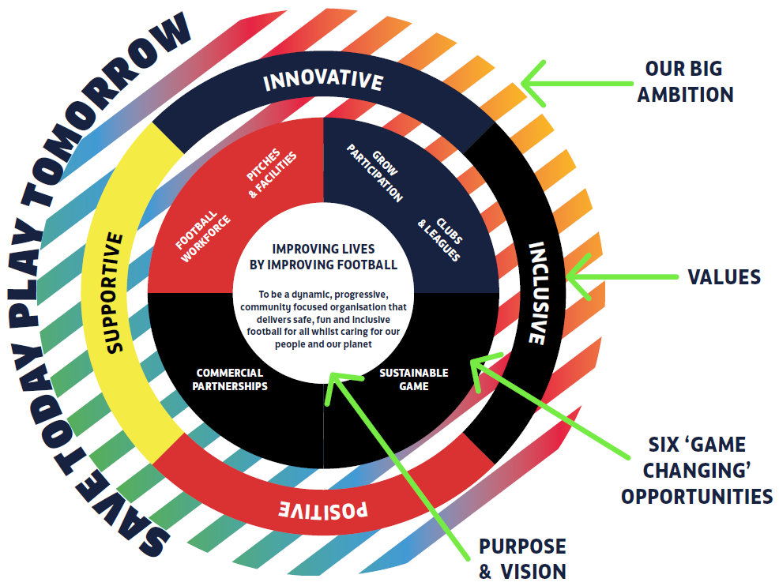

BCFA web site: https://www.birminghamfa.com
BCFA Strategy: https://www.birminghamfa.com/about/our-strategy-purpose-and-values
BCFA Governing Documents: https://www.birminghamfa.com/about/board-and-council
Save Today, Play Tomorrow: https://www.birminghamfa.com/about/save-today-play-tomorrow
The Football Association: https://www.thefa.com/
Kevin Shoemake
CEO

JOB PURPOSE & PERSON SPECIFICATION

ROLE PURPOSE
- To direct and monitor the business affairs of the Association by determining the vision and strategy, plans, policies and financial investment required to achieve the overall long-term business objectives.
- To direct and support the creation of a commercial partnership strategy and provide informed advice and support to the CEO and Executive and Board on business development, partnerships and grants that support and further the Association’s overall purpose and business objectives.
- To oversee and monitor all commercial and sponsorship agreements in respect of Birmingham County FA.
- To provide advice on improving customer service standards and use of insight that helps grow the game of football across the county.

LOCATION
- Birmingham County FA’s Head Office is in Great Barr in Birmingham.
- Board meetings are held quarterly with a mix of two face-to-face meetings and two online meetings each year.

ESTIMATED TIME COMMITMENT
- Additionally, it is anticipated that the post holder ideally dedicates a minimum of four hours a month to engage with key executive post holders to develop strategies, interrogate date and insight, formulate plans and monitor success.
- The post holder will work from home or can utilise the BCFA Head Office from time to time and/or to support their own work programmes.
- The current Board also commit to potentially meeting twice more (online) a year in the event of emergencies or important and immediate decisions affecting the business.
- Meetings are normally held on a Tuesday starting at 1pm and last in the region of 2-3 hours.

REMUNERATION OR EXPENSES
- This is a voluntary role.
- Relevant expenses will be paid in line with the current Birmingham County FA Expense Policy.
- With Board approval, there may be an opportunity for the post holder to earn an agreed commission to recompense their time, knowledge and contacts, especially if they have personally generated partnership income themselves.

RESPONSIBILITIES

GENERAL (ESSENTIAL)
- Serve as a Director of Birmingham County FA and to actively participate in its strategic management.
- Execute the responsibilities of a Company Director in accordance with the Companies Act (2006) and other relevant legislation.
- Safeguard the interests of the membership and stakeholders of the Association as per the Articles of Association and FA Code of Governance and Safeguarding frameworks.
- Establish clear objectives to deliver the agreed strategy and business plan and regularly review and monitor performance against business objectives and FA KPI's.
- Jointly oversee the management of risk to the Association.
- Jointly monitor the financial affairs of the Association and ensure the effective use of its finances.
- Promote equality of opportunity throughout the Association and wider football community.
- Represent the Association to partners and stakeholders in a professional manner.
- Act with discretion in respect of sensitive, confidential, or commercial information provided to you in this role.

COMMERCIAL (ESSENTIAL)
- Work with the CEO and SLT to ensure that the Association has a robust commercial strategy that supports the generation of income in line with the Associations strategic aims and objectives.
- Support improved engagement with new and existing communities and stakeholders.
- Support improved customer services standards.
- Identify and monitor partnerships that help meet the strategic and financial aims of the Association.
- Identify external grants in order to generate income that can be distributed for the benefit of the business and grassroots game as per the BCFA's Charitable Fund objectives.

MARKETING (DESIRABLE)
- Work with the CEO, SLT and key executives to ensure that the Association has innovative, data-driven
- marcomms strategies that support activity, promotes what we do and increases BCFA's reach and profile to new and existing communities and stakeholders.

PERSON SPECIFICATION

QUALIFICATIONS AND EXPERIENCE
- Business and commercial management experience.
- Company board level experience.
- An active network of relevant contacts within local business and sports communities.
- Experience of securing investment from multiple sources including external grants.
- Ability to contribute to the strategic thinking and direction of the Association.
- Designing, delivering and monitoring robust and effective business and commercial strategies
- Ability to analyse data and utilise insight to BCFA's advantage including customer excellence and engagement
- A successful sales and business development or account management background
- Knowledge of registered charity governance and external grant applications
- Skills and Personal Attributes
- Possess or show willingness to have an understanding of grassroots football.
- Financial and budgetary awareness.
- Analytical and rational thinking.
- Excellent communicator and confident presenter.
- Positive attitude and highly self-motivated with the ability to motivate others.
- A strong commitment to promoting and embedding equality, diversity, inclusion and safeguarding at all levels.
- An interest and understanding of environmental programmes and initiatives.
- Strong network of business and media contacts both inside and outside of football

Enhanced DBS Check required? NO

Check required on Companies House disqualified directors’ register? YES

Clean, full driving licence? YES

EQUALITY STATEMENT
Birmingham County FA is committed to equality and diversity and welcome applications from all sections of the community. Pease contact us or refer to our website for a copy of our equality and diversity policy. www.BirminghamFA.com/Equality.

APPLICATION PROCESS

Please complete the specific application form and ED&I form along with a ONE PAGE covering letter detailing why you are a good fit for this role, to: The Chief Executive: kevin.shoemake@birminghamfa.com – please add: ‘COMMERCIAL PARTNERSHIP DIRECTOR’ in the subject line.
Please feel free to attach a CV with your application but the separate application form and covering letter will be our primary sources of selection.
All applications will then have unconscious bias removed prior to the selection process being undertaken.
The closing date for applications is Friday 17th November 2023 with interviews scheduled for Friday 8th December 2023 at Birmingham County FA’s Headquarters: Ray Hall Lane, Great Barr, Birmingham, B43 6JF

The selected candidate would then start their initial term of office in January 2024 and be expected to attend the Board meeting on the 30th January 2023 starting at 1pm where their appointment will be ratified.

FOR OFFICE USE ONLY

Role profile reviewed  and modified by: | Kevin Shoemake, CEO, M. Penn, Chairman, S. Hampton, Snr INED, S. Kazmi, INED
Date role profile reviewed and modified: | 20th October 2023
Role profile authorised by: | BCFA Board of Directors

Signed by role holder
(on appointment):
Date signed:
One copy to be retained by the role holder, one signed copy to be stored confidentially by the Association.

