How to Apply
Leagues: In order to apply please e-mail Luke.Bowles@BirminghamFA.com – The League will need to be willing to complete a League Support and Delivery Plan in conjunction with BCFA and have 60% of all teams playing within the league, playing with in England Football Accredited Clubs.
Clubs: Log in to the Clubs portal – https://Clubs.TheFA.com and head to the Dashboard Tab
- The Dashboard tab is broken down in to three sections – Club, Officials and Documents:

The number in brackets next to each tab is the number of outstanding items, needing to be fulfilled, in order to complete the Accreditation Checklist
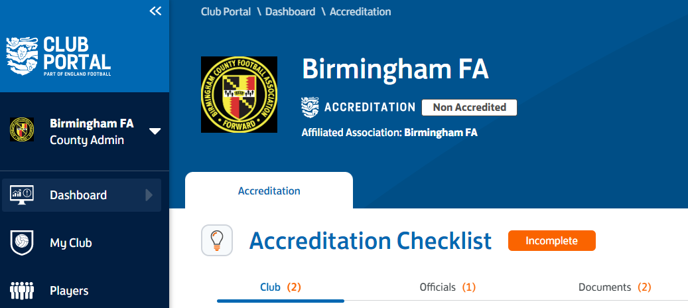
.
- Club Tab
- Club Affiliated to a County FA – Will be complete once affiliated
- Teams Playing in a League – Will be complete when one team is playing in an FA Sanctioned League
- Bank Account – Only applicable for Clubs with two or more teams – To satisfy this criterion you need to click the show more button, then click edit, then tick the yes box, then save – A copy of a bank statement also needs uploading to the My Club tab > Documentation Tab > Other Documents
- Club Meetings and Minutes - To satisfy this criterion you need to click the show more button, then click edit, then tick the yes box, then save – A copy of a recent set of minutes also needs uploading to the My Club tab > Documentation Tab > Other Documents
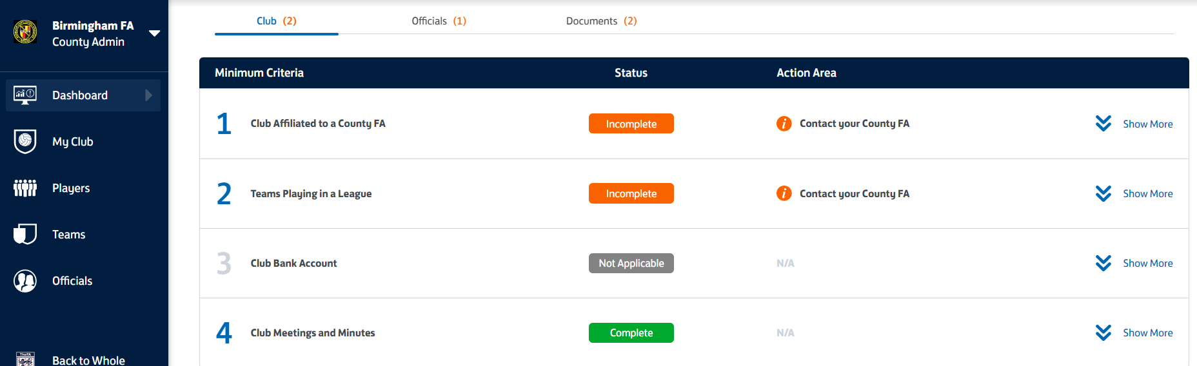

- Officials Tab
- Officials DBS Compliant – Mandatory requirement all volunteers in positions that require a DBS (activity with U18) must have an in-date certificate – If incomplete the ‘i’ button will show you who is out of date
- Club Welfare Officer – Mandatory requirement for Clubs with U18 Teams
- Safeguarding Committee Members Course – Mandatory requirement for Clubs with U18 Teams
- Adult Teams with First Aid in Football Education – All Adult teams (U19 and above) must have an individual attached to the team who holds an in-date FA Introduction to First Aid Football Qualification - If incomplete the ‘i’ button will show you which teams are non-compliant
- Youth Teams with Qualified Coach/Manager – All Youth Teams (U18 and below) must have an individual attached to the team who holds an FA Coaching Qualification, an in-date FA Introduction to First Aid in Football Qualification and an in-date FA Safeguarding Children Course Qualification - If incomplete the ‘i’ button will show you which teams are non-compliant
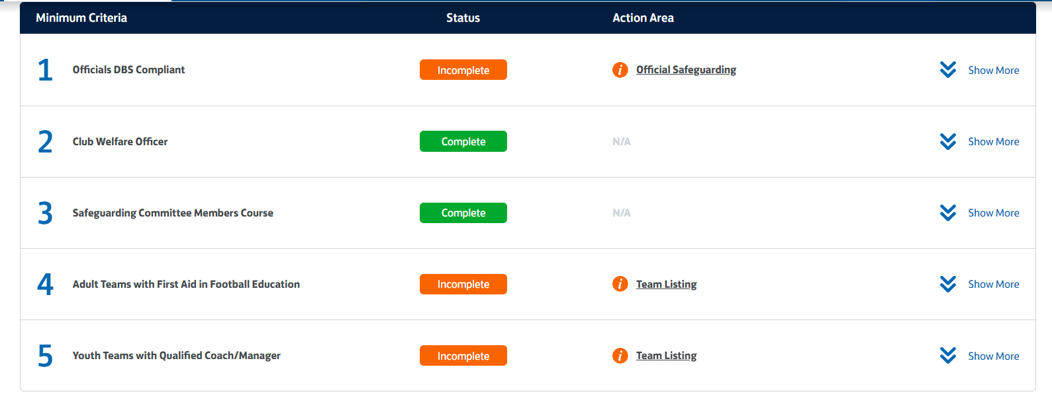

4. Documents
a. Club Rules – This can be completed by adopting the Club Rules document within the My Club tab > Documentation tab > FA Policies on the left-hand side
b. Safeguarding Children Policies - This can be completed by adopting both Safeguarding Children documents within the My Club tab > Documentation tab > FA Policies on the left-hand side
c. Equality Policy - This can be completed by adopting the Equality document within the My Club tab > Documentation tab > FA Policies on the left-hand side
d. Respect Code of Conduct - This can be completed by adopting the Respect Code of Conduct document within the My Club tab > Documentation tab > FA Policies on the left-hand side
e. Football Leadership Diversity Code - This can be completed by adopting the Football Leadership Diversity Code document within the My Club tab > Documentation tab on the left-hand side
f. Club Development Plan – This can be satisfied by uploading a Development Plan to the My Club tab > Documentation tab > Club Policies
g. Club Accounts - To satisfy this criterion you need to click the show more button, then click edit, then tick the yes box, then save – A copy of the accounts also needs uploading to the My Club tab > Documentation Tab > Accounts

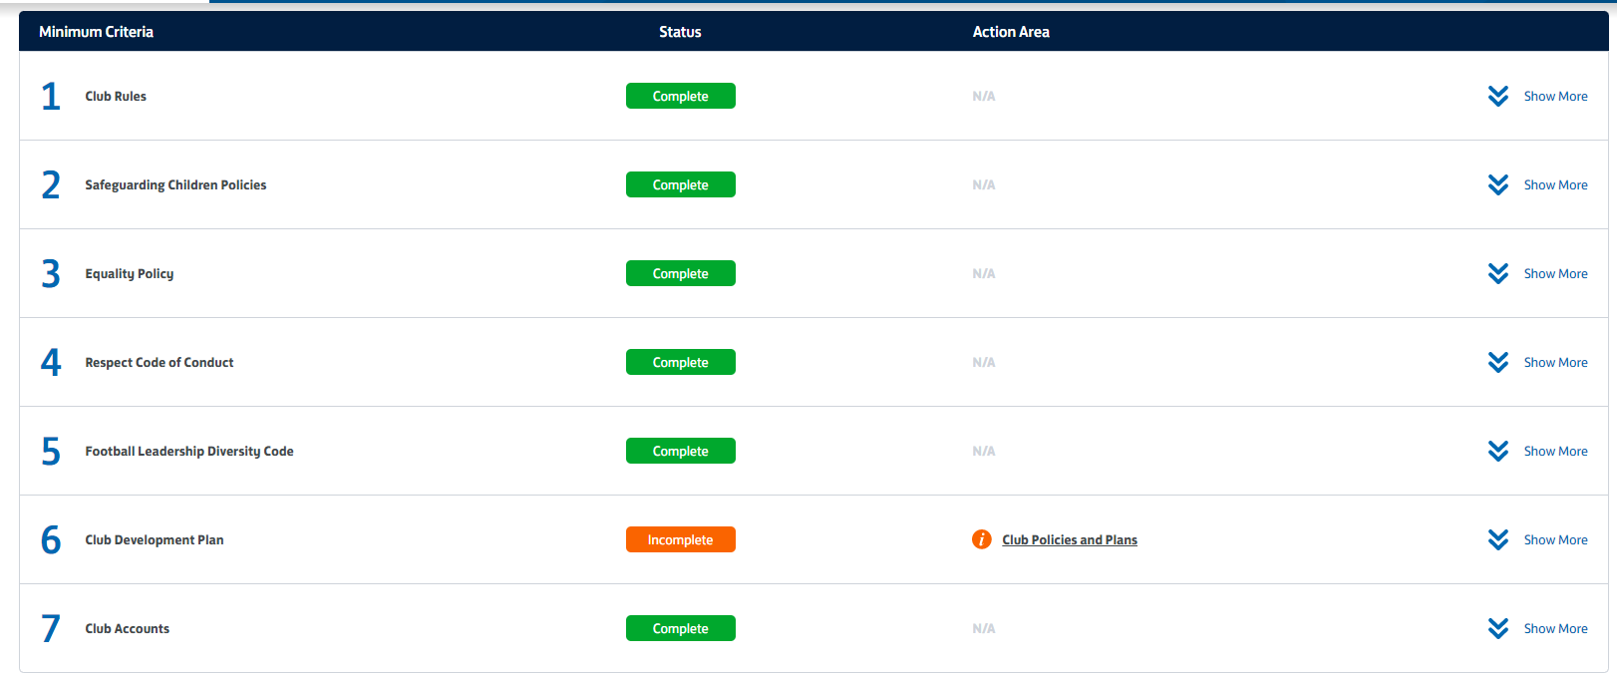

Once all criteria have been satisfied the ‘Apply for Accreditation’ button will appear on the top right-hand side of the checklist allowing you to submit the application:

