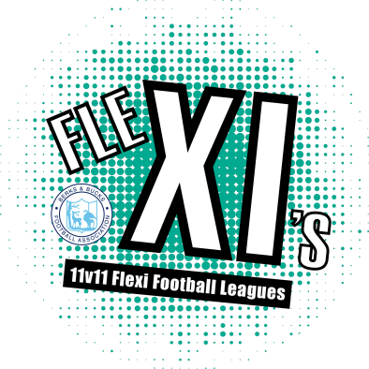
Flexi XI’s – Ryeish Green
Spring 2019- Team registration form
Please fully complete all sections to this form and return to Ellen.hopkins@Berks-BucksFA.com
TEAM REGISTRATION DEADLINE: Friday 8th February 2019
Team Name
Team experience (please select one) | Berks & Bucks affiliated Club |  |  | Unaffiliated team (recreational group)
Team Co-ordinator details
Full name
Contact number
Alternative contact number
FAN
Email address
Home address |  |  |  |  | Postcode
Team declaration
- I accept full responsibility on behalf of my team to fulfil and pay for all fixtures as required on Whole Game system and I agree to abide by the rules of the competition.  - I am aged 18 years or older. |  |  |  |  |  | Signed
 |  |  |  |  |  | Date

I agree to be contacted by Berks & Bucks FA in regards to similar flexi leagues in the future. | Please highlight as appropriate
 | Yes | No

Player registration Form
 | Player Name | DOB | E-Mail | Address | FAN (FA Number)
1
2
3
4
5
6
7
8
9
10
11
12
13
14
15
16
17
18
19
20
I was part of the previous league and I am happy for you to use the player registration information I submitted previously (tick if applicable) |  |  |  |  |  | YES

Once the above is complete, please email back to Ellen Hopkins via the following email: Ellen.Hopkins@Berks-BucksFA.com
You will need a minimum of 11 players when registering a team; you can add additional players at any point during the season by emailing Ellen the above information. Upon submitting your application you will also be required to pay the £40.00 registration fee over the phone within 5 working days.

