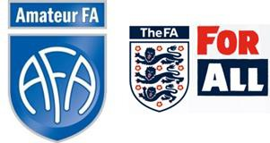

Amateur FA Football Services Guides

International Clearance

What is it?
Payers can only be registered with one national association at a time. Clubs must therefore request international clearance for:
- Any player who has previously been registered abroad; or
- The first time an overseas national registers with a club in England.
This applies at all levels of football and includes players previously registered for a club in Wales, Scotland or Northern Ireland.

Are there any age restrictions?
International clearance must be requested for any player over the age of ten.

Players under the age of 18 are also subject to the provisions of FIFA Article 19, under which international transfers are only allowed when:
- The player is moving to this country with his parents for non-football reasons; or
- The player’s residence and new club are within 50km of a national border (e.g. Wales)

Please refer to The FA’s guidance notes for international clearances for further information and documentation required for the application.

How do we request international clearance?
An application form must be sent directly to The FA at Registrations@TheFA.com along with a copy of the player’s passport photo page/national identity card. Forms can be downloaded from our website or requested from the Football Services Team.

What happens next?
The FA will contact the relevant National Association and request an International Transfer Certificate (ITC). National Associations have 30 days to issue an ITC; after that time The FA can provide provisional clearance.
Please note that The FA will contact the club directly. County FAs have no involvement in this process so we are unable to request assistance or fast track your application.
The player is not allowed to play until this clearance is received.

