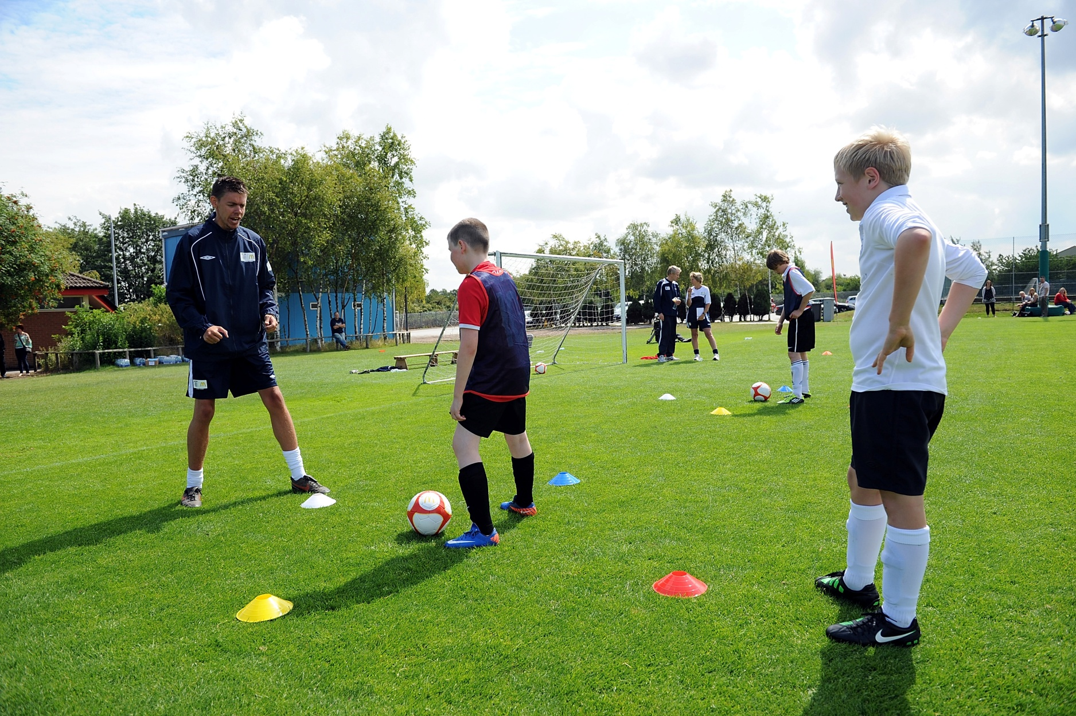

Event headline here!
<Insert exciting, dynamic club shot which is appropriate for the event. An action photograph will work for a match or festival promotion or players with trophies for an end-of-season awards.>

Saturday 5 April 2011, 7.00pm
Park Rangers FC Clubhouse, Downham Road
Tickets £5 adults, children free
Call 01XXX XXXXXX for more details



