FIFA World Cup Qatar 2022 Ticket Application Guide

Step 1 – Head to FIFA’s Ticket Portal
You can get onto FIFA’s Ticket Portal by following this link.

Step 2 – If you do not already have an account with FIFA you will need to create one. If you have one you should be able to log in and update your details. Please bear in mind FIFA have recently moved to a new log-in system meaning your old account might not be active.
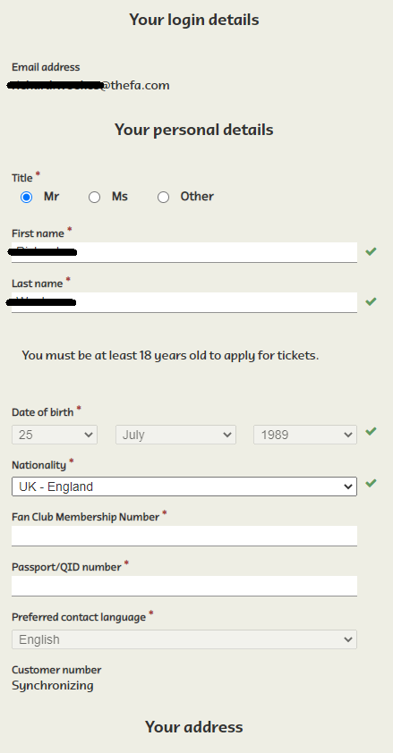
Your name, date of birth and FAN number must all match what we have on record for you under your membership. Failure to match these details may result in a voided application.
Please note that your Passport Number and address can be different to what we have on file.

Step 3 – Start your application!
Once you have finished entering in your personal details you will see the below link. Click here to start your ticket application process. Members who require accessibility tickets must click the bottom link.
Please note that members applying for accessibility tickets will be required to upload ‘proof of disability’. This document will be verified by The FA.
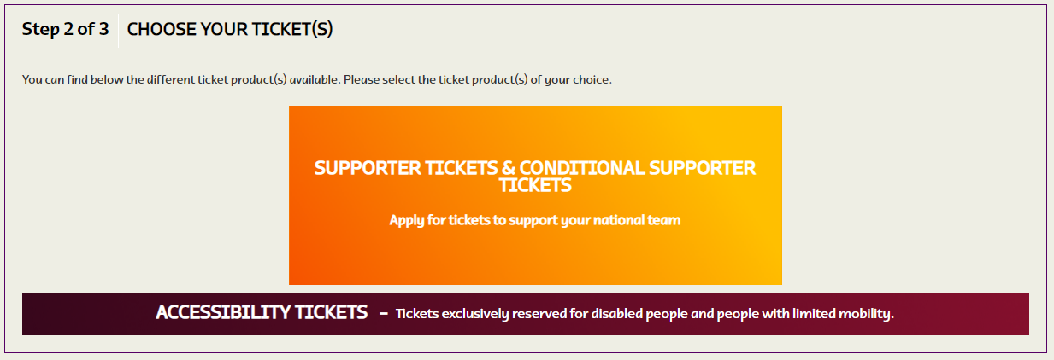

Step 4 – Pre-Application Information Window
Before you start selecting your matches you will be met with the following information from FIFA that you should take time to read carefully
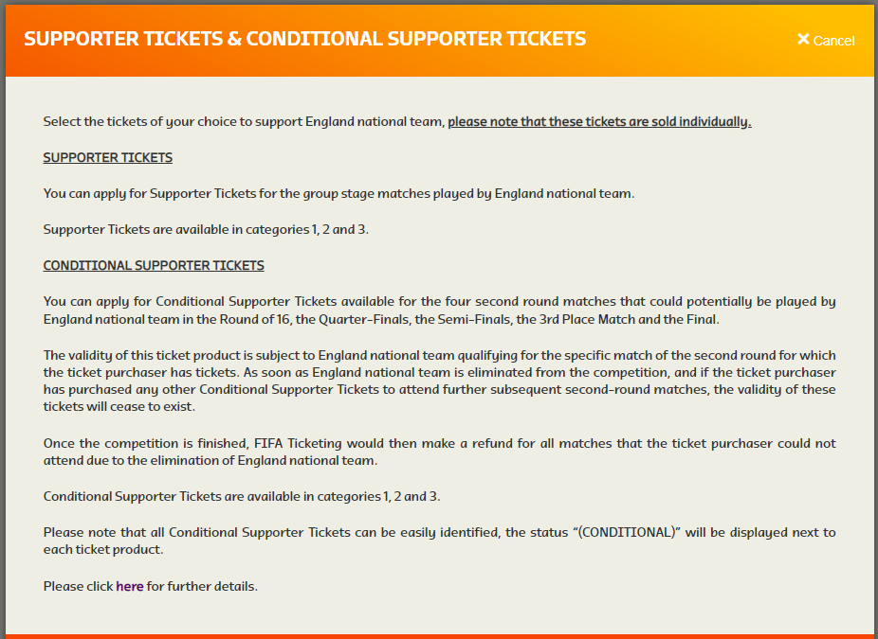

Step 5 – Selecting you match(es)
Now you can start applying for tickets to the matches you wish to attend. To view more information on the match, i.e. opponent and date, click ‘show match details’. You can apply for tickets by clicking on ‘select’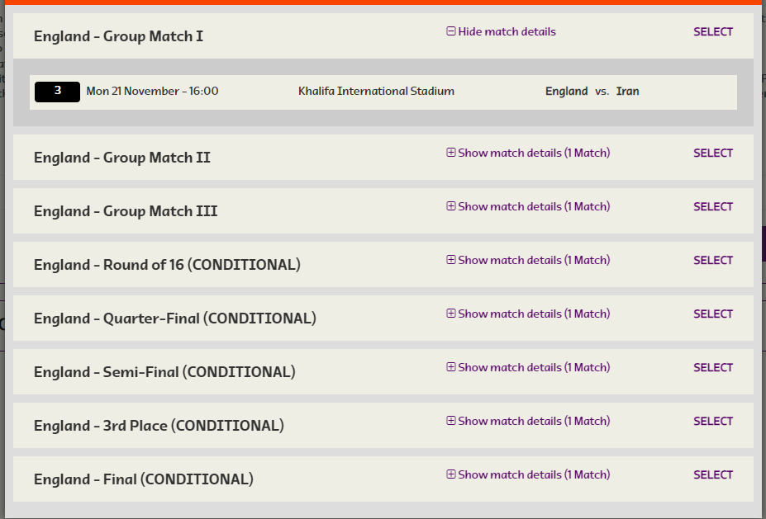

Step 6 – Choosing your category and number of tickets
Ensure that you choose your ticket category before selecting the total number of tickets you are applying for. Doing this the other way around will lead to all the guests being removed from this application. REMINDER – each ticket will need to be assigned to a current Travel Club member.
Whether you apply as an individual or for a group you will be unable to change the details of the ‘lead booker’
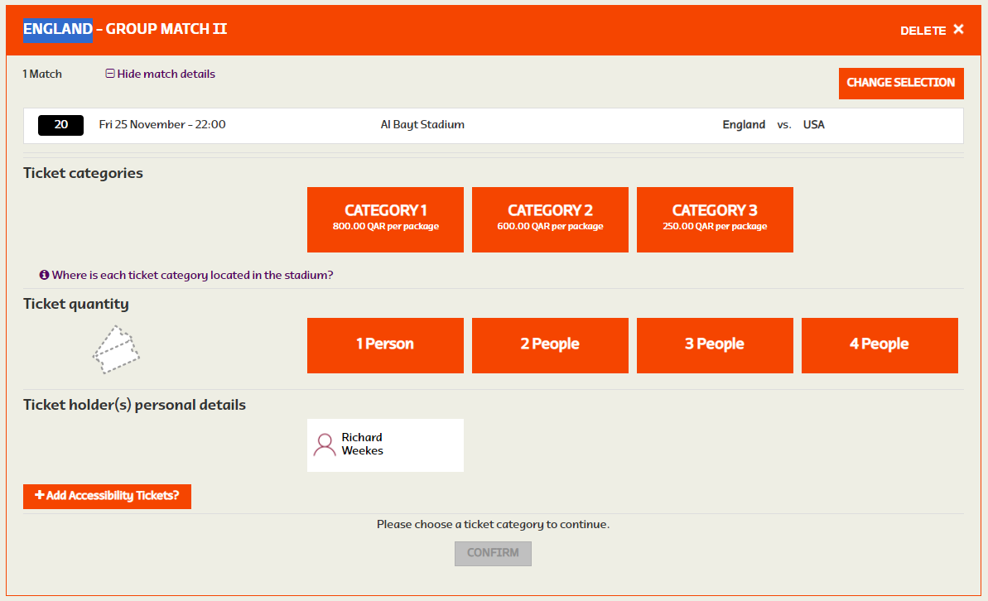

Step 7 – Adding Guests
If you are applying for more than one ticket, you will need select the total number of members you are applying for via the ‘ticket quantity’ section (see above).
A ‘Select a guest’ box will then appear next to the lead bookers name. You must then add the personal details for each guest you are applying for.

Please note that the last name, date of birth and FAN number must all match what we have on record for your guests. Failure to match these details may result in a voided application.
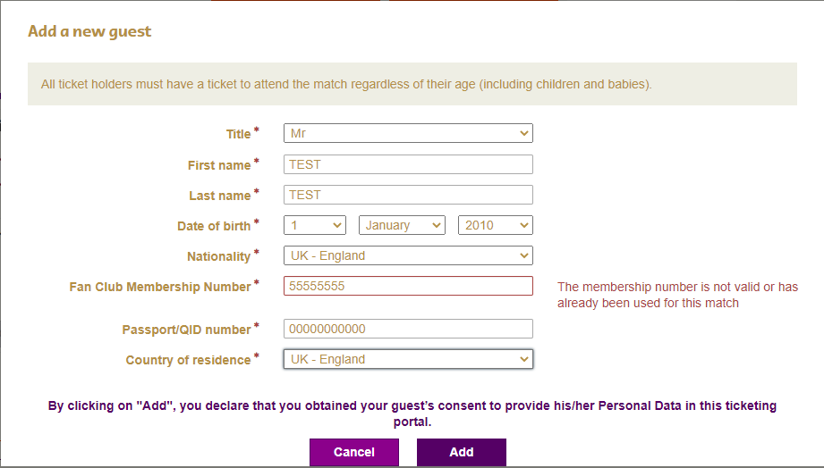

Step 8 – Applying for more tickets!
Once you have finished applying for a match you will be met with the following options.
You can either choose to submit your ticket application OR add more tickets for other games.
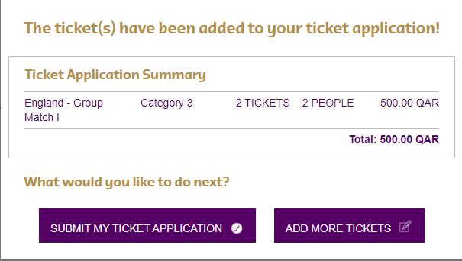

Step 9 – Increase your Chances!
Before you submit your application, you will be required to select whether you would be willing to be move categories to increase your chances of obtaining a ticket.
Should a match be oversubscribed, and we conduct a ballot, this option will give us the option of offering you a ticket in another category.
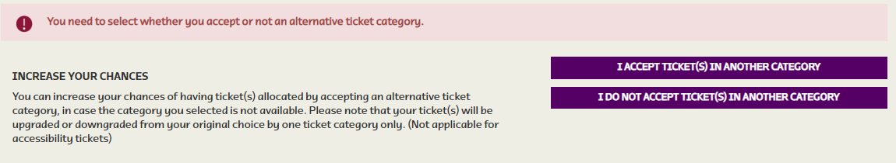

If you have any issues with your application, we advise that you check our FAQs page here. Otherwise, you can contact us directly at englandsupportersclub@thefa.com.

