Wiltshire

Disability Football

Fact Sheet 2023/24

Introduction
There are 9.4m people in England with a long-standing limiting disability, illness or condition which equates to 18 per cent of the population – almost one in five.

The good news is that there has never been a better time to get involved and play football, whatever your ability level.

We want to deliver a range of opportunities that sustain and grow opportunities for disabled people to participate and excel through football.

We are committed to creating positive environments in which football happens For All.

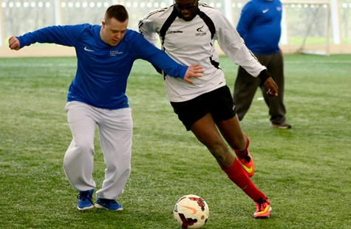

Disability football – a potted history
Prior to 1999 the development of disability football was limited and had no coherent national strategy.

The creation in 1998 of the Activity Alliance, the umbrella organisation for the eight national disability sports organisations, and the establishment by The FA of the football development department a year later, led to the development of the first disability football initiative: ‘Ability Counts’.

To read more about the history of Disability Football in England, follow this link: Disability Football at the FA

The strategic position
Today disability football is embedded across our 2020-24 Time for Change group strategy as well as our 2020-24 Survive, Revive, Thrive grassroots football strategy, ensuring the further development of disability football remains as one of The FA’s imperative goals.

Our philosophy is clear and guides all of our work within disability football. We believe:

- Appropriate opportunities (formal and informal) should be made available to all people whatever their level of ability;

- Disabled people should be playing in mainstream football, however we realise that some disabled players may be better provided for in settings such as ‘pan disability’ or impairment-specific football on a temporary or permanent basis and;

- Player development pathways should be available from grassroots to the elite level for various impairment groups, and that the resulting competitions structures should support the player’s development.

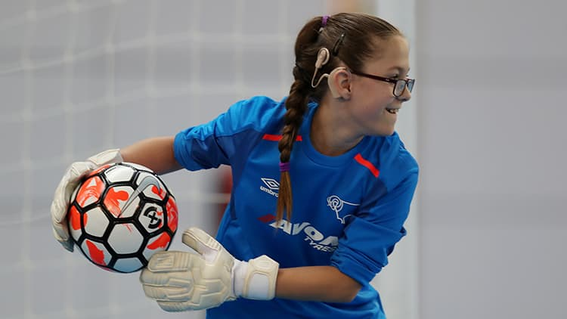

Dispensation policies

The FA dispensation policy

The FA’s rules, specifically the standard code of rules for youth competitions (SCORY), prescribe age groups for children to play in which are designed to ensure that they compete with peers of similar size and development.

However, for some children with a disability or significant physical development delay (SPDD), playing in the prescribed age group would put them at a substantial disadvantage to their non-disabled teammates, discouraging them from being involved or making it impossible for them to access football altogether.

The FA dispensation policy enables disabled children to play football in an age group other than that prescribed by their date of birth, providing all necessary criteria of the dispensation policy and assessment process is met.

(You can download a dispensation application pack and guide for parents in the resources on our website)

Mixed-gender dispensation

A pilot dispensation policy exists, specific to adult disability football competitions, in order to ensure there are still opportunities for females to play their own impairment specific format of football, even when there are not enough female players for a single-sex team or competition to be formed.

Adult disability competitions, such as the pan disability county leagues and the national impairment specific leagues, can request special dispensation to allow mixed-gender teams as a temporary measure, until the numbers become sufficient to have female-specific teams and competitions.

For more information about the adult mixed-gender dispensation policy for disability football please contact your local County FA, details of which can be seen here

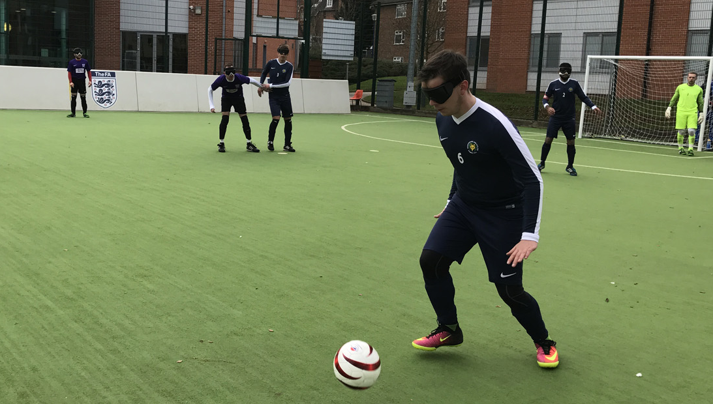
Age ranges

Youth disability football has dispensation to operate using a four-year age banding as opposed to the maximum two-year age banding within mainstream football. This is to ensure adequate player numbers to be able to establish disability teams and competitions across all areas of the country.

This means that an U16 competition could see players aged U13, U14, U15 and U16 playing together.
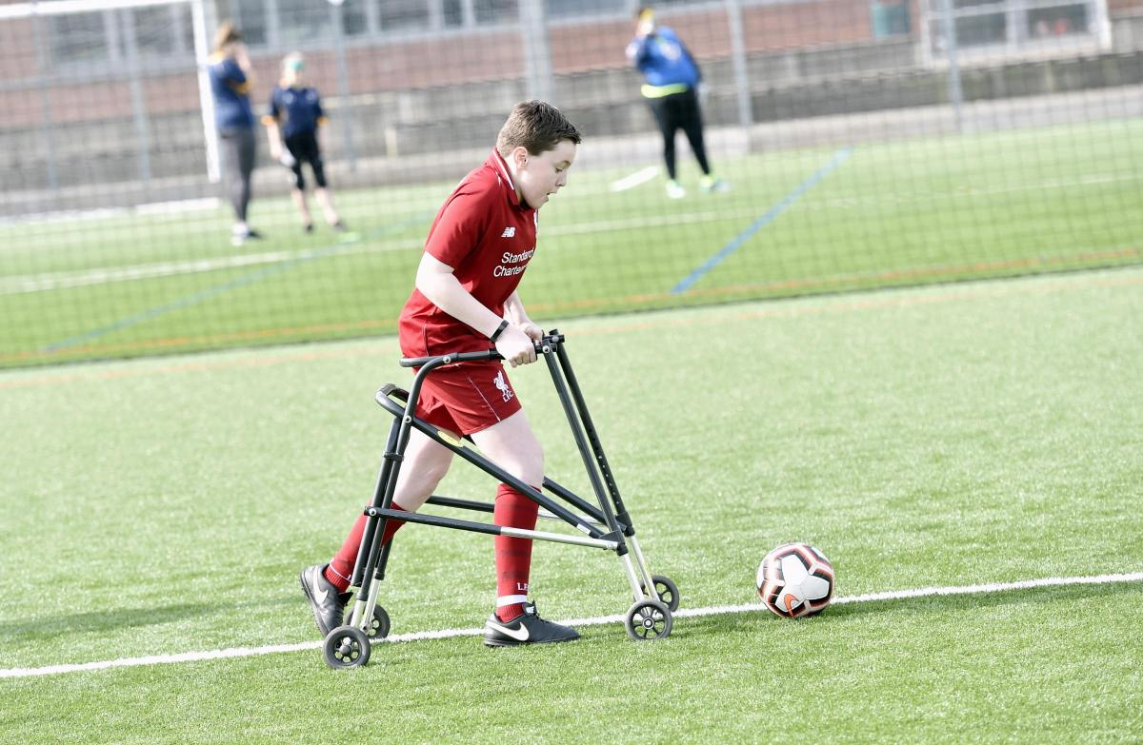

Pan-disability leagues and teams

There are now over 2,200 affiliated disability teams that mainly play across the 36-county pan-disability football leagues within England.

These teams and leagues form the foundation of the disability player pathway and provide an environment in which players can play competitively on a regular basis.

County leagues develop provision for a range of players playing pan-disability football: adult male; adult female; U16 mixed; U14 mixed; U12 mixed and more recently younger age groups such as U8 mixed.

The format varies but typically it will be either five, seven or nine-a-side with fixtures taking place monthly at a central venue throughout the football season.

County leagues work with County FAs to ‘signpost’ players that have the ability to participate in mainstream activity to the appropriate playing opportunities, allowing the leagues to focus their efforts on providing opportunities for players whose disability prevents them from achieving their potential in mainstream football.

The leagues adopt the principle of ‘ability banding’ where there are enough participating teams and clear differences in the ability level of players.

Disability Football in Wiltshire
In Wiltshire, there are plenty of opportunities to get involved with disability football.
Across the county we have numerous clubs that offer Pan-Disability football sessions.

To find out more about which clubs offer these sessions near you, please contact Harry Russell (Male and Disability Pathway FDO)

Email: Harry.Russell@WiltshireFA.com
Phone: 07788 596509

Ability Counts League
This season, we are restarting our Ability Counts League. This will be an organised competition that provides players up and down the county with the opportunities to play in 6 fixture dates throughout the year.

As the league has not fully been fully restarted, please wait for more information that will be released after our planned Ability Counts League Forum (Provisionally August 2023).

For more information on the league, please visit our website or get in contact with Harry Russell (Male and Disability FDO).

Opportunities to Provide Disability Football
At Wiltshire County Football Association, we are really keen for as many clubs as possible to provide disability football.
We want to make access to all football as easy as possible.

If you are part of a club that doesn’t already provide disability football and you have the aim to, please get in contact with us. We can help signpost you towards the best method of providing a disability pathway at your club.

See the graphic on the next page to learn about what disability community programmes consist of:
We can take you through what each programme represents, and which would be best suited to your club goals and what you are able to provide.

n.b. The Comets programme is still in the pilot phase and has not be rolled out nationally (19/07/2023)

