Resource Pack

Google Analytics

You need to have a Google account to set up Google Analytics. This is really easy and you can use any email address to do this.

If you don’t have Google Analytics, I would recommend starting the Google Analytics Academy to learn the basics and for a step-by-step guide to implementing it on your website.

Key terms to help monitor your website

- “Sessions” – the total number of sessions for the given date range.

- “Users” – the total number of users that visited during the given date range.

- “New users” – related to the first-time visitors to your site (this is triggered by a unique client ID which is created by your tracking code).

- “Page views” – the total number of times pages that included your Analytics tracking code were displayed to users (this includes repeated viewings of a single page by the same user).

- “Pages per session” – the average number of pages viewed during each session (this also includes repeated viewings of a single page).

- “Average session duration” – the average length of a session based on users that visited your site during the selected date range.

- “Bounce rate” – the percentage of users who left after viewing a single page on your site and took no additional action.

- “New vs. returning” – to the right of these metrics is a pie chart which displays the percentage of new vs returning visitors.

Google My Business

Setting up Google My Business is really easy once you have your Google Account set up. Not only does it increase your chances of showing up in local Google 3-Pack (the map), but when searching for your club by name, Google will also show up the knowledge panel (on the left).

The details are pulled straight from your GMB listing as well as other online sources and user-generated content.

- Log into the Google Account you want associated with your club.
- Go to google.com/business and select “Start now” in the top right-hand corner.
- Enter your club name.
- Enter your club address.
- If you go to your customers’ locations rather than having them come to you, check the box “I deliver goods and services to my customers.” If you work out of your house or another address you don’t want publicly shown, check “Hide my address (it's not a store). Only show region.” Finally, select your delivery area.
- Choose your business category. Try to choose the most accurate category possible – you’re essentially telling Google which type of customers should see your business listing.
- Add your club phone number or website.
- Choose a verification option. If you’re not ready to verify your club yet, click “Try a different method” then select “Later.”

How to Optimise Your GMB Listing
Go to the Google My Business dashboard, click the listing you'd like to work on, select "Info" and then choose a section to fill out or update.
Add as much information and media as you can, including a business profile photo, the area you serve, your hours, attributes (e.g. "wheelchair accessible," "free WIFI"), the day and year you opened, a public phone number and website URL.
Anyone can "suggest an edit" to your listing, so it's important to A) get everything right the first time (so you don't encourage random people to make their own changes) and B) periodically log into your GMB dashboard and make sure all the details look right.
According to Google, businesses with photos see 35% more clicks to their website and 42% higher requests for driving directions in Google Maps.
Photos should be at least 720 pixels wide by 720 pixels high and saved as JPG or PNG files.

Google Alerts
Using your Google Account, you can set up Google Alerts which is a great way to track mentions for your club and the latest news from the FA.

What Google Alerts give you

Simple keyword monitoring. You'll be able to track any keyword on the sources that Google tracks. That means blogs, forums, news sites and the wider web. It also includes YouTube since Google owns that platform.

Mentions delivered to your inbox. GA will send every mention of these keywords to your email inbox. You can also view them at google.com/alert any time.

In real(ish) time. Google lets you choose the frequency at which you'll receive them. One option is to get them as they happen. So, as soon as your keywords are mentioned online, you'll be notified by email. You can also elect to receive all your mentions once per day or once per week.

How to set up Google Alerts
It's very easy to create useful Google Alerts. Here's how it works:
- Go to google.com/alerts. Make sure you're logged in with the Google account you want to use.
- Choose your keywords. Try to make them unique. Brand names like Apple and Orange are just going to bring back noise.
- Select the frequency. The choice here is really "real time or when I have time?" If you want to receive notifications in close to real time, select "as it happens."
- Choose your sources. Google Alerts doesn't cover social media, but you can choose whether to track news, blogs, videos or even books.
- Select the language. If you only care about one specific language, now's your chance to make that choice.
- Choose the region. If your brand is present only in specific countries – or if you're expanding into new markets – this can be valuable.
- Choose between "only the best" and "everything". In other words, do you want every mention of your keywords or will you let Google choose the most important ones?
- Select the email address to deliver to. This will be the one you're logged into, but you could send your Alerts to an RSS feed if you prefer.
- Hit “create alert”. We're live!

On-page SEO vs Technical SEO

Technical SEO refers to optimising your site and site structure for search engines to crawl, index and understand your site quickly and efficiently.

SSL stands for Secure Sockets Layer. SSL is a secure protocol developed for sending information securely over the internet. Having an SSL keeps your name, address and credit card information (if they need to purchase through your site) between you and your player. Google rankings now favour websites that have an SSL certificate.

Site speed: Google uses your site speed as a ranking factor now. You can evaluate your page speed with Google’s PageSpeed Insights. Page Speed is also important for user experience. Pages with a longer load time tend to have higher bounce rates and lower average time on page. To increase your page speed, you should enable compression, reduce redirects, optimise images and minify CSS, Java Script and HTML (to name a few).

Meta description: The meta description is an HTML attribute that provides a brief summary of a web page. Search engines such as Google often display the meta description in search results, which can influence click-through rates.

On-site or on-page SEO refers to optimising your content both for search engine rankings as well as for users (you want them to see you in the SERPs and be attracted to what you may have to offer).

From an SEO perspective, all good content has two attributes. Good content must supply a demand and must be linkable.

Just like the world’s markets, information is affected by supply and demand. The best content is that which does the best job of supplying the largest demand.

From an SEO perspective, there is no difference between the best and worst content on the internet if it is not linkable. If people can’t link to it, search engines will be very unlikely to rank it and as a result, the content won’t drive traffic to the given website.

Social Image Sizes

- Twitter – 1200 x 675
- Facebook – 1200 x 628
- LinkedIn – 1200 – 628
- Instagram – 1080 x 1080

Sporting Connect
http://www.sportingconnect.com/surreyfa/

Safeguarding Resources:
http://www.thefa.com/football-rules-governance/safeguarding/section-6-safeguarding-in-the-digital-world

Surrey FA Player Noticeboard:
http://www.surreyfa.com/leagues-and-clubs/players-and-people/find-players

Social Image Templates

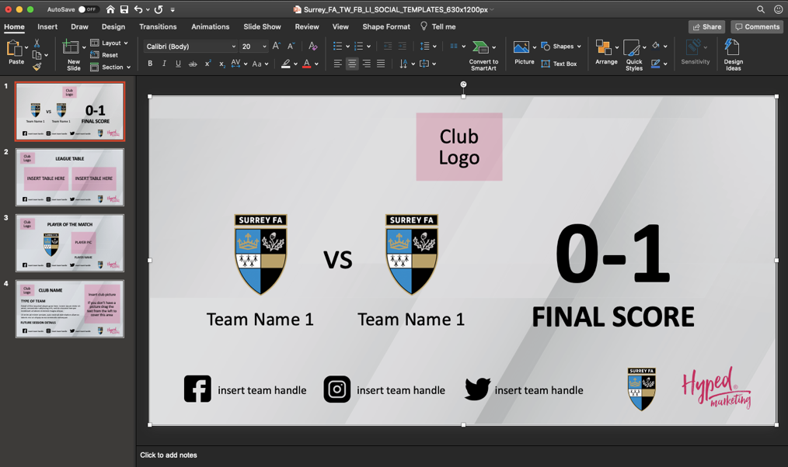
Select the background and go to the fill bucket to change the background to your team colours!
Simply drag your image over the placeholder box.

If your image is too small, simply delete the box in the background.
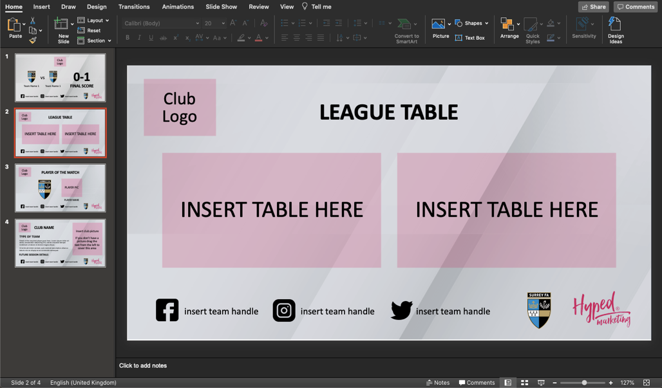

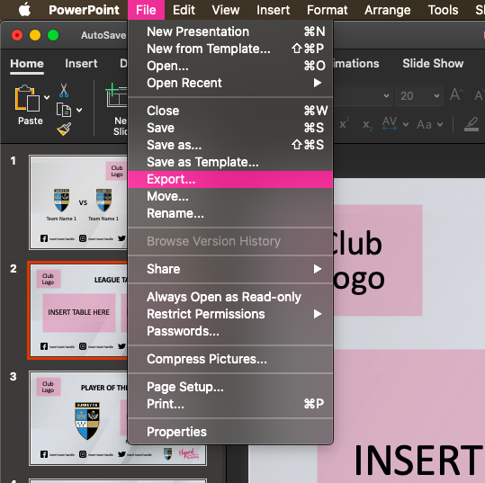
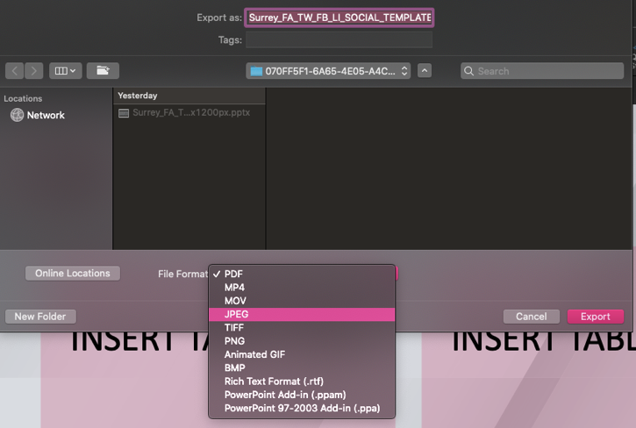
When exporting your photos, go to “file”, then “export” and make sure you select JEPG or PNG.

