Administrative Rules & Regulations

- Name & Management of the Competition
- The competition shall be named_______________________________________________
- The management committee, which shall include a Chairman and Secretary, shall be elected either at the Annual General Meeting or another General Meeting arranged for that purpose.
- The competition shall be governed by the laws of the game as determined by The FA. All matches shall conform with relevant rules relating to either ‘Mini-Soccer’ or ‘Small-Sided Football’ as issued by The Football Association.
- The competition shall be sanctioned by Suffolk County FA and all those competing shall be subject to the rules and regulation of the association.
- All Clubs shall be affiliated to Suffolk FA or another County FA.

2) Entry Fees
The entry fee for Clubs to partake in the competition shall be £ _______ per team.
Unaffiliated Clubs are not permitted to partake in the competition unless they pay a ‘one-off’ affiliation fee to Suffolk FA to affiliate them, prior to the date of the competition. No team may partake in the competition under the name of an affiliated Club without their full knowledge and approval.

- Management Committee
The Management Committee shall comprise of a total of people who shall be responsible for the management of the competition. These people shall comprise of:

Secretary: _____________________________
Chairman: _____________________________
Member: _____________________________
Member: _____________________________
Member: _____________________________
Member: _____________________________
Member: _____________________________

The Management Committee shall act upon and enforce the rules of the competition and have jurisdiction over all matters affecting the competition. They shall also adjudicate in all cases of dispute, protest or complaint.

4) Competition Rules
A copy of the competition rules shall be sent to all competing Clubs and to Suffolk County FA at least 21 days prior to the scheduled date.

5) Competition Format
- The competition shall be divided into the following age groups (select as appropriate)

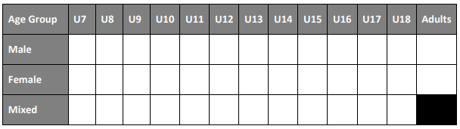

- All competing teams shall complete a player registration sheet, providing the name (and date of birth for youth competitions) which shall be returned to the Competition Secretary prior to the commencement of the competition.

- The competition shall provide football in line with FA Regulations in the format as specified below (tick as appropriate).

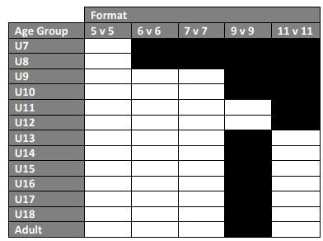

- The competition shall be played on the following basis (select as appropriate)

Format | Tick if Applicable
League Basis Only
League Basis & Knock Out
Knock Out Basis Only
Development Festival

League Basis Only
The competition shall be played on a league basis as determined by the Management Committee and each team shall play each team within the league once. Three points will be awarded for a win and one for a draw. If two teams are level on points the team with the best goal difference shall take precedence (Note: Goal difference should not be used for youth football, a play-off match should take place). If the goal difference is still level, the team scoring the most goals shall take precedence. If still level, the score in the match between the two teams shall be used with the winner taking precedence. If still level, a play-off match should take place to determine rankings.

League Basis & Knock Out
The competition shall be played on a league basis (firstly) as determined by the Management Committee and each team shall play each team once within groups determined by the Management Committee. Three points will be awarded for a win and one for a draw. If two teams are level on points the team with the best goal difference shall take precedence (Note: Goal difference should not be used for youth football, a play-off match should take place). If the goal difference is still level, the team scoring the most goals shall take precedence. If still level, the score in the match between the two teams shall be used with the winner taking precedence. If still level, a play-off match should take place to determine rankings.

Following the league stage a knock-out competition shall take place between _______ teams who shall be the top ________ team(s) from each group. The Management Committee shall make the draw for the knock-out competition.

Knock Out Basis Only
The competition shall be played on a knock out basis. The draw for the competition shall be made by the Management Committee.

Development
All age groups are permitted to play in competitions where results are collected/published (including those who do not normally do so) for the purpose of summer tournaments only. Trophies may be presented to the winners of the competitions if deemed necessary to do so. The age groups where results will be collected/published shall be indicated on the line below.

6) Club Colours
- Clubs shall notify the competition of their choice of Club colours (which must not be black shirts) when returning their application form. Should there be a clash of colours between two competing teams, an alternative (which may be bibs) shall be worn. In the case of bibs being required the tournament organisers shall provide them.
- The goalkeeper must wear colours that distinguish him/her from outfield players.

7) Match Duration
All matches shall be played in two equal periods of _______ minutes. In the event of a draw in the knock-out stage of the competition, two halves of ______ minutes shall be played. If scores are still level after extra time, penalties shall be taken in accordance with the laws of the game.

8) Squad Sizes and Substitutes
When playing Mini-Soccer the size of a squad must not exceed double that of the number of players in the team per age. (e.g. 5-a-side, max number is ten players). Repeat substitutions (rolling subs) are permitted in every age category. The maximum number of players permitted per team for small-sided football (not including Mini-Soccer) is as per the below table.

Format | Maximum Squad Size
5-a-Side | 8
6-a-Side | 9
7-a-Side | 10

9) Match Result Cards
The winning captain of each team or the referee shall return the match card to the Competition Organiser upon the conclusion of each match.

10) Match Officials
Referees shall be appointed by the Management Committee and shall be, as far as possible, registered with Suffolk FA. Referees will be entitled to a fee of £ _____ plus expenses of £_____

11) Protests and Appeals
All questions of eligibility or players or rule interpretations shall be referred to the Management Committee whose decision shall be final and binding. Any appeal against a decision of the Management Committee must be made to Suffolk FA within 7 days of the decision and accompanied by an appeal fee of £25.

12) Misconduct
Serious misconduct must be reported to Suffolk FA or the relevant County FA.

SSTF Part 3 – Participating Clubs

Club Name | Club Contact Name & Number | Age Groups Entered
Example United | Dave Smith – 01234 456789 | U8, U9, U13, U16

Confirmation of Sanction Approval

(To be completed by Competition Secretary)

I confirm that the teams stated on SSTF – Part 3 as listed above are affiliated to a County FA.

Signed: ___________________________ Name: _______________________________

Role: _____________________________ Date: ________________________________

---------------------------------------------------------------------------------------------------------------------------------------------------------------------

(To be completed by Suffolk FA)

Suffolk FA confirms the sanctioning of ____________________________________________________

Sanction Number ______________________ Date Confirmed: _________________________

Signed: ___________________________ Name: _______________________________

Role: _____________________________ Date: ________________________________

