8th January 2018

Dear Colleague,

FA Groundsman of the Year Awards 2017/2018

Following the success of last season’s Groundsman of the Year Awards, please find attached a copy of the Nomination Form for the 2017/2018 competition. We would again be grateful if you could nominate up to three candidates from your member clubs at Step 7 and below and rank them first, second & third. The first ranked club will then go forward to our national judging stage and undergo independent adjudication. The Groundsmen at this level of football are nearly all volunteers who give up hours of their time to provide the best pitches possible using very few resources. This competition is a great way for these volunteers to get recognised on a local and national level whilst also having the opportunity to meet and talk with the professional Groundsmen who conduct the judging.

Summary of 2016/2017 Awards

The Awards Day followed in the footsteps of the successful 2016 competition and took place in mid-August at St George’s Park. The nominees were given a guided tour of the site as well as an insightful presentation from Karl Standley (Head Groundsman at Wembley Stadium) and also a question and answer workshop with professional groundsmen from Southampton and Manchester City along with Karl from Wembley. The awards ceremony took place in the afternoon with members of The FA Facilities Committee presenting the winners with their certificates and trophies.

The winners were then invited as special guests for the England v Slovenia friendly fixture in October. The winners enjoyed the hospitality on offer before being treated to an opportunity to join the Wembley Ground Staff next to the pitch at half time. The feedback we received from our guests was overwhelmingly positive and we are extremely excited to see what this season brings.

If you have any questions about this please contact me using the details below. We look forward to receiving your nominations and would like to thank you for your continued support of the Awards.

Yours faithfully,
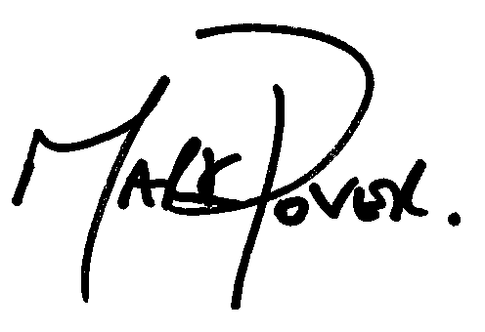

Mark Pover
National Facilities and Investment Manager
FacilitiesInfo@TheFA.com

