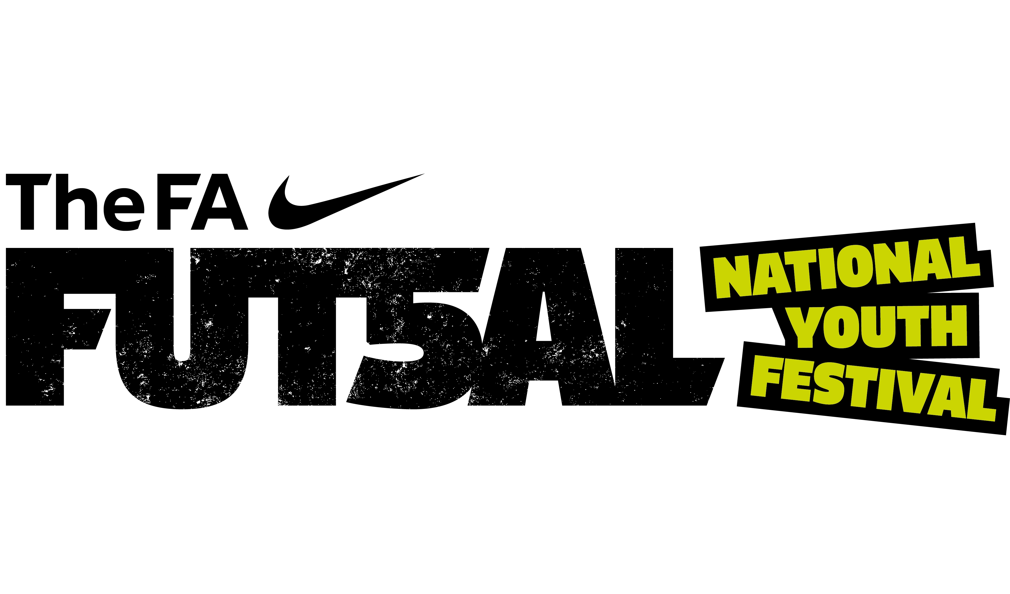

Shropshire FA County Futsal Qualifying Competition
Team Entry Form
Shropshire FA’s County Qualifiers for The FA Futsal National Youth Festival will be taking place on Thursday 12th April and Friday 13th April 2018 at TCAT, Telford College of Arts & Technology, Haybridge Rd, Wellington, Telford TF1 2NP
Thursday 12th April 2018 Friday 13th April 2018
AM - U10 Boys AM - U12 Boys
PM - U14 Boys PM - U16 Boys

Club
Team Name
Age Group | U10 | U12 | U14 | U16
Gender | Boys |  | Girls
Team Contact
Contact Email
Contact Number
Signed |  |  | Date:

Please note all team entries must be submitted no later than Monday 2nd April 2018.
Please return this form to Darren Beech, Football Development Team Leader, Shropshire FA, Oteley Road, Shrewsbury, SY2 6ST or Darren.Beech@shropshirefa.com . For more information, call 01743 362769.

