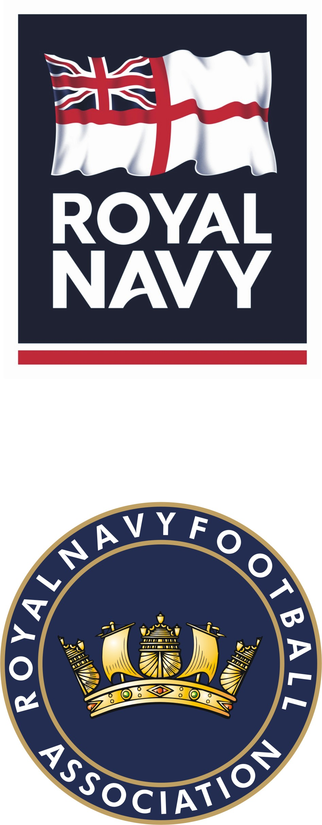 | Royal Navy Football Association  (Founded 1904)  Patron: HM QUEEN ELIZABETH II  Charity No:1164897 | The Secretary  HMS TEMERAIRE  Burnaby Road  PORTSMOUTH  PO1 2HB
Telephone: 02392 573032
Military network: 9380 28032
Email: navynps-peoplesptrnso3a@mod.uk

Our reference: RNFA/NC1718

See Distribution 2 Aug 17

ROYAL NAVY FOOTBALL ASSOCIATION – NAVY CUP 17/18 – SPONSORED BY IVOR DEWDNEY PASTIES

References:

A. RNFA Handbook
B. BR51 Vol 4

1. Introduction. The Royal Navy Football Association (RNFA) Cup will run from Sep 17 through to Apr 18 with a total of 24 teams entering the competition.

2. Competition Format. To ensure the competition best reflects the overall intentions and needs of the teams entering the competition, each team was asked to choose one of the following three formats i) a straight knockout competition ii) Cup and Plate knockout and iii) Champions League format. The overall majority voted in favour of a straight knockout competition therefore this is the chosen format for the competition.

3. Team Manager’s Responsibilities. The home Team Manager will be responsible for making all necessary arrangements for fixtures. In addition, both Team Managers must email POPT Charrett a completed Team Declaration Sheet and Referee Marking Form (Annex A&B) within 3 days of a fixture being played.

4. Fixtures and Results. All competition fixtures and results can be accessed via the following link:

https://fulltime-admin.thefa.com/league/comp/displayCompetition/readCompetitionForDisplay/600503471.html

5. Regional Referee Appointers. A list of Regional Referee Appointers can be found via the RNFA website www.royalnavyfa.com/referees/rnfa-referees-committee

6. Match result. The winning team after full time will progress through to the next stage of the competition. If a match ends in a draw, it will go straight to penalties in accordance with FIFA rules and regulations. The only occasion that 30 minutes of extra time will take place before penalties, is in the instance of a draw during the Semi Finals/Final.

7. Navy Cup Final. The RNFA will make all arrangements for the Navy Cup Final. The venue will be confirmed as the competition progresses to establish a suitable location for the teams that reach the final.

8. Rules. A copy of the rules can be found at Annex C. All Team Managers are to ensure they have read the rules and any questions are to be forwarded to POPT Charrett.

9. Recreational Travel. Recreational Travel is chargeable to Local Unit Budgets iaw JSP 752 Chap 4 para 0203.

10. Composition of Teams. Personnel may only play for the unit to which they are assigned. Where a unit is unable to enter a team of its own, personnel of that team must compete for that units accounting base. The rules of eligibility are laid down in Reference A, which allows up to 25% of the team to be Army, RAF and Foreign or Commonwealth (up to 5 out of 18). MOD civilians are not eligible. Accounting bases e.g. HMNB Portsmouth, HMNB CLYDE and HMS DRAKE are to declare which units are thus included in their own entry.

Signed on Original

S H Johnson
RNFA Secretary

Annexes:

A. Team Declaration Sheet.
B. Referees Marking Form.
C. Navy Cup Rules.

Distribution:

RNFA Executive Committee
PT Specialisation Advisor
Regional WOs
Regional CPOPTs
RMFA Secretary
Ships and Establishments

Annex A to
RNFA/NC1718
Dated 2 Aug 17

TEAM DECLARATION SHEET

Both Team Managers are required to complete a Team Declaration Sheet

Home Team: … …………………………. Away Team: ………………………………….

Round: ………. Date: …………………….. Venue: ………………………………

Referee: …………………….. Assistant: …………………. Assistant: …………….

PART 1
No | Rank/Rate | Name | Official No | Actual Place of Work
GK
2
3
4
5
6
7
8
9
10
11
12
13
14
15
16
17
18

PART 2
Result - Home Team: ………………………. Away Team: …………………….

N.B. Part 1 of the Team Declaration Sheet is to be completed prior to the kick off and then forwarded to POPT Charrett within 3 days of completion of a fixture being played in accordance with Reference A. Any substitutes who have entered the field of play are to be marked with an asterisk*.

Signed: ………………………… Name: ……………………………. Rank/Rate: ……………

Contact No: …………………………………….

Annex B to
RNFA/NC1718
Dated 2 Aug 17

REFEREE’S MARKING FORM

Both Team Managers are required to award the Referee a mark in all matches on a scale of 1-100 based on the following guide.

Assessment of Referee
(Please print)
Match ……………………………………........…… v …………………………………….........…..

Date ………………............... Competition......................................................................

Name of Referee ……………………………….................................

Overall control and decision-making

The mark must reflect the referee’s overall level of control, accuracy of decision-making and management of players. When deciding on a mark, consideration should be given to such aspects of the referee’s performance such as: impartiality, confidence, fitness, positioning, signalling, use of advantage and handling of major incidents

A mark between 91-100 would be regarded as ‘excellent’

A mark between 71 and 80 would represent the standard expected

Our club awards an overall mark of out of 100

When awarding a mark of 50 or less, an explanation must be provided in the box below to POPT Charrett with comments, which could help the Referee improve future performances.

(Signed) …………………………………………… (Team Manager)

Club………………………………………… Date ……………………………

To be returned to POPT Charrett within 3 days of a fixture being played.

Annex C to
RNFA/NC1718
Dated 2 Aug 17

NAVY CUP RULES

Presented to the RNFA for Competition by The Officers of The Fleet and Harbour Establishments in 1912

1. The Cup. The Cup shall be called the “Navy Cup” and shall not become the property of any one club. It shall be played for under the rules of the Football Association.

2. Trustees. The Secretary of the Royal Navy Football Association shall for all intents and purposes be the owner of the Cup, in trust for the Association.

3. Control and Organisation. The entire control and management of this Competition shall be in the hands of the General Council for the Royal Navy Football Association.

4. Eligibility.

a. Teams – The competition shall be open to teams selected from Naval or Royal Marine Establishments, Naval Air Stations, Ships or Submarines to which they are drafted by the Commodore, Captain Naval Personnel (CNPers) or other drafting service authority.
b. Players – As prescribed in the Royal Navy Sports Handbook
N.B. Should it be proved that a team includes an ineligible player, such a team will be removed from the Competition or the match ordered to be replayed as the Executive Committee of the RNFA may decide.

5. Ineligibility of Players. A player having played in one Cup Tie shall not be eligible to play for another team during the same season in the same competition, but players who have played in one Cup Tie may continue to play for the same team during the season even though serving elsewhere.

6. Management. All matches will be wholly administered by the Assistant Secretary of the RNFA.

7. Match Venue. In all matches the first named team shall have the choice of ground.

8. Match Officials. Referees and Assistant Referees will be appointed in accordance with the Regulations for Control of Referees.

9. Official Responsible for Teams. In all matches, in addition to the competing teams, a representative of each team shall be present throughout the match and shall be responsible that the composition of their team is in accordance with the competition rules.

10. Team Scratching. Teams intending to scratch must intimate their intention to the RNFA Secretary and the opposing team not less than seven days (7) before the date on which the match is scheduled to be played, failing which the RNFA Executive Committee shall have the power to impose a fine of £25.00 on the offending Club and compel them to pay any expenses incurred in connection with the match.

11. Names of Players. Every club playing in this competition shall, 30 minutes before each match starts, through the Captain of the team, hand to the opposing Captain and Referee a list of their players, signed by a representative..

12. Protests. Any objections relative to grounds, goalposts, bars or other appurtenances of the game must be lodged by the protesting club with the Referee 30 minutes before the start of the game, and cannot be withdrawn without the consent of the RNFA Secretary or his representative. Any other protests must be lodged with the RNFA Secretary, within three days (excluding Sunday), accompanied in all cases by full details in writing and a deposit of £25.00, which may be added to the funds of the RNFA if the protest is not sustained. All protests must be forwarded in duplicate.

13. League Placing. In the event of teams being level on points after the group stage, the final positions will be decided in order by:

a. goal difference.
b. number of goals scored.
c. the match result between the two teams.
d. the result of the sudden death penalty shootout between the two teams.

14. Duration of Match, Extra Time and FIFA Penalty Kicks. The duration of each match shall be two equal halves of 45 minutes. In the event of a draw in the Semi Finals and Final 30 minutes extra time will be played. Should the match result in a draw after extra time has been completed, the FIFA Penalty Kick Clause will be applied.

15. Goal Nets. Goal nets must be used in all matches.

16. Colours. Where the colours of the two competing teams are similar the second named team must change.

17. Mementoes. In addition to the Cup, the Association shall present mementoes to both teams taking part in the Navy Cup Final.

18. Substitutes. In accordance with General Rules of the Royal Navy FA Competitions, Section 3.

19. Discipline. All discipline reports received from match Officials will be dealt with in accordance with the current Football Associations Memorandum of procedures.

