Role Profile
Job title | RAF Football Association – FA Council Member
Reports to: | Chairman | Jobs Reporting into the Job Holder: |  | All Members of RAF FA Board of Trustees  (Organisational Chart Attached)
- Job Purpose
The role is to represent the RAF FA and RAF Football at The Football Association in promoting football at all levels and in assisting with the delivery of the RAF FA Strategy and Vision and meeting the (FA endorsed) strategic objectives cited within the 2021-2024 Business Reset Strategy. Key to this is the objective to, ‘Re-generate, evolve and expand participation at all levels, providing opportunities for all.

- Principal Accountabilities/Responsibilities
To support the RAF FA Board of Trustees as the link into The Football Association, the Council and its Committees, you have the following responsibilities: •

- Represent the RAF FA on the FA Council, including attendance at 5 FA Council Mtgs per season (or as organised).
- Represent the RAF FA at FA Council Members Mtgs on up to 4 occasions per season (or as organised).
- Represent the RAF FA and The FA on nominated Committee Mtgs as directed by The FA.
- Sit as a Trustee on the RAF FA Board of Trustees; commitment is 3-4 meetings per year.
- Ensure the RAF FA is adequately represented at The FA for all matters of Grassroots football.
- Ensure the RAF FA is aware of programmes of change, updates, interaction and participation raised by The FA.
- Make the RAF FA aware of issues raised by The FA on matters across all football.
- Back brief the RAF FA Board of Trustees on FA matters.
- Constant engagement with the RAF FA HQ Permanent Staff on matters relating to The FA.
- Maintain interaction with the Director of Sponsorship WRT Sponsorship availability at England home Internationals held at Wembley Stadium. Host guests on behalf of the RAF FA at such events.
- Maintain interaction with the Director of Sponsorship WRT sponsorship/hosting at FA Cup Semi Finals and Finals held at Wembley Stadium. Host guests on behalf of the RAF FA at such events.
- Contribute to raising the profile and the perception of the RAF FA in leading and developing grass roots football.
- Identify, manage and develop relationships with key partners (including sponsors) to meet the objectives and targets of the RAF FA.
- Undertake and support the compliance of Safeguarding 365.
- To support the England Football Accreditation Programme.
- Support the delivery of the Association’s 3-year business strategy, annual operational plan and FA KPIs
- Promote an inclusive working environment.
- Assist the RAF FA President in their duties at The FA including assisting with their bookings.

- Knowledge/Experience/Technical Skills/Behaviours
- Knowledge/Experience/Technical Skills/Behaviours
Essential: |  |  | Desirable:
· Knowledge of the structure and organisations within RAF FA  · Held previous positions within the RAF FA  · Knowledge of The FA and its Council and working practices  · Ability to work with partner organisations to deliver Football Development objectives  - Demonstrate a working understanding and application of inclusion, equality and anti - discrimination, safeguarding and best practice |  |  | · Practical experience of Sports / Football Development  · Demonstration of equality in action
b) Key skills – as defined in County Football Association Competency Model |  |  | Key Information
· Problem Solving  · Teamwork  · Communicating  · Delivery  · Customer Excellence  · Developing Self and Others  · Leadership |  |  | - Essential that the selected individual is of sufficient experience in English football to represent the largest Sports Association in the RAF at The FA.  - Time commitment demands regular engagement, with the post holder being able to utilise their diary to ensure maximum attendance as required by The FA and the RAF FA.  - Post holder must be able to attend FA Council Mtgs and any subsequent Committees of The FA Board or Council and enter into commitments as required.
Further Information
- Will the job-holder have direct access to young persons under the age of 18, within the context of the job or any subsequent related activities or responsibilities? Dependent upon which Committees the Representative gains at The FA.

Completed by Name/Role Signature Date
Signature
Date
This job description is only a summary of the role as it currently exists and is not meant to be exhaustive. The responsibilities/accountabilities and skills/knowledge/experience/behaviours might differ from those outlined and other duties, as assigned, might be part of the job.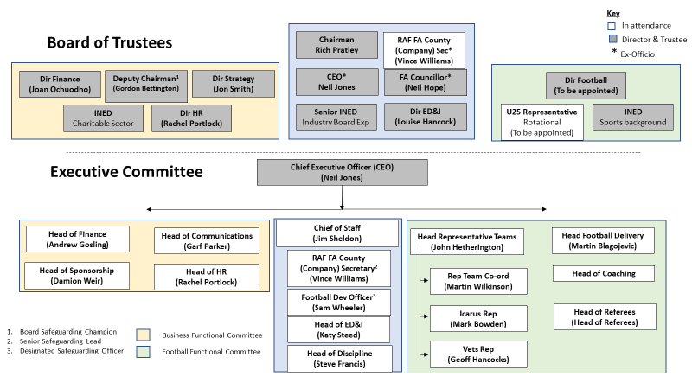

https://www.thefa.com/-/media/cfa/royalairforcefa/files/stratagies/raf---2021-24-business-reset-strategy_v7.ashx?la=en

