**UK Armed Forces Football Association E-Bulletin**

5 Nov 17

**MATCH REPORT**

UK Armed Forces 1 Vs Dutch Armed Forces 1

**HMS Temeraire, Portsmouth, ?? on October 2017**

FS Nick De-Long’s UKAF charges were given two options in their bid for Kentish Cup glory and history as they took to the field at HMS Temeraire, Portsmouth. A draw or a win over the Dutch Forces side would secure a hat-trick of cup wins and it was the former they had to settle for.

Having won their opening game over the French Armed Forces 2-1, De-Long’s men were buoyed following the 2-2 midweek draw between the French and Dutch teams. With a handful of changes to counter the unusual Dutch semi-long ball approach and height advantages of their midfield, the UKAF manager watched a slow, but positive start to the game as UKAF hassled and harried the men in orange in slippery conditions.

Cpl Tom Claisse, team captain who is celebrating five years in the role, said: “I missed out on the first game but the lads have been brilliant and they were brilliant in the opening game and I did not expect to play to be honest, but it was great to come on play my part on the pitch and I’ve tried to maintain my role off the pitch, with what is a brilliant bunch of lads.

“We have some massive characters in the squad, so it’s a pleasure to be involved. This is what we work for, the backroom staff, players and unknown people who have been grafting for us, it’s really good.

“Going back three or four years the squad would have been three different groups, but not anymore. This dream run can go on for years now, we have lads behind us who are more than capable to carry this on.”

The usual Dutch passing game wasn’t present from the off and great work from L/Cpl Peter Williams and AET Danny Earle then led to a great opening chance from L/Cpl Danny Stoneman. His 20-yard jinking run on the right saw him shoot from the edge of the area, forcing a good save from Dutch keeper Vendrig. A minute later, Cpl Callum Wilkinson rose highest but his backward header bounced narrowly away from his team mates.

By the 20 minute mark the UKAF men were slowly getting to grips as the Dutch team went into their shell and Pte Josh Hughes started causing havoc on the wing. On the half hour Earle received a yellow card after going for the ball and connecting with Vendrig in the visitors goal. Ten minutes later a powerful run from stand in captain L/Cpl Rob Farkins from inside his own half began the best move of the game and subsequent opening goal.

Power through the inside right position shadowed by Dutch midfielders found Hughes with a perfectly timed one-two before sending a second pass out wide which the Navy man fired across the box for AET Danny Kerr who fired home beautifully.

A chance for a second came from a Cpl Alex Woodhouse 42nd minute free kick that was headed over by Farkins. On the stroke of half-time Dutch defender Schur nearly headed into his own net, with Vendrig somehow pushing the ball to safety.

The second half saw the hosts produce a comfortable display with some promising attacks that were not put away, which would unfortunately come to haunt them late on.

On 54 minutes Wilkinson weakly hit a gilt edged chance straight to the keeper from 12 yards, minutes later Woodhouse put Todd (on for Wilkinson) through with a defence splitting forward pass, but the ball became stuck under his feet and the chance was gone.

On the hour some fabulous passing from Stoneman, Woodhouse and Todd had the Dutch chasing shadows, while Kerr then shot instead of passing to better placed team mates.

The game turned in a 30-second window on 70 minutes, as a superb break from the hosts saw Stoneman shoot instead of passing to the well placed Todd. The Dutch countered quickly and Sgt Carls Evans was harshly adjudged to have handled the ball and the men in Orange levelled form the spot.

A different looking Dutch team now bombarded the UKAF half, with stalwart defending being the order of the day from the hosts, despite some nervous clearances getting the crowd holding their breath.

Having made it to the 90 minute mark it was down to keeper L/Cpl Luke Cairney to save the day with two brilliant moments with the gloves, tipping one volleyed effort over acrobatically. Manager De-Long was then sent to the stands as the atmosphere became fraught, and there was still time for a diving header from Farkes to clear a bullet shot form 10-yards and keep the score line level to bring the Kentish Cup home again.

UKAF chairman Air Cdre Simon Harper said: “I am delighted for Nick and the team, they have worked so hard to reach this point. It is genuinely a team effort, we should have scored a second and to see the strength of UKAF football now, we have to retain the Trophy in France next year.”

FS De-Long, who described himself as emotional after the final whistle, said: “We defended well, we had to be careful, and we got the victory, it was more squeezing than pleasing, but we have earned the right to be the best and we are the best.”

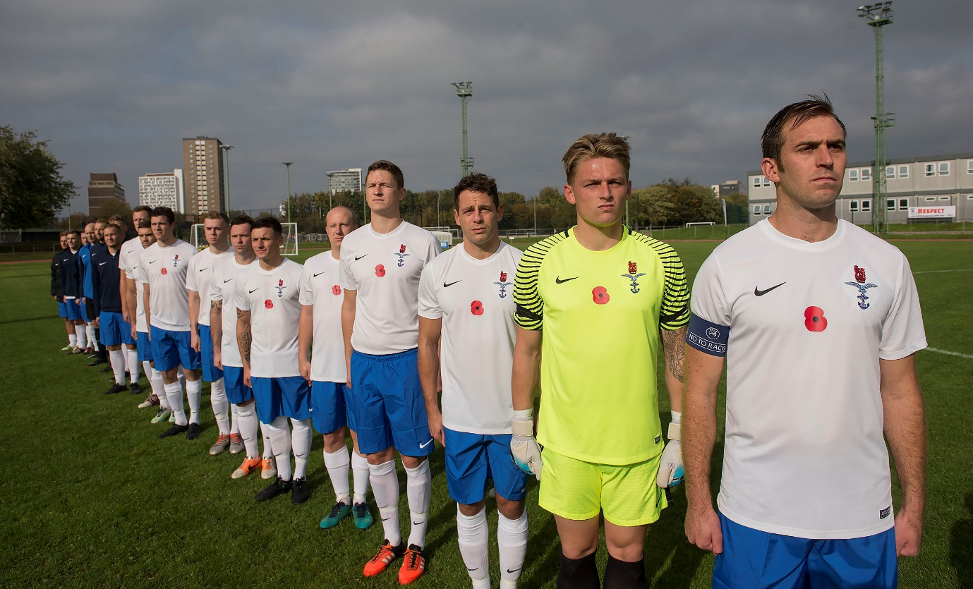

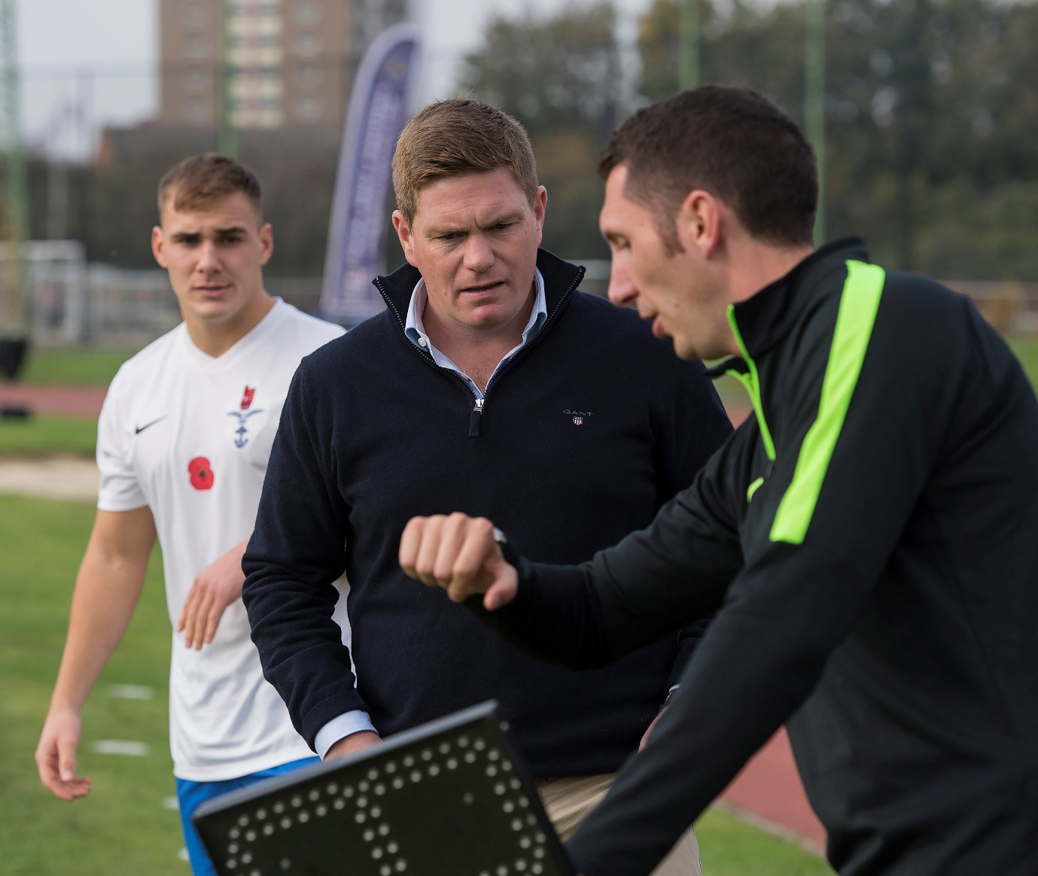

UKAFF Supported by



