**UK Armed Forces Football Association E-Bulletin**

5 Nov 17

**MATCH REPORT**

UK Armed Forces 2 Vs French Armed Forces 1

**HMS Temeraire, Portsmouth, 14.00 kick-off on Sunday 15th October 2017**

A second half strike from substitute CPO Andrew Todd proved decisive as defending champions UKAF kept their Kentish Cup 2017 dreams alive with a hard-fought 2-1 victory over the French Armed Forces (FAF).

UKAF Manager FS Nick De-Long announced his starting eleven three hours before kick-off.  De-Long asked for 100% commitment from his players and that is exactly what he got from them in a competitive match where both sides gave their all.

The early exchanges in the first half saw the FAF dominate possession without really creating too many gilt-edge chances; thanks to some excellent defensive work from captain, L/Cpl Rob Farkins, who was skippering the side for the first time.

The first real chance of the match came after six minutes when the FAF had a chance headed off the line by home skipper L/Cpl Farkins. UKAF then seemed to up their game and broke the deadlock after 26 minutes through front man Cpl Callum Wilkinson.  The goal came after a Wilkinson free-kick was saved by the FAF goal-keeper, who then saved a rebound effort from PTE Josh Hughes. The ball found its way back to Hughes who crossed the ball to the back post and Wilkinson made no mistake from six yards out – much to the delight of the home crowd.

The home side then looked to double their lead, with AET Danny Earle and Pte Hughes looking dangerous on the counter-attack.

On the stroke of half-time, the visitors won a free-kick from 25 yards out which SDT Mareval Remi struck beautifully with his left foot onto the UKAF crossbar and then out for a goal-kick.

Remi was causing the home side all sorts of problems with his creativity and movement, and it was to no surprise to anyone in the crowd when he levelled matters after 55 minutes.  SDT Alexis whipped in an inch-perfect left-wing corner that was met on the volley by Remi, and his left foot strike whistled passed L/Cpl Cairney.

The FAF then upped the ante but failed to go in front, thanks to some resolute UKAF defence work that was backed up by their goal-keeper, L/Cpl Cairney, who commanded his box exquisitely and made several telling saves to keep his side level.

UKAF manager FS Nick De Long’s gave a rousing half-time team-talk, mentioning the important role that his substitutes would have in the game and his prediction bore fruit. He brought off his goal-scorer and talisman Cpl Wilkinson and replaced him with CPO Andrew Todd on 70 minutes and the change paid dividends when he found the back of the net two minutes later which proved to be the winning goal.

UKAF won a free kick midway through the FAF half. Cpl Woodhouse played it quickly out wide to Pte Hughes who was on the left flank.  Hughes cut inside onto his trusty right foot and floated an excellent cross to the back post.  The ball was headed on by man-of-the-match L/Cpl Paddock, and CPO Todd forced the ball home from close range despite the best efforts of FAF centre-back SDT Sabo.

The game then got a bit heated and scrappy as the French pressed for an equaliser, and UKAF were doing all they could to slow the game down; Cpl Woodhouse was booked for time-wasting as a result. With the end of the game looming, the away side won a free-kick 30 yards from goal and their playmaker Remi grabbed the ball. Remi struck a beautiful left-foot free kick that sailed over the UKAF wall and it was heading towards the top corner, but L/Cpl Cairney tipped it over the cross bar.

The referee ordered for the free-kick to be taken again after he had penalised the UKAF wall for encroaching.  Remi stood over the ball once again and the crowd held its breath, but this time his free-kick sailed over miles the bar, and moments later the referee blew the final whistle and the home side then celebrated victory.

Goal scorer CPO Todd was delighted with the result, his side’s performance and he was understandably over the moon to score the winning goal:

“What a great result that was.  The gaffer told us all before that we would all have a part to play and he was right.  He got his tactics spot on and it is great to be able to come off the bench and get the winner - but it’s all about the team and we have all put a shift in. The back line was fantastic.  It’s all to play for now on Thursday (against the Netherlands Armed Forces) and it’s in our hands.”

It was an excellent defensive play which was epitomised by L/Cpl Rob Farkins who was proud to lead the side out for the first time and happy to get the job done:

“What a brilliant day.  Leading the lads out today as skipper was a proud moment and one that I will never forget.  It was a close game but we didn’t play our best, but this game is all about results.  We could have been a bit more composed on the ball but we have to give the French a bit of credit because they were up for this.  We have all worked our socks off today and we are looking forward to a rest before we go again on Thursday and we are hopeful of getting a result against the Dutch so that we retain the trophy.”

Midfielder Cpl Woodhouse remained level headed afterwards, and said that the team realise that there was still work if they are to retain the Kentish Cup:

“Well that’s one down, one to go.  We still have to get a result against the Dutch to make sure and we will be fired up for that one.  The French gave it a real go today and it was a close game but we just about got over the line.”

UKAF Manager De Long was in good spirits afterwards:

“That was some game.  There was plenty of spice and needle in that one.  They came to win.  We got the result today and we still have a few more gears to go through.  We need to be a bit more composed on the ball and we will be working on that before Thursday.  The French were no mugs and they pushed us all the way today but we got over the line.  We go into the Dutch game in confident mood.”

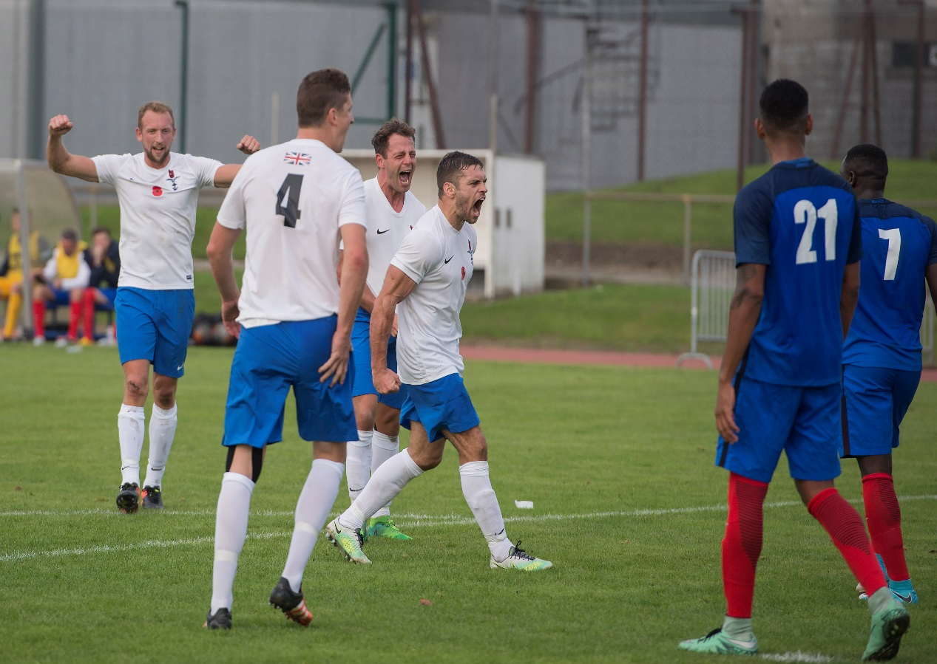

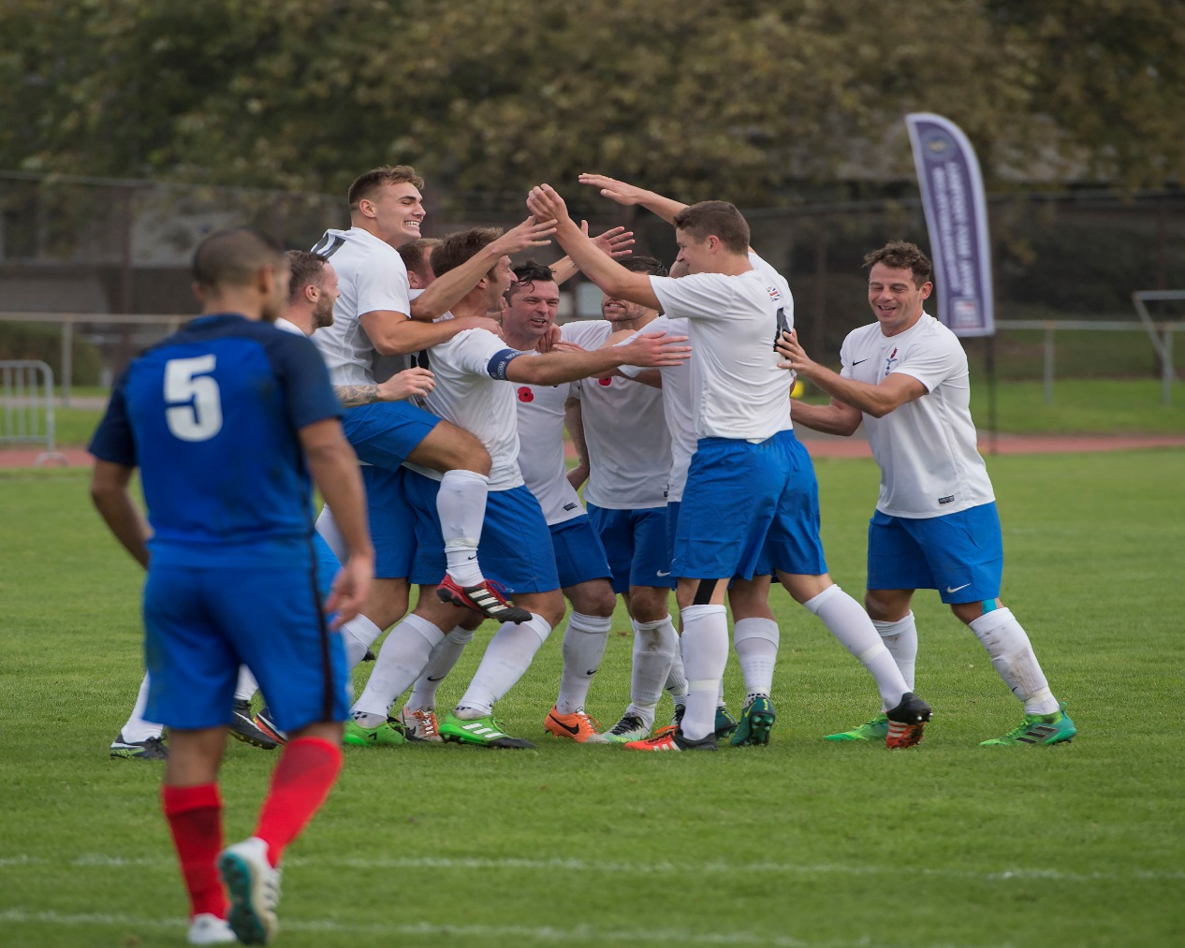

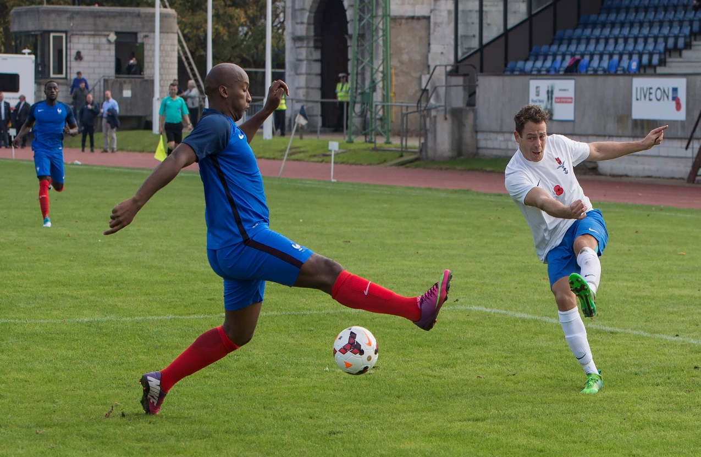

UKAFF Supported by



