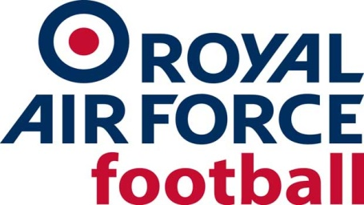

RAF Senior Rep Team

2022-23 Fixtures & Results

Date: Wed 20 July 22
Competition: Friendly
Opponents: Longlevens AFC
Venue: Away, Longlevens AFC
Result: W 2-4
Date: Wed 24 Aug 22
Competition: Friendly
Opponents: Swindon Town Academy
Venue: Home, Fairford Town FC
Result: D 0-0
Date: Wed 12 Oct 22
Competition: Friendly
Opponents: Aldershot Town XI
Venue: Home, Fairford Town FC
Result: W 3-2
Date: Wed 23 Nov 22
Competition: Friendly
Opponents: Shrivenham Town
Venue: Home, Fairford Town FC
Result: Called Off, waterlogged pitch
Date: Tues 13 Dec 22
Competition: Friendly
Opponents: Gedling Miners Welfare
Venue: Plains Road, Nottingham
Result: Called Off, frozen pitch
Date: Tue 10 Jan 23
Competition: Friendly
Opponents: Shifnal Town
Venue: Home, RAF Cosford
Result: L 3-4

Date: Tue 7 Feb 23
Competition: Friendly
Opponents: Cirencester Town
Venue: Away, Cirencester Town FC
Result: L 2-1
Date: Wed 15 Mar 23
Competition: Inter-Services
Opponents: Royal Navy
Venue: Away, Fratton Park, Portsmouth FC
Result: D 1-1
Date: Wed 29 Mar 23
Competition: Inter-Services
Opponents: Army
Venue: Home, Shrewsbury Town FC
Result: W 2-1
Date: Fri 2 June 23
Competition: Friendly
Opponents: Royal Navy/Army XI
Venue: Old Trafford, Manchester United FC
Result: L 2-4

