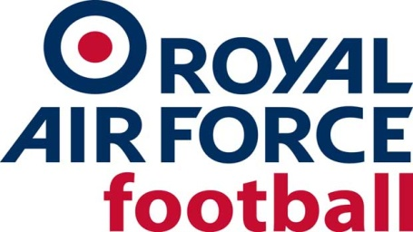

RAF Senior Rep Team

2018-19 Fixtures & Results
Date: Wed 5 Sept 18
Competition: Friendly
Opponents: Hartpury College
Venue: Home, RAF Cosford
Result: W 1-0
Date: Wed 26 Sept 18
Competition: Friendly
Opponents: Kidderminster Harriers XI
Venue: Home, RAF Cosford
Result: D 2-2
Date: Tue 9 Oct 18
Competition: Birmingham Senior Cup
Opponents: Lye Town
Venue: Away, Lye Town FC
Result: L 2-1
Date: Tue 16 Oct 18
Competition: Friendly
Opponents: Bromsgrove Sporting
Venue: Away, Bromsgrove Sporting FC
Result: L 2-1
Date: Wed 7 Nov 18
Competition: Friendly
Opponents: East Riding FA
Venue: Away, East Riding FA HQ
Result: W 3-5
Date: Tue 20 Nov 18
Competition: Walsall Senior Cup 2nd Round (bye in first round)
Opponents: Walsall Wood
Venue: Away, Walsall Wood FC
Result: W 1-2
Date: Tue 4 Dec 18
Competition: Friendly
Opponents: Prison Service
Venue: Home, RAF Cosford
Result: W 6-1
Date: Thur 6 Dec 18
Competition: Friendly
Opponents: Fire Service
Venue: Home, RAF Cosford
Result: L 3-4
Date: Wed 9 Jan 19
Competition: Friendly
Opponents: Hartpury College
Venue: Away, Hartpury College
Result: W 3-4
Date: Tue 26 Feb 19
Competition: Friendly
Opponents: Worcester City
Venue: Away, Pershore Town FC
Result: W 0-1
Date: Wed 13 Mar 19
Competition: Walsall Senior Cup, Quarter Final
Opponents: Lye Town
Venue: Away, Lye Town
Result: L 2-1
Date: Wed 20 Mar 19
Competition: Inter-Services
Opponents: Army
Venue: Away, Aldershot Town FC
Result: L 3-0
Date: Wed 27 Mar 19
Competition: Inter-Services
Opponents: Royal Navy
Venue: Home, Shrewsbury Town FC KO 1900
Result: W 4-1

