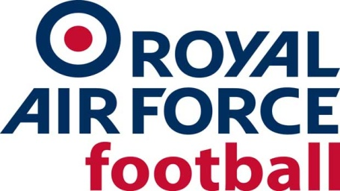

RAF MDS (U23) Rep Team
Results 2018-19

Date: Thurs 9 Aug 18
Competition: Friendly
Opponents: Fairford Town
Venue: Away, Fairford Town
Result: L 2-3
Date: Sun 7 Oct 18
Competition: Friendly
Opponents: Sutton Coldfield U19s
Venue: Home, RAF Cosford
Result: W 6-1
Date: Tues 20 Nov 18
Competition: Friendly
Opponents: Sleaford Town
Venue: Away, Sleaford Town FC
Result: W 1-4
Date: Thurs 22 Nov 18
Competition: Friendly
Opponents: Chadderton Reserves
Venue: Away, Abbey Hey
Result: D 2-2
Date: Thurs 13 Dec 18
Competition: Friendly
Opponents: Welsh Colleges
Venue: Home, RAF Cosford
Result: W 3-2
Date: Sat 5 Jan 19
Competition: Friendly
Opponents: England Schools
Venue: Home, RAF Cosford
Result: L 1-2
Date: Tue 22 Jan 19
Competition: Friendly
Opponents: Cambrian & Clydach
Venue: Away, Cambrian & Clydach FC
Result: L 2-0
Date: Wed 23 Jan 19
Competition: Friendly
Opponents: STM Sports
Venue: Cardiff University
Result: L 8-1
Date: Thur 24 Jan 19
Competition: Friendly
Opponents: Welsh Leagues U19s
Venue: Away, Port Talbot FC
Result: W 0-1
Date: Wed 6 Feb 19
Competition: Inter-Services
Opponents: Royal Navy
Venue: Away, HMS Temeraire
Result: L 3-2
Date: Wed 13 Feb 19
Competition: Inter-Services
Opponents: Army
Venue: Home, RAF Cosford
Result: D 3-3
Date: Wed 24 Apr 19
Competition: Presidents Cup
Opponents: Royal Netherlands Air Force
Venue: RAF Cosford
Result: L 0-4

